Chemotherapeutic activity of silybin liposomes combined

with Doxil in TUBO breast cancer cell bearing mice
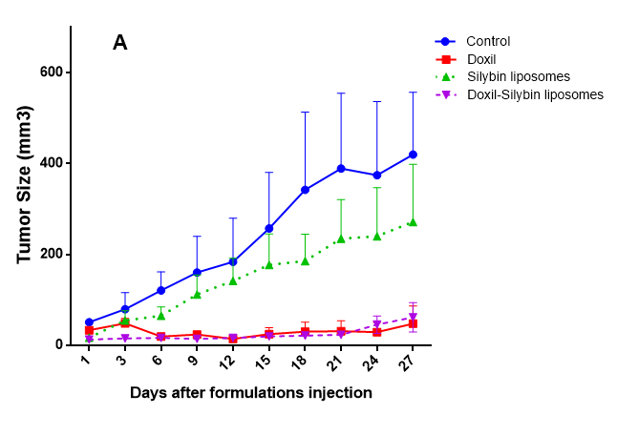
Fatemeh Gheybi, Department of Medical Biotechnology, Faculty of Medicine, Mashhad University of Medical Sciences, Mashhad, Iran.
Seyed Mahdi Rezayat, , Department of Toxicology and Pharmacology, School of Medicine, Tehran University of Medical Sciences, Tehran, Iran.
Helaleh Kaboli Farshchi, Department of Horticultural Sciences, Ferdowsi University of Mashhad, Mashhad, Iran.
Elham Zendedel, Department of Biochemistry and Biophysics, Faculty of Sciences, Mashhad Branch, Islamic Azad University, Mashhad, Iran.
Mahmoud R. Jaafari, Biotechnology Research Center, Nanotechnology Research Center, School of Pharmacy, Mashhad University of Medical Sciences, Mashhad, Iran.

Abstract
According to different studies, high intake of natural products is associated with reduced cancer risk. It is suggested that the specific concentrations of phytochemicals may have cancer chemopreventive effects without causing significant levels of toxicity. Nowadays, there is an increasing emphasis on combination chemotherapy using cytotoxic and natural chemotherapeutic agents. The successes of combination chemotherapy suggested that all cancers could be treated by providing the correct combination of drugs at the correct doses and correct intervals of administration. Silybin is the active ingredient of Silybum Marianum that has been used in traditional medicine because of its liver protective effects in different countries. It can also modulate imbalance between cell survival and apoptosis through interference with expressions of cell cycle regulators and proteins involved in apoptosis. In present study, nanoliposomal formulations containing silybin, have been prepared and their anti-tumor activities alone and in combination with Doxil were assessed in a mouse TUBO breast tumor model. After injection of liposomes, tumor size and survival were monitored on 3 occasions a week for 100 days. The results of in vivo studies showed that anti-tumor efficacy of silybin liposome formulations alone in treated mice were not significantly more than control animals on day 27. In the other two groups, the efficacy of Doxil and Doxil-Silybin (p<0.001) liposomes were significantly more than control animals (Figure 1). Also according to our data, even 100 days after inoculation, 83% percent animal survival was observed in Doxil-silybin liposome were used simultaneously but in case of Doxil alone, the survival percentage reached to almost 40% and for silybin liposomes alone reached to 20%. Therefore there is a significant difference between survival percent in control group with Doxil alone (p<0.001) and Doxil-silybin liposomes combination (p<0.001). The survival percent of the control group reached to zero, on around 40 days after tumor inoculation (Figure 2).

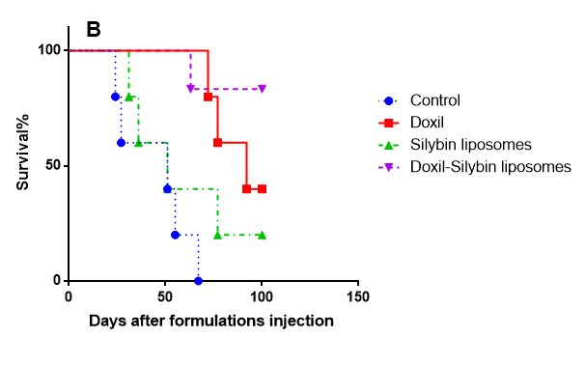

Figure 1: (A) Mean relative change in tumor volume; and (B) Survival study in TUBO-tumor bearing mice treated with a dose of 10 mg/kg Doxil, Silybin liposomes or Doxil-Silybin Liposomes formulations or 200 µl dextrose 5% (control) as i.v. injection on day 14 after tumor inoculation. Each value represents as mean ± SE (n = 5 or 6).

In conclusion, these results indicated that combination therapy using Doxil and silybin can induce improvement in chemotherapy of treated mice.
Recent Publications
1. Fantini M, Benvenuto M, Masuelli L, Frajese GV, Tresoldi I, Modesti A, et al. In vitro and in vivo antitumoral effects of combinations of polyphenols, or polyphenols and anticancer drugs: perspectives on cancer treatment. International journal of molecular sciences. 2015;16(5):9236-82.
2. Gu J, Hu W, Zhang Dd. Resveratrol, a polyphenol phytoalexin, protects against doxorubicin induced cardiotoxicity. Journal of cellular and molecular medicine. 2015;19(10):2324-8.
3. Kim TH, Shin YJ, Won AJ, Lee BM, Choi WS, Jung JH, et al. Resveratrol enhances chemosensitivity of doxorubicin in multidrug-resistant human breast cancer cells via increased cellular influx of doxorubicin. Biochimica et Biophysica Acta (BBA)-General Subjects. 2014;1840(1):615-25.
4. Sheng H, Ogawa T, Niwano Y, Sasaki K, Tachibana K. Effects of polyphenols on doxorubicin induced oral keratinocyte cytotoxicity and anticancer potency against oral cancer cells. Journal of Oral Pathology & Medicine. 2018.
5. Zhou Y, Zheng J, Li Y, Xu D-P, Li S, Chen Y-M, et al. Natural polyphenols for prevention and treatment of cancer. Nutrients. 2016;8(8):515.

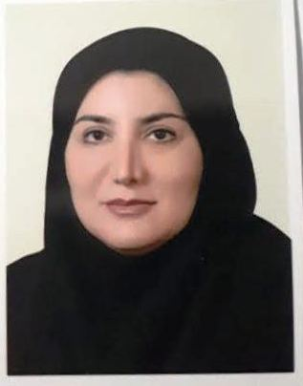
Fatemeh Gheybi is currently Assistant Professor at Mashhad University of Medical Sciences in Iran. She obtained her M.S. degrees in Nutrition and Biochemistry and her Ph.D. in Medical Nanotechnology at Tehran University of Medical Science. Fatemeh has her expertise in liposomal drug delivery systems and targeted cancer therapy. In her Ph.D. thesis work under supervision of professor Mahmoud R. Jaafari, she studied pH sensitive nanoliposomal formulation of a polyphenolic compound, Silybin. Her work lead to development of a new method for incorporation of polyphenols into the liposomes. Fatemeh has over 10 publications and 3 patents in the field of liposome technology.

