Effect of copper concentration on the physical properties of ZnS:Cu alloys prepared by chemical bath deposition
Abdelhak JRAD, PhD, Tunis El Manar University, Tunisia
Tarek BEN NASR, Dr, Tunis El Manar University, Tunisia
Souad AMMAR, Pr, Paris Diderot University, France
Najoua KAMOUN, Pr, Tunis El Manar University, Tunisia

Abstract
ZnS:Cu films were deposited on glass substrates by chemical bath deposition technique for different doping ratios y = [Cu³⁺]/[Zn²⁺] (y = 0, 6, 12 and 18 at.-%). Structural, compositional and optical properties were studied by X-ray diffraction (XRD), Fourier transform infrared spectroscopy (FTIR), X-ray photoelectron spectroscopy (XPS) and spectrophotometry. The patterns of the films prepared with a nominal Cu content higher than 6 at.-% exhibit the signature of CuS covellite phase. FTIR analysis shows the existence of characteristic vibration band of hydroxyl groups at 3436 cm⁻¹. Whereas a strong and sharp band situated at 1636 cm⁻¹ can be observed and assigned to adsorbed water (H–O–H) on the surface of the as-grown layers [1]. The bands appearing at around 2350 cm⁻¹ can be ascribed to the absorption peak of CO₂ [1]. The absorption bands appearing in the ranges of 1000–1250 cm⁻¹ and 1300–1400 cm⁻¹ can be assigned to various S–O vibrational frequencies [2]. The absorption bands observed below 900 cm⁻¹ can be assigned to the Zn–S vibration [1]. Finally, the absorption bands located at 2922 and 2961 cm⁻¹ are usually attributed to aliphatic C-H vibrations [3]. The high resolution XPS spectra of Cu ²P signal evidence two main components, Cu ²P_{3/2} and Cu ²P_{1/2} which are characteristics of Cu²⁺ cations. For all the films, the high resolution XPS spectra of S ²P signal can be fitted with 2 main components, of different intensities; a higher intensity peak, usually attributed to sulfide S²⁻ anions [4] and a lower intensity one, usually assigned to SO₄²⁻ species. The transmittance of the films decreases with increasing Cu doping ratio. The band gap energy obtained by the differential reflectance spectra is about 3.7 eV in agreement with the obtained result by Arbi et al. [5].

Image
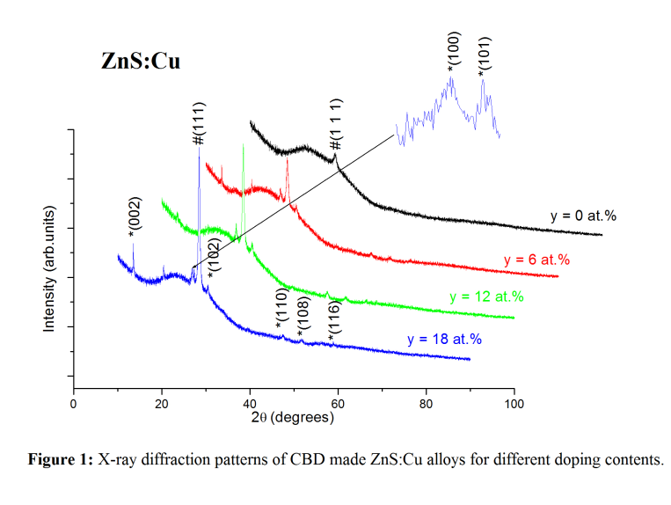
Recent Publications
- Chen Y, Zhang L, Zhang J, Liu P, Zhou T, Zhang H (2015) Fabrication of transparent ZnS ceramic by optimizing the heating rate in spark plasma sintering process. Optical Materials 50:36–39.
- Chlique C, Merdrignac-conanec O, Hakmeh N, Zhang X, Adam J (2013) Transparent ZnS Ceramics by Sintering of High Purity Monodisperse. American Ceramic Society 3074:3070–3074.
- Ashwini K, Pandurangappa C (2014) Solvothermal synthesis, characterization and photoluminescence studies of ZnS:Eu nanocrystals. Optical Materials 37:537–542.
- 5. Inamdar A I, Cho S, Jo Y, Kim J, Han J, Pawar S M (2016) Optical properties in Mn-doped ZnS thin films: Photoluminescence quenching. Materials Letters 163:126–129.
- Arbi N, Ben Assaker I, Gannouni M, Kriaa A, Chtourou R (2015) Experimental investigation of the effect of Zn/S molar ratios on the physical and electrochemical properties of ZnS thin films. Materials Science in Semiconductor Processing 40:873–878.

Biography
Abdelhak is a third-year Ph.D. student in physical chemistry studies. My research interests include synthesis of nanomaterials and their structural, compositional, morphological, optical, electrical and magnetic characterization.

Email: abdelhak.jrad@gmail.com

