Oral nanocarrier for insulin colon delivery

Miriam Colombo
Università degli Studi di Milano-Bicocca

Abstract

The current treatment of diabetes disease relies on insulin subcutaneous injection [1]. Because of parenteral administration drawbacks, alternative administration routes have been investigated [2]. Among all, the oral administration may lead to a better glucose regulation exploiting the liver first-pass metabolism of insulin, thus preventing the risks of fluctuating glycaemia. However, the oral bioavailability of peptides is very low and several efforts have been attempted to promote insulin bowel absorption. Despite all, the oral delivery of insulin remains an unmet need [3].

The aim of work was to prepare, characterize and evaluate both in vitro and in vivo a novel nanoformulated multiple-unit colon delivery system, i.e. coated pellets, as a possible oral nanocarrier for insulin. Insulin-loaded polymeric nanoparticles (NPs) were synthesized according to previously published protocols with some improvements [4]. The driving force of NPs formation was the opposite charges of polyethyleneimine and dextran sulphate resulting in the insulin entrapment into the polymeric matrix. NPs were incorporated into cores that were subsequently coated with three overlapping layers, aiming to release insulin into the large intestine: this gastrointestinal site is indeed characterized by a relatively low proteolytic activity. The system was evaluated in vitro for its physico-technological characteristics, NPs dispersion, disintegration and release performance, showing delayed release behavior. Finally, the coated nanoformulation effect was tested in diabetic rats: a significant hypoglycaemic activity, due to the synergistic effect of NPs and colon delivery, was observed.

In this study, a new approach for the oral administration of insulin is proposed. The synergistic effect due to the nanoformulation of insulin and the encapsulation in a triple-layer pellet system for colon-release delivery results in a significant and long-lasting hypoglycemic effect. The impact of our multitasking macromolecule delivery system for oral insulin in controlling diabetes is clinically appealing, since it represents an oral route for insulin administration, with a prolonged hypoglycemic activity and a more physiological insulin metabolism.

Image
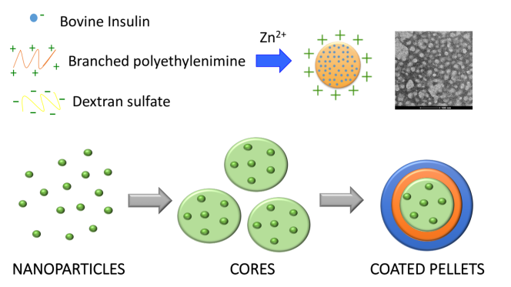
Recent Publications
1. T. Bailey, Am J Med 2013, 126, S10-S20.
2. S. Dal, N. Jeandidier, A. Schaschkow, A.H. Spizzo, E. Seyfritz, C. Sookhareea, W. Bietiger, C. Péronet, F. Moreau, M. Pinget, E. Maillard, S. Sigrist, Fundam. Clin. Pharmacol. 2015, 29, 488-498.
3. A. Maroni, L. Zema, M.D. Del Curto, A. Foppoli, A. Gazzaniga Adv. Drug. Delivery Rev. 2012, 64, 540-556.
4. W. Tiyaboonchai, J. Woiszwillo, R.C. Sims, C.R. Middaugha, Int. J. Pharm. 2003, 255, 139-151.



Biography
Miriam Colombo obtained her PhD in Biology in 2012 at the university of Milano-Bicocca. From September 2013 she is Assistant Professor in Clinical Biochemistry at the Dep. Biotechnology and Bioscience of University of Milano-Bicocca, Italy.
She is author of 44 peer-reviewed scientific publications.
Email: miriam.colombo@unimib.it

