
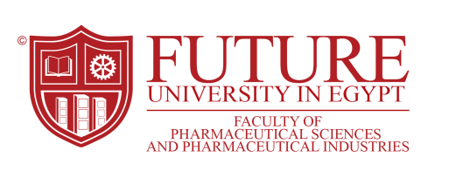
New Trends in Nanotechnology-Based Targeted Drug Delivery Systems

Prof. Dr. Hussein O. Ammar

Future University,Cairo,Egypt.
Husseinammar@fue.edu.eg

In recent years, theranostics are emerging as the next generation of multifunctional nanomedicine to improve the therapeutic outcome of cancer therapy. Polymeric nanoparticles with targeting moieties containing magnetic nanoparticles as theranostic agents have considerable potential for the treatment of cancer.

The use of directed enzyme prodrug therapy (DEPT) has been investigated as a means to improve the tumor selectivity of therapeutics. Magnetic DEPT involves coupling the bioactive prodrug-activating enzyme to magnetic nanoparticles that are then selectively delivered to the tumor by applying an external magnetic field.

Gene therapy is an attractive method for meeting the needs for curing brain disorders, such as Alzheimer’s disease and Parkinson’s disease. On the other hand, due to the fact that hepatocellular carcinoma (HCC) is resistant to standard chemotherapeutic agents, gene therapy appears to be a more effective cure for HCC patients.

Ultrasound-mediated drug delivery is a novel technique for enhancing the penetration of drugs into diseased tissue beds noninvasively. This technique is broadly appealing, given the potential of ultrasound to control drug delivery spatially and temporally in a noninvasive manner.

