A Graphical based approach for early diagnosis of Alzheimer disorder
Pooja Khurana, Associate Professor, Department of Applied Science, Manav Rachna International Institute of Research and Studies

Abstract
Alzheimer is a step wise and progressive neurodegenerative disorder caused by neuronal cell death. Characteristic changes within the brain due to Alzheimer Disease (AD) usually occur almost 20 years before symptoms arise. This minimally symptomatic phase offers a potential chance for therapeutic intervention which can be aimed to slow or predict the advancement to clinical AD. Mild cognitive impairment (MCI) is the stage before AD. The conversion from MCI to AD has been of agreeable interest within the analysis of biomarkers for early AD detection. Determination of causative agents is a necessary step for the understanding and to figure out the effective
treatment of a disease Assessment of significant biomarkers can be overriding to early (preclinical) diagnosing,
treatment, monitoring, and continuing phases of Alzheimer’s analysis, for that graph theoretical measures can be
utilized to infer neurobiological mechanisms leading to loss of cognitive functions, behavioural and other brain
disorders. Also, complex networks of brain can be well characterized by graph functions that distinguish Alzheimer
brain from the normal ones. This paper highlights the role of graph theory as an emerging tool for the early diagnosis of AD.

Image
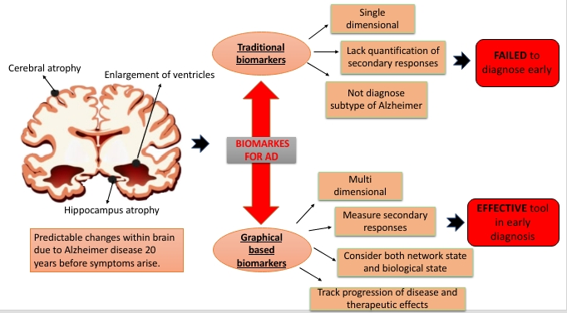
Recent Publications
- Craig-Schapiro, R.; Perrin, R. J.; Roe, C. M.; et al. YKL- 40: A Novel Prognostic Fluid Biomarker for Preclinical Alzheimer’s Disease. Biol. Psychiatry 2010, 68, 903–912. https://doi.org/10.1016/j.biopsych.2010.08.025
- Daulatzai MA. Pharmacotherpy and Alzheimer's Disease: The M-Drugs (Melatonin, Minocycline, Modafinil, and Memantine) Approach, 2016;22(16):2411-30. https://doi.org/10.2174/1381612822666160203142111
- Blennowa K, Duboisb B, Faganc MA, Lewczukd P, Leone M, Hampel H. Clinical utility of cerebrospinal fluid biomarkers in the diagnosis of early Alzheimer’s disease. Alzheimers Dement. 2015; 11: 58–69. https://doi.org/10.1016/j.jalz.2014.02.004
- Dawkins, E.; Small, D.H. Insights into the physiological function of the β-amyloid precursor protein: Beyond Alzheimer’s disease. J. Neurochem. 2014, 129, 756–769. https://doi.org/ 10.1111/jnc.12675
- Hardy J. The Alzheimer family of diseases: many etiologies, one pathogenesis? Proc Natl Acad Sci USA. 1997;94:2095-2097. Proc Natl Acad Sci U S A. 1997 Mar 18; 94(6): 2095–2097.doi: 10.1073/pnas.94.6.2095
- Jon delEtoile and Hojjat Adeli. Graph Theory and Brain Connectivity in Alzheimer’s Disease. The Neuroscientist 1–11. DOI: 10.1177/1073858417702621


Biography (150 word limit)
Dr. Pooja Khurana is the professional academician with strong analytical skills seeking the position of Associate professor and researcher focusing in Biomathematical modeling. She has published multiple papers in the areas of biomathematics, social networking indexed in Scopus, Web of Science; presented various mathematical reports in conferences and seminars. She is an expert in applying mathematical principles to complex real world problems and well-versed with the mathematical software such as Mathematica, MATLAB. She is currently mentoring three scholar candidates and skilled with applying the concepts of statistics, numerical analysis and probability in building and simulation of mathematical model for improving healthcare.
Email: pooja.fet@mriu.edu.in

Notes/Comments:

