Locally nonlinear embedding and dimensionality reduction of MFCCs information of stethoscope heart sounds

Jiann-Ming Wu
Professor
Department of Applied Mathematics, National Dong Hwa University, Taiwan

Abstract
Nonlinear dimensionality reduction (NDR) mapping aims to transform observations to images in an embedding low-dimensional manifold from the original high-dimensional space. NDR mapping is feasible for data visualization and emulating cortex-like mapping. Locally nonlinear embedding (LNE) extends linear relations among high-dimensional observations to nonlinear constraints of distance preservation for NDR mapping. This work introduces LNE-based NDR mapping for processing MFCCs (Mel-Frequency Cepstral Coefficients) information of bluetooth stethoscopic heart sounds. Neural organization, unsupervised learning and LNE transformation are introduced for NDR mapping. Graph-organized neural modules are trained subject to given training observations. Each module contains a receptive field and 2K+1 Adalines, respectively referring to a cluster centroid and internal representations of a PCA-based bounded support within an intermediate subspace in dimension K. A neural module activates to indicate the membership of an input to a correspondent cluster support. Graph edges or lateral interconnections of organizing neural modules are adaptable, mainly maintaining neighboring relations of distributed cluster supports and secondary receptive fields required for calculating distance or minimal path distance between centroids of two neighboring or unconnected cluster supports. Distances among all centroids set constraints of characterizing a large scale LNE transformation that is resolved by the Levenberg-Marquardt algorithm for inducing transformed images of all centroids, equivalently posterior weights. Massive testing observations can be transformed in parallel way for real time analysis. Every testing observation belongs to one cluster support and its distances to centroids of surrounding cluster supports pose constraints of an individual LNE transformation, whose solution represents the transformed image. Testing observations are transformed without reserving training observations. Numerical experiments show the presented approach effective for NDR mapping and visualization of 12-dimensional MFCCs features of bluetooth stethoscopic heart sounds, including both normal and murmur cases.

Image
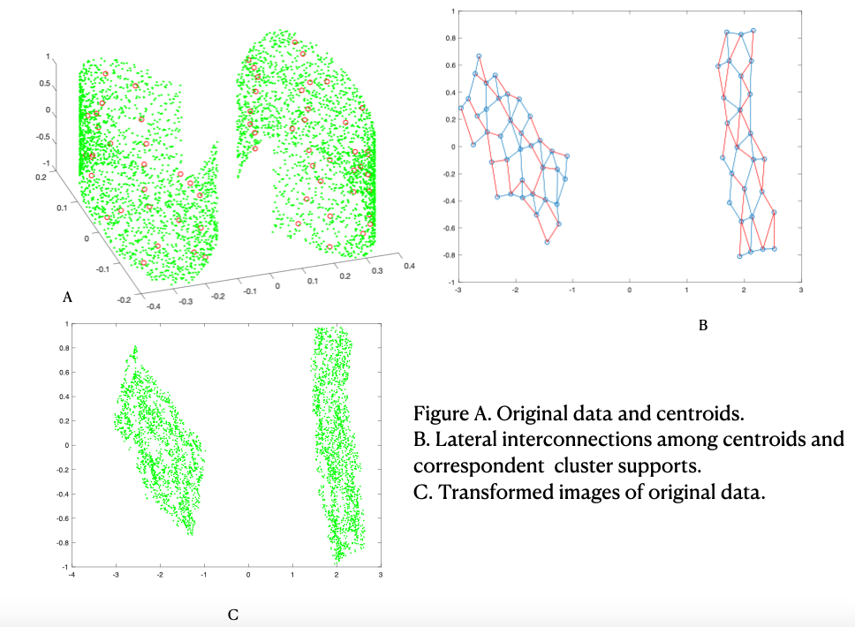
Recent Publications
- Wu, S.-S.; Jong, S.-J.; Hu, K.; Jiann-Ming Wu*. Learning Neural Representations and Local Embedding for Nonlinear Dimensionality Reduction Mapping. Mathematics 2021, 9, 1017.
- Jiann-Ming Wu* and Chao-Yuan Tien, “ MatConvNet Deep Learning and IOS Mobile App Design for Pattern Recognition : Emerging Research and Opportunities,” April 2020, IGI Global, Hershey, Pennsylvania, United States of America.
- Jiann-Ming Wu*, Chun-Chang Wu, Jia-Ci Chen and Yi-Ling Lin, “Set-valued functional neural mapping and inverse system approximation,” Neurocomputing, Vol.173, pp.1276-1287, January 2016.
- Jiann-Ming Wu*, Pei-Hsun Hsu and Cheng-Yuan Liou, “Sudoku Associative Memory,” Neural Networks, Vol.57, pp.112-127, September 2014.
- Jiann-Ming Wu*, Chun-Chang Wu and Ching-Wen Huang, “Annealed cooperative-competitive learning of Mahalanobis-NRBF neural modules for nonlinear and chaotic differential function approximation,” Neurocomputing, Vol.136, No.20, pp.56-70, July 2014.
- Jiann-Ming Wu*, M.H. Chen and Lin Z.H., “Independent component analysis based on marginal density estimation using weighted Parzen windows,” Neural Networks, Vol.21, pp.914-924, September 2008.
- Jiann-Ming Wu,*, “Multilayer Potts perceptrons with Levenberg-Marquardt learning,” IEEE TRANSACTIONS ON NEURAL NETWORKS, Vol.19, No.12, pp.2032-2043, December 2008.
- Jiann-Ming Wu*, Z.H. Lin and Pei-Hsun Hsu, “Function approximation using generalized adalines,” IEEE Trans. On Neural Networks, Vol.17, No.3, pp.541-558, May 2006.
- Jiann-Ming Wu* and Pei-Hsun Hsu, “Annealed Kullback-Leibler divergence minimization for generalized TSP, spot identification and gene sorting,” Neurocomputing, Vol.74, pp.2228-2240, June 2011.
- Jiann-Ming Wu*, “Fetal electrocardiogram extraction by annealed expectation maximization,” Neurocomputing, Vol.71, pp.1500-1514, March 2008.

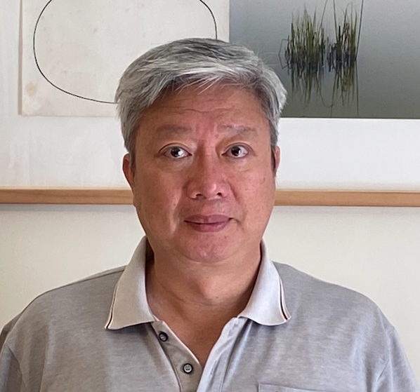
Biography
Jiann-Ming Wu was born in Taiwan, on November 22, in 1966. He received the B.S. degree in computer science in 1988 from National Chiao Tung University, the MS. degree and the Ph.D. degree in computer science and information engineering from National Taiwan University in 1990 and 1994 respectively. In 1996, he joined the Faculty as an associate professor, serving as chairman during 2019-2021 at the Department of Applied Mathematics in National DongHwa University, where he is currently a professor. His current research interests include neural networks and medical signal and information processing. In the past decade, he has developed effective learning methods for neural networks toward solving ICA, self-organization, classification, data driven function approximation and density estimation, nonlinear dimensionality reduction.

Email: ett2012@gmail.com
Email: jmwu@gms.ndhu.edu.tw

Notes/Comments:

