National Covid-19 registry in Iranian hospitals: Development of an agile information system for Covid-19-affected patients' data collection
Somayeh Abedian, PhD (c), Iranian Emergency Medical Services Organization, Iran
Peirhossein Kolivand, PhD, Iranian Emergency Medical Services Organization (Head of the organization)
Hamid Reza Lornejad, MD, Iranian Emergency Medical Services Organization, Iran

Abstract

COVID-19’s rapid spreads has caused a global pandemic. On 19th February 2020, Iran reported its first confirmed cases of infections in Qom City and the number of diagnosed cases and the death toll rose exponentially in March [1-3]. Managing the disease, which is considered a pandemic according to the World Health Organization (WHO) [4], requires definite approaches differing according to various factors in each country, which may also lead to (in)effective dealing with the disease. For every plan by governances, the first step is collecting information on epidemic distribution for the purpose of isolating provinces and cities at a national scale. Thus, Ministry of Health and Medical Education of Iran (MOHME) attempted to collect the minimum required data on the infection-affected patients based on medical records and epidemiological factors, such as demographic data (gender, age and national code), exposure history (close contact with the infected, suspect patients or even having traveled) and signs and symptoms (fever, cough, shortness or difficulties in breathing, fatigue, anorexia, hemoptysis, sputum production, dyspnea, Myalgia, Pharyngalgia, nausea, vomiting, Diarrhea, Headache, Abdominal pain, Dizziness, etc.). Therefore, to ensure accuracy and validity, and to speed up data collection in an area, Information Technology (IT) tools were required [5]. In this regard, developing an information system with a simple format and user-friendly interface in the shortest possible time was the aim. Thus, an agile information system for COVID-19 outbreak monitoring in Iranian hospitals developed in March 2020, which has been registering hospitalized Covide-19-affected patients in Iranian hospitals up till now. In other words, we made a national system as a health registry that includes clinical information on admitted Covid-19 patients in Iranian hospitals from admission to discharge or death. This system is supported by MOHME, and along with outpatient Point of Care Information Systems (POCS), feeds the national and international pandemic reports and decisions. The information system is designed based on professional advice and emerging requirements. The government is using this data repository beside other clinical data resources in order to improve the quality of health services acceptability, continuity/sustainability, clinical effectiveness in a minimum time and prevent further spreading of the virus.
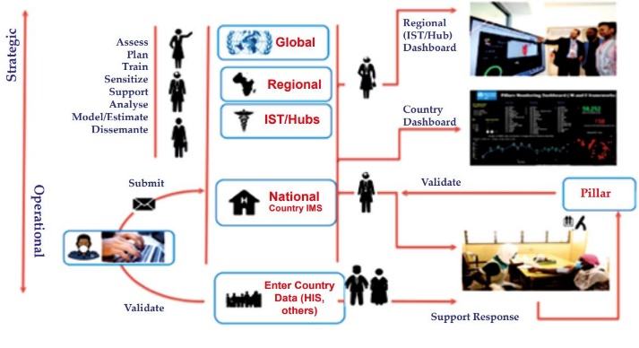

The COVID-19 data collection process from Iranian hospitals

Recent Publications
- 1. York Times. "How Iran Became a New Epicenter of the Coronavirus Outbreak". New Archived from the original on 27 June 2021. Available from: https://www.newyorker.com/news/our-columnists/how-iran-became-a-new-epicenter-of-the-coronavirus-outbreak
- 2. Iranian Ministry of Health and Medical Education. Coronavirus epidemic in Iran. Available from: http://ird.behdasht.gov.ir/. Accessed August 3, 2020.
- 3. Venkatesan P. COVID-19 in Iran: round 2. Lancet Infect Dis. 2020 Jul;20(7):784. doi: 10.1016/S1473-3099(20)30500-4. PMID: 32592672; PMCID: PMC7314444.
- 4. Prevention UCfDCa. Coronavirus Disease 2019 (Covid-19). (2020).https://www.cdc.gov/coronavirus/2019-nCoV/summary.html
- 5. Rassouli Maryam, Ashrafizadeh Hadis, Shirinabadi Farahani Azam, Akbari Mohammad Esmaeil, "COVID-19 Management in Iran as One of the Most Affected Countries in the World: Advantages and Weaknesses", JOURNAL: "Frontiers in Public Health", VOLUME:8, 2020, Available from: https://www.frontiersin.org/article/10.3389/fpubh.2020.00510, DOI:10.3389/fpubh.2020.00510,ISSN:2296-2565





Presenter Biography
Somayeh Abedian is PhD candidate in ITM and has +15 years' experience in health information systems analysis and evaluation. She has expertise in evaluation and passion for improving health and wellbeing based on Health Information Systems (HIS). Her and colleagues' model based on the crisis situation, has provided an opportunity for the government to gather critical data about hospitalization COVID-19 affected-patients. She was head of Information Technology office at the National EMS organization in Iran when the project was launched.
Email: so.abedian@gmail.com ,s.abedian@behdasht.gov.ir
Notes/Comments:
This project supported by the Iranian Ministry of Health and Medical Education, attempts were made to improve the reliability and validity of COVID-19-affected patients’ information and statistics.

