Simplifying Health Care Payment in the US – and Reducing Cost with Existing IT Infrastructure
Jeffrey R. Helton, PhD, Metropolitan State University of Denver, USA

Abstract
Statement of the Problem: Reimbursement to health care providers for services in the United States entails a lengthy, detailed, and expensive process of documenting services, diagnostic services, and composing an invoice for payment. This process conservatively consumes a minimum of ten percent of the costs of care in the U.S. Health providers and insurers in the U.S do not leverage investments in health information technology to increase efficiency in this process.
Methodology & Theoretical Orientation: This theoretical concept paper proposes a technological framework to leverage existing technologies from both the insurer and provider perspectives to create as more efficient revenue collection/insurer reimbursement system in the U.S. This proposal will describe the adoption of simplified electronic health record user interfaces with greater use of structured data, existing computer assisted coding tools, modification of common billing rules, use of existing EDI tools, and automated claims adjudication to provide an expedited reimbursement to the U.S provider in a manner similar to that done in the French health care system now. With automated processing of provider payments, there is greater risk of billing fraud. This proposal will also describe automated fraud screening algorithms to mitigate much of this risk arising from automated claims adjudication.
Findings: This paper will calculate an estimated savings of approximately eight percent (8%) in health care spending in the U.S. based on elimination of administrative processes that do not add value to patient care in that country.
Conclusion & Significance: This paper proposes integration of existing technologies to streamline health care provider payment in the U.S. In so doing, the U.S. health care system could reap significant savings of administrative expenses that greatly inflate the costs of health care and free up resources to provide care to the millions of persons in this country without health insurance coverage.

Illustration of concept
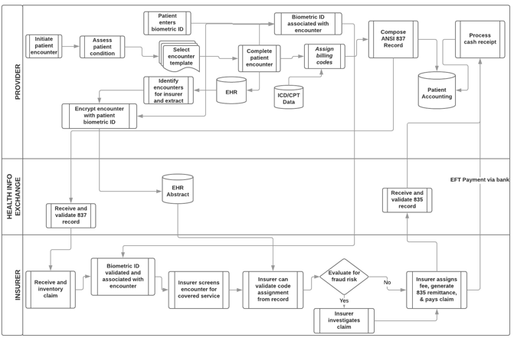
Recent Publications
- Pakhomov, S., Buntrock, J., & Chute, C. (2006) Automating the Assignment of Diagnosis Codes to Patient Encounters Using Example-based and Machine Learning Techniques. Journal of American Medical Informatics Association 13:516-525.
- Healthcare Information and Management Systems Society. (2008) Real Time Adjudication of Healthcare Claims. HIMSS Financial Systems Financial Transactions Toolkit Task Force White Paper.
- Helton, J. (2010) Avoiding Fraud Risks Associated with EHRs. (2010). Healthcare Financial Management, 64 (7): 76-81.

 Speaker Biography
Jeff Helton is a former health system chief financial officer, leading hospitals, health plans, and integrated heath systems in the U.S. over a span of nearly thirty years. He is now an Associate Professor of Health Care Management at Metropolitan State University of Denver, and holds adjunct appointments in biomedical informatics at the University of Texas School of Biomedical Informatics, health economics at the University of Colorado at Denver, and health care finance at George Washington University. He has written on the impacts of health information technology on the operational efficiency of hospitals in the United States and on the fraud risks associated with electronic health records having made numerous professional presentations on these topics. He holds a PhD from the Universty of Texas with dual studies in health economics and health informatics and is co author of the text Health Operations Management – A Systems Perspective.
Email: jhelton2@msudenver.edu

Notes/Comments:

