Abdominal Trauma: Five Years Experience in National Centre Hospital, Mauritania
A. Moulaye Idriss1*, Y. Tfeil1, J. S. Baba1, S. M. Boukhary2, B. Hamad2, M. Abdllatif2, T. A. Kane1, M. Abdllahi2, B. Moctar2, B. Taleb1
1Department of Surgery, Faculty of Medicine, Nouakchott Al Aasriya University, Nouakchott, Mauritania
2General Surgery Department, National centre Hospital, Nouakchott, Mauritania

Abstract
Trauma care including abdominal trauma is a big challenge. It is associated with high morbidity and mortality and continues to be a public health problem worldwide. The main aims of our study were to assess the patterns and outcomes of our patients, and to describe our experience in management of abdominal trauma. This descriptive retrospective study was conducted in general surgery department at National Centre Hospital of Nouakchott in Mauritania. We recruited patients presented at our department with abdominal trauma (2012-2016). Out of 100 cases, 92% were men. Mean age: 22.78 years (5 - 70 years). Eighty percent of patients suffered of penetrating abdominal trauma. Stab injuries were the most frequent mechanism (60%). The commonest organ injury was small intestine (16%). Mortality has been strongly related to road traffic accidents. Cares of severe abdominal traumas are not common in our hospital, due to lack of required overall data. Emergency health system is needed to better care of trauma patients in Mauritania.
Keywords Abdominal Trauma, Blunt, Stab Wounds, Laparotomy, Mauritania

Image

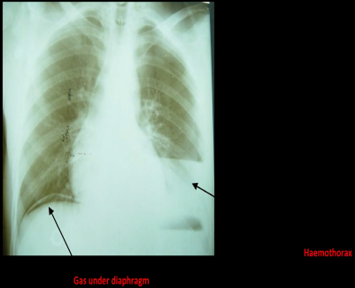
Recent Publications

Choledocolithiasis about 272 cases treated chn nouakchott - mauritania. Ihpba journal, april 2016, volume 18, supplement 2, page e671. 2016 published by elsevier inc.
- Cholécystectomie par voie coelioscopique en mauritanie a propos de 742 cas A. Moulaye Driss, SA. Zeidane, MSM. Mouamar, A. Brahim, K. Ba, SR. Bidiel, SMS. El Issawi, Ch. Mechri, B. Kane Le journal de Coelio-chirurgie - Edition numérique - N° 94 - Juin 2015.

Thyroid Cancers in Mauritania About 70 cases managed in National Center Hospital CHN Nouakchott in Mauritania 2015-04-24 | http://www.epostersonline.com/asgbi2015/node/198

Cholelithiasis in mauritania about 1427 of cases treated chn nouakcott 2014-12 | book http://www.cimmicmm.org/page/anglais/saudiarabia_abstract/abstract-40thworldcongress2014.pdf

Colo-rectal cancer About 98 cases treated National Center Hospital Nouakchott – Mauritania 2014 | conference-poster http://www.epostersonline.com/asgbi2014/?q=node/1413&page=11

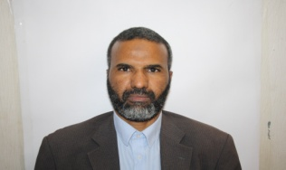
General surgeon MD. Associate Professor / General surgery Department / National center Hospital, Faculty of Medicine, Nouakchott University.
Has completed his certificate of specialization in General Surgery in 2001 from UCAD of Dakar University in Senegal and become Associate General surgeon 2006 in Nouakchott University. He is involved in Teaching GI and Human anatomy. Research interest in Medical pedagogy, Surgical oncology, Public health and 3D slicer Imaging.

Email: carcinologie@yahoo.fr

Notes/Comments: Would be pleased to participate in this event
Thanks

