5th International Conference on Medical Informatics & Telemedicine
August 31- September 01, 2017 |Prague, Czech Republic
Theme: Intersecting healthcare and technology to improve lives of patients

Students and telemedicine: Connecting technology to campus healthcare
Jodee Fitzgerald, (DHEd), MS, CHES, Metropolitan State University, USA

Abstract Image
Statement of the Problem: Students often have limited healthcare options due to a variety of reasons including being impacted by health disparities within an ecological perspective. When higher education universities have more than one primary location, using technology to connect the students (patients) to healthcare is critical. With 17% of our total student population uninsured, selecting a healthcare system that would cast a wide reach throughout the state of Minnesota (USA) was critical. Not only did this effect the quality of lives of our students (patients), it also aimed to decrease ecological problems that existed throughout our population. Methodology & Theoretical Orientation: An action research approach was taken, which sought to engage the students in the process of selecting a campus wide healthcare system. Qualitative data collection included focus groups and interviews with students. Findings: The students in this study were very eager to assist with locating a new campus wide healthcare system. Although there were many challenges to finding the appropriate healthcare system, the students were enthusiastic to utilize technology to meet their healthcare needs. They clearly knew what they were seeking in terms of healthcare, and their vision was then brought to life. Conclusion & Significance: In the end, the university ended up selecting a telemedicine option which addressed the needs of all of our students throughout the state of Minnesota. Without the assistance of technology and telemedicine, our university would not have been able to identify a comprehensive healthcare system that met the needs of all of our students due to the multiple campuses within our university. Telemedicine has been the frontrunner within our campus community and will continue to grow with an increase in utilization and visibility.
Figure 1: Effects of telemedicine on access to quality healthcare.
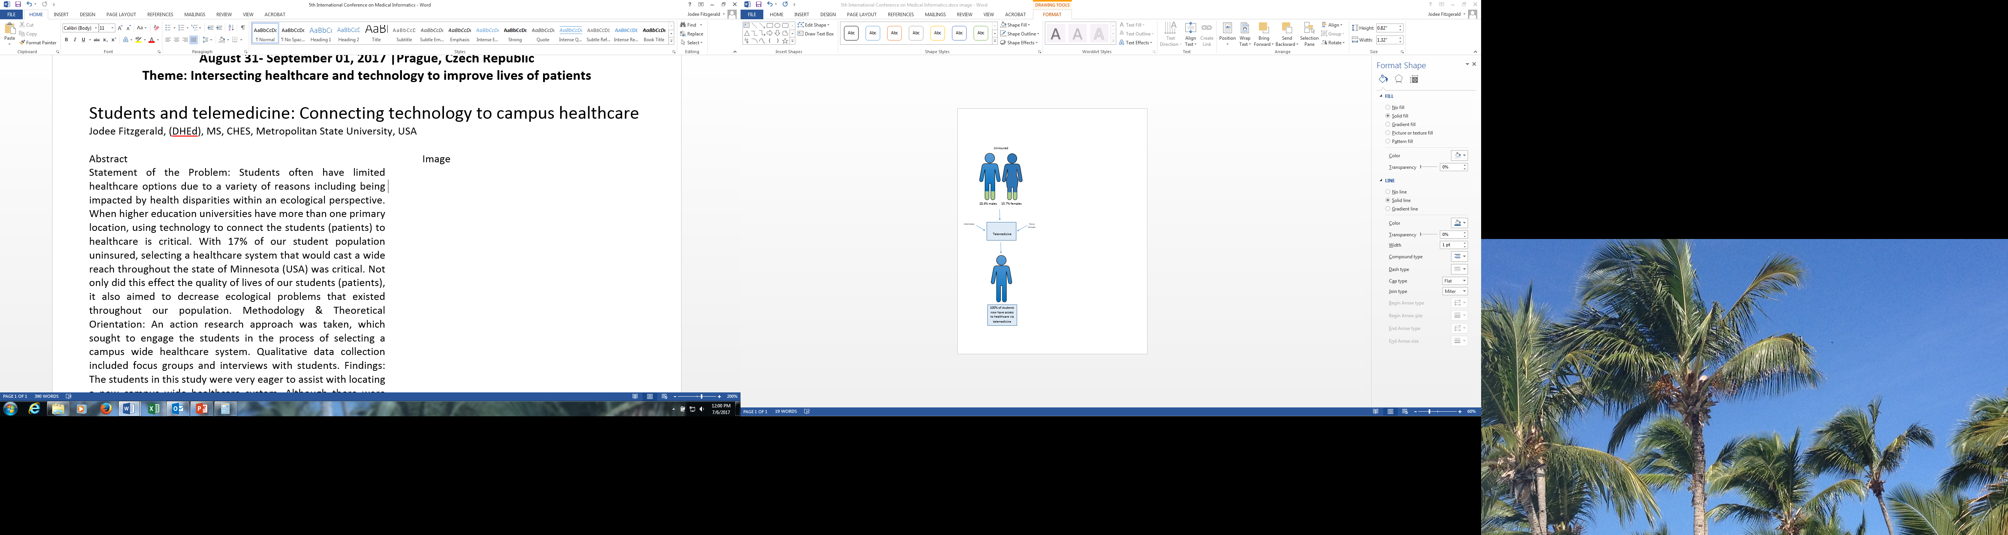

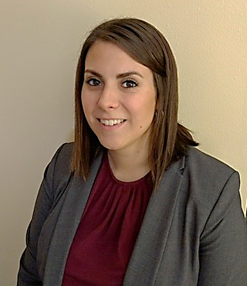Biography:
Jodee Fitzgerald has extensive expertise in healthcare implementation and evaluation. Her primary focus has been on health promotion throughout the field of higher education and in managed care organizations. She holds a master’s degree in health promotion from Mississippi State University, and is currently working toward a doctorate in health education from A.T. Still University and will be ABD in December 2017.
Email: jodee.fitzgerald@metrostate.edu

