INVASIVE MUCORMYCOSIS
Abstract
A case of mucormycosis presenting primarily as a subcutaneous mass on the right ankle joint in an immunocompetent individual is described. The patient went on to have an X ray and MRI and ultimately a histopathological examination lesion revealed degenerated hyphae associated with acute necrotizing and chronic granulomatous inflammation which is consistent with mucormycosis.

Case Report
A 57-year-old male presented with painful, purulent swelling on the posterior medial aspect of the right ankle joint. There was no history of trauma, fever or systemic symptoms. The patient had no history of diabetes or immunosuppression. A routine set of bloods Including full blood count, renal function tests and CRP were not significant. Blood cultures failed to grow any organism. An X ray of the right ankle showed a mass posterior to calcaneum. Subsequent MRI report mentioned that the lesion showed haemorrhagic and cystic areas with increased vascularity and surrounding soft tissue edema. The features were suggestive of a possible malignant soft tissue mass lesion. The lesion was biopsied and the findings were in keeping with a diagnosis of cutaneous invasive mucormycosis.

Discussion
Mucormycosis, or Zygomycosis, is a rare fungal infection caused predominantly by members of the family Mucoraceae of the order Mucorales. Fungus commonly isolated clinically belongs to the genera Absidia, Mucor or Rhizopus. They can cause devastating illness in previously well patients when compared to other filamentous fungi. Mortality varies depending on site of infection and patient co-morbidity. Single site infection in patients with no underlying pathology has an overall mortality of 35% but disseminated disease has a mortality of 96%.The most common predisposing factors include Diabetes, immunosuppression and history of trauma. Patients with chronic renal failure are also susceptible. Rhinocerebral/rhinofacial form is the most common but occasionally pulmonary, gastrointestinal and cutaneous forms may also occur. Mucormycosis of the cutaneous and subcutaneous tissues is relatively uncommon. Mucormycosis can be diagnosed in histopathologic sections by hematoxylin and eosin stain (H&E) with the aid of PAS or GMS stain. The fungal forms of mucormycosis are broad, non-septate hyphae. They are wider than Aspergillus species and branch irregularly. The angle of branching is greater than other organisms, and usually approaches 90°. Angioinvasion is common and may elicit intravascular thrombosis. There is often a marked inflammatory response which may be neutrophilic and granulomatous. Sometimes, there is minimal inflammatory response, particularly in immunosuppressed individuals.
Routine blood work may not suggest anything and the cultures may not grow any organisms often. Treatment includes, complete excision or debridement of the lesion with systemic Amphotericin-B. If left untreated or in case of inadequate removal of lesion, it may destroy the surrounding local areas or extend into deep tissues that may require amputation.
Summary
To summarize, cutaneous and subcutaneous forms of mucormycosis are rare. This case was particularly rare as there was no obvious predisposing factor. The management needs to be aggressive and should include control of the predisposing factors as well.

IMAGES
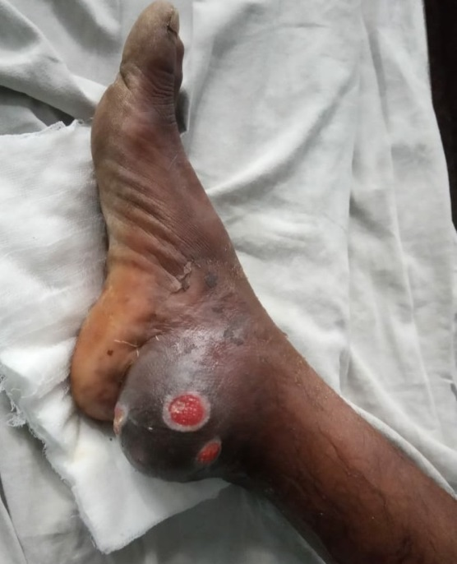
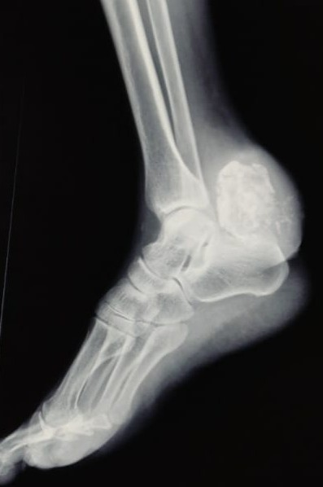
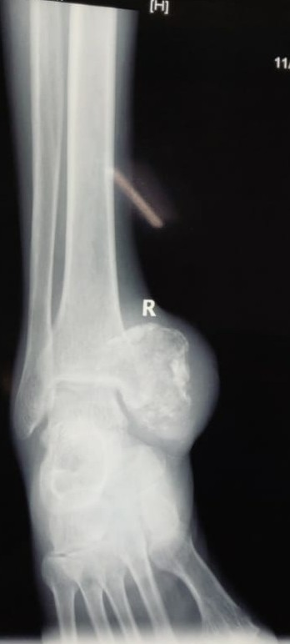
References
- ANNALS OF CLINICAL AND LABORATORY SCIENCE, Vol. 29, No. 1
- The Intensive care society case reports
- National Institute for Health and Care Excellence: Clinical Guidelines, UK

AUTHORS
- Dr Chirag Shah, University College of Medical Sciences, New Delhi
- Dr Shitanshu Kalani , Royal Blackburn Hospital, UK
- Dr Munim Tariq , Royal Blackburn Hospital, UK

