
Design and characterization of nano hybrid gelatin and silicon oxide styptic for massive bleeding

M. Chenani

Biomaterials Group, Department of Medical Engineering, Science and Research Branch, Islamic Azad University, Tehran, Iran.
maryam.chenani@srbiau.ac.ir
Maryam.chenani@gmail.com

Abstract

In the past decade, much effort has been made to develop hemostatic agents. But the existing options have ample restrictions, including failure to maintain the structure of the styptic in the face of severe bleeding and rapid changes in pH. Since variation in the pH of the injury site is an important factor in the failure of styptic and its structural damage, in this study the behavior of a gelatin-silica hybrid in severe bleeding was evaluated under different pH values. On the other hand, the effect of the hybrid particle size, which is one of the key physical properties of the hybrid, has been studied in rapid control of hemostasis. The hybrid hemostatic behavior varied drastically by changing the particle size, so that the hybrid contain SiO₂ with the average particle size of about 1 micro-meter (Hyb-MSiO₂) demonstrated very poor ability in platelet adhesion in neutral pH. Also the aPTT was not shorter than the normal time, whereas reduction of the particle size beyond a certain limit (with nano-meter SiO₂ for Hyb-NSiO₂), led to both increasing platelet adhesion and very considerable reduction of aPTT in neutral pH. Alignment of all results showed that the particle size reduction improves the hemostatic behavior of the hybrid toward its best performance by controlling excessive bleeding. By changing the pH for a certain particle size, structural integrity and thereupon the hybrid hemostatic behavior changed dramatically. So that the nano-hybrid showed the most blood absorption and acceded to a coherent structure. The results demonstrated that in alkaline or acidic environment, the hybrid hemostatic behavior was limited, so that in acidic pH the blood absorption was reduced and the normal clotting time was longer. Based on the results of this study, it was found that changes in the hybrid behavior in acidic pH were much more drastic than in alkaline pH, and also the hybrid with the optimum particle size (Hyb-NSiO₂) can maintain the structural integrity with rapid hemostasis. Based on the objective that the pH at the injury site change to the alkaline side, the resulting hybrid has an excellent ability to control excessive bleeding and can be proposed for further in vivo studies as a novel styptic.

Images and Table

Table 1. The code of samples based on particle size.
Sample code | composed materials (%w) | Water/Oil ratio | Stirring rate (rpm) | Particle Size (nm)
Hyb-NSiO₂ | 20Nano Si-80G | 0.4 | 1800 | 102
Hyb-MSiO₂ | 20Micro Si-80G | 0.1 | 600 | 1010
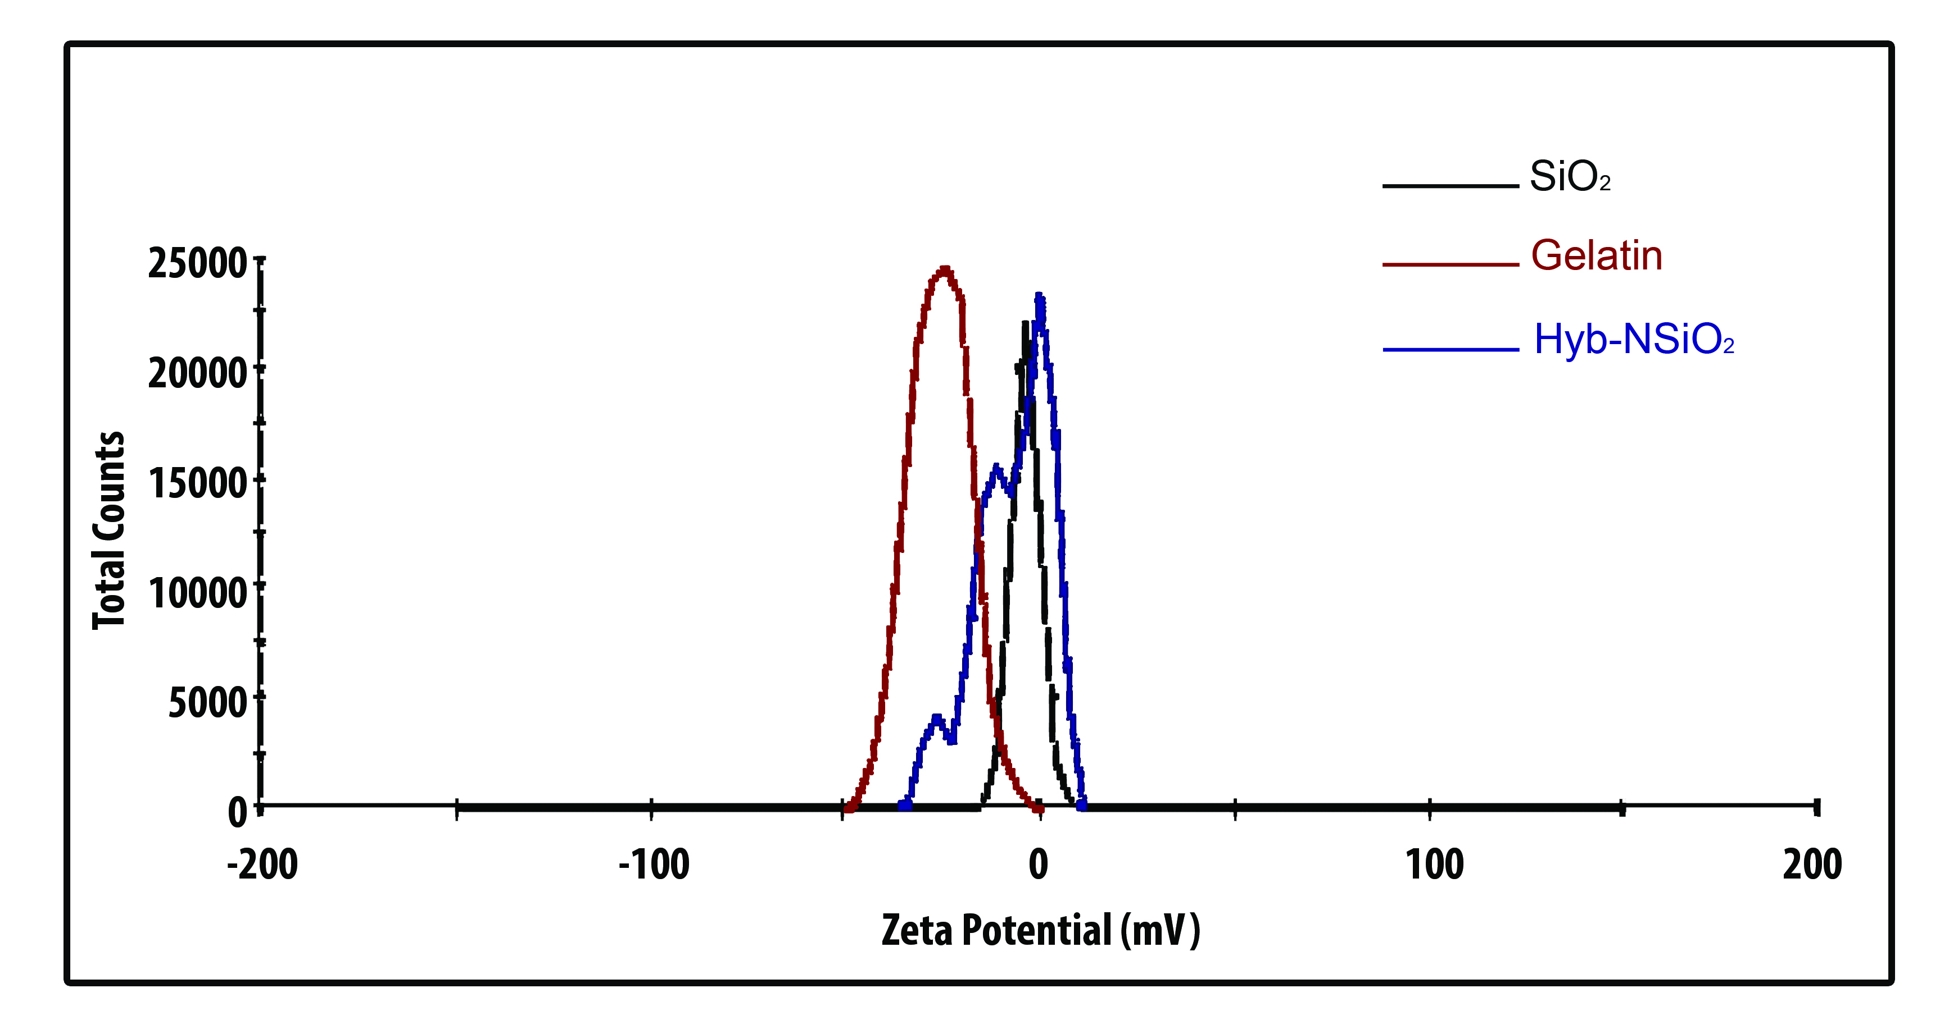
Figure 1. The Zeta potential curve of nano-silica, gelatin and Hyb-NSiO₂.
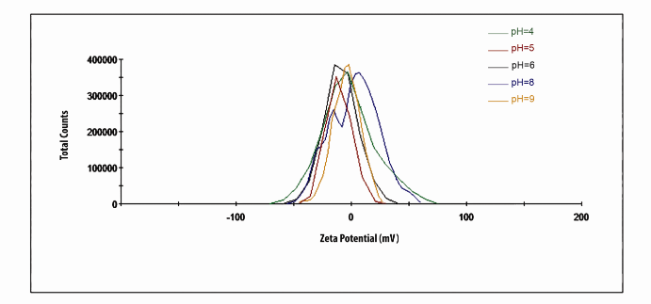
Figure 2. The Zeta potential curve of Hyb-NSiO₂ in different pH.
Recent Publications
- Chenani M., Ahmadinejad M. 2016. Preparation and characterization of novel gelatin/silica nano-hybrid as a styptic for massive bleeding. J. Nano. Bio., 4, 1277-1288.
- Chenani M., Behnamghader A. July 21, 2015. "The Evaluation Alginate-Enriched Nano-Silica Static Blood Performance in Extreme Bleeding", International Conference on Research in Engineering, Istanbul, Turkey.
- Chenani M., Khorasani M. July 21, 2015. "Zeolite Hybrid Homeostasis Behavior Characterized by Thrombin", International Conference on Research in Engineering, Istanbul, Turkey.
- Chenani M., Ahmadinejad M. April 14 & 15, 2015. "Comparison of Nano-Powder Treated by Thrombin with Quick clot, Hem con, Wound State and Standard Dressing", International Conference on Engineering Sciences (ICOAC) University of Barcelona, Spain.
- Chenani M., Moradi S. December 11 & 12, 2014. "Evaluation and Characterization of Kaolin-Treated by Thrombin on Hemostatic Improvement for Massive Bleeding", International Conference on Engineering, University of Szczecin, Poland.
- Chenani M., Kamyar N. In winter 2016 “nano-materials in medical engineering” book completed due to be published in a print queue.
- Chenani M., Ahmaditabatabaei S.A. In autumn 2015 “introduction to nano-biomaterials and design” book published.

. | .




Biography
Maryam Chenani has been studying and researching in new biomaterials and drug release for more than 7 year, she spend 5 years of her professional studies on blood coagulation in severe bleeding. She collaborates in coagulation part of the Iranian Blood Transfusion Organization to design the gelatin-base nano-hybrid which are recently tested on animals. These tests recorded the extraordinary effect of this material on reduce the coagulation time. There are two published books in design and creation of nano-materials by Maryam Chenani. In addition, she has been attended to several international conferences and published some papers in these fields
Email: maryam.chenani@srbiau.ac.ir
Maryam.chenani@gmail.com

Notes/Comments:

MEDICAL IMAGING 2018

