Use of Technology Enhanced Teaching and Learning of Human Anatomy to Medical and Allied Health Students

AUTHOR(S):
Gopalakrishnakone Pon, Singapore Institute of Technology, Singapore (Presenter)

ABSTRACT
Background: Teaching anatomy is very complicated spatial expression and description of organs and Systems of human body needs more than words. It needs 3D visualization, segmentation, and surface Rendering, spatial labeling as well as virtual dissection and 3D rotation and simulation. Various technologies Have been adapted and adopted by our group to achieve these goals.
Summary of Work: Virtual reality, augmented reality, mixed reality and 360 immersive videos were some of the technologies we used to teach cardio vascular system, respiratory system, Male and female
Reproductive systems. In addition a Virtual Human Anatomy museum has been created using 360 Immersive video technology based on a real anatomy museum as well as QR Coding of each specimens along the lines of famous Natural history museums .This virtual anatomy museum will be used by the students to review the specimens at home or in remote location in a virtual world. This virtual museum has been tested among students.
Summary of Results: VR Experience made the students very excited and encouraged them to self-learn and self-motivated and were able to take the learning environment and the teacher to their home.
Discussion and Conclusions: Immersive technologies have a very important place in teaching and learning of subjects like human anatomy at various levels ranging from medical students to surgeons as well as to Allied health students. We have to very clearly thing, plan what areas need VR, AR and MR, and focus on
those areas and make a short and sharp experience rather than a boring and exhaustive experience which will make to user sick of using the VR Gear for a long time.
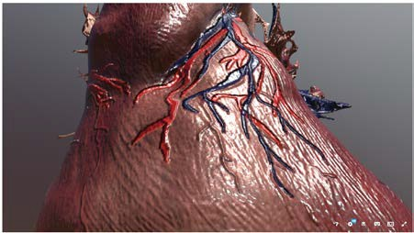
Take-home Messages: Immersive technologies have a definitive place in teaching and learning of human Anatomy for medical and allied health students but it has to be carefully planned using deep thinking. Side effects of immersive technologies also should be considered as well as the expenses in creating these

Sample

experience.

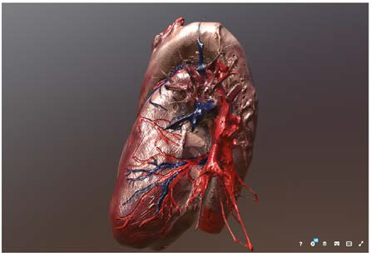

Sample





HIGH LEVEL SYSTEM OVERVIEW
LAN

- instructors and administrators to authenticate via ADFS

VR LAPTOP + VR Headset

AUTHENTICATION

AWS

Authenticate via thru AD

AUTHENTICATION

Trainee x 5

VR Application

  - Control the complexity of the content

Admin

Record and Stored Student Assessment upon start of assessment

Filename by studentid Student001-180602.mp4

Instructor access to view the recorded Student assessment video

Instructors
Web Application
  - Manage the test sessions, author test questions and track student test performance
  - Instructors review all students Test result & export the result to csv file
  - start/pause/stop the recording and to playback the test scene seen and action taken by the students
  - The application may also interface with SIT Student Information System via database view and/or the LMS via LTI to pull in the student information
  - The administration interface shall allow administrators to authorise user account access to this administrative interface and set the role to administrator or instructor


Solutions for the Digital Economy
INSTRUCTORS ACCESS WORKFLOW
Instructors
http://vhap.sit.edu.sg
NETOP CLASSROOM GT SYSTEM
WEB BROWSER
USER LOGIN*
GROUP VIVE E
GROUP VIVE D
GROUP VIVE C
GROUP VIVE B
HOMEPAGE - DASHBOARD
GROUP VIVE A

VIEW STUDENTS ASSESSMENT VIDEO

VIEW BY LESSON
EXPORT STUDENTS SCORES

MULTIPLE CHOICE QUESTIONS
ADD/EDIT/DELETE ANSWERS
ANSWERS 04
ANSWERS 03
ANSWERS 02
ANSWERS 01
ADD / EDIT / DELETE MULTIPLE CHOICE QUESTIONS X
VIEW BY STUDENTS
EXPORT STUDENTS SCORES

    - Maximum 4 answers
LESSON 01
LESSONS
MENU
STUDENTS SCORES
ADD / EDIT / DELETE LESSONS

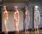
    - Set the CORRECT answer choice

STUDENT ACCESS WORKFLOW


Show the whole human anatomy

3D MODEL PART 1

3D MODEL PART 1
FUNCTIONS
3D MODEL PART 1
DETAIL PAGE
VIEW PARTS BY
LISTING
CARDIOVASCULAR SYSTEM
LEARNING MODE
USER LOGIN*
OPENING SCREEN [START]
MENU X
MENU 2
TEST MODE
* = Optional
# = Skippable
SINGLE/MULTI PLAYER
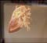
MAIN MENU

QUESTIONAIRES
      - Highlight/Select parts 2.Extract/Move Hold, 3.Rotate, Zoom, Scale 4.Reset , Undo
5.Hide Selected or Hide others 6.View Cross-section
7.Play animation / sound

