A Turn for the Worse
Jane Burns, Jonathan Soye,
Our Lady of Lourdes, Drogheda, Co. Louth, Ireland
Abstract:
A 51 year-old gentleman had multiple admissions with left iliac fossa pain, guarding and nausea. He was initially treated as acute diverticulitis. Initial imaging appeared to confirm this. However, with recurrent presentations and further review he was found to have acute left-sided appendicitis with a midgut malrotation. He was initially treated with antibiotics and subsequently developed an abscess which required intra-abdominal drain insertion. After MDM discussion, it became apparent that this gentleman had a midgut malrotation. He had an uncomplicated open appendicectomy.
Midgut malrotation is a common congenital anomaly due to non-rotation or incomplete rotation of the primitive intestinal loop around the SMA during foetal development. CT often detects the anomaly as an incidental finding in adults. This case is a good example of how an unrelated intra-abdominal pathology may lead to an atypical clinical picture.

Introduction:
Midgut malrotation is a common congenital anomaly due to nonrotation or incomplete rotation of the primitive intestinal loop around the SMA during foetal development¹. It occurs in about 1 in 500 births, with most cases presenting before 1 year. The most severe presentation is with volvulus, which constitutes a surgical emergency. Over 75% of cases present by five years old. Therefore, it is often considered a disease of childhood. However, literature estimates the incidence in adults to be between 0.0001 to 0.19%². As many cases are asymptomatic, it is difficult to estimate true prevalence. In adults, it may be an incidental finding and can act as a confounding factor in common presentations, like acute appendicitis. This can lead to delayed diagnosis, prolonged hospital stays and significant morbidity, as highlighted by this case.

Case:
A 51-year-old gentleman with no background medical history, presented with sudden onset severe epigastric pain, nausea, poor appetite and vomiting for one day. On examination, he displayed rebound tenderness and guarding in the LIF, with raised inflammatory markers. He was commenced on IV co-amoxiclav for likely acute diverticulitis. CT-AP suggested this diagnosis. He responded to four days of IV therapy and was discharged on oral ciprofloxacin and metronidazole, in keeping with local antimicrobial guidelines. He was arranged to have a full colonoscopy within 8 weeks.

One week later, he re-presented, distressed with persistent LIF pain, which did not resolve with the course of antibiotics. On exam, an LIF mass was palpated. He was commenced on Tazocin and gentamicin for a presumed diverticular abscess. Repeat CT demonstrated an 11x11x9.5cm LIF abscess that appeared to be arising for the proximal sigmoid colon. The collection contained dense, calcified material, of uncertain aetiology, the largest measuring 1.3cm. It was amenable to percutaneous drainage. During the drain insertion, 250ml of pus was aspirated immediately and a 14F pigtail catheter was left in situ. Unfortunately, he continued to spike temperatures and faecal matter began to drain. As he was not improving clinically, the surgical team planned for a Hartmann’s procedure.

His case was discussed at the radiology MDM and it was decided that prior to surgery, repeat imaging be done to assess if a fistula had developed between the bowel wall and the abscess, for interval change and to assess the position of the drain. These images were subsequently reviewed by a consultant radiologist with a special interest in paediatric radiology. It became apparent that there was a midgut malrotation, with the large bowel lying on the left and the small bowel on the right. The LIF abscess related to the caecal pole and likely represented a perforated acute appendicitis with abscess formation. The calcified materials noted on prior imaging were appendicoliths. At this stage, the abscess had completely resolved. The case was subsequently re-discussed at MDM and it was decided that he be discharged with the drain in situ with outpatient follow-up to remove the drain and with the view to perform an interval appendicectomy.

Unfortunately, post-drain removal, he developed worsening LIF pain, which CT confirmed to be a recurrence of a localised collection in the LIF. At this stage, an open appendicectomy was performed with a drain left in situ for one week. He was discharged without complication.

Discussion:
CT is a useful imaging modality for this anomaly, with it often being detecting as an incidental finding in adults undergoing imaging for another reason³. Like in our case, the large bowel may lies mainly on the left with the small bowel lying mainly on the right. Additionally extra-intestinal manifestation such as an abnormal relationship between the SMA and SMV may be appreciated. It may show a vertical relationship or left-right inversion⁴. While they are useful in guiding the diagnosis, they may be seen in patients without a malrotation. In the case of a CT demonstrating focal inflammation within the intestinal tract, in conjunction with an anomaly in the SMA/SMV relationship, it is good practice to confirm the position of the caecum in order to out-rule an acute appendicitis. Additionally, the pancreas may have an absent uncinate process or may be underdeveloped. This case is a good example of how an unrelated intra-abdominal pathology may lead to an atypical clinical picture.

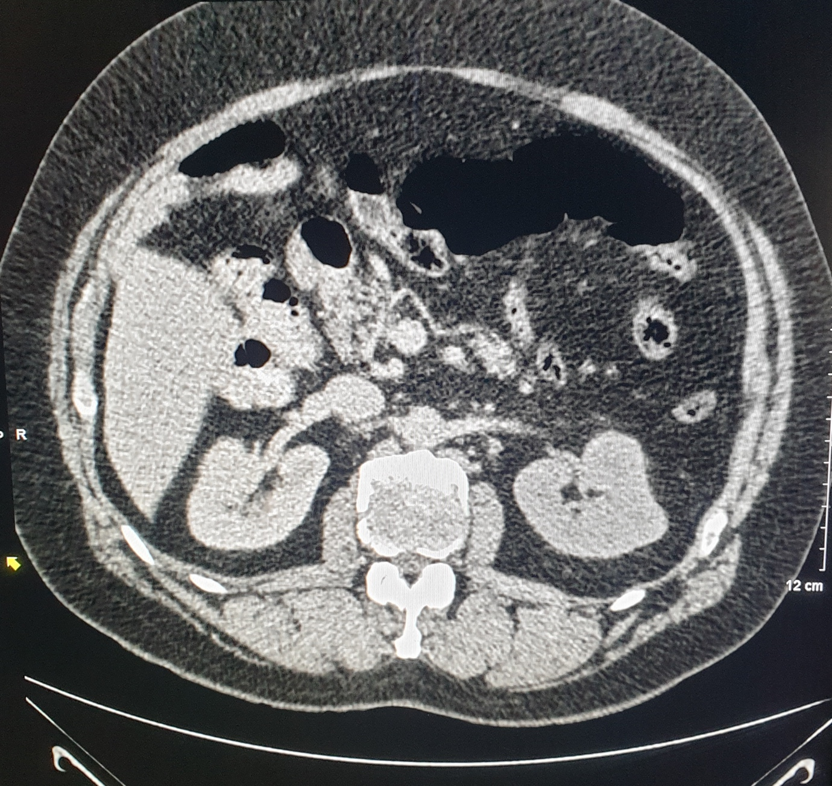

Fig 1. Reversal of SMV and SMA

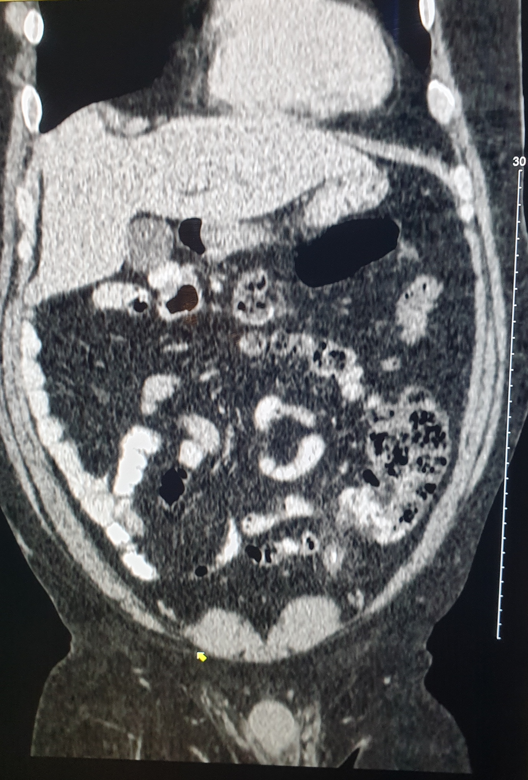
Fig 2. Inflammation surrounding a tubular structure in the left lower abdomen, subsequently recognised as acute appendicitis

References:
¹Alani M, Rentea RM. Midgut Malrotation. StatPearls [Internet]. 2020 Aug 1.
²Nichols DM, Li DK. Superior mesenteric vein rotation: a CT sign of midgut malrotation. American journal of roentgenology. 1983 Oct 1;141(4):707-8.
³Gnanadev P, Krishnappa R, Taluru HR, Subbaiah G, Vasantha GM, Nagaraj DK, Damodaran G. A rare presentation of midgut malrotation as an acute intestinal obstruction and perforation in an adult. International Surgery Journal. 2020 Sep 23;7(10):3459-62.
⁴Çağlar E, Arıbaş B, Tiken R, Keskin S. Midgut malrotation presenting with left-sided acute appendicitis and CT inversion sign. Case Reports. 2014 Mar 28;2014:bcr2013202709.

