Combined Effect of Baclofen and Acamprosate in Experimental Models of
Peripheral Neuropathic Pain in Wistar rats
Varun Vikas Vij, M.Pharmacy (Pharmacology) Pursuing PhD, D M C & H Ludhiana Punjab India

Neuropathic pain (NP) is defined as pain associated with damage or permanent alteration of the peripheral or central nervous system. Current drug treatment for the management of neuropathic pain associated with various adverse effects. The present study was designed to investigate the combined effect of acamprosate and baclofen in experimental model of peripheral Neuropathic pain in wistar rats. Material and Methods: Neuropathic pain was induced by chronic constriction injured (cci) of sciatic nerve in rats. A camprosate (100 and 200 mg/kg p.o) and baclofen (10 and 20 mg/kg p.o) was given in different groups for 14 days starting on 7th day post sciatic nerve ligation. Further combination of acamprosate(100 mg/kg p.o) and baclofen (10 mg/kg p.o) was also given to one group. On 1th, 3rd, 7th, 14thand 21stday behavioral parameters like mechanical allodynia and thermal hyperalgesia were assessed. Then animals were sacrificed on 22nd day and biochemical parameters (gsh, lpo, catalase, nitrite, sod) were assessed. Results: ligation of sciatic nerve significantly induced mechanical allodynia and thermal hyperalgesia with increase in oxidative stress (increase in lpo and nitrite) and decline of anti-oxidant enzyme levels (catalase, sod, gsh) in sciatic nerve homogenate. A camprosate (100 and 200 mg/kg p.o) and baclofen (10and 20 mg/kg p.o) attenuated all the behavioural and biochemical parameters alone and/or combination. | IMAGE  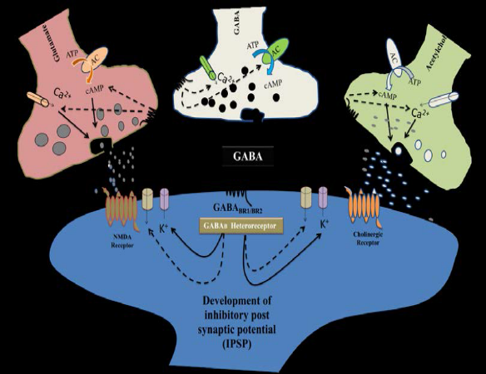  GABAergic Signaling and effect of GABAergic signaling on glutamatergic  and cholinergic signalling  REFERENCE:-  1. Merskey H, Bogduk N. (1994). Classification of chronic pain: descriptions of chronic pain syndromes and definitions of pain terms, 2nd ed. IASP press, Seattle, WA.  2. Daousi, C., Benbow, s. & Macfarlane, I. 2005. Electrical spinal cord stimulation in the long‐term treatment of chronic painful diabetic neuropathy. Diabetic medicine, 22,  393-398.  3. Gilron, I., Watson, C. P. N., Cahill, c. M. & moulin, D. E. 2006. Neuropathic pain: a practical guide for the clinician. Canadian  Medical Association Journal, 175, 265-275.  4. Nagy, G. G., Watanabe, M., Fukaya, M. & Todd, A. J. 2004. Synaptic distribution of the NR1, NR2A and NR2B subunits of the  N‐methyl‐d‐aspartate receptor in the rat lumbar spinal cord revealed with an antigen‐unmasking technique. European Journal of Neuroscience, 20, 3301-3312.  5. Ultenius, C., Linderoth, B., Meyerson, B. A. & wallin, J. 2006. Spinal NMDA receptor phosphorylation correlates with the presence  of neuropathic signs following peripheral nerve injury in the rat. Neuroscience letters,399, 85-90.
 Biography
Mr. Varun Vikas Vij has done M pharmacy in Pharmacology and pursuing PhD from Baba Farid University of Health Sciences Faridkot Punjab India and currently working as a Pharmacy Executive in Dayanand Medical College and Hospital Ludhiana Punjab India. Mr. Vij has 11 years of experience in pharmaceutical industry (9 years in Pharmaceutical marketing and 2 years in Hospital pharmacy). He has 2 International publications. He has keen interest in Neuro Pharmacology.
Varunkumar1982dec@gmail.com

