Color Comparison Study on the Aqueous Extract of Areca catechu “Bunga” (Arecaceae) Fruit and Methanolic Extracts of Bixa orellana “Atsuete” (Bixaceae) Seed and Hibiscus rosa-sinensis Linn. “Gumamela” (Malvaceae) Flower as Red Colorants

By
Cura, Cary U.
Custodio, Dennice R.
Dañas, Adeline N.
De Castro, Maicheryll I.
Eman, Mark Angelo F.
Famini, Bianca Joyce F.
Gonzales, Ronnell John R.

2017

TABLE OF CONTENTS

Title Page i
Table of Contents ii

Abstract iv

Chapter I : Introduction 1
1.1 Background of the Study 1
1.2 Taxonomic Classification 2
1.3 Botanical Description and Origin 3
1.4 Folkloric and Plant Parts Used 4
1.5 Chemical Constituents 5
1.6 Recent and On-Going Studies 6
1.7 Pharmacological Uses 9
1.8 Natural Dyes 10
1.9 Toxicity Studies on Allura Red 11
1.10 Banning of other commonly used Synthetic Dyes according to the US-FDA 12
1.11 Methods for Color Measurement 13
1.12 Significance 16
1.13 Research Objective 16
1.14 Research Questions 17
1.15 Research Hypothesis 17
1.16 Scope and Limitations 17
1.17 Conceptual Framework 18

Chapter II : Methodology 19
2.1 Locale, Period of Collection, Sampling and Authentication 19
2.2 Plant Extraction 19
2.3 Color Comparison of Areca catechu, Bixa Orellana, Hibiscus rosa-sinensis extracts and Allura Red via UV-Vis Spectrometry 20
2.4 Statistical Analysis 20

Chapter III: Results and Discussion 21
3.1 Percentage Yield 21
3.2 Transmittance Values of the Plant Samples and the Standard 21
3.3 CIELAB Values 26
3.4 One way Analysis of Variance (ANOVA) 27

Chapter IV: Summary, Conclusion and Recommendation 29
4.1 Summary 29
4.2 Conclusion 29
4.3 Recommendations 27

References 31
Appendices 36
Curriculum Vitae 46

ABSTRACT

Natural colorants are used in the coloration of food, handicraft items, toys, textiles and in leather processing. Many of the color-yielding plants are used as medicines in various traditional medicinal systems. Interest for natural colorants has increased dramatically worldwide due to the awareness of possible toxicity that can be caused by modern synthetic dyes. Synthetic colors have been banned in certain countries due to allergic and carcinogenic symptoms that they can cause. More eco-friendly colorants are now being developed to replace synthetic dyes which can be toxic and hazardous to health. Thus, the researchers wanted to study natural colorants from three botanical sources namely, Areca carechu, Bixa orellana and Hibiscus rosa-sinensis as possible alternative for the commercially used Food, Drug and Cosmetic colorant, Allura Red. UV-Vis Spectrometry was used to measure the transmittance of the samples which were used to obtain their CIELAB values and to compare the colorants quantitatively. Natural colorant from Areca catechu, Bixa orellana, and Hibiscus rosa-sinensis mean L* values were 21.6097, 44.3664 and 19.0708 respectively; mean a* values were 89.2146, 65.3665 and 69.7741 respectively; and mean b* values were 99.0016, 110.3789 and 21.6674 respectively. These results revealed that the natural colorants from Areca catechu, Bixa orellana, and Hibiscus rosa-sinensis all fall within the dark, red and yellow spectra of colors. Using One Way Analysis of Variance (ANOVA), it was found out that both the natural colorants from A. catechu and B. orellana yielded p-values of 0.042 and 0.024 respectively. These are both lower than the level of significance at ∝ 0.05 which means that there is a significant difference between the combined CIELAB values for color characterization of the natural colorants obtained from A. catechu and B. orellana to that of Allura Red. Thus it can be inferred that they can’t be utilized and further studied as possible alternative colorants to Allura Red. Only H. rosa-sinensis yielded a p-value of 0.641 that is greater than the level of significance at ∝ 0.05. This means that there is no significant difference between the combined CIELAB values for color characterization of the natural colorant obtained from Hibiscus rosa-sinensis to that of the standard, Allura Red making it a potential alternative. It can also be inferred through such data that among the three natural colorants that were analyzed in this study, the natural colorant from H. rosa-sinensis is the closest to Allura Red in term of combined color characteristics.

Keywords: Colorant, Areca catechu, Bixa orellana, Hibiscus rosa-sinensis, UV-Vis Spectrometry, CIELAB

CHAPTER I
INTRODUCTION

1.1 Background of the Study
The art of dyeing has been practiced around the world since the ancient times. In those early times, dyes were obtained from natural sources such as plants (e.g. turmeric and indigo), animals (e.g. cochineal and kermes), minerals (e.g. calamine and clay), and microorganisms (e.g. Serratia marcescens and Cortinarius sanguineus) often used as medicinal remedies. These natural dyes were also used in funerals, tribal rituals, body painting, and clothing. During the 700 B.C.E., Egyptians used plants to color their food and this practice migrated from Persia to England. By the mid-1800s, the use of these natural dyes started to decrease because of the discovery and use of synthetic alternatives such as Mauveine which was discovered by William Henry Perkin in 1856 and was recognized as the first synthetic dye. Concerted research efforts in the field of synthetic dyes and rapid industrialization of textile production resulted in almost complete replacement of natural dyes by synthetic dyes on account of their easy availability in ready-to-apply form, simple application process, consistency of shades, and better fastness properties (Saxena and Raja, 2014). However, almost all of the synthetic dyes are being synthesized from petrochemical sources through hazardous chemical processes. This poses threat towards the environment and human body health (Kasiri & Safapour, 2015).
In the pharmaceutical industry, dyes have been widely used to give identity to various dosage forms by allowing consumers to easily recognize their products on sight. Dyes are considered to be the “cosmetics” for pharmaceutical dosage preparations because they give aesthetic appearance by using suitable colorants. They have also linked the aesthetic appearance produced by the colorants to its psychological effects to the patient (especially for children whom is often given with syrups). This results to an improvement in medication compliance and influences the efficacy of therapy (Allam & Kumar, 2011).
The advantages of the natural dyes over synthetic dyes cannot be disregarded as proven by studies that try to discover their potential as colorants. Natural dyes are obtained from inexpensive renewable resources with considerable viability. Majority of natural dyes are extracted from wild and self-growing plants that require no additional cost for the cultivation. Some natural dyes have intrinsic additional properties such as antibacterial, moth proof, anti-allergy, anti-ultra violet (UV) irradiation, etc. They are eco-friendlier than the synthetic ones because for natural materials, the synthesis process is natural; with the absence of adulterants. In addition, these materials are readily biodegradable and do not produce hazardous waste upon degradation in the environment. Thus, there is no need for further treatment of effluent before discharging into the environment (Kasiri & Safapour, 2014).
There are studies that have revealed that these dyes have potential hazardous effects to the human body and the environment, reviving the interest on the use of the natural dyes. Lancaster and Lawrence (1991) detected the presence of p-cresidine, aniline and 1-naphthylamine in Allura Red. It is “reasonably anticipated to be a human carcinogen,” according to the U.S. National Toxicology Program (1981), and is “possibly carcinogenic to humans”, according to the International Agency for Research on Cancer (IARC). Food and Drug Administration considered aniline to be weakly carcinogenic to rats, though other agencies have not determined that aniline and 1-naphthylamine and pose a risk to humans (FDA, 1985).

1.2 Taxonomic Classification
1.2.1 Areca catechu
The taxonomic classification of Areca catechu was adopted from Integrated Taxonomic Information System’s website (1996), https://www.itis.gov/servlet/SingleRpt/SingleRpt?search_topic=TSN&search_value=506702#null and is shown below:
Kingdom: Plantae
Subkingdom: Viridiplantae
Superdivision: Embryophyta
Division: Tracheophyta
Subdivision: Spermatophytina
Class: Magnoliopsidae
Superorder: Lilianae
Order: Lilianae
Family: Arecaceae
Genus: Areca
Species: catechu
1.2.2 Bixa orellana
The taxonomic classification of Bixa orellana was adopted from US Department of Agriculture Natural Resources Conservation Service’s website, https://plants.usda.gov/java/ClassificationServlet?source=display&classid=BIOR and is shown below:
Kingdom: Plantae
Subkingdom: Viridiplantae
Superdivision: Spermatophyta
Division: Magnoliophyta
Class: Magnoliopsida
Subclass: Dilleniidae
Order: Violales
Family: Bixaceae
Genus: Bixa
Species: Orellana
1.2.3 Hibiscus rosa-sinensis
The taxonomic classification of Hibiscus rosa-sinensis was adopted from Integrated Taxonomic Information System’s website (1996), https://www.itis.gov/servlet/SingleRpt/SingleRpt?search_topic=TSN&search_value=21616 and is shown below:
Kingdom: Plantae
Subkingdom: Viridiplantae
Superdivision: Embryophyta
Division: Tracheophyta
Subdivision: Spermatophytina
Class: Magnoliopsida
Superorder: Rosanae
Order: Malvales
Family: Malvaceae
Genus: Hibiscus
Species: rosa-sinensis

1.3 Botanical Description and Origin
1.3.1 Areca catechu
Areca catechu is an erect, unbranched palm reaching heights of 12-30 m, depending upon the environmental conditions. The stem, marked with scars of fallen leaves in a regular annulated form, becomes visible only when the palm is about 3 years old. Girth depends on genetic variation and soil conditions. Root system adventitious is a typical of monocots. The adult palm has 7-12 open leaves, each with a sheath, a rachis and leaflets. The leaf stalk extends as the midrib until the end of the leaf and ends as leaflets. Male flowers very numerous, sessile, without bracts; calyx 1-leaved, small, 3-cornered, 3-parted; petals 3, oblong, rigid striated; stamens 6, anthers sagittate. Female flowers are solitary or 2 or 3 at or near the base of each ramification of the spadix, sessile, without bracts; sepals permanent; staminodes 6, connate, styles scarcely any; stigmas 3, short, triangular. The fruit is a monolocular, one-seeded berry, 3.8-5 cm long, smooth orange or scarlet when ripe, with a fibrous outer layer (Orwa et al., 2009).
A. catechu also known as the Areca nut or Nganga in Tagalog, is a native tree of China, Malaysia and Indonesia. This specie of palm tree is now found throughout tropical Pacific Islands and Asian countries such as India, Japan, Philippines, Thailand, Vietnam, Bangladesh and Sri Lanka. In the Philippines, it’s widely distributed in the Batangas, Ilocos, Nueva Ecija, Laguna, Palawan, Pampanga and Quezon provinces. It can grow to a height of 20-28meters, and bears fruit throughout the year. The Areca catechu is part of the Arecaceae family (referred to as palm family also known Palmae), which contains over 200 genera and about 2600 species. Most members of the Arecacea family only grow in tropical or subtropical climates. Arecanut almost always exists in cultivation; therefore, conditions of its natural habitat are difficult to assess. It however thrives in areas of high rainfall. Although tolerant to moderate elevations on mountains, it generally does best in low altitudes. Being a shade-loving species, A. catechu always does well when grown as a mixed crop with fruit trees (Orwa et al., 2009).
1.3.2 Bixa orellana
Bixa orellana is an evergreen shrub or small tree, 2-8 m high; trunk up to 10 cm in diameter; bark light to dark brown, tough, smooth, sometimes fissured, lenticellate; inner bark pinkish towards the outside with orange sap, slightly bitter; twigs green with minute, rusty, reddish-brown scales, becoming dark brown. Leaves are spirally arranged, simple, stipulate, ovate, 7.5-24 x 4-16 cm, shallowly cordate to truncate at base, longly acuminate at apex, green or dark green above, grey or brownish-green beneath; scaly when young, glabrous; petiole terete, thickened at both ends, 2.5-12 cm long. Flowers are in terminal branched panicles, 8-50 flowered, fragrant, 4-6 cm across; pedicel scaly, thickened at the apex, bearing 5-6 large glands; sepals 4-5, free, obovate, 1-1.2 cm long, caducous, covered with reddish-brown scales; petals 4-7, obovate, 2-3 x 1-2 cm, pinkish, whitish or purplish tinged; stalks scaly; stamens numerous, 1.6 cm long; anthers violet; pistil 1.6 cm long, composed of bristly 1-celled, superior ovary; style thickened upwards, 12-15 mm long; a short, 2-lobed stigma. The fruit is a spherical or broadly elongated ovoid capsule, 2-4 x 2-3.5 cm, flattened, 2 valved, more or less densely cloaked with long bristles, green, greenish-brown or red when mature; seeds numerous, obovoid and angular, 4.5 mm long, with bright orange-red fleshy coats (Orwa et al., 2009).
B. orellana is a plant native to Brazil but grows in other regions of South and Central America. It is grown in tropical countries such as Peru, Mexico, Ecuador, Philippines, Indonesia, India, Kenya, and East Africa. This specie is widely cultivated in the provinces of Batangas, Davao, Ilocos, Laguna, Pampanga, Negros, Quezon, Samar and Zambales provinces. The seeds of this plant produce one of the dyes most frequently used worldwide, not only in food products but also in the textile, paint, and cosmetic industries. Its use has been stimulated due to the ban on the use of synthetic dyes in food and cosmetics, where it is one of the few accepted by the World Health Organization (WHO), since, in addition to being nontoxic, it does not seem to change the food value. Another interesting fact is that 70% of all natural coloring agents consumed worldwide are derived from annatto. Despite the existence of several species, the most common in our country is Bixa orellana L., named after Francisco Orellana, who was the first European to navigate the Amazon (Orwa et al., 2009).
1.3.3 Hibiscus rosa-sinensis
Hibiscus rosa-sinensis, known colloquially as the Chinese hibiscus, China rose and shoe flower, is an evergreen flowering shrub native to East Asia. It is popularly known as Gumamela in the Philippines. It is widely grown as an ornamental plant throughout the tropics and subtropics. In the country, it is an abundant flora in the provinces of Baguio, Palawan, Pampanga, Rizal, Quezon, and Zamboanga. The flowers are large, generally red in the original varieties, and firm, but generally lack any scent. Also many colors are available in a single, double or multi-shades including white, yellow, orange, red, pink, salmon, purple, etc. Hibiscus rosa-sinensis is the national flower of Malaysia. The leaves are alternate, simple, and ovate to lanceolate, often with a toothed or lobed margin. The flowers are large, conspicuous, and trumpet-shaped, with five or more petals. The fruit is a dry five-lobed capsule, containing several seeds in each lobe, which are released when the capsule dehisces (splits open) at maturity (Missouri Botanical Garden, n.d.).
Hibiscus rosa-sinensis is a genus of flowering plants in the mallow family Malvaceae.The genus is quite large, comprising several hundred species that are native to warm temperate, subtropical and tropical regions throughout the world. Member species are renowned for their large, showy flowers and are commonly known simply as hibiscus, or less widely known as rose mallow. The genus includes both annual and perennial herbaceous plants, as well as woody shrubs and small trees (Bose & Nag, 2012).

1.4 Folkloric and Plant Parts Used
1.4.1 Areca catechu
A. catechu nut is popular chewable items used in traditional herbal medicine (Amudhan et al., 2012; Heatubun et al., 2012). It exhibits multiple therapeutic properties like, aphrodisiac (Norton, 1998), antihypertensive (Xie et al., 2007), wound healing (Azeez et al., 2007), hypoglycemic (Grover et al., 2002; Mukherjee et al., 2006 ) and antidepressant (Dar & Khatoon, 2000). Nganga is chewed either alone or in combination with betel leaves or “pan” (Piper betle L.), lime, tobacco, camphor, which is locally called “Tambula” or betel quid. It has both religious and medical significance. Chewing increases production of saliva, gastric juices and strengthens gums. Traditionally betel nut and betel leaves are offered in religious functions (Balasimha & Rajagopal, 2004).
The history of betelnut chewing has been established among Aryans atleast 2000 years ago. The tradition of “Tambula” offerings was probably prevalent as early as Gupta period. The chewing habit is also prevalent in other countries like Nepal, Sri Lanka, Burma, Thailand, Philippines, Africa, Arabia, South China, Pakistan and Bangladesh. The habit of areca chewing has been mentioned by Marco Polo in 1298 A.D. The receipt of betelnut and betel leaves in marriage ceremonies have also been depicted in inscriptions at the times of Nayaks of Tanjore. In Assam and West Bengal arecanut is used as an important commodity in religious ceremonies and chewing. The medicinal uses of arecanut was known to Vagbhata as early as 4th century A.D. He has described its use against leucoderma, leprosy, cough, epilepsy, worms etc. Bhavamista (13th century A.D.) had used it as stimulant and appetizer. Powdered nuts were used as antihelminthic for dogs (Balasimha & Rajagopal, 2004).
1.4.2 Bixa orellana
Annatto is a native plant from South America, more specifically of the Amazon region. The popular name “urucum” comes from the Tupi word “ru-ku,” which means “red.” The wide dissemination of its use is related to the growing demand for natural dyes by many pharmaceutical, cosmetic, textile, and especially food industries (Barbosa-Filho, 2006). According to Correa (1978), seeds urucum supplies seeds that have been used as a condiment as well as laxative, cardiotonic, hypotensive, expectorant, and antibiotic. In addition, it has anti-inflammatory activity for bruises and wounds and has been used for the treatment of bronchitis and for wound healing purposes. Oil is also obtained from this plant. The infusion of the leaves has been shown to be effective against bronchitis, sore throat, and eye inflammation. The pulp, which includes the seed, is used for soft drinks and febrifuge. Moreover, it can provide valuable dyeing materials such as yellow (orellin) and red (bixin) substances, with the latter constituting a crystallized active ingredient. In the food industry, it is used to color butter, margarine, mayonnaise, sauces, mustard, sausage, soup, juice, ice cream, bakery products, macaroni, and cheese, where it is commonly called “do reino” (of the kingdom), coming from Holland. It is also widely used in the printing industry and dye manufacturing. Many Aborigines use annatto for dyeing, where the dye is naturally obtained as a mixture and used to color ceramics and other vases for domestic use. Moreover, most endogenous people use this dye on their skin to beautify themselves during religious rituals and mainly to protect themselves from ultraviolet radiation and from mosquitoes that infest forests (Barbosa-Filho, 1998). The bast provides fibers for rough cordage, and the powder resulting from grinding the seeds has been used as an aphrodisiac. Finally, the infusion of cold buds serves to wash inflamed eyes, whereas the decoction of the leaves has been used for antiemetic therapy during pregnancy. Thus, despite the different culture and traditions among the countries in South and Central America, several of the popular uses of Bixa orellana are the same, for example, antipyretic, aphrodisiac, antidiarrheal, antidiabetic, and insect repellent (Correa, 1978).
1.4.3 Hibiscus rosa-sinensis
Hibiscus rosa-sinensis are common Hibiscus flower in India. Hibiscus flower preparations are used for hair care. The flowers themselves are edible and are used in salads in the Pacific Islands. The flowers are used to shine shoes in parts of India. It is also a pH indicator. China rose indicator turns acidic solutions to magenta/dark pink and basic solutions to green. It is also used for the worship of Devi and especially the red variety takes an important part in tantra. In Indonesia, these flowers are called "kembang sepatu", which literally means "shoe flower". Hibiscus rosa-sinensis is considered to have a number of medical uses in Chinese herbology (Ali, El-Mohamedy & El-Khatib 2011). It’s also used to induce abortion, ease menstrual cramps and to help in childbirth. A preparation from the leaves is used to treat postpartum relapse sickness, to treat boils, sores and inflammations. Hibiscus flowers are reported to possess anti-fertility property by ancient Ayurvedic texts (Sankhadip & Souvik, 2012).

1.5 Chemical Constituents
1.5.1 Areca catechu
Areca catechu is one of the most commonly used drugs in the world, containing alkaloids, tannins, polyphenols, sugars, and lipids that have anthelmintic, antifungal, antibacterial, anti-inflammatory, and antioxidant activities. Tannins are another characteristic component of Nganga, and the main types are condensed tannins (also called proanthocyanidins). The main classes of tannins in A. catechu are the catechuins (Staples & Bevacqua, 2006). The main constituents of A. catechu are carbohydrates, fats, fiber, polyphenol including flavonoids and tannins, alkaloids and minerals (IARC, 2004). The fatty acid constituents of the A. catechu nut oil are; lauric 19.5, myristic 46.2, palmitic 12.7 stearic 1.6, decanoic 0.3, oleic 6.2, linoleic 5.4, dodecenoic 0.3, tetradecenoic 0.6, and hexadecenoic 7.2%. The chief component glycerides are 56% of fully saturated; 30% monounsaturated-disaturated and 14% of diunsaturated-monosaturated. The amino acids present are traces of tryptophan, methionine and larger amounts of proline, tyrosine, phenylalanine and arginine. Areca catechu nut contains tannins, commonly known as chogaru, are predominantly catechol tannins which closely resemble Mimosa bark tannins and are used to convert the putrefiable hides and skins into leather, for treating fishing nets and for making inks. The polyphenols of A. catechu seed are mainly flavonoids and their concentration decreases with the maturity of the nut (Jaiswal et al., 2011).
1.5.2 Bixa orellana
Bixin, a red-colored carotenoid, is the pigment present in high concentration in the annatto seed aril. It is the main substance responsible for the dyeing characteristics of seeds, where its concentration can be as high as 5.0%. However, different seeds may have levels less than 2.0%, and because their commercial value is based on the bixin percentage, levels higher than 2.5% are usually required for export (Franco et al. 2008). Many other carotenoids (C19, C22, C24, C25, C30, andC32) occur in Bixa orellana but constitute a minor percentage of the pigments. The major oily constituent of annatto seeds is geranylgeraniol, representing 1% of dry seeds. Norbixin is a demethylated derivative of bixin and although it is a naturally occurring compound, it is almost always referred to as a saponification product of bixin. This is the form used for commercial purposes (Venugopalan et al. 2011). Currently, more than two dozen substances have been isolated from the seeds of Bixa orellana. Besides bixin and norbixin, other compounds such as isobixin, beta-carotene, cryptoxanthin, lutein, zeaxanthin, orellin, bixein, bixol, crocetin, ishwarane, ellagic acid, salicylic acid, threonine, tomentosic acid, tryptophan, and phenylalanine have been found in the seeds of annatto. Inaddition, the following compounds, in their respective concentrations, are found in these seeds: 40 to 45% cellulose, 3.5 to 5.5% sugars, 0.3 to 0.9% essential oils, 3% fixed oils, 1.0 to 4.5% pigments, and 13 to 16 % proteins and alpha and beta-carotene, as well as tannins and saponins (Taylor, 2002; Oliveira, 2005).
1.5.3 Hibiscus rosa-sinensis
Root and barks of Hibiscus rosa-sinensis contains tannins and mucilage. The flower of Hibiscus contain: 15-30% plant acids, including citric, malic and tartaric acids and a unique hydroxycitric acid called hibiscus acid which give the tea a pleasant tart taste. The flower also contain approximately 1.5% anthocynanins including delphinidin 3-sambubioside, 15% mucilage and make a pleasantly sweet tea, which on hydrolysis affords traces of galactose, arabinose, glucose, rhamnose, galacturonic acid, xylose and mannose. For the rest only ubiquitous substances have been detected. The flowers of H. rosa-sinensis are rich in mucilage, a complex mixture of polysaccharides that form a soothing gelatinous in fiber when water is added (Sankhadip & Souvik, 2012).

1.6 Recent and On-Going Studies
1.6.1 Areca catechu
1.6.1.1 Effects of Chewing Betel Nut (Areca catechu) on the extrapyramidal symptoms of people with schizophrenia in Palau, Micronesia
Betel chewers with schizophrenia scored significantly lower on the positive and negative sub-scales of the PANSS than did non-chewers. There were no significant differences in extrapyramidal symptoms or tardive dyskinesia. Therefore the study concluded that betel chewing associated with milder symptomatology and avoidance of more harmful recreational drugs (Allen et.al., 2011).
1.6.1.2 The Effects of Areca Catechu L Extract on Anti-Aging
The anti-aging effects of Areca catechu extract (CC-516) on skin were investigated both in vitro and in vivo. The CC-516 has a high proportion of proline (13%) of free amino acid content. The inhibitory effect of CC-516 on the elastase exhibited 37 to 90% inhibition by 10 to 250 μg/ml concentration; the IC inline image values with 40.8 μg/ml for porcine pancreatic elastase (PPE) and 48.1 μg/ml for human leukocyte elastase (HLE), respectively. One of the effects of elastase is that it is known to reduce the number of elastin fibers at the level of the enzyme deposition. The number of elastin fibers was increased when we drift from the deposit number of elastase with 100 mg/ml of CC-516. CC-516 showed protection of elastic fiber against degradation by the enzyme in an ex vivo assay. The CC-516 increased proliferation of human fibroblast cell by 85% at 10 inline image concentration, compared with control, whereas the increase by ascorbic acid was 50%. The collagen synthesis was increased by 40% at 10 inline image% concentration of CC-516. The treatment with CC-516 improved skin hydration, the skin elasticity, and skin wrinkles (Choi & Lee, 1999).
1.6.2 Bixa orellana
1.6.2.1 Anti-inflammatory Activity of Annatto Extract
Achiote or Annatto (Bixa orellana L.) has been traditionally used in Central and South America to treat a number of ailments, including internal inflammation. This medicinal use has been supported by a laboratory study done in the Department of Biomedical Sciences, Faculty of Medicine and Health Sciences, Universiti Putra Malaysia. The anti-inflammatory activity of the aqueous extract of annatto was tested in a chemically induced inflammation in rats. The study concluded that the aqueous extract of annatto inhibited the histamine-induced paw edema as compared to a control group. These results confirmed the validity of the use of annatto extract in the treatment of inflammatory disorders (Yong et al., 2013).
1.6.2.2 Antigonorrhoeal activity of Annatto
The Faculty of Chemical Sciences and Pharmacy in Guatemala found that the bark of Bixa orellana has the ability to inhibit the development of five strains of N. gonorrhoea through the process of standard bacteriological procedures. This study supports the traditional herbal use of annatto in the treatment of gonorrhoea, a sexually transmitted disease (Stohs, 2013).
1.6.2.3 Annatto extract and β-carotene enhances antioxidant status and regulate gene expression in neutrophils of diabetic rats.
The antioxidant activity of annatto extract was investigated in Universidade Federal de Ouro Preto, Ouro Preto, Brazil. The study showed that the treatment of annatto extract and β-carotene has decreased the reactive oxidative species production and the mRNA levels of p22(phox) and p47(phox) while it increased the mRNA levels of SOD and CAT in neutrophils from diabetic rats. These data suggest that annatto extract and β-carotene exerts antioxidant effect via inhibition of expression of the NADPH oxidase subunits and increase expression/activity of antioxidant enzymes (Rossoni et.al., 2012).
1.6.2.4 Anticancer Activity of Annatto Pigment (Norbixin)
Norbixin, a pigment of Bixa orellana was believed to possess antioxidant potential being a carotenoid. This property has been examined in the Instituto de Biologia Roberto Alcântara Gomes, Universidade do Estado do Rio de Janeiro and has identified that Norbixin is an unusual dicarboxylic water-soluble carotenoid present as a component in the pericarp of the seeds of Bixa orellana L. Norbixin on the response of Escherichia coli cells to DNA damage induced by UV radiation, hydrogen peroxide (H₂O₂) and superoxide anions (O₂*-) has protective activity against these agents. It was also found that that norbixin has antimutagenic properties, with a maximum inhibition of H₂O₂-induced mutagenic activity of 87%, based on the Salmonella mutagenicity test. These results suggest that achiote pigment (norbixin) has effectively quenched free radicals and may be of valuable pharmacological application against cancer (Júnior et.al., 2005).
1.6.2.5 Protective effect of Bixa orellana L. against radiation induced chromosomal aberration in Swiss albino mice
Radioprotective effect of hydroalcoholic extract of seeds of Bixa orellana have been studied by examining chromosome aberration in cells of bone marrow in irradiated mice. Pretreatment with the extract compounds resulted in a significant reduction in the percentage of aberrant metaphases as well as in the different types of aberration scored. The extract was not toxic at 1500 mg kg–1 body weight. Being non-toxic and easily available natural source Bixa orellana extract may be use for as radioprotective for human beings (Karchuli & Ganesh, 2009).
1.6.3 Hibiscus rosa-sinensis
1.6.3.1 Sun protection factor of Hibiscus rosa-sinensis from extract gel
The result obtained were showed that ability of extract to absorb UV radiation and hence proved UV protection ability. Further, isolated extract have, the major antioxidant of Hibiscus rosa-sinensis Linn is also stable when exposed to UVB irradiation. Qualitatively investigation indicates that presence of flavonoid in the extract. This flavonoids are colored compound pigment found in various leaves and flower amongst the natural source. They are well known for their attractive colors and pharmacological activities, it absorbs light and helps to protect as photosensitive substances in the flower and leaves. Thus it play key role in defense mechanisms in plant. The absorption of UV radiation is a main characteristic for identification of flavonoids in natural source. Due to presence of these flavonoids the result showed strong to moderate absorbance of UV radiation along the whole ranges. It is essential for collection of similar data for different plant and there flowers, as well as other parts. This proved activity of plant showed its importance and prophylactic utility in anti-solar formulation. This will be a better, cheaper and safe alternative to harmful chemical sunscreens that used now a day in the industry (Lokapure et al., 2014).
1.6.3.2 Antidiabetic potential of Hibiscus rosa-sinensis
A study revealed a reduction in the body weight of diabetic rats upon administration of H. rosa-sinensis extract. However, oral administration of the leaves extract to diabetic rats showed a significant improvement in body weight. Similar observation was also noted in the diabetic rats treated with Gliclazide. The results of the present study clearly indicate that the ethanolic extract of Hibiscus rosa-sinensis leaves possess hypoglycemic, hypolipidemic and antioxidant potential (Anandhi et.al., 2014).
1.6.3.3 Hibiscus-rosasinensis extract as an alternative colorant for carbonated soft drinks
A study showed the possibility of replacing the artificial colourings of a carbonated soft drink with natural red colour pigments extracted from the petals of Red-layered Hibiscus flowers. The natural colouring was stored in a clear glass bottle at 4ºC and the minimum shelf life of the colouring was found to be 8 weeks. No significant (P>0.05) differences were noticed in the preferences for the standard carbonated soft drink and the natural colouring added samples prepared by increasing 2% of the citric acid amount and essence volume. All tested physicochemical and microbiological parameters of the test samples were found to be within the accepted ranges. When the test samples are stored under direct sunlight, their colour started to fade after 5 days. When these samples were stored under indirect sunlight or in a refrigerator, no significant (P>0.05) difference in colour was observed during the eight-week monitoring period (Jayawardana et.al., 2014).

1.7 Pharmacological Uses
1.7.1 Areca catechu
1.7.1.1 Anthelminthic property
In India or China, areca nut has been used as an anthelminthic in man and animals from time immemorial. It was so efficacious against tapeworms and roundworms and so highly esteemed by people that it was introduced to British Pharmacopoeia. Its powdered seeds were tried against tapeworms with good results, then further credited with astringent properties and has been used with satisfactory results in the relaxed condition of the bowels which sometimes occurs in tropical climates. Large doses of it however produce gripping and irritation and loose motions may start as a result of such irritation (Chandler & Chopra, 1928; Chopra et.al., 1933).
1.7.2 Bixa orellana
1.7.2.1 Antimicrobial activity
A study was conducted to analyze the antimicrobial activity of Annatto extract. For this purpose, an organic extract of Bixa orellana leaves obtained in 95% ethanol was examined for in vitro antifungal and antibacterial activity using the agar diffusion and tube dilution methods. The extract (5 mg/ml) produced antimicrobial action in agar diffusion assays against standard strains of Gram-positive bacteria including Bacillus subtilis, Staphylococcus aureus, and Streptococcus faecalis while exerting only slight action against Escherichia coli, Serratia marcescens, Candida utilis, and Aspergillus niger. The zones of inhibition obtained against the susceptible bacteria were 15-17 mm while those obtained in assays with Chloramphenicol and phenol positive controls were 12-18 mm and 10-28 mm, respectively. The minimum inhibitory concentration (MIC) of the extract was 4-16 mg/ml while its bactericidal action (MBC) was exerted at higher doses (16-64 mg/ml) (Irobi et.al., 1996).
1.7.2.2 Analgesic and Hypoglycemic activity
Evaluation of the Analgesic and Hypoglycemic activity of Bixa orellana was already conducted. Methanol extract showed significant hypoglycemic activities when administered 15 min. After glucose load using a modified oral glucose tolerence test with swiss webster mice as a test animal. An infusion of B. Orellana was found to lower blood glucose level when administered 45 min. before glucose load (Jusal et.al., 2008).
1.7.2.3 Antidiarrheal activity
Results of a study in India showed that the methanol leaf extract (125, 250 and 500 mg/kg BW) inhibited castor oil induced diarrhea in mice. Antidiarrheal activities were supported by a statistically significant decrease in the total number of stools (including wet stools) and dose-dependently the total number of faces and the total number of wet faces with IC₅₀ value of 22.36 μg/ml (Shilpi et.al., 2006).
1.7.2.4 Gastrointestinal motility
A bioactive sesquiterpene (ishwarane) was isolated from dichloromethane extract of the air-dried leaves of B. orellana by silica gel chromatography and identified by ¹H and ¹³C NMR. At dose levels of 25, 50, and 100 mg/kg ishwarane was tested for gastrointestinal mobility. Results of the prophylactic assay showed the antitoxic property at 100 mg/kg. At a dose of 50 mg/kg ishwarane resulted in a more propulsive movement of the gastrointestinal tract (88.38 ± 13.59%) as compared to negative control (78.47 ± 10.61%). A methanol leaf extract (125, 250 and 500 mg/kg, 30 min) was found to delay the intestinal transit of charcoal meal in mice to a statistically significant level (P < 0.01) with 79.55% inhibition at a dose of 500 mg/kg (Shilpi et al, 2006).
1.7.3 Hibiscus rosa-sinensis
1.7.3.1 Antibacterial Activity of Hibiscus rosa-sinensis
Synergistic effect of H. rosa-sinensis extract and Amoxicillin against some human pathogens was studied in India. A total of five clinical isolates (P. aeruginosa, Serratia, Micrococcus, Enterobacter and Salmonella) belonging to different bacterial species were collected. All bacterial isolates were sensitive to Ciprofloxacin and Norfloxacin. The minimum inhibitory concentration (MICs) of Amoxicillin was tested against the five MDR isolates. The watery extracts of H. rosa-sinensis was evaluated against isolates and the results showed that the crude extracts of them with boiling water were more effective than the cold watery extracts. Of this work the combination between H. rosa-sinensis and Amoxicillin showed synergistic effect against the tested bacteria than each of them alone (Al-Alak et.al., 2015).
1.7.3.2 Gastroprotective effect of flower extracts of Hibiscus rosa-sinensis
A study discovered the gastroprotective effect of flower extracts of Hibiscus rosa-sinensis against acute gastric lesion. Hibiscus rosa sinensis L. flower extracts were selected and evaluated for gastroprotective activity by using Pylorus ligation, aspirin induced and ethanol induced ulceritis in rats. Phytochemical and pharmacological screening of extracts revealed the presence of flavonoids, alkaloids and tannins and significant (p <0.05) gastroprotective action in all the gastric ulcer induced models compared to reference standard. Aqueous extract 250 mg/kg offered more percentage of protection, 84.17%, 77.12% and 76.8% in pylorus ligation, aspirin induced and ethanol induced ulcer models, respectively. The protective effect observed is attributed to its effect on mucus production and free radical scavenging effect of flavonoids and tannins present in crude extract (Kumar et.al., 2014).

1.8 Natural Dyes
Natural dyes are derived from natural resources and based upon their source of origin; these are broadly classified as plant, animal, mineral, and microbial dyes although plants are the major sources of natural dyes. The discovery and use of natural dyes and pigments contributed to the maintenance of the age-old bond between humankind and nature and could now help to revive and enhance it (Cardon, 2010). Natural dyes were used only for coloring of textiles from ancient times till the nineteenth century. Aside from their application in textiles, natural dyes are also used in the coloration of food, medicines, handicraft items and toys, and in leather processing, and many of the dye-yielding plants are used as medicines in various traditional medicinal systems (Saxena & Raja, 2014).
Interest for natural dyes has increased dramatically worldwide due to the awareness regarding the therapeutic properties of natural dyes. Unlike natural colorants, synthetic colors have been banned due to allergic and carcinogenic symptoms that they can cause. Because of this, the public prefer natural colors nowadays (Saxena & Pal, 2016). More eco-friendly dyes are now being developed to replace synthetic dyes which are toxic and hazardous to health (Al-Amoudi et.al., 2009).
Since the ancient times, plants were already utilized in the extraction of natural dyes. Various plant parts including roots, leaves, twigs, stems, heartwood, bark, wood shavings, flowers, fruits, rinds, hulls, husks, and the like serve as natural dye sources. in the past, some of the natural dyes were well known for their dyeing properties and have remained in use even now. A renewed interest in natural dyes has led to the utilization of common plants as colorants. Table 1 lists the common natural sources of dyes (Hitesh et.al., 2014; Saxena & Pal, 2016).

Table 1. Colorants from natural sources

Common name | Botanical name | Part(s) used | Color obtained
Indigo | Indigofera tinctoria | Leaves | Blue
Indian madder | Rubia cordifolia | Roots, stems | Red
Brazil Wood/Sappan Wood | Caesalpina sappan | Wood | Red
Morinda | Morinda citrifolia | Root, bark | Red
Safflower | Carthamus tinctorius | Flower | Red
Paprika | Capsicum annuum | Fruit | Red
Tomato | Solanum lycopersicum. | Fruit | Red
Beet Root | Beta vulgaris | Fruit | Red
Henna | Lawsonia inermis | Leaves | Orange
Turmeric | Curcuma longa | Rhizomes | Yellow
Saffron | Crocus sativus | Stigmas of flower | Yellow
Annato | Bixa Orellana | Seeds | Yellow orange
Barberry | Berberis aristata | Roots, Bark, and Stems | Yellow
Pomegranate | Punica granatum | Fruits | Yellow
Myrobolan | Terminalia chebula | Fruits | Bright yellow
Marigold | Tagetes | Fruits | Bright yellow
Flame of the Forest | Butea monosperma | Flower | Yellow to brown, orange
Kamala | Mallotus phillipensis | Fruit | Orange-yellow, Golden-yellow
Onion | Allium cepa | Outer Skin of onion | Yellow
Weld | Reseda luteola | Flower, leaves | Yellow
Dolu | Rheum emodi | Roots, rhizomes | Yellow
Apart from the common natural dye sources mentioned in Table 1, efforts of researchers paved the way for the exploration of local flora for their potential to dye textiles. Leaves, flowers, wood, bark, and so on of several plant materials have been utilized for the dyeing of various textile substrates with varying results in terms of deepness of color produced on the substrates and their color fastness properties (Saxena & Pal, 2016).

1. 9 Toxicity Studies on Allura Red
Synthetic dyes are widely used due to their high tinctorial strength, uniformity, stability, and low cost. However, many of them become toxic after prolonged use causing health problems such as indigestion, anemia, and allergic reactions (e.g. asthma and urticaria) and even pathological lesions in the brain, kidney, spleen, and liver; tumors and cancer; paralysis; mental retardation; abnormalities in offsprings; growth retardation; and, eye defects resulting in blindness (Ashida et al., 2000; Moutinho et al., 2007). McCann et al. (2007) also concluded that, exposure to two mixtures of four synthetic colors plus the preservative sodium benzoate in the diet results in an increased hyperactivity in 3-year-old and 8- to 9-year-old children in the general population.
According to Kobylewski and Jacobson (2010), Allura Red (FD&C Red No. 40) is by far the most-widely used and consumed dye but banned in countries like Denmark, Belgium, France, Germany, Switzerland, Sweden, Austria and Norway (Allam & Kumar, 2011). There are studies stating that this synthetic colorant may accelerate the appearance of the immune system tumors in mice (Center for Science in the Public Interest, 2010). The Health Canada scientists, using a test method that could detect bound and free contaminants, identified small amounts of aniline, p-cresidine, and 1-naphthylamine in the dye (Lancaster & Lawrence, 1991). The p-cresidine is “reasonably anticipated to be a human carcinogen,” according to the U.S. National Toxicology Program (1981), and is “possibly carcinogenic to humans”, according to the International Agency for Research on Cancer (IARC) (1978). FDA considered aniline to be weakly carcinogenic to rats, though other agencies have not determined that aniline— and 1-naphthylamine—pose a risk to humans (FDA, 1985).
Meanwhile, the genotoxic properties of Allura Red remain controversial. In the majority of genotoxicity assays performed, Allura Red was negative. However, it tested positive in in vivo comet assay in the glandular stomach, lungs, and colon of mice (Sasaku, et al. 2002) which indicates that it can cause DNA damage. In the study of Zetterberg and Ilback (2013), an evaluation whether the Allura Red is genotoxic using a flow cytometer-based micronucleus assay in peripheral blood of mice was conducted. The analyses did not show any significant difference in either the cell proliferation or in the frequency of micronucleated polychromatic erythrocytes. Examined tissues and urine showed that Allura Red also was distributed among investigated tissues, although not quantified, and subsequently excreted in the urine. Based on the testing circumstances, one can conclude that Allura Red is not genotoxic (Zetterberg & Ilback, 2013).
In 2009, the European Food Safety Authority (EFSA) Panel considered all relevant results, recommended further research, and the Red 40 has been critically evaluated by the EFSA. It was clear that such effects could not be scientifically supported when considering all available and published data (EFSA, 2009). Based on the decision of European Parliament and the Council, when Allura Red is added to foodstuffs, the labeling shall include the additional information “may have an adverse effect on activity and attention in children” (Regulation [EC] No. 1333/2008). In different doses of Allura Red, DNA damage (comet assay) in mice has found a significant increase in migration of nuclear DNA in several organs. However, the authors conclude that the effect observed was not likely to be due to general cytotoxicity (Tsuda et al., 2001). Based on the report of the Scientific Opinion of the EFSA Panel, this synthetic dye may cause allergic reactions such as urticaria and asthma, especially when administered in mixes with other synthetic color additives. However, the Panel concluded that there is no need to change the acceptable daily intake since current levels of use in the European population are far from reaching the official limit of 0.4e0.6 mg daily in the 95th percentile of the population (EFSA Panel on Food Additives and Nutrient Sources added to Food, 2009a; Fallico et al., 2011).

1.10 Banning of Other Commonly used Synthetic Dyes According to the US-FDA
FD&C Red No. 3 was banned by the FDA in the 1990s to be used in cosmetics, externally applied drugs, and the like because it is known to cause thyroid tumors. Rat studies showed development of thyroid tumors when high doses of erythrosine were administered. FD&C Red No. 3 is also known to contain erythrosine, a coal tar-based compound. There is also suspicion that this colorant may be carcinogenic. Other dermatologic reactions, including photosensitivity, erythroderma, and desquamation have also been attributed to erythrosine (Khanal, n.d.).
On the other hand, FD&C Yellow No. 5 is also known as Tartrazine. Yellow 5 is primarily metabolized in the guts of rats after an oral dose, where the gut microflora performs most of the compound’s degradation. The hypersensitivity effects of Yellow 5 were reported most frequently in cases in the form of urticaria and asthma. It has been known to cause hives in less than 0.01% of those exposed to it and may develop chronic nasal blockage and loss of senses of taste and smell. Tartrazine have also led to increased urinary excretion of zinc in hyperactive children and is known to be potentially dangerous in aspirin-intolerant individuals. It was reported that it can cause of anaphylactic shock from using of enema that contained Yellow 5 and Yellow 6. Reactions to tartrazine include acute bronchospasm, eosinophilia, and angioedema. Tartrazine also causes relapsing vascular purpura (purple spots), swelling of the legs, and angioneurotic edema of the face (Amchova et.al., 2015).
FD&C Blue No. 1 (Brilliant Blue) causes allergic reactions and hyperactivity disorders in children as well. Also, in an in vitro test, Blue 1 inhibited neurite growth and acted synergistically with L-glutamic acid, suggesting the potential for neurotoxicity. Male mice had a statistically significant increased incidence of kidney tumors in the mid-dose group. That is particularly worrisome for fetuses and babies under the age of six months whose blood-brain barrier is not fully developed (Perez-Ibarbia et.al., 2016).
Another is the FD & C Blue No. 2 Cochineal, also known as carmine, which is derived from insects and therefore is neither vegan nor vegetarian. It has also been known to cause severe, even life-threatening allergic reactions in rare cases. Statistically significant incidence of tumors such as in the bladder and in the, brain particularly brain gliomas, in male rats have also been reported (Kobylewski & Jacobson, 2010).
FD & C Yellow No. 6 (Sunset Yellow) has been associated with distaste for food, gastrointestinal intolerance, abdominal pain, stomach cramps, vomiting, indigestion, retching, belching, eosinophilia and hives. In studies involving rats, Yellow 6 has higher incidences of adrenal medullary adenomas and testicular tumor and occasionally causes severe hypersensitivity reactions (Amchova et.al., 2015).
Fast Green (FD&C Green No. 3), in histopathological examination, can cause significant increases in bladder transitional, cell/urothelial neoplasms, testes Leydig’s cell tumors, and liver neoplastic nodules in high-dose male rats. Regarding the urinary bladder neoplasms, the high-dose male rats had a significantly increased incidence of benign tumors (Perez-Ibarbia et.al., 2016).
Last is the Orange B which is poorly absorbed in rats. In the two highest-dose groups of male and female rats showed lymphoid atrophy of the spleen and bile-duct proliferation. All examined animals in the highest dose group experienced moderate chronic nephritis. Finally in 1978, the FDA proposed banning of Orange B (Khanal, n.d.).

1.11 Methods for Color Measurement
Color is a perception or subjective response of an observer to the objective stimulus of radiant energy in the visible spectrum extending over the range 400nm to 700 nm in wavelength. And in order to see color, three things must be present; a light source or an illuminant, an object, and an observer/processor (X-Rite, 2007). And with the help of instrumental methods for measurement of color, more objective data than the subjective viewing of colors by a small number of individuals can be provided. The basis of any instrumental measurement of color is that the human eye has been shown to detect color via the three “receptors” namely, (1) blue, (2) green, and (3) red cones. When light strikes a cone, it interacts with proteins called opsin and chromophore, which is a derivative of retinol. For a person to see an object in color, at least two kinds of cones must be triggered. The color perceived is based on the relative level of excitation of different cones (Williamson & Cummins, 1983). Hence, all colors can be broken down into a mixture of three radiant stimuli that are suitably chosen to excite all three receptors in the eye. Although no single set of real light sources can be used to match all colors (i.e., for any three lights chosen, some colors require a negative amount of one or more of the lights), three arbitrary stimuli have been defined, with which it is possible to define all real colors. Through extensive color-matching experiments with human subjects having normal color vision, distributing coefficients have been measured for each visible wavelength (USP 36, 2012).
The two most advanced color measurement instrument types are colorimeters and spectrometers, both of which use sophisticated technologies to accurately and precisely quantify and define color (Helena, 2016).
A colorimeter is designed to perform a type of psychophysical sample analysis by mimicking human eye-brain perception. In other words, it is designed to see color the way we do. By using a set illuminant and CIE (International Commission on Illumination - also known as the CIE from its French title, the Commission Internationale de l´Eclairage) 10-degree standard observer combination along with a tristimulus absorption filter that isolates a broad band of wavelengths, a colorimeter distills color information into tristimulus values to produce objective color data. If desired, this data may be compared to a standard or reference to determine acceptability (X-Rite, 2007).
Colorimeters are extraordinarily accurate for straightforward color measurement and ideally suited for determination of color difference, fastness, and strength as well as routine comparisons of similar colors. As such, they can be invaluable for color quality control and are primarily used in the production and inspection phases of manufacturing. While colorimeters can produce highly accurate color measurements, they also have several shortcomings; they are not able to identify metamerism or colorant strength, are not ideally suited for color formulation, and cannot be used under variable illuminant/observer conditions (ASTM, n.d.).
Meanwhile, spectrometers are designed for physical sample analysis via full spectrum color measurement. By providing wavelength-by-wavelength spectral analysis of a sample’s reflectance, absorbance, or transmittance properties, it produces precise data beyond that observable by the human eye. If desired, spectrometers can be used to calculate psychophysical colorimetric information as well (USP 36, 2012).
Spectrometers offer a higher level of flexibility and versatility than colorimeters due in part to the fact that they offer multiple illuminant/observer combinations and can operate in multiple geometric arrangements, including 45°/0° and d/8°. As such, spectrometers are capable of measuring metamerism, identifying colorant strength, analyzing a comprehensive range of sample types, and giving users a choice between including or excluding specular reflectance to account for geometric attributes. Full spectrum analysis also provides for greater specificity, potentially identifying color differences missed by colorimeters. Spectrometric instruments are ideally suited for a broad range of applications in the research and development phase, including color formulation and color system development, as well as color quality control throughout production. Although historically spectrometers have been significantly larger and more complex instruments that made them unattractive to some, today’s technological advances have made it possible to manufacture smaller and more user-friendly spectrometers, eliminating many of those concerns. However, not all manufacturers require the capabilities of spectrometric instruments and may find that their needs are met by a colorimeter (USP 36, 2012).
Even when two colors seen is said to be the same, they still differ because each color has its own distinct appearance based on three elements: hue, chroma, and value (lightness). By describing a color using these three attributes, a person can accurately distinguish it from any other. When asked to identify the color of an object, the answer most likely speaks of its hue. Quite simply, hue is how an object’s color is perceived¬ – red, orange, green, blue, etc. Chroma, on the other hand, describes the vividness or dullness of a color, in other words, how close the color is to either gray or the pure hue. Value is the luminous intensity of a color or its degree of lightness. Colors can be classified as light or dark when comparing their value (X-Rite, 2007).
The CIE is the body responsible for the international recommendations for photometry and colorimetry. The CIE Color systems utilize three coordinates to locate a color in a color space. These color spaces include: CIE XYZ, CIE L* a* b*, and CIE L*C*h* (Hunter, 2006).
To obtain these values, one must understand how they are calculated. As stated earlier, the eyes need three things to see color: a light source, an object, and an observer/processor. The same is true for instruments. Color measurement instruments receive color the same way eyes do – by gathering and filtering wavelengths of light reflected from an object. The instrument perceives the reflected light wavelengths as numeric values. These values are recorded as points across the visible spectrum and are called spectral data. Spectral data is represented as a spectral curve. This curve is the color’s fingerprint (Hunter, 2006).
Moreover, the CIE Tristimulus Values (XYZ) are calculated from the CIE Standard observer functions, taking into account the type of illumination and transmittance of the sample. At each wavelength, x, y, and z are multiplied by the spectral energy emitted by the light source. Then that value is multiplied by the transmittance of the sample at each wavelength. The values for all the wavelengths are then summed. The XYZ values are calculated based on the luminosity of a perfect reflecting diffuser which has a transmittance of 100 at each wavelength. The sums are divided by the sum of the spectral energy times y at each wavelength because Y for the perfect white must equal 100 by definition. However, the XYZ values do not fit into a color solid, so it is difficult to determine the actual color of an object based solely on its XYZ values. The XYZ values are most often used as a starting point for the calculation of other color values which fit into various color solids, yield the same values from which the actual color of an object may be more easily determined based on these numbers alone (Whetzel, 2015).
On the other hand, CIELAB is one of two systems adopted by CIE in 1976 as models that better showed uniform color spacing in their values. CIELAB is an opponent color system based on the earlier system of Richard Hunter called L, a, b. Color opposition correlates with discoveries in the mid-1960s that somewhere between the optical nerve and the brain, retinal color stimuli are translated into distinctions between light and dark, red and green, and blue and yellow. CIELAB indicates these values with three axes: L*, a*, and b* (Hunter, 2006).
The central vertical axis represents lightness (signified as L*) whose values run from 0 (black) to 100 (white). This scale is closely related to Munsell's value axis except that the value of each step is much greater. This is the same lightness valuation used in CIELUV (Hunter, 2006).

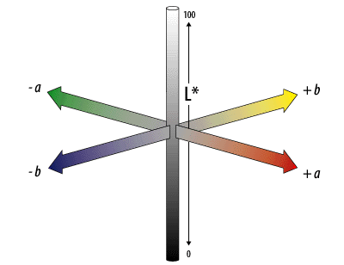
Figure 4. CIELAB color axes
Figure 4 shows the CIELAB color axes with the following representations: L* is for the lightness of the color, a –a* indicates a green color, +a* signifies a red color, -b* represents a blue color, and +b* implies a yellow color. This figure was retrieved from http://dba.med.sc.edu/price/irf/Adobe_tg/models/cielab.html.
The color axes are based on the fact that a color cannot be both red and green, or both blue and yellow, because these colors oppose each other. On each axis, the values run from positive to negative. On the a-a' axis, positive values indicate amounts of red while negative values indicate amounts of green. On the b-b' axis, yellow is positive and blue is negative (Adobe Systems Incorporated, 2000).
The CIE L*C*h* color scale is an approximately uniform scale with a polar color scale. The CIELCh scale values are calculated from the CIELAB scale values. L*, lightness is still the same. The C* value, is chroma, and the h* value, is the hue angle. C* and h* are both calculated from the a* and b* of the CIELAB (HunterLab, 2008).
According to the CIE Color Space Notation, if the value for lightness (L*) yielded a value within the range of 51-100, it is termed as “lighter”, while “darker” is for the value which fall in the range of 0-100. On the other hand, the color of an object is considered “redder” if its ∆a* value is positive, while “greener” for the opposite. For the ∆b*, the color is determined as “yellower” for positive and “bluer” for the negative value (Hunter, 2006).

1.12 Significance
Studies on dyes have posited the preference for pharmaceutical dyes from natural sources over synthetic dyes (Hitesh, et al., 2014; Amchova, Kotolova & Ruda-Kocerova, 2015). These studies revealed that certain synthetic dyes produce skin allergy, tumor formation, possible carcinogenicity and teratogenicity. Hence, several studies, as cited in this paper, had been undertaken which had looked into the possibility of several plant extracts to serve as pharmaceutical dyes.
The potential of obtaining colorants from natural resources poses a great opportunity for the community and the industry. If a natural colorant, with similar color characteristics with that of the widely used synthetic colorant in the market can be discovered, it can be a potential alternative for coloring various food, drug and cosmetic preparations.
In the studies of Balasimha and Rajagopal (2004), Barbosa-Filho (2006), and Jayawardana et.al. (2014), it has been noted that Areca catechu fruit, Bixa orellana seed and Hibiscus rosa-sinensis flower produce red colorants. It should be noted that no study on dyes from natural sources has ever used Areca catechu fruit and Hibiscus rosa-sinensis flower as possible alternative colorant. Therefore, a study that shall test its potential as a dye is being undertaken.

1.13 Research Objective
The present study’s general objective is to determine and compare if there is a significant difference between the CIELAB color coordinates of the red dye of Areca catechu fruit, Bixa orellana seed, and Hibiscus rosa-sinensis flower from Allura Red using UV-Vis Spectrometer. Specifically, it aims to extract a red colorant from Areca catechu fruit via maceration using water as solvent and red colorants from Bixa orellana seed and Hibiscus rosa-sinensis flower via maceration using methanol as a solvent. It also aims to determine the transmittance and CIELAB values of Allura Red, Areca catechu, Bixa orellana and Hibiscus rosa-sinensis red colorants using UV-Vis Spectrometry; Lastly, it aims to compare and see if there is a significant difference between the CIELAB color coordinates of the red colorants of Areca catechu fruit, Bixa orellana seed, and Hibiscus rosa-sinensis flower to that of the standard, Allura Red to identify which has a potential to be an alternative colorant for the said standard using the statistical software, Statistical Package for the Social Sciences® (SPSS) version 20 software.

1.14 Research Questions
The researchers aim to answer the following research questions:
- What are the percentage yields of the aqueous extract of Areca catechu and methanolic extracts of Bixa orellana and Hibiscus rosa-sinensis?
- What are the transmittance values of the Areca catechu, Bixa orellana and Hibiscus rosa-sinensis natural red colorants when analyzed using UV-Vis spectrometry?
- What are the CIELAB values of the Areca catechu, Bixa orellana and Hibiscus rosa-sinensis natural red colorants?
- Which among the Areca catechu, Bixa orellana and Hibiscus rosa-sinensis natural red colorants is the closest in terms of overall color characteristics to the standard, Allura Red?
- Is there a significant difference between the combined CIELAB values for color characterization of the natural colorants obtained from Areca catechu, Bixa orellana and Hibiscus rosa-sinensis to that of the standard, Allura Red?

1.15 Research Hypothesis
Null Hypothesis:
There is no significant difference between the combined CIELAB values for color characterization of the natural colorants obtained from Areca catechu, Bixa orellana and Hibiscus rosa-sinensis to that of the standard, Allura Red.
Alternative Hypothesis:
There is a significant difference between the combined CIELAB values for color characterization of the natural colorants obtained from Areca catechu, Bixa orellana and Hibiscus rosa-sinensis to that of the standard, Allura Red.

1.16 Scope and Limitations
In the present study, the Areca catechu fruit, Bixa orellana seed, and Hibiscus rosa-sinensis flower were obtained using methanol and distilled water as solvents through maceration and were concentrated via rotary evaporator.
The transmittance values of Areca catechu fruit, Bixa orellana seed, Hibiscus rosa-sinensis flower and Allura Red were measured using UV-Vis Spectrometer within 380-770 nm wavelength of the electromagnetic spectrum at 10 nm intervals.
CIELAB values were obtained through EasyMatch QC software version 4.30 for color comparison of the three plant samples to that of the standard colorant, Allura Red.
The optimal concentration of the natural colorants was not identified in this study for there were limited reagents and solvents that were provided.
No other quality control and preformulation tests for dyes as pharmaceutical excipients were performed in this study
1.17 Conceptual Framework

INPUT |  | PROCESS |  | OUTPUT
The following were conducted in order to obtain raw data which were subjected to analyses as stated in the method:  - A. catechu fruit, B. orellana seed and H. rosa-sinensis flower samples were obtained  - A. catechu fruit, B. orellana seed and H. rosa-sinensis flower samples were subjected to air-drying  - Methanol was obtained from the laboratory department  - Allura Red was purchased |  | This includes plant sample collection and laboratory procedures:  A. catechu, B. Orellana and H. rosa-sinensis  - Authentication  - Plant extraction and concentration  - Color comparison using UV-Vis Spectrometer  - Statistical Analysis |  | The following are the results after the raw data were subjected to respective tests and analyses:  - CIELAB results  - Statistical analysis results

CHAPTER II
METHODOLOGY

2.1 Locale, Period of Collection, Sampling and Authentication
2.1.1 Areca catechu
Areca catechu fruits were collected from Lopez, Quezon Province in the midseason of July 2017. Sampling of fifty (50) leaves from current season’s Areca catechu trees with an average height of 12-30 m in an area estimated 280 square meters was done before the collection of the fruits for the study.
2.1.2 Bixa orellana
Bixa orellana fruits were collected from Bauan, Batangas Province in the midseason of July 2017. Sampling of fifty (50) leaves from current season’s Bixa orellana trees with an average height of 2-8 m and a trunk diameter of 10 cm in an area estimated 280 square meters was done before the collection of the fruits for the study.
2.1.3 Hibiscus rosa-sinensis
Hibiscus rosa-sinensis flowers were collected from Morong, Rizal in the midseason of July 2017. Preference will be given for trees with an average height of 1-4 m. Flowers should be around 10 cm long and 12 cm in diameter. Deep-red colored flowers will be selected with the absence of any abrasion.
All of the samples were identified and authenticated by the Botany Division of National Museum, Manila, Philippines.

2.2 Plant Extraction
The plant samples collected were washed repeatedly with running water to remove any extraneous matter and dirt.
2.2.1 Areca catechu
The outer cover of the fresh Areca catechu fruit was removed and the hard flesh part was cleaned, dried and cut. The fresh fruits’ crusts were removed and were allowed to dry first at room temperature in a shade. The aqueous extract was prepared by the addition of 250 gram of small pieces of the dried fruits with 100 mL of distilled water and kept for 48 hours refrigerated. The resulting extract was then filtered (Soheil et.al., 2017).
2.2.2 Bixa orellana
Ten (10) grams of abraded seeds of the Bixa orellana tree were utilized. It was soaked with 300 mL of 95% methanol and kept for maceration. It was placed in a dark room for two days at room temperature. The resulting extract was then filtered (Satheesahbabu et.al., 2014).

2.2.3 Hibiscus rosa-sinensis
Ten (10) grams of fresh Hibiscus rosa-sinensis flower petals were cut into small pieces. Other parts of the flower such as the leaves and stigma were removed. Only the petals were utilized for the extraction procedure. It was macerated with 300 mL of 95% methanol. It was placed in a dark room for two days at room temperature. The resulting extract was then filtered (Bose et.al., 2012).
All the filtered plant extracts were concentrated using a rotatory evaporator. The resulting extracts were then placed in a watch glass and allowed to further dry up inside the fume hood until a powder like consistency was observed.

2.3 Color Comparison of Areca catechu, Bixa orellana, Hibiscus rosa-sinensis extracts and Allura Red via UV-Vis Spectrometry
The preparation of the samples for the spectrometer was done by weighing an empty and dry 100 mL volumetric flask to the closest milligram (± 0.001g). The flask was filled with distilled water up to the mark. The stopper was replaced and dried. The flask was again reweighed (ASTM, n.d.).
Four solutions for UV-Vis spectrometer analysis were prepared. Using an analytical balance, 7.0 g of Areca catechu, 6.0 g of Bixa orellana, 5.0 g of Hibiscus rosa-sinensis and 1.0 g of Allura Red were weighed and transferred to a beaker with 50 mL distilled water, then again transferred to a 100 mL volumetric flask then diluted with distilled water to the mark. The preparation of the plant samples were made by achieving the closest color possible to that of Allura Red standard sample (ASTM, n.d.).
To obtain the spectra of each sample, each stock solution filled 2/3 of the UV-Vis glass cuvette. UV1100® Spectrometer was used for the determination of the transmittance of the samples from 380 to 770 nm at 10 nm interval. The results will be expressed in percentage, the maximum being 100. Three trials were performed in this study for each sample solution. These transmittance values were utilized to obtain the CIELAB values of the samples using EasyMatch QC software version 4.30. Statistical analyses were then performed to identify which plant sample yielded the closest color spectra with the standard (Hunter, 2006).

2.4 Statistical Analysis
Using the Statistical Package for the Social Sciences® (SPSS) version 20 software, One Way Analysis of Variance was performed for the mean average of the CIELAB values of the natural colorants obtained from A. catechu, B. Orellana, Hibiscus rosa-sinensis and Allura Red. This is to test if there is a significant difference between the color characteristics of the four colorants through the CIELAB parameter. If there is a significant difference discovered in the test samples, Post Hoc Test analysis using Bonferroni was utilized to identify where the significant difference is. Two-tailed test was performed since the researchers are testing non-directional hypothesis. The p-values that were obtained were compared to the level of significance ∝ = 0.05. Values lesser than the ∝ value (0.05) indicates a significant difference thus rejecting the null hypothesis, there’s no significant difference between the combined CIELAB values for color characterization of the natural colorants obtained from Areca catechu, Bixa orellana and Hibiscus rosa-sinensis to that of the standard, Allura Red; Values greater than the ∝ value (0.05) indicates no significant difference thus accepting the null hypothesis.

CHAPTER III
RESULTS AND DISCUSSION
This chapter presents the results and discussion of the UV-Vis spectrometer analysis, CIELAB color coordinates and statistical analyses performed on the natural colorants Areca catechu, Bixa orellana, Hibiscus rosa-sinensis and the standard, Allura Red.

3.1 Percentage Yield
Percentage Yield formula:
$$\% Yield= \frac{weight of extract}{initial weight of plant sample} x 100$$

3.1.1 Areca catechu
$$\% Yield= \frac{9.4351 g}{150.0216 g} x 100$$
6.2892%

3.1.2 Bixa orellana
$$\% Yield= \frac{3.0418 g}{10.3461 g} x 100$$
29.4005%

3.1.3 Hibiscus rosa-sinensis
$$\% Yield= \frac{1.4632 g}{10.2125 g} x 100$$
14.3275%

3.2 Transmittance Values of the Plant Samples and the Standard
3.2.1 Allura Red
Table 2 shows the transmittance values of the standard, Allura Red, measured using UV-Vis spectrometer from 380-770 nm at 10 nm interval.
Table 2. Percent Transmittance (%T) of Allura Red
Allura Red
Wavelength  (nm) | % Transmittance
Wavelength  (nm) | Trial 1 | Trial 2 | Trial 3
380 | 1.4791 | 1.6520 | 2.3335
390 | 0.5445 | 0.6730 | 0.4256
400 | 0.2317 | 0.1888 | 0.2553
410 | 0.1000 | 0.1067 | 0.1000
420 | 0.1000 | 0.1000 | 0.1000
430 | 0.1000 | 0.1000 | 0.1000
440 | 0.1000 | 0.1000 | 0.1000
450 | 0.1000 | 0.1000 | 0.1000
460 | 0.1000 | 0.1000 | 0.1000
470 | 0.1000 | 0.1000 | 0.1000
480 | 0.1000 | 0.1000 | 0.1000
490 | 0.1000 | 0.1000 | 0.1000
500 | 0.1000 | 0.1000 | 0.1000
510 | 0.1000 | 0.1000 | 0.1000
520 | 0.1000 | 0.1000 | 0.1000
530 | 0.1000 | 0.1000 | 0.1000
540 | 0.1000 | 0.1000 | 0.1000
550 | 0.1000 | 0.1000 | 0.1064
560 | 0.2056 | 0.1455 | 0.2286
570 | 3.0200 | 1.9011 | 1.4757
580 | 19.2752 | 13.3660 | 18.6638
590 | 49.7737 | 32.7341 | 42.3643
600 | 74.4732 | 53.3335 | 68.8652
610 | 89.1251 | 73.2825 | 86.4968
620 | 95.7194 | 87.7001 | 94.6237
630 | 98.4011 | 94.8418 | 98.1748
640 | 99.5405 | 98.8553 | 98.8553
650 | 100.0000 | 99.3116 | 99.3116
660 | 100.0000 | 100.0000 | 99.7700
670 | 100.0000 | 100.0000 | 100.0000
680 | 100.0000 | 100.0000 | 100.0000
690 | 100.0000 | 100.0000 | 100.0000
700 | 100.0000 | 100.0000 | 100.0000
710 | 100.0000 | 100.0000 | 100.0000
720 | 100.0000 | 100.0000 | 100.0000
730 | 100.0000 | 100.0000 | 100.0000
740 | 100.0000 | 100.0000 | 100.0000
750 | 100.0000 | 100.0000 | 100.0000
760 | 100.0000 | 100.0000 | 100.0000
770 | 100.0000 | 100.0000 | 100.0000

3.1.2 Areca catechu
Table 3 shows the transmittance values of the natural colorant extracted from Areca catechu measured using UV-Vis spectrometer from 380-770 nm at 10 nm interval.
Table 3. Percent Transmittance (%T) of Areca catechu
A. catechu
Wavelength  (nm) | % Transmittance
Wavelength  (nm) | Trial 1 | Trial 2 | Trial 3
380 | 0.1000 | 0.1000 | 0.1000
390 | 0.1000 | 0.1000 | 0.1000
400 | 0.1000 | 0.1000 | 0.1000
410 | 0.1000 | 0.1000 | 0.1000
420 | 0.1000 | 0.1000 | 0.1000
430 | 0.1000 | 0.1000 | 0.1000
440 | 0.1000 | 0.1000 | 0.1000
450 | 0.1000 | 0.1000 | 0.1000
460 | 0.1000 | 0.1000 | 0.1000
470 | 0.1000 | 0.1000 | 0.1000
480 | 0.1000 | 0.1000 | 0.1000
490 | 0.1000 | 0.1000 | 0.1000
500 | 0.1000 | 0.1000 | 0.1000
510 | 0.1000 | 0.1000 | 0.1000
520 | 0.1000 | 0.1000 | 0.1000
530 | 0.1000 | 0.1000 | 0.1000
540 | 0.1000 | 0.1000 | 0.1000
550 | 0.1000 | 0.7762 | 1.1561
560 | 4.7863 | 4.7973 | 4.2462
570 | 16.4816 | 16.1436 | 14.6218
580 | 30.5492 | 30.1995 | 28.2488
590 | 40.0867 | 39.7192 | 37.3250
600 | 44.6684 | 45.8142 | 43.4510
610 | 50.3501 | 50.4661 | 48.0839
620 | 53.7032 | 54.5758 | 51.2861
630 | 57.9429 | 57.8096 | 55.0808
640 | 60.2560 | 60.1174 | 57.1479
650 | 61.2350 | 62.5173 | 59.9791
660 | 63.6796 | 64.7143 | 61.3762
670 | 65.9174 | 66.3743 | 63.5331
680 | 68.8652 | 68.5488 | 65.9174
690 | 70.7946 | 70.9578 | 67.1429
700 | 72.9458 | 72.4436 | 68.7068
710 | 73.1139 | 73.4514 | 70.4693
720 | 73.7904 | 75.1623 | 71.6143
730 | 74.8170 | 76.2079 | 73.4514
740 | 76.3836 | 77.2681 | 74.3019
750 | 77.4462 | 77.9830 | 75.1623
760 | 79.0679 | 78.8860 | 75.6833
770 | 79.6159 | 79.6159 | 76.9130
3.1.3 Bixa orellana
Table 4 shows the transmittance values of the natural colorant extracted from Bixa orellana measured using UV-Vis spectrometer from 380-770 nm at 10 nm interval.
Table 4. Percent Transmittance (%T) of Bixa orellana
B. orellana
Wavelength  (nm) | % Transmittance
Wavelength  (nm) | Trial 1 | Trial 2 | Trial 3
380 | 0.1000 | 0.1000 | 0.1000
390 | 0.1000 | 0.1000 | 0.1000
400 | 0.1000 | 0.1000 | 0.1000
410 | 0.1000 | 0.1000 | 0.1000
420 | 0.1000 | 0.1000 | 0.1000
430 | 0.1000 | 0.1000 | 0.1000
440 | 0.1000 | 0.1000 | 0.1000
450 | 0.1000 | 0.1000 | 0.1000
460 | 0.1000 | 0.1000 | 0.1000
470 | 0.1000 | 0.1000 | 0.1000
480 | 0.1000 | 0.1000 | 0.1000
490 | 0.1000 | 0.1000 | 0.1000
500 | 0.1000 | 0.1000 | 0.1000
510 | 0.1000 | 0.1000 | 0.1000
520 | 0.1000 | 0.1000 | 0.1000
530 | 0.1000 | 0.1000 | 0.1000
540 | 0.1000 | 0.1000 | 0.1000
550 | 0.4467 | 0.1000 | 0.5236
560 | 1.3964 | 0.2661 | 1.8239
570 | 2.6182 | 1.4894 | 2.8774
580 | 4.0272 | 2.9580 | 4.1591
590 | 5.4075 | 4.2462 | 6.4417
600 | 6.6069 | 5.9841 | 6.7298
610 | 7.5509 | 7.1121 | 7.3451
620 | 8.4918 | 8.0910 | 8.6696
630 | 9.2897 | 8.9743 | 9.0782
640 | 9.5719 | 9.4624 | 9.5940
650 | 9.6605 | 9.6161 | 9.6828
660 | 9.7275 | 9.7051 | 9.7499
670 | 10.1391 | 10.3992 | 10.6660
680 | 11.1429 | 10.9144 | 11.4288
690 | 11.9950 | 11.7220 | 12.2744
700 | 12.1899 | 11.9674 | 12.3880
710 | 12.6474 | 12.3880 | 13.1522
720 | 13.0317 | 12.8529 | 13.3660
730 | 13.3968 | 13.0617 | 13.6458
740 | 13.7088 | 13.3352 | 14.0605
750 | 13.9316 | 13.7721 | 14.3880
760 | 14.2889 | 14.0605 | 14.7571
770 | 14.4877 | 14.3880 | 14.9279
3.1.4 Hibiscus rosa-sinensis
Table 5 shows the transmittance values of the natural colorant extracted from Hibiscus rosa-sinensis measured using UV-Vis spectrometer from 380-770 nm at 10 nm interval.
Table 5. Percent Transmittance (%T) of Hibiscus rosa-sinensis
H. rosa-sinensis
Wavelength  (nm) | % Transmittance
Wavelength  (nm) | Trial 1 | Trial 2 | Trial 3
380 | 0.1406 | 0.1062 | 0.1919
390 | 0.1091 | 0.1000 | 0.1146
400 | 0.1000 | 0.1000 | 0.1000
410 | 0.1000 | 0.1000 | 0.1000
420 | 0.1000 | 0.1000 | 0.1000
430 | 0.1000 | 0.1000 | 0.1000
440 | 0.1000 | 0.1000 | 0.1000
450 | 0.1000 | 0.1000 | 0.1000
460 | 0.1000 | 0.1000 | 0.1000
470 | 0.1000 | 0.1000 | 0.1000
480 | 0.1000 | 0.1000 | 0.1000
490 | 0.1000 | 0.1000 | 0.1000
500 | 0.1000 | 0.1000 | 0.1000
510 | 0.1000 | 0.1000 | 0.1000
520 | 0.1000 | 0.1000 | 0.1000
530 | 0.1000 | 0.1000 | 0.1000
540 | 0.1000 | 0.1042 | 0.1000
550 | 0.1067 | 0.2449 | 0.1227
560 | 0.2673 | 0.3855 | 0.2443
570 | 1.8239 | 1.4454 | 1.8113
580 | 4.2560 | 3.7068 | 3.7931
590 | 10.6660 | 7.7090 | 9.2897
600 | 33.0370 | 30.7610 | 26.4180
610 | 51.9996 | 48.9779 | 43.5512
620 | 75.8578 | 57.5440 | 53.2108
630 | 80.7235 | 67.6083 | 67.2977
640 | 90.9913 | 86.6962 | 88.9201
650 | 91.8333 | 90.1571 | 92.8966
660 | 95.2796 | 93.1108 | 95.7194
670 | 95.9401 | 94.4061 | 96.1612
680 | 97.7237 | 95.4993 | 97.0510
690 | 97.9490 | 97.7237 | 97.4990
700 | 98.1748 | 98.4011 | 97.7237
710 | 98.6279 | 98.8553 | 97.9490
720 | 99.0832 | 99.0832 | 98.8553
730 | 99.5405 | 99.7700 | 99.3116
740 | 99.7700 | 100.0000 | 99.7700
750 | 100.0000 | 100.0000 | 100.0000
760 | 100.0000 | 100.0000 | 100.0000
770 | 100.0000 | 100.0000 | 100.0000
These transmittance values played an essential role in the color comparison of the Areca catechu, Bixa orellana and Hibiscus rosa-sinensis to that of the standard, Allura Red for they are needed to obtain the CIELAB values of each colorant. The natural colorants can then be quantitatively compared in terms of the color characteristics.

3.3 CIELAB Values
Table 6 shows the CIELAB values of Allura Red, Areca catechu, Bixa orellana and Hibiscus rosa-sinensis. These were obtained through the EasyMatch QC software version 4.30 utilized for extracting CIELAB values from raw spectral data.
Table 6. CIELAB Values of Allura Red, A. catechu, B. orellana and H. rosa-sinensis
CIELAB Values
Allura Red |  | Trial 1 | Trial 2 | Trial 3 | Mean
Allura Red | L* | 28.5371 | 31.7382 | 27.3785 | 29.2179
Allura Red | a* | 57.4212 | 56.2813 | 59.6654 | 57.7893
Allura Red | b* | 41.8372 | 44.1621 | 38.9641 | 41.6545
A. catechu | L* | 19.8377 | 23.9564 | 21.0351 | 21.6097
A. catechu | a* | 89.2146 | 87.0371 | 92.1742 | 89.2146
A. catechu | b* | 98.8853 | 97.9812 | 100.1382 | 99.0016
B. orellana | L* | 44.3642 | 42.8712 | 45.8637 | 44.3664
B. orellana | a* | 65.3771 | 63.4712 | 67.2512 | 65.3665
B. orellana | b* | 110.8213 | 109.0742 | 111.2412 | 110.3789
H. rosa-sinensis | L* | 21.2173 | 18.4739 | 17.5212 | 19.0708
H. rosa-sinensis | a* | 68.4812 | 69.5738 | 71.2673 | 69.7741
H. rosa-sinensis | b* | 20.4719 | 21.7482 | 22.7821 | 21.6674
Legend
L*: lightness of the color; the higher the value, the lighter the color is
a*: degree of redness or greenness of the color; (+) positive value indicate that it is red while (-) negative value means it is green
b*: degree of yellowness or blueness of the color; (+) positive value indicate that it is yellow while (-) negative value means it is blue
The results of the CIELAB values were utilized to see the color characteristics of each colorant, both from the natural sources and the standard in numerical value. This allows the researchers to compare the colors of the colorants quantitatively across the three trials. L* value stands for the lightness or darkness of the color. It ranges from 0-100 wherein a darker color falls within the 0-50 range while a lighter color falls within the 51-100 range. Natural colorant from Areca catechu, Bixa orellana, and Hibiscus rosa-sinensis mean L* values were 21.6097, 44.3664 and 19.0708 respectively. These are within the 0-50 range for L* values which means the colorants are relatively dark in color. The lower the value for L*, the darker the color is. a* value tells whether a colorant is red or green. A positive value signifies that the colorant is red while a negative value tells that the colorant is green. The mean a* values for Areca catechu, Bixa orellana, and Hibiscus rosa-sinensis were 89.2146, 65.3665 and 69.7741 respectively. All are positive figures which mean they all fall on the red spectra of color. The higher the value for a*, the more red the color is. Lastly, the b* value tells whether a colorant is yellow or blue. A positive value signifies that the colorant is yellow while a negative value tells that the colorant is blue. Natural colorants from Areca catechu, Bixa orellana, and Hibiscus rosa-sinensis mean b* values were 99.0016, 110.3789 and 21.6674 respectively. The higher the value for b*, the more yellow the color is.

3.4 One way Analysis of Variance (ANOVA)
In order to determine whether there is a significant difference between the four colorants namely Areca catechu, Bixa orellana, Hibiscus rosa-sinensis and Allura Red in terms of the combined or overall color characteristics based on CIELAB values (L*, a*, b*), One Way of Analysis of Variance was performed. One way ANOVA is a hypothesis test used to test the equality of three or more population means simultaneously using variance. Only one independent variable exists and three or more levels of one factor are being compared.
Table 7. One Way Analysis of Variance and Post Hoc test for the analysis of the CIELAB values of the colorants
One Way Analysis of Variance
 | Allura Red | A. catechu | B. orellana |  | H. rosa-sinensis | F-value |  | p-value
CIELAB Values | 42.8872 | 70.0289 | 73.3706 |  | 36.8374 | 4.200* |  | .013
Post Hoc Analysis (Bonferroni)
Comparisons |  | Mean Difference |  | p-value |  |  | Remarks
Allura Red vs. A. catechu |  | 27.14 |  | 0.042* |  |  | Significant
Allura Red vs. B. orellana |  | 30.48 |  | 0.024* |  |  | Significant
Allura Red vs. H. rosa-sinensis |  | 6.05 |  | 0.641 |  |  | Not Significant
* ∝ = 0.05
To find out if there is a significant difference between the natural colorants obtained from A. catechu, B, orellana and H. rosa-sinensis to that of the standard, Allura Red, One Way Analysis of Variance was utilized. Results show that there is an F-value of 4.200 which is significant at a p-value of 0.013 (0.013< ∝ 0.0.5). This warrants the rejection of the null hypothesis and acceptance of the alternative hypothesis. This means that there is a significant difference in the color characteristics of the four colorants based on CIELAB values. In order to locate where the significant differences exist, Post Hoc Analysis using Bonferroni was performed. In comparing the results between Allura Red and A. catechu, there was an observed mean difference of 27.14. Post Hoc test result showed that the mean difference is significant at a p-value of 0.042 (0.042< ∝ 0.05). This indicates that there is a significant difference between Allura Red and A. catechu with respect to the color characteristics based on CIELAB values. In the comparison of Allura Red and B.orellana, there was an observed mean difference of 30.48. Post Hoc test result showed that the mean difference is significant at a p-value of 8 0.024 (0.024< ∝ 0.05). This shows that there is a significant difference between Allura Red and B. orellana with respect to the color characteristics based on CIELAB values. Allura Red and H. rosasinensis were also compared and a mean difference of 6.05 was obtained. Post Hoc test result revealed that the mean difference is significant at a p-value of 0.641 (0.641> ∝ 0.05). This signifies that there is no significant difference between Allura Red and H. rosa-sinensis.
With the objectives of the researchers at hand, the researchers wanted to know which among the colorants obtained from natural sources is the closest to that of the standard based on the combined color characteristics using CIELAB parameters. There should be no significant difference between the combined color characteristics between the natural colorant and that of the standard because they should both belong in the same spectra of color across the aforementioned characteristics in order for it to be considered as a possible alternative colorant. Among the three natural colorants that were utilized in this study, both the natural colorants from A. catechu and B. orellana yielded p-values of 0.042 and 0.024 respectively. These are both lower than the level of significance at ∝ 0.05. This means that the null hypothesis, there is no significant difference between the combined CIELAB values for color characterization of the natural colorants obtained from Areca catechu and Bixa orellana to that of the standard, Allura Red is rejected and the alternative hypothesis is then accepted. There is a significant difference between the aforementioned colorants to that of the standard. Thus it can be inferred that they can’t be utilized and further studied as possible alternative colorants to Allura Red. Only H. rosa-sinensis yielded a p-value of 0.641 that is greater than the level of significance at ∝ 0.05. This means that the null hypothesis, there is no significant difference between the combined CIELAB values for color characterization of the natural colorants obtained from Hibiscus rosa-sinensis to that of the standard, Allura Red is accepted. There is no significant difference between the two colorants across the combined color characteristics making it a possible alternative colorant to that of the standard in terms of color characterization alone. Among the three natural colorants that were analyzed in this study, it can be implied that the natural colorant from H. rosa-sinensis is the closest to Allura Red in term of combined color characteristics.

CHAPTER IV
SUMMARY, CONCLUSION, & RECOMMENDATION
This chapter presents the summary of the different results obtained from the experimentation conducted on the aqueous extract of Areca catechu and methanolic extract of Bixa orellana and Hibiscus rosa-sinensis as well as the conclusions and the recommendations for the future studies.

4.1 Summary
The following findings were obtained after conducting the research study:
- The percentage yield of Areca catechu, Bixa orellana and Hibiscus rosa-sinensis are 6.2892%, 29.4005% and 14.3275% respectively.
- The natural colorants from Areca catechu, Bixa orellana and Hibiscus rosa-sinensis are all dark in color based on the L* value of the CIELAB parameter.
- The natural colorants from Areca catechu, Bixa orellana and Hibiscus rosa-sinensis are all red in color based on the a* value of the CIELAB parameter.
- The natural colorants from Areca catechu, Bixa orellana and Hibiscus rosa-sinensis are all yellow in color based on the b* value of the CIELAB parameter.
- One way Analysis of Variance revealed that there is a significant difference between the color characteristics using CIELAB parameters between the standard, Allura Red and the natural colorants from Areca catechu and Bixa orellana.
- Combined CIELAB parameters revealed that the closest natural colorant to that of the standard, Allura Red is from Hibiscus rosa-sinensis as supported by statistical analysis that there is no significant difference between the two samples.

4.2 Conclusion
The results obtained in the present study revealed that the natural colorants from Areca catechu, Bixa orellana, and Hibiscus rosa-sinensis all fall within the dark, red and yellow spectra of colors based on their L*, a* and b* values respectively of the CIELAB parameter. Among the three natural colorants that were utilized in this study, both the natural colorants from A. catechu and B. orellana yielded p-values of 0.042 and 0.024 respectively which are both lower than the level of significance at ∝ 0.05. This means that there is a significant difference between the aforementioned colorants to that of the standard. Thus it can be inferred that they can’t be utilized and further studies as possible alternative colorant to Allura Red. Only H. rosa-sinensis yielded a p.value (0.641) that is greater than the level of significance at ∝ 0.05. This means that the null hypothesis, there is no significant difference between the combined CIELAB values for color characterization of the natural colorants obtained from Areca catechu, Bixa orellana and Hibiscus rosa-sinensis to that of the standard, Allura Red is accepted. It can also be inferred that there is no significant difference between the two colorants across the combined color characteristics making it a possible alternative colorant to that of the standard in terms of color characterization alone. Lastly, this can indicate that among the three natural colorants that were analyzed in this study, the natural colorant from H. rosa-sinensis is the closest to Allura Red in term of combined color characteristics.

4.3 Recommendations
The following are the recommendations of the researchers for future studies:
- Isolation and identification of the specific constituent(s) present in Hibiscus rosa-sinensis crude extract that is/are responsible for the production of its color production;
- Using other methods of extraction for Hibiscus rosa-sinensis that may attain higher percentage yield such as Sohxlet extraction;
- Using other solvent for extraction for Hibiscus rosa-sinensis that may attain higher percentage yields;
- Assessment of various concentrations of the natural colorant from Hibiscus rosa-sinensis that can yield an optimum color that is closer to the standard, Allura Red;
- Quality control tests for Hibiscus rosa-sinensis extract as colorant;
- Lyophilization of the crude extract of Hibiscus rosa-sinensis for easier storage and analysis
- Compatibility studies to determine the stability of the red colorant of Hibiscus rosa-sinensis through Differential Scanning Calorimetry, Differential Thermal Analysis, Accelerated Stability Study and Chromatography (Thin Layer Chromatography, High Pressure Liquid Chromatography/HPLC); and
- Toxicological studies for the red colorant of Hibiscus rosa-sinensis.

REFERENCES

Adiga, S., Amudhan, S., Azeez, S., Rao, N., Rao, N. & Udupa, L.A., (2007). Wound healing profile of Areca catechu extracts on different wound models in wistar rats. Kuwait Medical Journal, 39, 1, 48-52.
Adobe Systems Incorporated. (2000). Technical guides: color models CIELAB. Retrieved from http://dba.med.sc.edu/price/irf/Adobe_tg/models/cielab.html

Ahmad, Z., Lian, E.C.G., Kadir, A.A., Somchit, M.N., Yong, Y.K. & Zakaria, Z.A., (2013). Chemical constituents and antihistamine activity of Bixa orellana leaf extract. BMC Complement Alternative Medicine, 13-32. doi: 10.1186/1472-6882-13-32
Al-Amoudi, E. S. & Osman, E. M. (2009). Optimization of dyeing performance of an ecofriendly natural dye “vervain barks” applied to silk fabrics at different pH values. Research Journal of Textile and Apparel, 13(1), pp. 34-45. doi: http://dx.doi.org/10.1108/RJTA-13-01-2009-B004
Alam, M.S., Sadhu, S.K., Shilpi, V.S., Taufiq-Ur-Rahman, M. & Uddin, S.J., (2006). Preliminary pharmacological screening of Bixa orellana L. leaves. Journal of Ethnopharmacology, pp. 264-271.
Ali, N.F., El-Mohamedy, R.S. & El-Khatib, E.M. (2011). Antimicrobial Activity of Wool Fabric Dyed with Natural Dyes. Research Journal of Textile and Apparel, 15, 3, 1-10. https://doi.org/10.1108/RJTA-15-03-2011-B001
Allam, K. V. & Kumar, G. P. (2011). Colorants the cosmetics for the pharmaceutical dosage forms. International Journal of Pharmacy and Pharmaceutical Sciences, 3(3), 13-21.
Allen, J.S., Nero, K., Otto, C., Sullivan, R.J. & Tiobech, J., (2000). Effects of Chewing Betel Nut (Areca catechu) on the symptoms of people with schizophrenia in Palau, Micronesia. British Journal of Psychiatry, 177, 174-178.
Amchova, P., Kotolova, H., & Ruda-Kucerova, J. (2015). Health safety issues of synthetic food colorants. Regulatory Toxicology and Pharmacology, 73, 914-922. doi: http://dx.doi.org/10.1016/j.yrtph.2015.09.026
Amor, E.C., Perez, G.G. & Quanico, J.P., (2008). Analgesic and hypoglycemic activities of Bixa orellana, Kyllinga monocephala and Luffa acutangula. Philippine Journal of Science, 137, 1, 69-76.
Amudhan, M.S., Begum, V.H. & Hebbar, K.B., (2012). A review on phytochemical and pharmacological potential of Areca catechu L. seed. International Journal Pharmaceutical Science and Research, 3, 4151-4157.
Anderson, W.A., Irobi, O.N. & Moo-Young, M.. (1996). Antimicrobial activity of annatto (Bixa orellana) extract. International Journal of Pharmacognosy. pp. 87-90.
Anthony, S., Jamnadass, R., Kindt, R., Mutua, A., Orwa, C. & Simons, A., (2009). Agroforestree Database: a tree reference and selection guide version 4.0. Retrieved July 07, 2017 from http://www.worldagroforestry.org/sites/treedbs/treedatabases.asp

Araújo, G.R., Chaves, M.M., Costa, D.C., Magalhães, C.L., Pádua, B.C., Pedrosa, M.L., Rossoni, J.V. & Silva, M.E., (2012). Annatto extract and β-carotene enhances antioxidant status and regulate gene expression in neutrophils of diabetic rats. Free Radical Research, 329-30. doi: 10.3109/10715762.2012.656100
Areca catechu L., (n.d). Retrieved July 07, 2017 from ITIS Report website from https://www.itis.gov/servlet/SingleRpt/SingleRpt?search_topic=TSN&search_value=506702#null

Asad, L.M., Asad, N.R., Felzenszwalb, I., Júnior, A.C., Kovary, K. & Oliveira, E.B., (2005). Antigenotoxic and antimutagenic potential of an annatto pigment (norbixin) against oxidative stress. Genetics and Molecular Research, 4, 1, 94-99.
Ashida, H., Hashimoto, T., Tsuji, S. & Danno, G. (2000). Synergistic Effects of Food Colors on the Toxicity of 3-Amino-1,4-dimethyl-5H-pyrido[4,3-b]indole(Trp-P-1) in Primary Cultured Rat Hepatocytes. Journal of Nutritional Science and Vitaminology, 46, 3, 130-6. DOI: 10.3177/jnsv.46.130
Baker, W., Dransfield, J., Flynn, T., Heatubun, C.D., Mogea, J. P. & Tjitrosoedirdjo S. S., (2012). A monograph of the betel nut palms (Areca: Arecaceae) of East Malesia. Botanical Journal of the Linnean Society, 168, 147-173.
Balasimha, D. & Rajagopal, V., (2004). Arecanut. Central Plantation Crops Research Institute. Retrieved July 07, 2017 from https://www.google.com.ph/url?sa=t&rct=j&q=&esrc=s&source=web&cd=1&cad=rja&uact=8&ved=0ahUKEwjcn5qn2_XUAhVGGZQKHV9WC-cQFggiMAA&url=http%3A%2F%2F14.139.158.118%2Fbioinf%2FCP2813.pdf&usg=AFQjCNGE1bacRRzubzZaKcLj_2R7z1IAQQ
Barbosa-Filho, J.M., Silva-Filho, R.N. & Lira, B.F. (1998). Teor de bixina em quatro variedades de Bixa orellana L. cultivadas na Para´ıba. Revista Brasileira de Farmacognosia, Vol. 7-8, pp. 41–47.
Barbosa- Filho, J.M. (2006). Bixa orellana: Retrospectiva de usos populares, atividades biol´ogicas, fitoqu´ımica e emprego na fitocosm´etica, no continente americano, Simp´osio Brasileiro do Urucum, SIMBRAU, Jo˜ao Pessoa, Brazil.
Bevacqua, R.F. & Staples, G.W., (2006). Areca catechu (betel nut palm). Specific Profiles for Pacific Island Agroforestry, 1.3.
Bose, S. & Nag, S. (2012). Isolation of Natural Dyes from the Flower of Hibiscus Rosa-Sinensis. American Journal of Pharmtech Research, 2, (3), 2249-3387.
Cardon, D. (2010). Natural dyes, our global heritage of colors. Textile Society of America Symposium Proceedings, (1)1. Lincoln: University of Nebraska.
Chandler, A.C. & Chopra, R.N., (1928). Anthelminthics and their Uses in Medical and Veterinary Practice. The William Wilkins & Co., Baltimore.
Choi, J.D. & Lee, K.K., (1999). The Effects of Areca Catechu L Extract on Anti-Aging. International Journal of Internal Sciences. DOI: 10.1046/j.1467-2494.1999.196563.x
Chopra, R.N., Chopra, I.C., Handa, K.L. & Kapur, L.D., (1933). Areca catechu Linn., (Palmae). Chopra’s Indigenous Drugs of India (2nd ed.). Academic Publishers: Kolkata.
Classification for Kingdom Plantae Down to Species Bixa orellana L., (n.d.). Retrieved July 07, 2017 from USDA Natural Resources Conservation Service website from https://plants.usda.gov/java/ClassificationServlet?source=display&classid=BIOR
Correa, M.P. (1978). Dicion´ario das Plantas. Uteis do Brasil e das Ex´oticas Cultivadas, Vol. 4, Minist´erio da Agricultura/IBDF, Rio de Janeiro, Brasil.
Dar, A. & Khatoon, S., (2000). Behavioral and biochemical studies of dichloromethane fraction from the Areca catechu nut. Pharmacology Biochemistry and Behavior, 65, 1, 1-6.
Dongc, H., Fiscus, R.R., Paul, P.H., Xie, Y.W. & Xuc, H.X., (2007). Role of nitric oxide in the vasorelaxant and hypotensive effects of extracts and purified tannins from Geum japonicum. Journal of Ethnopharmacology, 109, 128-133.
Franco, C.O., Fabri, E.G., Barreiro Neto, M., Manfiolli, M. H. Harder, M. N. C. & Rucker, N.C. (2008) Urucum: Sistema de Produc¸˜ao para o Brasil. Emepa-Pb,Apta, Jo˜ao Pessoa, Brazil.
Ganesh, N. & Karchuli, M.S., (2009). Protective effect of Bixa orellana L. against radiation induced chromosomal aberration in Swiss albino mice. International Journal of Phytomedicine, 1, 18-21.
Grover, J.K., Vats, V. & Yadav, S., (2002). Medicinal plants of India with anti-diabetic potential. Journal of Ethnopharmacology, 81, 81-100.
Helena K. (2016). Colorimeter vs. spectrophotometer: knowing the differences among color measurement technologies. Retrieved from https://www.hunterlab.com/blog/color-measurement-2/colorimeter-vs spectrophotometer-knowing-the-differences-among-color-measurement-technologies/
Hitesh, S., Lokesh, K., Ganesh, K., Yogesh, M., & Shweta, G. (2014). AN OVERVIEW TO SOME NATURAL COLOURING AGENTS USED IN PHARMACEUTICAL FORMULATIONS. World Journal of Pharmaceutical Research, 3, 3, 3904-3916.
Houghton, P.J., Maiti, K., Mukherjee, K. & Mukherjee, P.K., (2006). Leads from Indian medicinal plants with hypoglycemic potentials. Journal of Ethnopharmacology, 106, 1-28.
Ibarbia, L., Maidanski, T., Schubert, S., Windhah, N. & Schubert, U. (2016). Safety and Regulatory Review of Dyes Commonly Used as Excipients in Pharmaceutical and Neutraceutical Applications. European Journal of Pharmaceutical Sciences, 93, 264-273.
Integrated Taxonomic Information System (n.d.). Rerieved July 07, 2017 from ITIS Report website from https://www.itis.gov/servlet/SingleRpt/SingleRpt?search_topic=TSN&search_value=21616.
International Agency For Research On Cancer, (1978). IARC Monographs of the Evaluation of the Carcinogenic Risk of Chemicals to Man: Some aromatic amines and related nitro compounds – hair dyes, colouring agents and miscellaneous industrial chemicals, 16, 171-186.
Jaiswal, P., Kumar, P., Singh, D.K. & Singh, V.K., (2011). Areca catechu L.: a valuable herbal medicine against different health problems. Research Journal of Medicinal Plant, 5, 2: 145-152 DOI: 10.3921/rjmp.2011.145.152
Kasiri, M. B. & Safapour, S. (2015). Exploring and exploiting plants extracts as the natural dyes/antimicrobials in textiles processing. Progress in Color, Colorants Coatings, 8, 87-114.
Khanal, D.S. (n.d.). Systemic Review Helping Ingredients (excipient) in Pharmaceutical formulation: Coloring Agents – use and health concern. Journal of Manmohan Memorial Institute of Health Sciences, 40.
Kobylewski, S. & Jacobson M.F. (2010). Food dyes: a rainbow of risks. Washington DC: Center for Science in the Public Interest.
Kumar, S., Kumar, V., Prakash, O. (2011). Microscopic evaluation and physicochemical analysis of Dillenia indica leaf. Asian Pacific Journal of Tropical Biomedicine, 1(5), pp. 337-340. doi:10.1016/S2221-1691(11)60076- 2
Kumar, V. R., Kumar, S., Sanitha S. S. (2011). Stability of lycopene from Solanum lycopersicum as colorants in pharmaceutical formulation. Journal of Pharmacy Research, 4(3), 905-906.
Lancaster, F.E. & Lawrence, J.F. (1991). Determination of Total Non-sulphonated aromatic amines in tartrazine, sunset yellow FCF and allura red by reduction and derivatization followed by High-Performance Liquid Chromatography. Food Additives & Contaminants, 8, 249-264.
Missouri Botanical Garden (n.d.) Hibiscus rosa-sinensis. Retrieved July 4, 2017 from http://www.missouribotanicalgarden.org/PlantFinder/PlantFinderDetails.aspx?kempercode=b557
Norton, S.A., (1998). Betel: Consumption and consequences. Journal of the American Academy of Dermatology, 37, 81-88.
Oliveira, J.S. (2005). Caracterizac¸˜ao, Extrac¸˜ao e Purificac¸˜ao por Cromatografia de Compostos de Urucum (Bixa orellana L.) Tesis doctoral en Ingenier´ıa Qu´ımic, Universidade Federal de Santa Catarina, Florian´opolis, Brazil.
Preedy, V.R., Watson, R.R. & Patel V.V., (2011). Betel nut (Areca catechu) usage and its effects on health. Nuts and Seeds in Health and Disease Prevention. p 197.
Saxena, R. & Pal, Y. (2016). A Review on natural colour yielding Plants. International Journal of Research in Pharmacy and Pharmaceutical Sciences, 1, 4, 46-48.
Saxena, S. & Raja, A. S. M. (2014). Natural dyes: sources, chemistry, application and sustainability issues. Roadmap to Sustainable Textiles and Clothing: Eco- friendly Raw Materials, Technologies, and Processing Methods. Retrieved from http://www.springer.com/978-981-287-064-3

Stohs, S.J., (2014). Safety and efficacy of Bixa orellana (achiote, annatto) leaf extracts. Journal of Ethnopharmacology, 48, 2, 956-60. doi: 10.1002/ptr.5088
Taylor, L. (2002). Herbal Secrets of the Rainforest. Sage Press, Rocklin, California, USA, 2nd edition.
United States National Toxicology Program, (1981). N-Nitrosodiethanolamine. CAS No. 116-54-7. Report on Carcinogens, 11th ed., 3, 124-141.
United States Pharmacopoeia. (2012). <631> Color and Achromicity. (35th ed., pp. 265-266). Retrieved from http://www.drugfuture.com/Pharmacopoeia/usp3 5/PDF/ 02650266%20[631]%20COLOR%20AND%20ACHROMICITY.pdf
United States Pharmacopoeia. (n. d.). <1061> Color—instrumental measurement. Retrieved from https://hmc.usp.org/sites/default/files/documents/HMC/GCs- Pdfs/c1061.pdf
Venugopalan, P.A., Giridhar, G.A. & Ravishankar, A.G. (2011). Food, Ethanobotanical and diversified applications of Bixa orellana L.: a scope for its improvement through biotechnological mediation. Indian Journal of Fundamental and Applied Life Sciences, Vol. 1, pp. 9–31.
Whetzel, N. (2015). XYZ - CIE tristimulus values - an04_96a. Retrieved from https://support.hunterlab.com/hc/en-us/articles/203994325-XYZ-CIETristimulus-Values-an04-96a
Williamson, S. J. & Cummins, H. Z. (1983). Light and color in nature and art. Retrieved from http://hyperphysics.phyastr.gsu.edu/hbase/Optics/optref.html# c
X-rite. (2017). A Guide to Understanding Color Communication. Retrieved from http://tqmsystems.nl/uploads/Understand_Color_en.pdf

APPENDIX A
Gantt Chart

 | 2017
 | JUNE | JULY |  |  |  | AUGUST |  |  |  | SEPTEMBER |  |  |  |  | OCTOBER
TASK | 30 | 7 | 14 | 21 | 28 | 4 | 11 | 18 | 25 | 1 | 8 | 15 | 22 | 29 | 6 | 13 | 20
Finalization of topic
Title Composition
Construction of introduction and methodology
Initial submission of Paper
Collection of plant sample
Plant authentication
Air drying of plant sample
Plant extraction
Spectrometry
Data Analysis
Wring of Final Paper

APPENDIX B
Budget Plan

Plant Authentication | ₱ 240
Allura Red | ₱ 500
Methanol | ₱ 300
Statistician and Proofreading | ₱ 1,000
Printing | ₱ 700
Transportation | ₱ 500
Miscellaneous | ₱ 1,000
TOTAL: | ₱ 5,010.00

APPENDIX C
Areca catechu, Bixa orellana and Hibiscus rosa-sinensis Certificate of Authentication

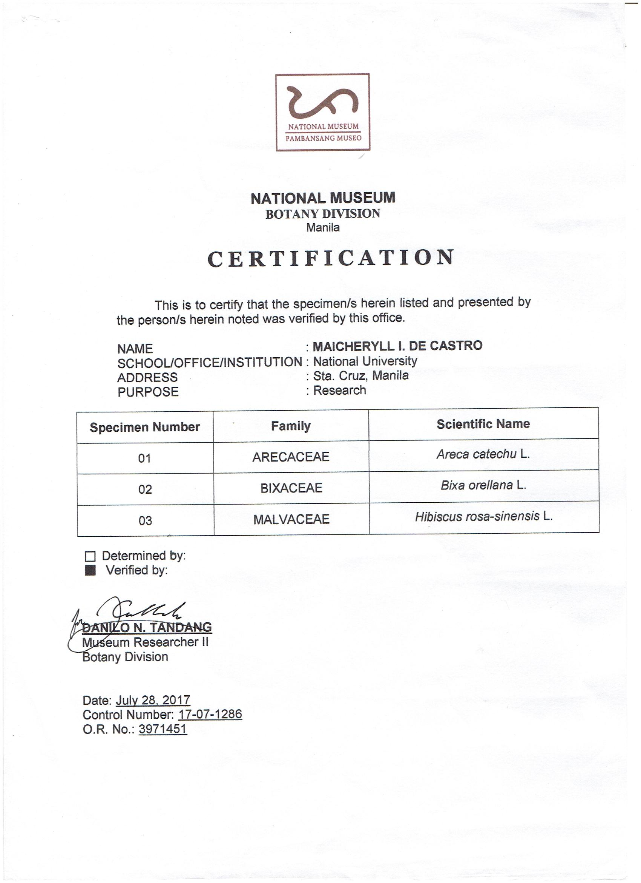
Figure 5. Certificate of Authentication from the National Museum Botany Division
APPENDIX D
Areca catechu Extraction Process
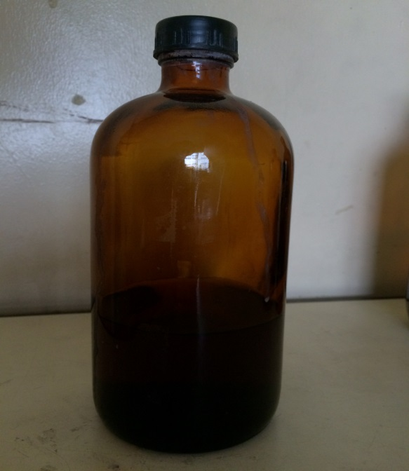
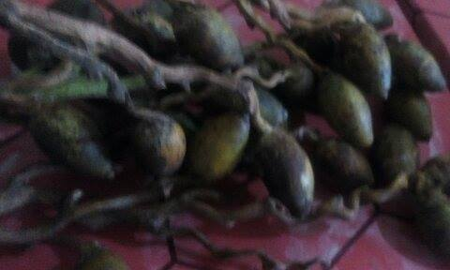

Figure 7. Maceration of A. catechu in distilled water

Figure 6. Drying of A. catechu fruit

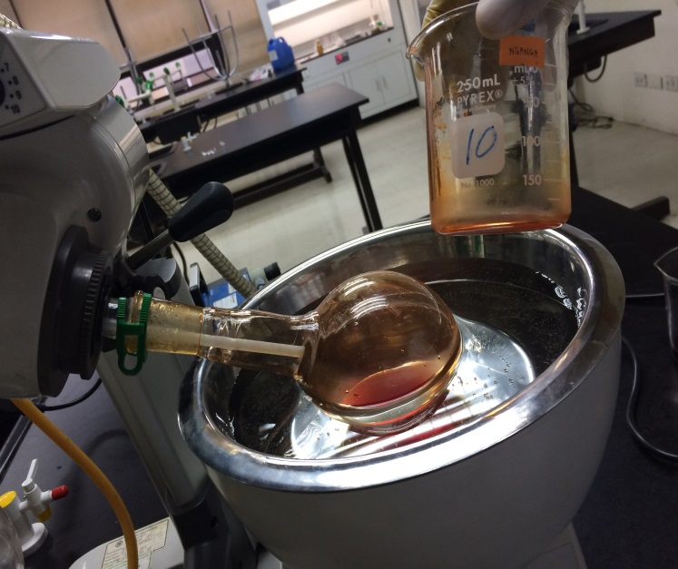
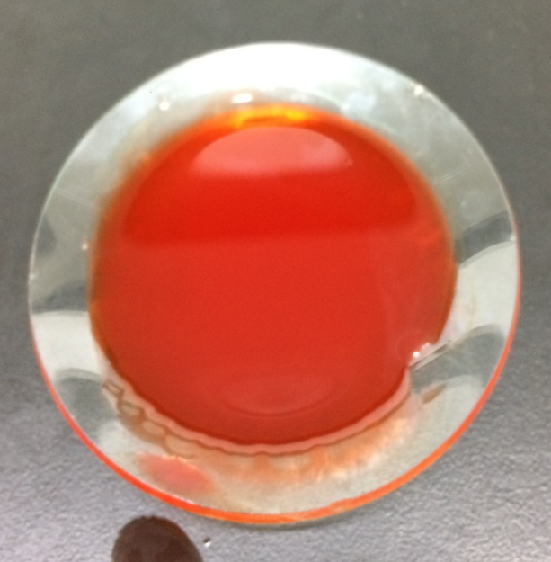

Figure 9. Drying of A. catechu extract
Figure 8. Rotary evaporation of A. catechu extract

APPENDIX E
Bixa orellana Extraction Process

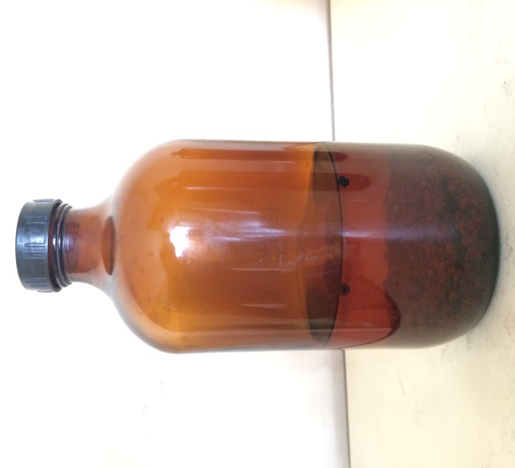
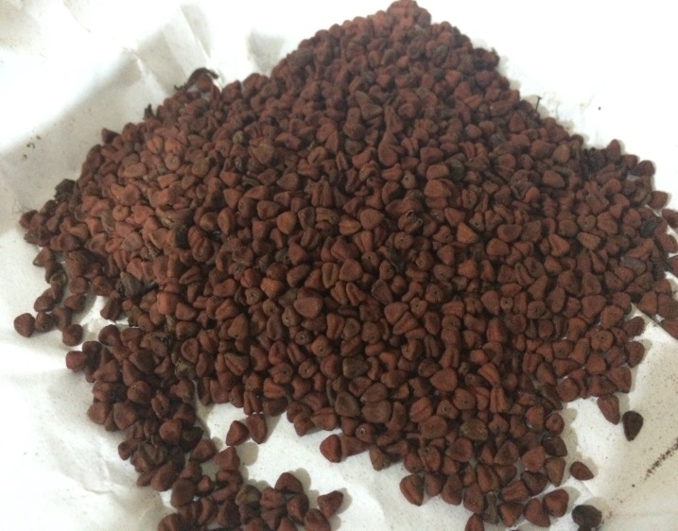

Figure 11. Maceration of B. orellana seeds in methanol

Figure 10. Drying of B. orellana seeds

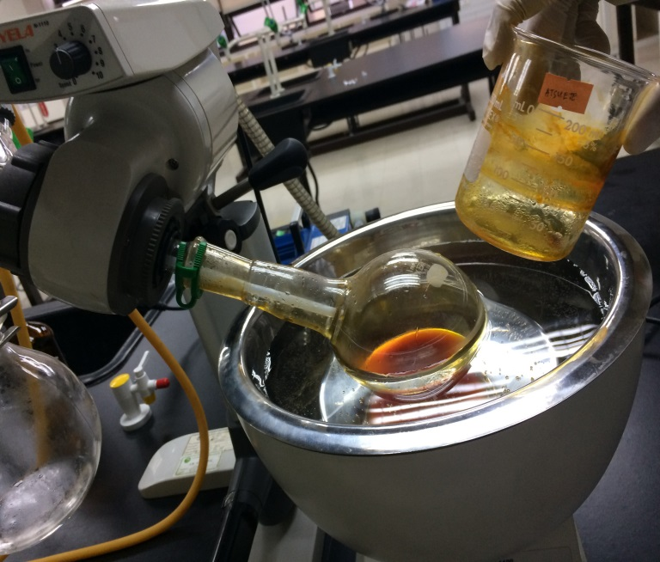
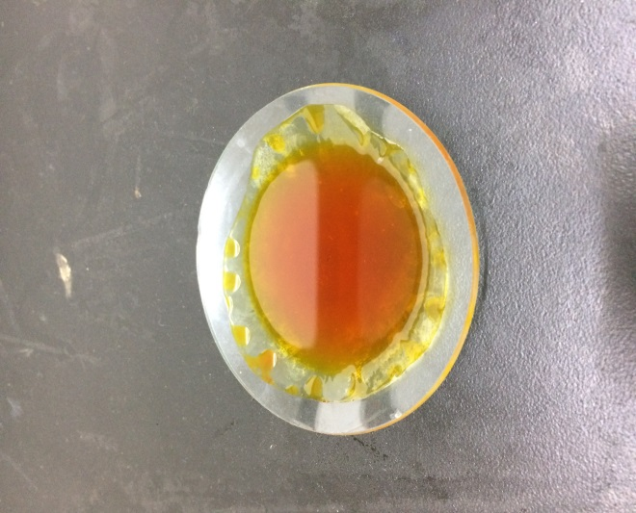

Figure 12. Rotary evaporation of B. orellana extract
Figure 13. Drying of B. orellana extract

APPENDIX F
Hibiscus rosa-sinensis Extraction Process

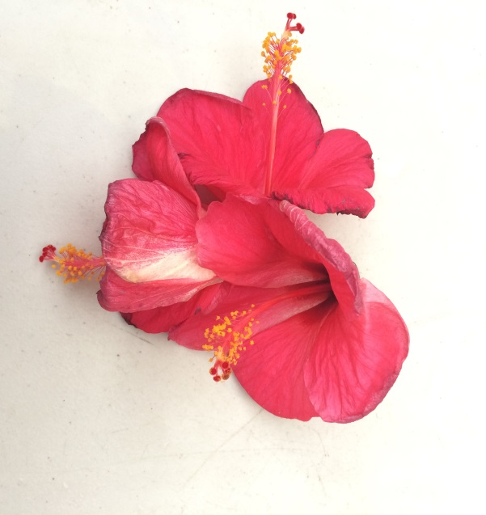
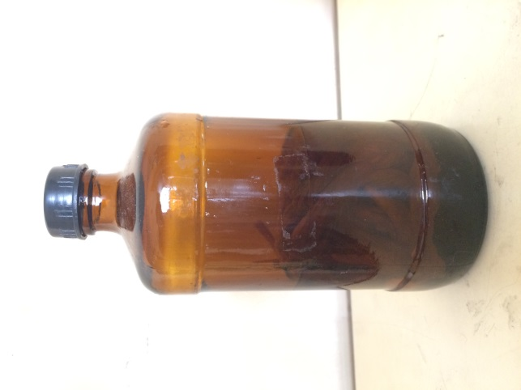

Figure 15. Maceration of H. rosa-sinensis flower in methanol

Figure 14. Drying of H. rosa-sinensis flower

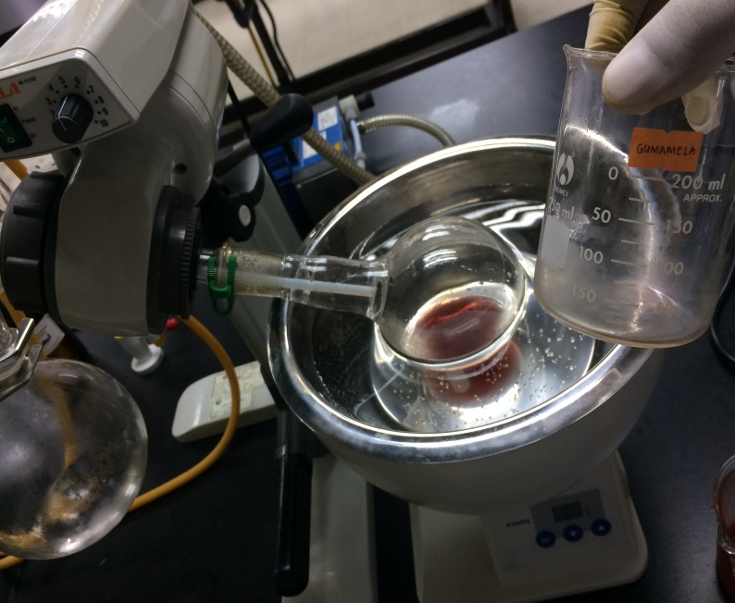
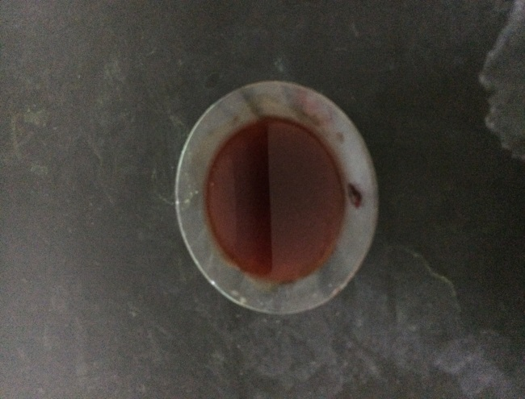

Figure 17. Drying of H. rosa-sinensis extract
Figure 16. Rotary evaporation of H. rosa-sinensis extract

APPENDIX G
UV-Vis Spectrometer Analysis
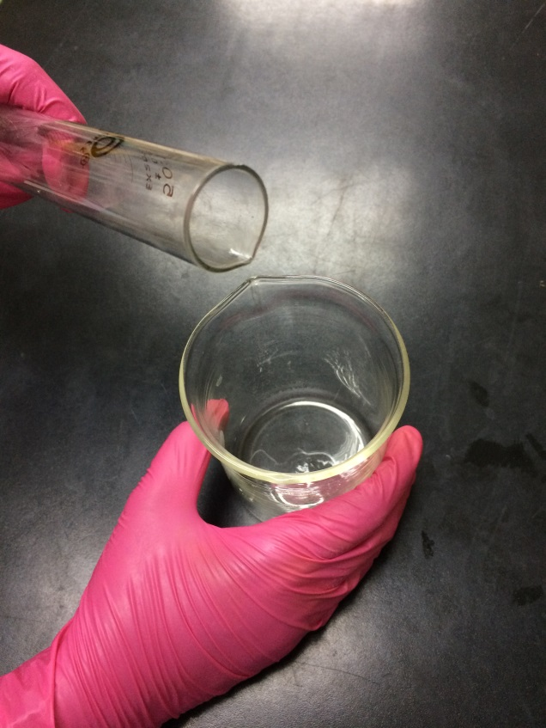

Figure 19. Preparation of medium for spectral analysis
Figure 18. Spectrometer apparatus

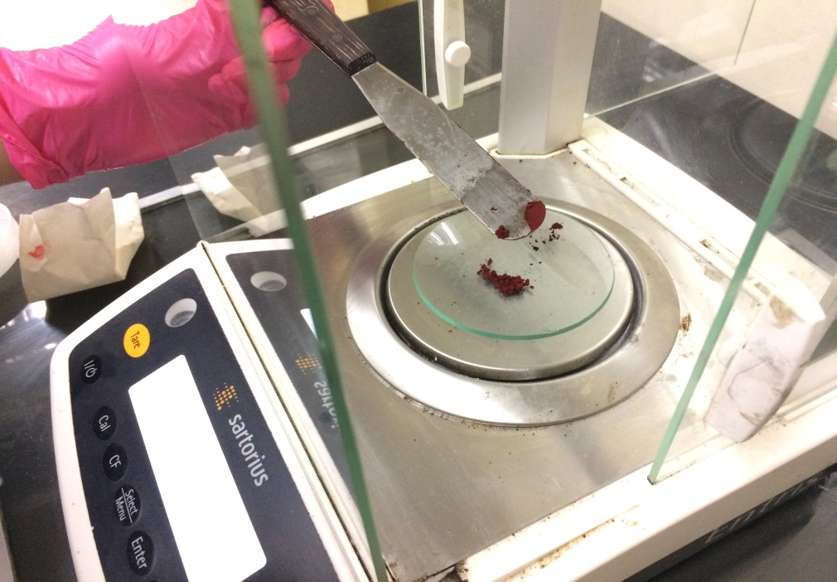

Figure 20. Weighing of dried natural colorants and standard

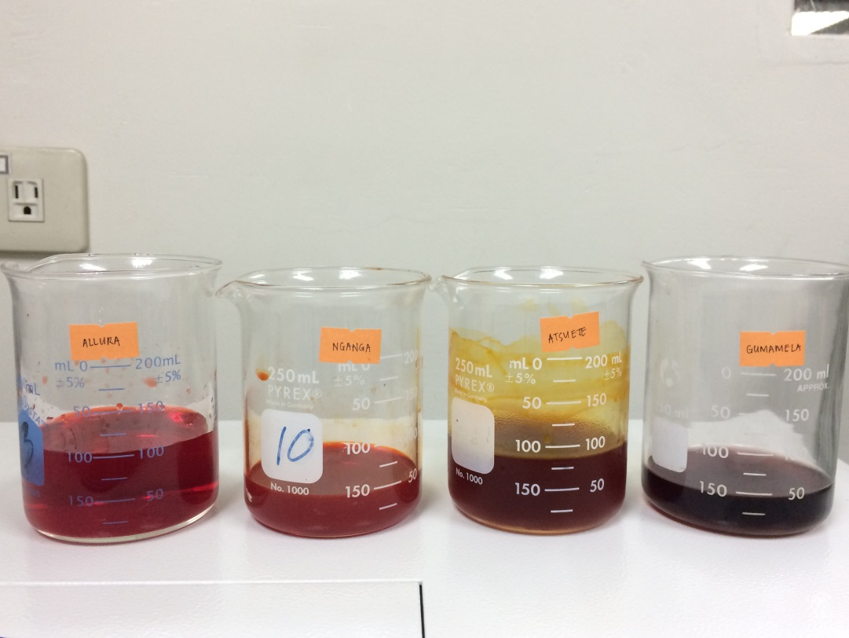

Figure 21. Prepared solutions for spectral analysis (from left to right: Allura Red, A. catechu, B. Orellana and H. rosa-sinensis)

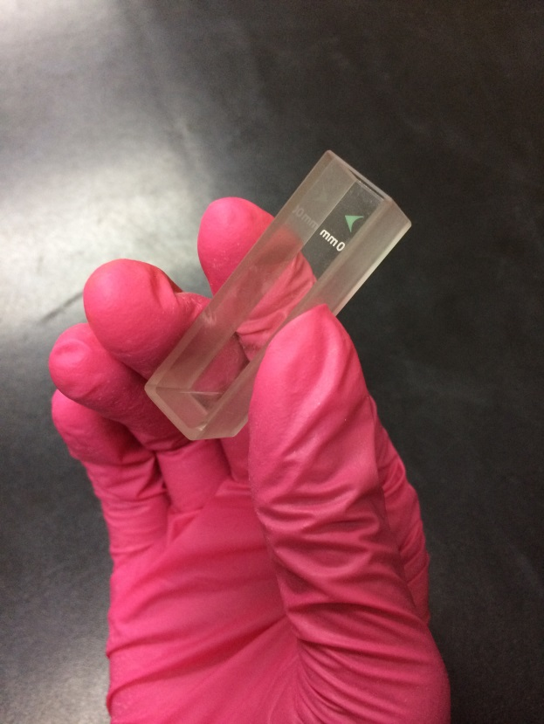

Figure 22. Transferring of samples in the cuvette

APPENDIX H
Actual Color Output using the CIELAB values

The following color outputs were obtained through the online color converter, Color Nix Sensor from https://nixsensor.com/free-color-converter/.

Allura Red
L* = 29.2179 a* = 57.7893 b* = 41.6545

Figure 23. Allura Red color output

A. catechu
L* = 21.6097 a* = 89.2146 b* = 99.0016

Figure 24. A. catechu color output

B. orellana
L* = 44.3664 a* = 65.3665 b* = 110.3789

Figure 25. B. orellana color output

H. rosa-sinensis
L* = 19.0708 a* = 69.7741 b* = 21.6674

Figure 26. H. rosa-sinensis color output

APPENDIX I
Proofreading Certificate

October 10, 2017

CERTIFICATE OF PROFESSIONAL PROOFREADING

This is to certify that the manuscript entitled, Comparative Colorimetric Study on the Aqueous Extract of Areca catechu “Bunga” (Arecaceae) Fruit and Methanolic Extracts of Bixa orellana “Atsuete” (Bixaceae) Seed and Hibiscus rosa-sinensis Linn. “Gumamela” (Malvaceae) Flower as Red Colorants using UV-Vis Spectrometry prepared by authors Cary U. Cura, Dennice R. Custodio, Adeline N. Dañas, Maicheryll I. De Castro, Mark Angelo F. Eman, Bianca Joyce F. Famini and Ronnell John R. Gonzales was proofread for proper English grammar, language, punctuation and spelling, and proper American Psychological Association (APA) format.


Tristan L. Piosang
Bachelor in Secondary Education, Major in English
National University, Manila

CURRICULUM VITAE


CARY U. CURA
Brgy. Tunhac 2 Famy, Laguna ǀ 09478537014 ǀ curacary@yahoo.com

EDUCATION

2013 – Present National University Bachelor of Science in Pharmacy

2009 – 2013 Liceo de Pakil
Secondary

2004 – 2009 Blessed James Cusmano Academy
Primary

POSITIONS HELD & AFFILIATIONS

2015 – 2016 NU College of Pharmacy Student Council Zeta Chapter
Head, Socio-cultural Committee

2012 – 2013 Liceo de Pakil, Campus Youth Ministry
4th Year Representative

2012 – Present Federation of Junior Chapters Philippine Pharmacists Association
Member

INTERNSHIP EXPERIENCE

Manufacturing Pharmacy
June – November 2016 First Asia Manufacturing Corporation

Community Pharmacy
April – May 2013 Watsons Drugstore

DENNICE R. CUSTODIO
616 T. Claudio St. Sagbat Maybancal Morong, Rizal ǀ 09279050099 ǀ dennice.custodio123@gmail.com

EDUCATION

2016 – Present National University Bachelor of Science in Pharmacy

2012 – 2013 Adamson University Bachelor of Science in Pharmacy

2008 – 2011 Morong National High School
Secondary

2003 – 2008 Maybancal Elementary School
Primary

POSITIONS HELD & AFFILIATIONS

2011 – 2013 NU College of Pharmacy Student Council Zeta Chapter
Head, Finance and Sponsorship Committee

2014 – 2015 NU College of Pharmacy Student Council Zeta Chapter
2nd Year Representative

2012 – Present Federation of Junior Chapters Philippine Pharmacists Association
Member

2014 – Present Philippine National Red Cross National University Chapter Member

INTERNSHIP EXPERIENCE

Manufacturing Pharmacy
May – June 2016 Akita Herbal Product

Hospital Pharmacy
April – June 2017 Lung Center of the Philippines

Community Pharmacy
April – May 2013 Watsons Drugstore


ADELINE N. DAÑAS
Silk Residences Santol St. Sta. Mesa, Manila ǀ 09155616575 ǀ adelinedanas@gmail.com

EDUCATION

2014 – Present National University Bachelor of Science in Pharmacy

2010 – 2014 Lopez National Comprehensive High School
Secondary

2004 – 2010 Lopez West Elementary School Bldg.1
Primary

POSITIONS HELD & AFFILIATIONS

2016 – 2017 NU College of Pharmacy Student Council Zeta Chapter
Treasurer

2015 – Present Red Cross Youth – Manila Chapter
Member

2014 – Present Federation of Junior Chapters Philippine Pharmacists Association
Member

INTERNSHIP EXPERIENCE

Hospital Pharmacy
June – July 2017 East Avenue Medical Center

Manufacturing Pharmacy
October – November 2016 Pharmahex Inc.

Community Pharmacy
April – May 2016 Mercury Drug Corp.

MAICHERYLL I. DE CASTRO
316 Pulang Lupa, Brgy. Locloc, Bauan, Batangas ǀ 09172761168 ǀ decastromai_97@yahoo.com

EDUCATION

2017 – Present National University Bachelor of Science in Pharmacy

2014 – 2017 St. Jude College- Manila Bachelor of Science in Pharmacy

2010 – 2014 Sta. Teresa College
Secondary

2004 – 2010 Locloc Elementary School

Primary

POSITIONS HELD & AFFILIATIONS

2014-Present Youth Task Force Development
Member

INTERNSHIP EXPERIENCE

Manufacturing Pharmacy
December 2016 – February 2017 Medicamenta Inc.

Hospital Pharmacy
August – October 2016 St. Jude Hospital

Community Pharmacy
September- October 2015 Mercury Drug Corporation



MARK ANGELO F. EMAN
#20 Pagalagala, Pinamalayan Oriental Mindoro, 5208, Philippines ǀ 09153868809 ǀ markangeloeman@yahoo.com

EDUCATION

2013 – Present National University Bachelor of Science in Pharmacy

2009 – 2013 Immaculate Heart of Mary Academy
Secondary

2004 – 2009 Quinabigan Elementary School
Primary

POSITIONS HELD & AFFILIATIONS

2014 – Present Philippine National Red Cross-National University Chapter Member

2013 – Present Federation of Junior Chapters Philippine Pharmacists Association
Member

2012 – 2013 IMHA School Council of Students
Treasurer

2010 – 2012 IMHA School Council of Students
Business Manager

INTERNSHIP EXPERIENCE

Manufacturing Pharmacy
April– May 2016 Akita Herbal Products

Hospital Pharmacy
May – June 2017 Philippine Children’s Medical Center

Community Pharmacy
April – May 2014 Watsons Your Personal Store – San Lazaro


BIANCA JOYCE F. FAMINI
313 Masikap St. Tawiran Extn., Santolan, Pasig City ǀ 09065794850 ǀ bianca_famini@icloud.com

EDUCATION

2017 – Present National University Bachelor of Science in Pharmacy

2014 – 2017 St. Jude College- Manila Bachelor of Science in Pharmacy

2010 – 2014 Christ the King College of Cavite Foundation
Secondary

2004 – 2010 Grace Horizon Grade School

Primary

POSITIONS HELD & AFFILIATIONS

2016-2017 St. Jude College - Manila
Assistant Treasurer

2013 –2014 Christ the King College of Cavite Foundation Newspaper Publication
Editor

INTERNSHIP EXPERIENCE

Manufacturing Pharmacy
April –May 2017 Medicamenta Inc.

Hospital Pharmacy
December 2016- February 2017 St. Jude Hospital

Community Pharmacy
September- October 2015 Mercury Drug Corporation

RONNELL JOHN R. GONZALES
Block 19 Lot 12 District 1-B EPZA Pulung Cacutud, Angeles City, Pampanga ǀ 09482293935 ǀ rongonzalespharma@gmail.com

EDUCATION

2016 – Present National University Bachelor of Science in Pharmacy

2013 – 2014 Our Lady of Fatima University – Valenzuela Bachelor of Science in Pharmacy

2011 – 2013 Angeles University Foundation Bachelor of Science in Pharmacy
Dean’s Lister (Four Consecutive Semesters)

2007 – 2011 Angeles University Foundation – Integrated School
Secondary
6th Honorable Mention

2001 – 2007 EPZA Resettlement Elementary School
Primary
Batch Valedictorian

POSITIONS HELD & AFFILIATIONS

2017 – 2018 NU College of Allied Health Student Council
President

2011 – 2013 The AlliMed Explorer Collegiate Publication
News Correspondent

2010 – 2011 Hi-News High School Publication
News Editor

2013 – Present Federation of Junior Chapters Philippine Pharmacists Association
Member

INTERNSHIP EXPERIENCE

Manufacturing Pharmacy
April – May 2017 Soapking Incorporated

Hospital Pharmacy
May – June 2014 Philippine General Hospital

Community Pharmacy
April – May 2012 Watsons Drugstore

