Heme polymerization inhibition of some plants from Lamiaceae family

Somayeh Esmaeili¹, Mahboubeh Irani¹, Maryam Hamzeloo-Moghadam¹, Homa Hajimehdipoor², Mahmoud Mosaddegh¹.
¹Traditional Medicine and Materia Medica Research Center, Shahid Beheshti University of Medical Sciences, Tehran, Iran.
²School of Traditional Medicine, Shahid Beheshti University of Medical Sciences, Tehran, Iran.

Abstract

Statement of the Problem: Malaria is one of the most important parasitic diseases in the world caused by Plasmodium species. According to the latest reports, there were 212 million new cases of malaria and an estimated 429 000 malaria deaths worldwide in 2015(1). Plasmodium has got several detoxification mechanisms to protect itself from toxic heme (2). The most important mechanism is hemozoin formation (3). Identifying compounds that inhibit heme detoxification is an approach for detecting antimalarial drugs. The present was intended to screen selected plants from Lamiaceae family for evaluation of their antimalarial mechanism. Methodology & Theoretical Orientation: Methanol extracts of Marrubium astracanicum Jacq. , Lamium album L., Phlomis caucasica Rech.f., Nepeta transcaucasica Grossh., Salvia sahendica Boiss. & Buhse, Salvia grossheimi Sosn. and Scutellaria virens Boiss. & Kotschy were prepared by maceration method. Heme detoxification (ITHD) (4) assessment was done by spectrophotometric analysis of β-hematin formation. Hemin Chloride, tween 20 and samples were added in each well of a 96-wells plate, and incubated at 60ºC. The absorbance was recorded with a micro-ELISA reader at 405 nm, and percentage of heme polymerization inhibition was calculated. Findings: Methanol extracts of M. astracanicum and P. caucasica demonstrated inhibition of β-hematin formation at concentration of 200 µg.ml⁻¹. Other plants didn’t show any remarkable inhibition. Conclusion & Significance: This is the first report that mentioned mode of antimalarial action of M. astracanicum and P. caucasica. Since, antiprotozoal activity of these plants has been reported (5-6); they could be proper candidates for drug discovery programs in malaria studies.

Image

A
B
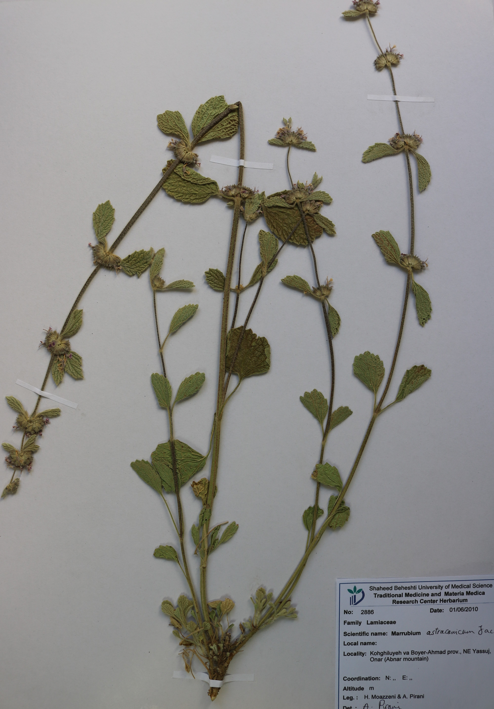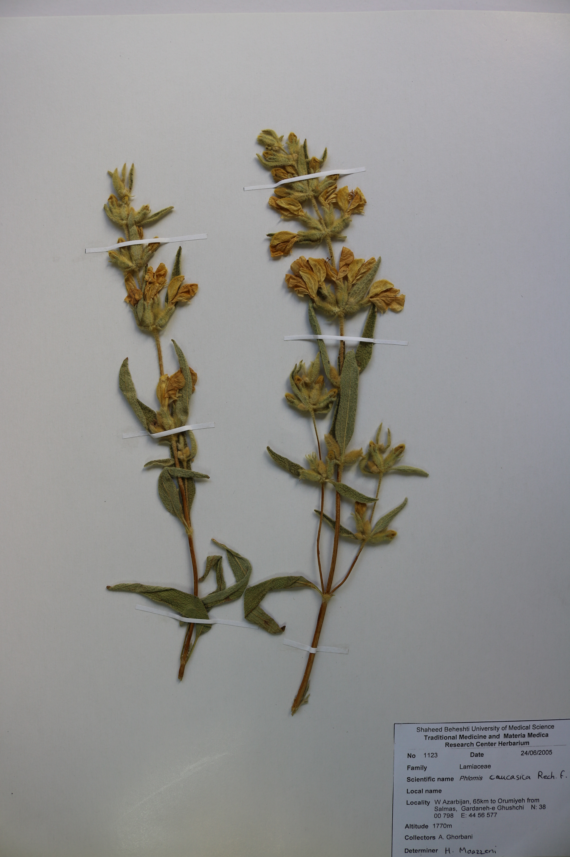

Figure 1. A: Marrubium astracanicum Jacq. , B: Phlomis caucasica Rech.f.

Recent Publications
- WHO | Fact Sheet: World Malaria Report (2016) WHO. 2017 [cited 2017 Jun 10]; Available from: http://www.who.int/malaria/media/world-malaria-report-2016/en/
- Huy NT, Serada S, Trang DT, Takano R, Kondo Y, Kanaori K, Tajima K, Hara S, Kamei K (2003) Neutralization of toxic heme by Plasmodium falciparum histidine-rich protein 2, Journal of Biochemistry 133: 693-698.
- Egan Timothy J (2008) Haemozoin formation. Molecular & Biochemical Parasitology 157:127-136.
- Naghibi F, Irani M, Ghiaee A, Ghafari S, Esmaeili S, Mosaddegh M (2015) Inhibition test of heme detoxification (ITHD) as an approach for detecting antimalarial compounds. 4th National Congress on Medicinal Plants, Tehran- Iran, 1240
- Kirmizibekmez H, Atay I, Kaiser M, Yesilada E, Tasdemir D (2011) In vitro antiprotozoal activity of extracts of five Turkish Lamiaceae species. Natural Product Communications 6:1697–700.
- Kirmizibekmez H, Calis I, Perozzo R, Brun R, Donmez A, Rude P, Tasdemir D (2004) Inhibiting activities of the secondary metabolites of Phlomis brunneogaleata against parasitic protozoa and plasmodial enoyl-ACP Reductase, a crucial enzyme in fatty acid biosynthesis. Planta Medica 70: 711–7.

Biography
Somayeh Esmaeili research interests include antimalarial and cytotoxic evaluation of medicinal herbs and natural products along with exploring the traditional manuscripts for biological evaluation or preparation of modern dosage forms.
Email: sesmaeili@sbmu.ac.ir

