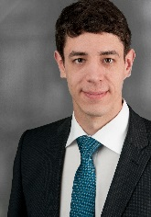

Implementation of a Human-Machine-Interaction Control System in a Human-Robot-Collaborative Riveting Process in Aircraft Assembly
Prof. Dr.-Ing. Rainer Müller
Dipl.-Wirt.-Ing. (FH) Matthias Vette-Steinkamp M.Eng.
Tobias Masiak M.Eng., ZeMA gGmbH Gewerbepark Eschberger Weg 46, 66121 Saarbrücken Germany

Abstract
Assembly processes in aircraft production are difficult to automate due to technical risks. Examples of such technical challenges are small batch sizes, large product dimensions and limited work space. Full automation of complex processes is expensive as it requires much effort with respect to service and maintenance. A semi-automated process, utilizing Human-Robot-Collaboration, is the most effective approach for optimizing aircraft production in relation to aircraft section assembly.
In the assembly process of the aft section of aircrafts, the pressure bulkhead is assembled with the section barrel using hundreds of rivets. This assembly process is a non-ergonomic and demanding task in which two people are working together collaboratively. Working conditions can be improved through collaboration between the opera-tor and the robot system. The approach is based on the process requirements as well as dynamic and skill-based task sharing between the operator and the robot. This is demonstrated by positioning a robot within section 19 (Fig. 1). The robot's task is to position the anvil tool, while the operator performs the more complex task of inserting the rivet and operating the riveting tool.
An intuitive operating is implemented to increase operator acceptance and to enable interaction with production equipment. Within the framework of natural and intuitive Human-Machine-Interaction, smart devices are integrated to control process-specific production equipment. Graphical user interfaces in smartphones or smart-watches and the integration of mixed reality technology offers new possibilities for visualization and assistance.
The developed systems allows intuitive configuration and operation of the station using an open control concept and dynamic task sharing. The operator is therefore supported with a collaborative robot in combination with additional assistance systems in order to improve production quality and ergonomics during the riveting process.
The results are part of the EU’s Horizon 2020 research and innovation programme in the FourByThree project at ZeMA.

Key words: Automated large-scale structure assembly, Human-Robot-Collaboration, Human-Machine-Interaction, Assembly process, Riveting

Image
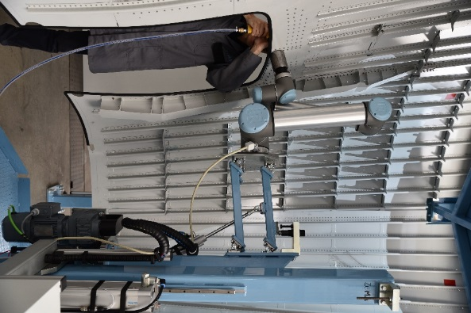
Fig. 1: Collaborative riveting process between humans and robots at ZeMA.
Recent Publications (minimum 5)
- Prof. Dr.-Ing. Rainer Müller; Dipl.-Wirt.-Ing. (FH) Matthias Vette M.Eng.; Aaron Geenen M.Eng.; Tobias Masiak M.Eng., Improving Working Conditions in Aircraft Productions using Human-Robot-Collaboration in a Collaborative Riveting Process, DOI: 10.4271/2017-01-2096, SAE Technical Paper, 2017.
- Prof. Dr.-Ing. Rainer Müller; Dipl.-Wirt.-Ing. (FH) Matthias Vette-Steinkamp M.Eng.; Aaron Geenen M.Eng.; Tobias Masiak M.Eng.; Ali Kanso M.Sc.; Methodology for design of mechatronic robotic manipulators based on suitability for modern application scenarios, IFAC, 2017.
- Prof. Dr.-Ing. Rainer Müller; Dipl.-Wirt.-Ing. (FH) Matthias Vette-Steinkamp M.Eng.; Tobias Masiak M.Eng., Development of a mechatronic construction kit for a safe Human-Robot-Collaboration, VDI-Kongress Baden-Baden AUTOMATION, 2017.
- Prof. Dr.-Ing. Rainer Müller; Dipl.-Wirt.-Ing. (FH) Matthias Vette-Steinkamp M.Eng.; Tobias Masiak M.Eng., Improving Working Conditions in Aircraft Productions using Human-Robot-Collaboration in a Collaborative Riveting Process, Roboterinnovationen für die Produktion der Zukunft, Technologie Centrum Westbayern GmbH, 2018.
- Prof. Dr.-Ing. Rainer Müller; Dipl.-Wirt.-Ing. (FH) Matthias Vette-Steinkamp M.Eng.; Tobias Masiak M.Eng., A. Methodology for design of reconfigurable robot systems based on suitability for modern application scenarios. 4. IFToMM D-A-CH Konferenz, Lausanne, 2018.

Biography
Tobias Masiak is a research assistant at ZeMA in Human-Robot-Collaboration in the areas of aircraft production, process development as well as Human-Machine-Interaction in the frame of automation and handling devices. Moreover, he is a managing director of a marketing agency and runs a start-up as well.

Presenting author details
Full name (As per the passport): Tobias Masiak
University/Industry/Organization name: ZeMA - Zentrum für Mechatronik und Automatisierungstechnik gemeinnützige GmbH
Designation(Director/Prof/Assistant or Associate prof/Researcher/Student): Research Assistant
Country: Germany
Mobile number: 004917647714883
Email: t.masiak@zema.de
Track number: https://mechatronics.conferenceseries.com/abstract-submission.php (For track number follow this link)
Category (Oral presentation/ Poster presentation/Young researcher forum/E-poster): Oral presentation
Research interest: Human-Robot-Collaboration, Artificial Intelligence, Assembly processes
Your profile page URL in your department: http://www.zema.de/de/zema/mitarbeiter/name/tobias-masiak/
Year of birth: 26.10.1989
Linked In/Facebook/twitter account: https://www.linkedin.com/in/tobias-masiak-876b73117/

Note: Please fill up the Red mark fields so that it would be easier for us to cite your details in the conference particulars. (Please do not forget to fix your photo and Logo above the title)

