Coulomb´s memoir on human-machine interaction
Agamenon R. E. Oliveira, DSc, Polytechnic School of Rio de Janeiro, BRAZIL

Abstract
Coulomb´s memoir Sur la Force des Hommes is an attempt to understand human work mechanically and is the first publication on physiology and ergonomics. Historically, the approach used by Coulomb to study the problem of fatigue with a mechanical model has an important meaning that is to consider the old question of how to measure human capacity to do a day’s work. His basic concern was to measure mean values of work in a day and not maximum or minimum values. In other words, Coulomb was looking for an actual measurement of work in a regular day’s work.
In 1821, Coulomb’s mechanical studies were published, including the memoir Sur la Force des Hommes. By introducing the question of human work as a machine operation, it was possible to study the work carried out by a machine economically. This double analogy created the conditions to construct the concepts of net work and global work applied to a given machine in order to measure its efficiency, costs, energy consumption, etc., providing the necessary theoretical tools to compare two different machines.
Sur la Force des Hommes should be considered a pioneering work in modern biomechanics, notwithstanding the many studies since antiquity, mainly addressed at the development of robotics in which it is attempted to reproduce the movement of animals and man. What in fact makes the difference in Coulomb’s memoir is the application of the concept of quantity of action (later called work) to obtain a mathematical model using the new tools of Rational Mechanics and differential calculus.

Image
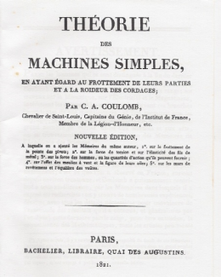

Fig. 1: Coulomb´s memoir
Recent Publications
- Oliveira A R E (2016) Charles-Augustin-Coulomb the founder of physiology and ergonomics. AHS Journal 5: 207-222.
- Oliveira A R E (2013) A history of the work concept: from physics to economics. Springer.
- Coulomb C (2002) Théorie des machines simples. Librairie Albert Blanchard.
- Oliveira A R E (2011) Coriolis´ theory of machines and mechanisms. IFToMM Congress.
5. Vatin F (1999) Le travail, sciences et societé. Éditions de l´Université de Bruxelles.

 Biography
Agamenon Oliveira has his expertise in mechanical engineering, mainly solid mechanics and in the last ten years in History of Mechanics. He is DSc in Mechanical Engineering (1982) as well as DSc in History of Sciences and Technology (2006), both by COPPE/UFRJ, Rio de Janeiro, Brazil. He published 80 papers and one book: History of the work concept- from physics to economics, by Springer (2013). He is member of IFToMM (International Federation for the promotion of Mechanism and Machine Science) and of SBHC (Brazilian Society of History of Sciences). He is also Professor of Mechanics and History of Technology at Polytechnic School o Rio de Janeiro, Brazil.

Email: agamenon.oliveira@globo.com

Notes/Comments:

