Title: Modelling of Ammonia Combustion in a Gas Turbine with GT-Suite
Süleyman Kağan AYAZ and Önder ALTUNTAŞ, Anadolu University, Faculty of Aeronautics and Astronautics, 26470, Eskisehir, TURKEY

Abstract
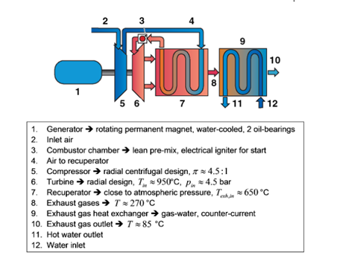
Today’s increasing global warming effects and need for alternative energy sources can put forward different energy sources for sustainable environment. Ammonia, which is a commonly used feedstock, can be seen as a promising fuel to decrease global warming effects of fossil fuels since it has no carbon content. It is possible to combust ammonia resulting only water vapor and nitrogen. 40 years ago, project developed by University of Berkeley which was also first to use ammonia in a gas turbine showed that ammonia can be useful, economical and alternative to fossil fuels. Both ammonia transportation and storage are significantly easy than methanol or hydrogen because of high auto ignition temperature. Negative properties of ammonia is slow laminar burning velocity (0.0015 m/s) and high minimum ignition energy (8 MJ). This study focuses on effects of using ammonia in microturbine called Turbec T100. System scheme of the microturbine is shown in Figure 1. The gas turbine model have been developed using the software GT Suite. Effects of ammonia fraction in compared to other fuels such as methane, hydrogen and kerosene is the main concern of this paper. Energetic, exergetic and sustainability analyses have been carried out for optimizing power generation utilizing ammonia fuel blends. Preliminary study shows that ammonia usage up to 20% fraction with natural gas can increase sustainability parameters of the microturbine compared with 10% and 0% ammonia fraction.

Image
Figure 1. System scheme
Recent Publications
- Süleyman Kağan Ayaz and Önder Altuntaş (2017) Assessment of a ramjet engine for different Mach numbers. Int. J. Sustainable Aviation Vol. 3, No. 4. https://doi.org/10.1504/IJSA.2017.090299.
- Süleyman Kağan Ayaz and Önder Altuntaş (2018) Exergetic and Sustainability Analyses of Ammonia Usage in a Gas Turbine. 3rd International Hydrogen Technologies Congress, March 15-18 Alanya, Turkey.
- Süleyman Kağan Ayaz, Önder Altuntaş and Emin Açıkkalp (2016) The Exergy Of Lift During Climb And Cruise For Different Engine Types. Journal of Aeronautics and Space Technologies Vol. 9 No. 1:15-23. http://www.jast.hho.edu.tr/JAST/index.php/JAST
- Önder Altuntaş, Mehmet Ziya Söğüt, Enver Yalçin, Tahir Hikmet Karakoç (2017) Assessment of Thermodynamic and Environmental Performances in Subcooling Process for Different Refrigerants. International Journal of Exergy Vol. 24 No. 2/3/4: 216-. Link: http://www.inderscience.com/link.php?id=10008597.
- Önder Altuntaş, Tahir Hikmet Karakoç, Arif Hepbaşli (2015) A Parametric Study of a Piston-Prop Aircraft Engine Using Exergy and Exergoeconomic Analysis Methods. International Journal of Green Energy Vol. 12 No. 1: 2 - 14.

Biography (150 word limit)
Süleyman Kağan Ayaz completed his Master degree in Airframe and Powerplant Department of Anadolu University in 2015. He is currently a PhD student and also a Research Assistant at the same department. His research areas include exergy analysis and combustion in gas turbines.
Email:skayaz@anadolu.edu.tr
- Full Name: Süleyman Kağan AYAZ
- Personal Email: s_kaganayaz@hotmail.com
- Mobile Number: +905074266938
- Linked In:
- Facebook:
- Session Name/ number:
- Category: Oral presentation
- Date of Birth: 20.01.1988
- Postal Address: Anadolu University Faculty of Aeronautics and Astronautics 26470, Eskisehir, TURKEY

Notes or Comments:

