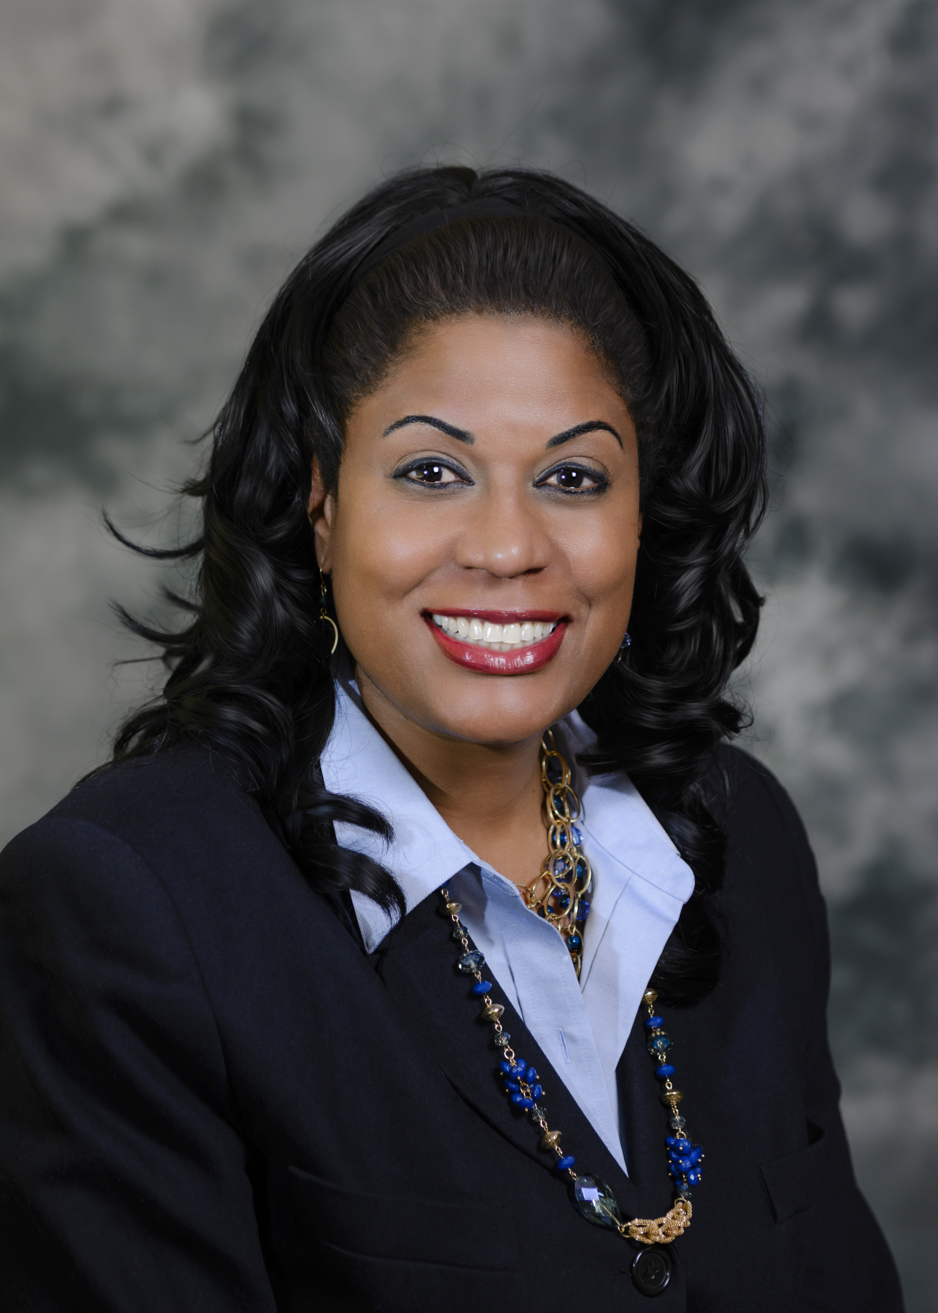

Title: Global Diversity and Inclusion Practices Are Key to the Advancement of Mechanical & Aerospace Engineering

Name: Judi Brown Clarke, Ph.D.
Michigan State University, BEACON Center for the Study of Evolution in Action

The modern world is fast-paced and dynamic; it can only be negotiated effectively through the use of evolving technologies and creative innovative practices. Higher education globally is developing technological innovations that are tremendous catalysts of change. This means more high-performing engineering students, and/or future employees, are ready to tackle the wicked problems of today and tomorrow. As competition for the best talent becomes more intense, organizations are becoming more aggressive and employing innovative practices to attract the best candidates. Additionally, as demographics shift, organizations are increasingly focused on recruiting top diverse talent. As diversity and inclusion (D&I) becomes an increasingly important part of a organization’s overall business strategy, it is imperative to establish the structures that define the mission and vision, set the strategy, determine implementation tactics, measure, track and communicate progress, and ensure accountability. Effective D&I efforts can help in establishing the prestige and recognition of an organization, and as a result, assist in its attractiveness as a school or employer of choice. Community outreach and global partnerships involve relationships that are developed with targeted organizations to leverage their unique combination of resources, knowledge, and established presence within diverse communities. These relationships foster a culture of inclusion and help to build and sustain a strong pipeline of talent. In summary, the advancement of mechanical and aerospace engineering is directly related to its ability to effectively recruit and retain a diverse pool of high-performing talent.

Biography

Judi is the Diversity Director for the BEACON Center. Her responsibilities include the facilitation of an overarching vision, strategic goals development, evaluation of policies and practices, and oversight of initiatives across the five-school consortium for consistency of effective practices and impacts. She is a member of the International Advisory Committee for the Joint Institute of Nuclear Astrophysics’ Center for the Evolution of the Elements; the Director's Research Scholars Program at MSU's National Superconducting Cyclotron Laboratory; Nevada’s EPSCoR Grant for the Study of Solar, Wind and Water Power; and the Alfred P. Sloan Foundation for Minorities in Engineering Program at MSU.

Presenting Author Details:
Contact number: 1-517-353-5985
Twitter account: @jbc_judi
LinkedIn account: www.linkedin.com/in/judi-brown-clarke-phd-a499164
Session name/number:
Category: Oral Presentation

