EROSION BEHAVIOUR OF HYDROTURBINE MATERIAL UNDER AIR JET EROSION TESTER USING D-GUN COATING

Dipender Kumar Dev

Head of Department, Mechanical Engineering

Desh Bhagat Foundation Group of Institutions, Moga Punjab (INDIA)

hodmechanicaldbfgi@gmail.com

Abstract- This paper is concerned with the experiment investigation into erosion behavior of D-gun coated hydro turbine blade material using Air Jet Erosion Tester. The two type of powder coating on alloy steel (CA6nm) used are Al₂O₃-13%TiO₂ and Cr₃C₂–25NiCr with the help of Thermal Spray Technique to improve the mechanical property of Alloy steel (CA6NM).The Present study describes and compares the mechanical and erosion properties of Al₂O₃-13%TiO₂ and Cr₃C₂–25NiCr . D-sprayed coatings deposited on substrate (CA6NM). Experiments using Air Jet Erosion is performed in order to evaluate erosion properties of coated and uncoated tested sample under Air Jet Erosion Tester was characterized under SEM and EDAX. Cumulative weight loss and volume loss is found of coated as well as uncoated samples under Air Jet Erosion at 45°, 60°, 90°. The result of weight loss & volume loss is discussed and compared. It is concluded Cr₃C₂–25NiCr coating is good erosion resistant with CA6NM using Detonation spray process.

Keywords: Al₂O₃ 13TiO_{2,} Cr₃C₂–25NiCr Detonation, SEM, EDAX.
- INTRODUCTION

Erosion is the most common problem faced in hydropower plant e.g. Erosion in Runner, nozzle, guide vane. Erosion problem of alloy steel (CA6NM) selected as a case study in this paper work face Air jet erosion tester where the erosion of CA6NM material takes place.
The purpose of surface technology including thermal spraying is to produce functionally effective surface. Although there are different techniques available for the deposition of materials on suitable substrates, thermal spraying process is being widely used for deposition thick coating for various industrial applications. The type of thermal spraying depends on the type of heat source employed and consequently flame spraying, high velocity oxy-fuel spraying(HVOF), plasma spraying etc. come under the umbrella of thermal spraying. A lot of studies have been done related to the erosion resistance of coating deposited by plasma spray and HVOF method, but a very little effort have been done on the use of detonation Gun Spray coating method to improve erosion resistance. After going through various articles on this subject, coating technique has been selected to deposit coating on this material. It has been learnt from the literature that D-spray process provides a dense coating which serves as a good erosion resistance.
- Experimental Procedure
Alloy steel (CA6NM) was studied whose chemical compositions and basic mechanical properties are shown in Table 1.

Table 1
Chemical composition (wt. %) and mechanical properties of CA6NM

Material | wt%
C | 0.04
Mn | 0.37
Si | 0.66
S | 0.004
P | 0.019
Al | 0.012
Cu | 0.11
Cr | 12.9
Mo | 0.56
Ni | 3.8
Pb | 0.009
Ti | 0.003
V | 0.06
W | <.010

Sample of cuboids shape with length 25mm, Breadth 25mm, Thickness 5mm are selected. The grinding of end faces is done using emery paper of fine different grade 220, 400, 600, 800, and 1000 in same order. Grinding was followed by diamond polishing. Two type coating powder namely a) Al₂O₃-13%TiO₂ b) Cr₃C₂–25NiCr are selected for Detonation Spray Coating Process after the literature survey. Both powder form hard, dense and excellent bonded coating on the samples. The erosion tests were performed in a machine (Air Jet Erosion Tester TR-471-400). Erosion tests of coated as well as uncoated specimen were conducted under following parameters:-
- Sample Size= 25x25x5mm
- Erodent Discharge=2gm/min
- Testing Condition=Room Temperature
- Test Duration=20min
- Angle=45°,60°,90°
Density of Coating Powder
1. Coating Powder =Al₂O₃-13%TiO₂
a) Particle Size: 5 -30 microns.
b) Company Name (Powder): Praxair
c) Product Code: ALO-121
d) Density: 0.004 g/mm3
e) Type of thermal spray process used:
Detonation Gun Spray Process

2 Coating Powder =75%Cr3C2-25%NiCr

a) Particle Size: 15-45 microns
b) Company Name (Powder): H.C. Starck, Germany
c) Product Code: Amperit 584
d) Density: 2.3 - 3.0 g/cm³
e) Type of thermal spray process used:
Detonation Gun Spray Process

Weight Loss: It is the difference of initial weight and final weight. The data were reported in the form of plot showing the cumulative weight loss Vs angle for all cases. Bar chart was also drawn to show net weight loss for all the cases.
Weight Loss (mg) = Initial Weight (mg) – Final Weight (mg)
Volume loss: Volume loss was calculated from weight loss and density of the coating as well as substrate material for all the investigated cases. The data were reported in the form of plot showing the cumulative Volume loss Vs angle for all cases. Bar chart was also drawn to show net Volume loss for all the cases.
Volume loss (mm³) = Weight Loss / Density x 1000
Erosion Value:
Erosion Value (mm3/g) = Volume loss of specimen/mass of abrasive particle impacted the specimen
III Testing Result
The testing result of coated and uncoated sample under Air Jet Erosion Tester is shown in Table 2.

Table 2
Test result of coated and uncoated sample under Air Jet Erosion Tester

Sample | Impingement Angle | Initial Weight | Final Weight | Weight Loss | Volume Loss | Erosion Value
Sample | Impingement Angle | (mg) | (mg) | (mg) | (mm3) | (mm3/g)
Base(CA6NM) | 45 | 24337.28 | 24335.13 | 2.15 | 0.279 | 1.39x10⁻³
Base(CA6NM) | 60 | 24329.7 | 24327.57 | 2.13 | 0.276 | 1.38x10⁻³
Base(CA6NM) | 90 | 24103.28 | 24102.42 | 0.86 | 0.111 | 5.59x10⁻³
C 1(Cr3C2–25NiCr) | 45 | 25603.87 | 25603.1 | 0.77 | 0.256 | 1.28x10⁻³
C 1(Cr3C2–25NiCr) | 60 | 24927.04 | 24925.5 | 1.54 | 0.513 | 2.56x10−3
C 1(Cr3C2–25NiCr) | 90 | 25357.83 | 25357.73 | 0.1 | 0.033 | 0.16x10−3
C 2(Al2O3-13%TiO2) | 45 | 25413.6 | 25410.52 | 3.08 | 0.77 | 3.85x10⁻³
C 2(Al2O3-13%TiO2) | 60 | 24797.54 | 24788.97 | 8.57 | 2.142 | 10.71x10−3
C 2(Al2O3-13%TiO2) | 90 | 24809.16 | 24805.59 | 3.57 | 0.892 | 4.46x10−3

The erosion produced during testing of coated and uncoated samples were studied by SEM and EDAX genesis software indicates the elemental composition (weight %) present at point/area of interest. The results of volume loss are reported.

IV Discussion
Cumulative volume loss for tested sample is compared in figure 1. SEM micrograph of tested samples at 45°, 60°, and 90° under Air Jet Erosion tester (coated as well as uncoated sample) is shown in figure 2.Cumulative volume loss figure shows the volume loss of sample at angle 45, 60, 90 in air jet

erosion testing machine. From Figure 1 it is clear that Cr3C2–25NiCr Coating show better performance than uncoated steel at 45°, 90° in which test was performed. Cr3C2–25NiCr Coating show minimum erosion than Al₂O₃-13%TiO₂.

Figure 1: Cumulative Volume Loss (mm3) for two coating on
CA6NM & base At angle 45°, 60°, 90° in bar chart
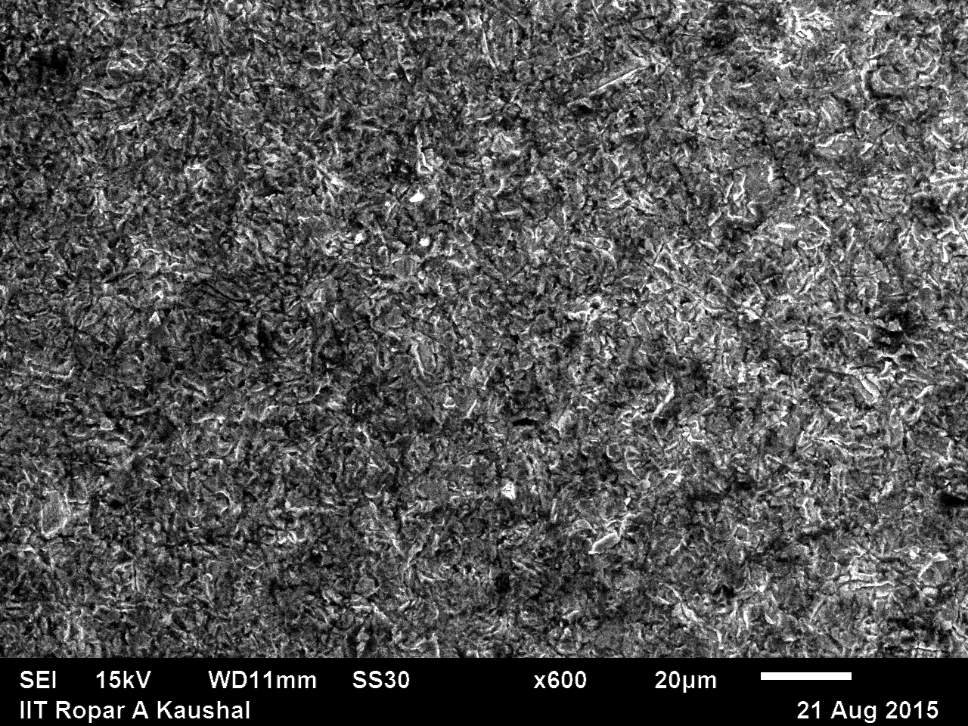
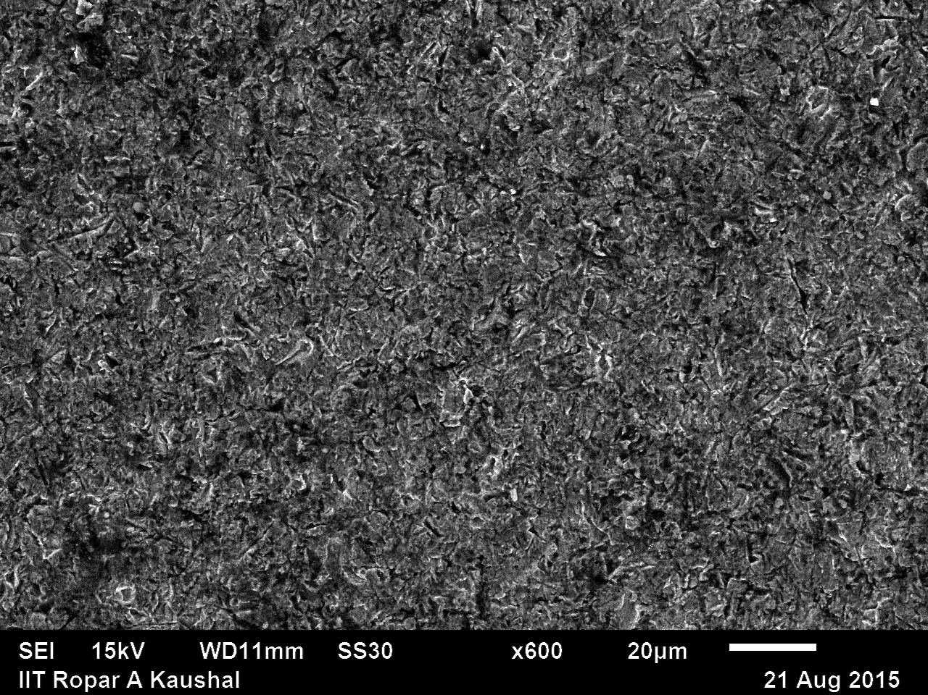
B
A

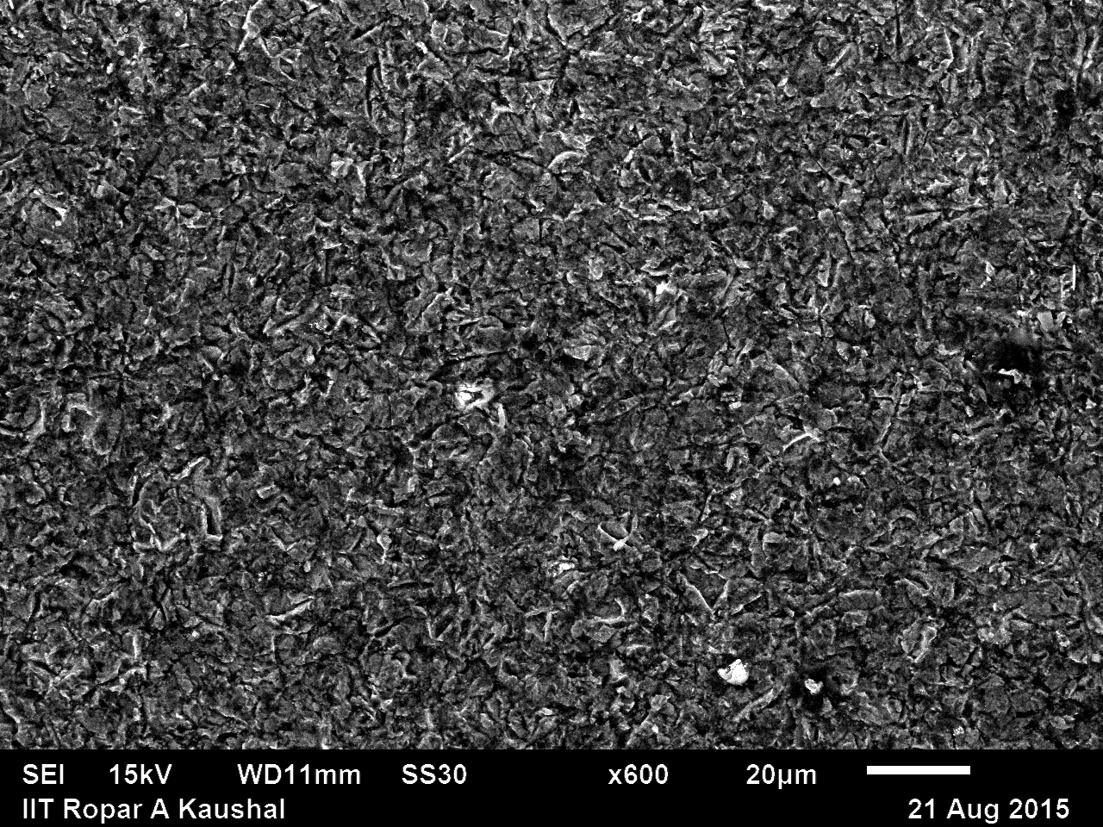
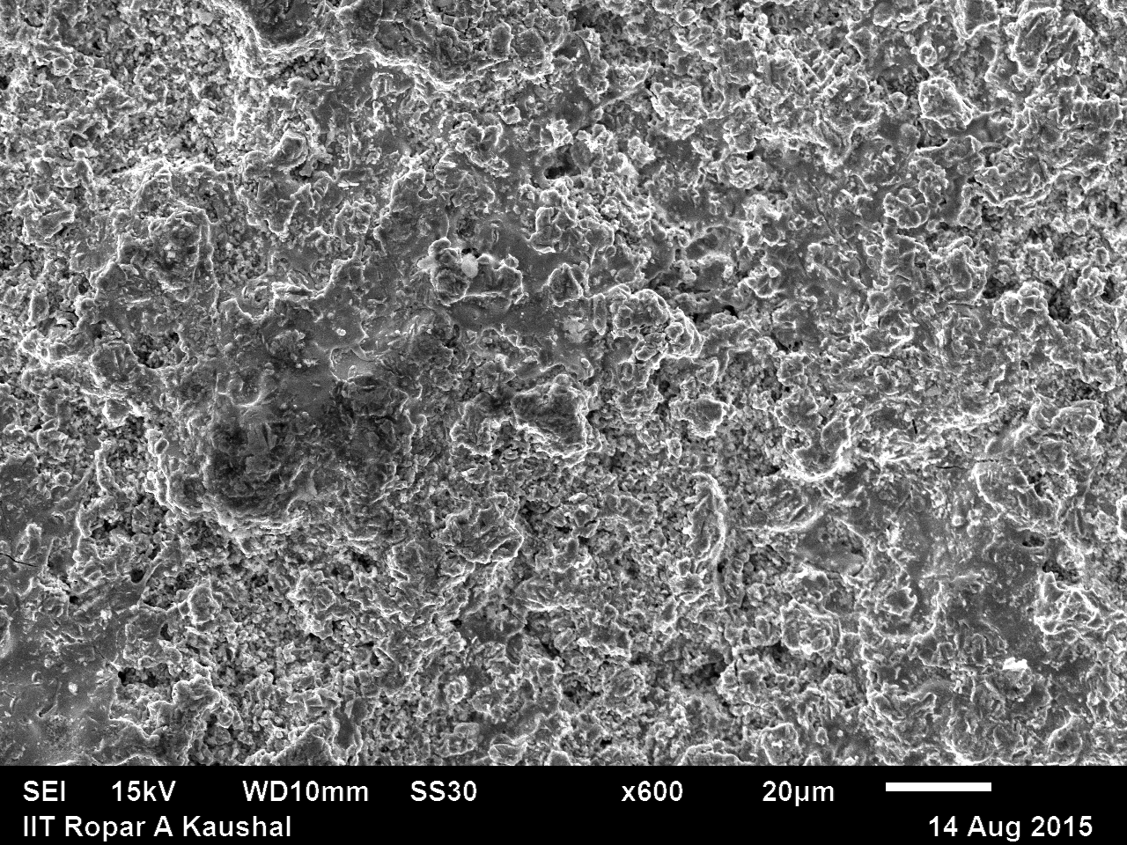

D
C

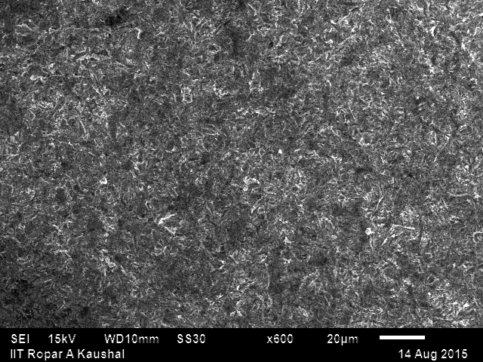
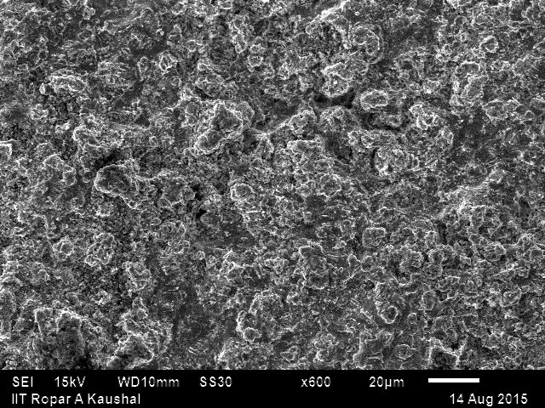

F
E

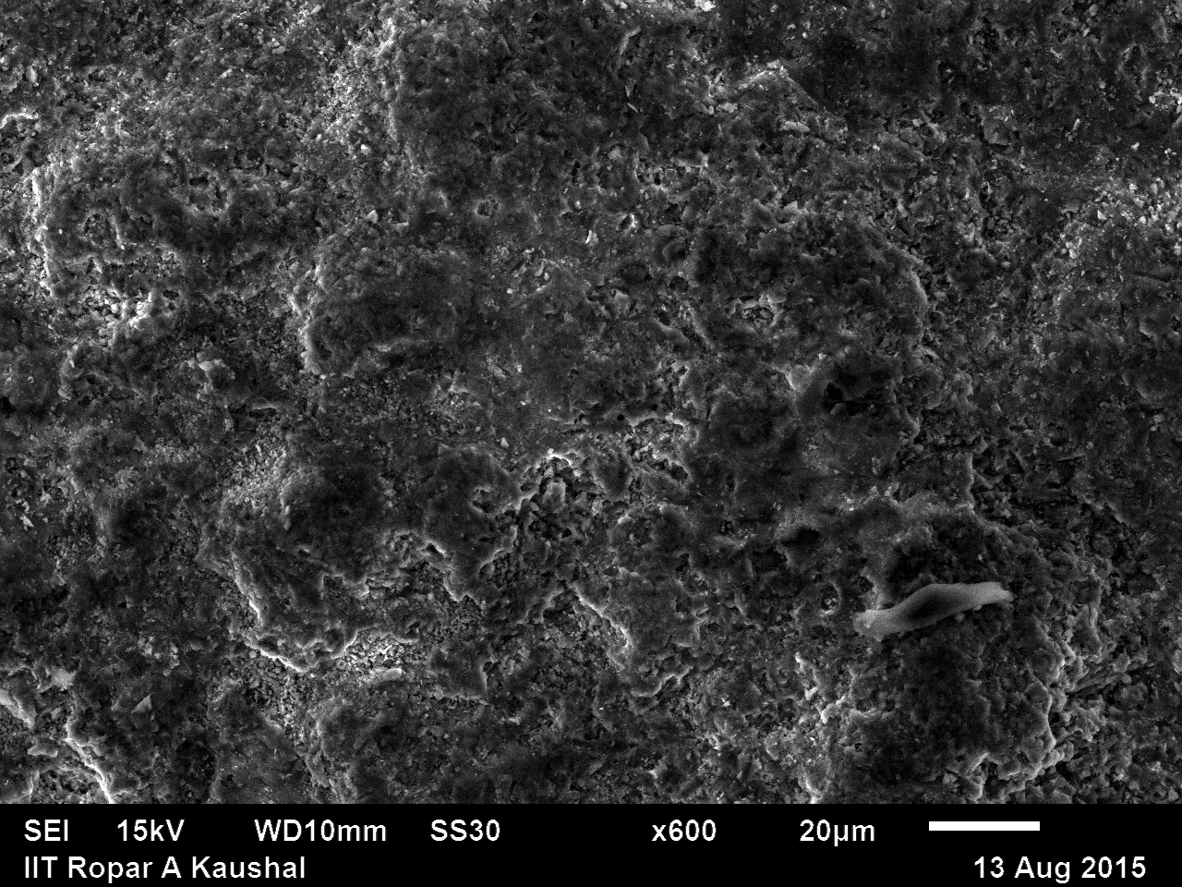
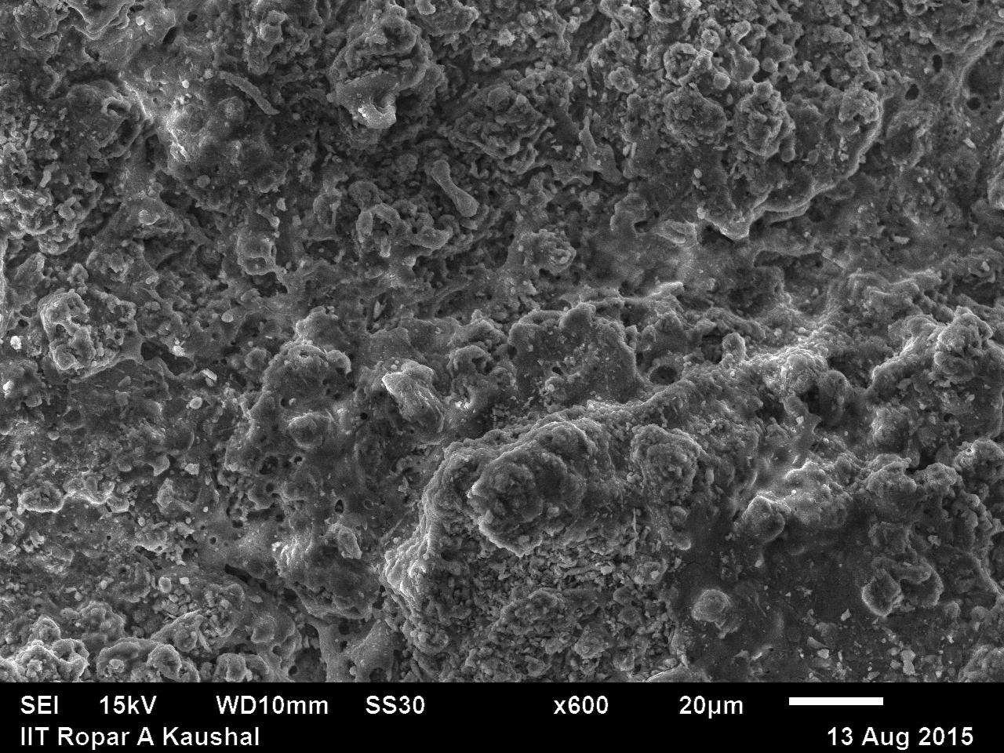

H
G

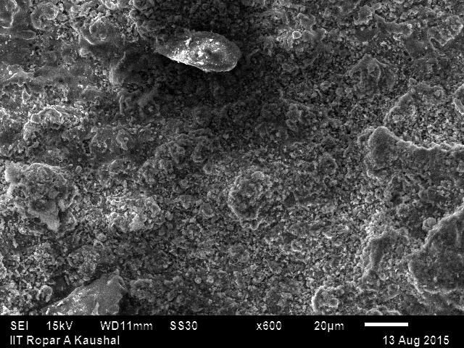

I

Figure2. : SEM Micrographs erode out uncoated Alloy Steel (CA6NM) material at (A) 45°,(B) 60°,(C)90°
SEM Micrographs erode out (Cr3C2–25NiCr) Powder coating at (D) 45°, (E) 60°, (F) 90°
SEM Micrographs erode out (Al₂O₃-13%TiO₂) Powder coating at (G) 45°, (H) 60°, (I) 90°

IV. Conclusion

- Erosion rate of 13Cr4Ni steel is found decreases with respect to increase impact angle.
- Cr3C2–25NiCr Coating show better performance than uncoated steel at 45°, 90° in which test was performed.
- Al₂O₃-13%TiO₂ Coating show worse performance than uncoated steel at all conditions in which test was performed.
- Cr3C2–25NiCr Coating show minimum erosion than Al₂O₃-13%TiO₂. The maximum erosion rate found with Al₂O₃-13%TiO₂.
- For uncoated 13Cr4Ni steel maximum erosion is at 60° impact angle and minimum at 90°.
- For both coating maximum erosion is at 60°.
- At higher angle 13Cr4Ni steel shows better performance but at higher angle Cr3C2–25NiCr shows a slightly better performance.
References

- Goyal, D.K., Kumar, H., Sahni, V. and Singh, H. (2012), “Slurry Erosion Behavior of HVOF Sprayed WC-10Co-4Cr and Al2O3+13TiO2 Coatings on a Turbine Steel”, Wear, Vol. 298, pp.46–57.

- Goel Akhilesh Chauhan., Prakash D.B. (2010) Erosive Wear of a surface coated hydrotubine steels. Bull. Mater. Sci., 33, 483-489.

- Mann B.S., Arya Vivek. (2001) Abrasive and erosive wear characteristics of plasma nitriding and HVOF coatings: their applications in hydro turbines. Wear, 249,354-360.

- J.G.A. Bitter, A study of erosion phenomena. Part II, Wear, vol. 6, pp.169–190, 1963.
- G.P. Tilly, W. Sage, The interaction of particle and material behaviour in erosion process, Wear, vol. 16, pp. 447–465, 1970.

- G. Sundararajan, Manish Roy, Solid particle erosion behaviour of metallicmaterials at room and elevated temperatures, Tribol. Int., vol. 30, pp. 339–359, 1997.

- Sidhu H S, Sidhu B S and Prakash S 2007 Surf. Coat. Technol. 202 232

- Celis, J. P., A systems approach to the tribological testing of coated materials. Surface and Coatings Technology, 1995, 74–75, 15–22.

- Celis, J. P., A systems approach to the tribological testing of coated materials. Surface and Coatings Technology, 1995, 74–75, 15–22.

- Leyland, A. and Matthews, A., Thick Ti/TiN multilayered coatings for abrasive and erosive wear resistance. Surface and Coatings Technology, 1994, 70, 19–25.

- Hazoor Singh Sidhu, Buta Singh Sidhu, S. Prakash, Solid particle erosion of HVOF sprayed NiCr and Stellite-6 coatings, Surface & Coatings Technology 202, 2007, pp. 232-238.

- Erosion behaviour of hydro turbine steels, Bull. Mater. Sci., Vol. 31, No. 2, April 2008, pp. 115–120. © Indian Academy of Sciences Akhilesh K Chauhan, D B Goel and Satya Prakash

- N.K. Rao and R. Chattopadhyay, Study of erosion of runner
blades in hydroturbine, Power India 88, New Delhi, October
1988.

