Title: Moisture Content to mitigate stiffness in modified collagen fibril structures
Susyn Kelly, BE(hons), Massey University, NZ

Abstract (300 word limit)
Skin derived collagen materials, such as leather, are required to be both flexible and strong to suit their function as garments and other hard wearing covers. The natural operating environment of skin is highly hydrated giving the tissue elasticity and suppleness. However, when the tissue is dehydrated to form products like leather, the material properties change to being stiffer. The mechanical properties of collagen are known to change with dehydration. Changes in water concentration result in structural changes in the collagen affecting its mechanical properties. Material strength depends in part on collagen fibril alignment; however leather produced by tanning under strain not only increases the fibril alignment but also leads to less flexible leather. The structural basis for flexibility in leather was investigated and the moisture content varied. Small angle X-ray scattering was used to determine collagen fibril orientation, D-spacing and intermolecular spacing conditioned at controlled relative humidity environments. Flexibility was measured by three point bend tests. Mechanical observations showed the relative fibril orientation to be a dominate feature in material stiffness but when moisture contents were increased so was the flexibility. Closer inspection of the leather structure as the moisture content increased showed the collagen fibrils to have larger intermolecular spacing, fibril diameters and D-spacing. It is suggested that the collagen fibrils are lubricated by water which gives them greater freedom of movement and therefore greater flexibility. Applying strain during tanning to increase the fibril alignment also increases the packing of the collagen molecules, reducing their ability to move relative to each other. This is mitigated to some extent with increasing moisture content. Our findings offer insights into how the moisture content of leather can be controlled to optimize properties in the final product.

Image
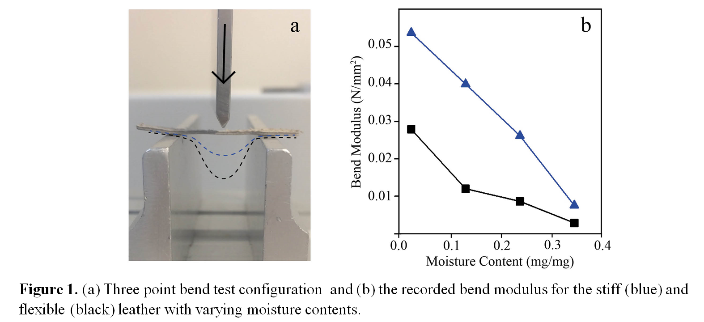
Recent Publications (minimum 5)
- Kelly, S., Edmonds, R., Cooper, S., Sizeland, K., Wells, H., Ryan, T., Kirby, N., Mudie S. and Haverkamp R., Mapping Tear Strength and Collagen Fibril Orientation in Bovine, Ovine and Cervine Hides and Skins. Journal of the American Leather Chemists Association, 2018. 103(1): p. 1-11.
- Kelly, S., P. Kelly, H. Wells, K. Sizeland, R Haverkamp, A. Armien, P. Bolfa, Corneal Epithelial Hyperplasia Combined with a Superficial Corneal Stromal Collagen Disorder as the Main Underlying Changes in Tropical Keratopathy (Florida Spots) in Cats. Journal of Comparative Pathology, 2018. 158: p. 95.
- Wells H., K. Sizeland, S. Kelly, M. Basil-Jones, R. Edmonds, R. Haverkamp, Fibril orientation and strength in collagen materials and adaptation to strain. Advanced Materials Letters, 2018. 9(6): p. 411-418.
- Kelly, S., Wells H., Sizeland K., Kirby N., Edmonds R., Ryan T., Hawley A., Mudie S., Haverkamp R., Artificially modified collagen fibril orientation affects leather tear strength. Journal of the Science of Food and Agriculture. 2017 Dec 30. doi: 10.1002/jsfa.8863.
- Sizeland, K; Wells, H; Kelly, S; Nesdale, K; May, B; Dempsey, S; Miller, C; Kirby, N; Hawley, A; Mudie, S; Ryan, T; Cookson, D; Haverkamp, R. Collagen Fibril Response to Strain in Scaffolds from Ovine Forestomach for Tissue Engineering. ACS Biomaterials Science & Engineering 2017 3 (10), 2524-2532.

Biography (150 word limit)
Susyn is a PhD student at Massey University in Palmerston North, New Zealand. Her thesis looks to investigate the nano-structural motifs of collagen in collagen based materials such as skins and the cornea. Her work builds upon key findings from the Haverkamp research group who has utilized the Australian Synchrotron to characterize collagen structures a range of collagen based materials at the nano-scale and there effect on physical characteristics
Email:S.Kelly2@massey.ac.nz
- Full Name: Susyn Joan Rosemarie Kelly
- Personal Email: S.Kelly2@massey.ac.nz
- Mobile Number: +64273798063
- Linked In: https://www.linkedin.com/in/susynkelly/
- Facebook:
- Session Name/ number: Material Structure Mechanics, Track 41-1
- Category: Oral presentation
- Date of Birth: 13 Dec 1989
- Postal Address: Massey University, School of Engineering and Advanced Technology, Private Bag 11 222
- Palmerston North, 4442, New Zealand

Notes or Comments:

