Nanoparticles for soft ferrites: influence on sintered microstructure
Carolina Clausell-Terol, Chemical Engineering Department. Jaume I University of Castellón, SPAIN
Antonio Barba-Juan, Chemical Engineering Department. Jaume I University of Castellón, SPAIN
Juan Carlos Jarque-Fonfría, Chemical Engineering Department. Jaume I University of Castellón, SPAIN
Luis Nuño-Fernández, Communications Department, Polytechnic University of Valencia, SPAIN

Abstract
Cu-doped NiZn ferrites are typical electromagnetic wave absorbers, which absorption capacity (calculated from experimental measures of complex permeability and complex permittivity, for a given frequency range) is related to thickness body and, especially and more critical, to its microstructure.
Ideal microstructure would consist of sintered bodies with no porosity, small average grain size and narrow grain size distribution. Moreover, the finer grain size the better absorption capacity. Literature shows that physical properties of ceramic bodies improve when particle-size distribution decreases from the microscale to the nanoscale.
Ferrites from nanoparticles have been sintered controlling average grain size and relative density with sintering temperature. Green microstructure has been set constant using uniaxial dry pressing at 200 MPa as the shaping method.
Sintered microstructure has been observed by Scanning Electron Microscopy (SEM), obtaining the average grain size by image analysis of the SEM micrographs. Relative density was determined by the Archimedes method, using true density material value. Magnetic permeability was measured in the frequency range from 1 MHz to 3 GHz by using an Agilent model E4991 ARF impedance analyzer with the 16454A test fixture, and this later parameter has been related to average grain size and relative density.
Finally, the results obtained from nanoparticulate ferrite powder have been compared with those previously obtained from microparticulate ferrite powders, noting an improvement in performance.

Aknowledgements
The study has been partially funded by the Spanish National Plan for Scientific Research, Development, and Technology Innovation of the Spanish Minister of Economy and Competitiveness (project MAT2016-76320-R) and the Jaume I University of Spain (project UJI-B2017-48).

Image
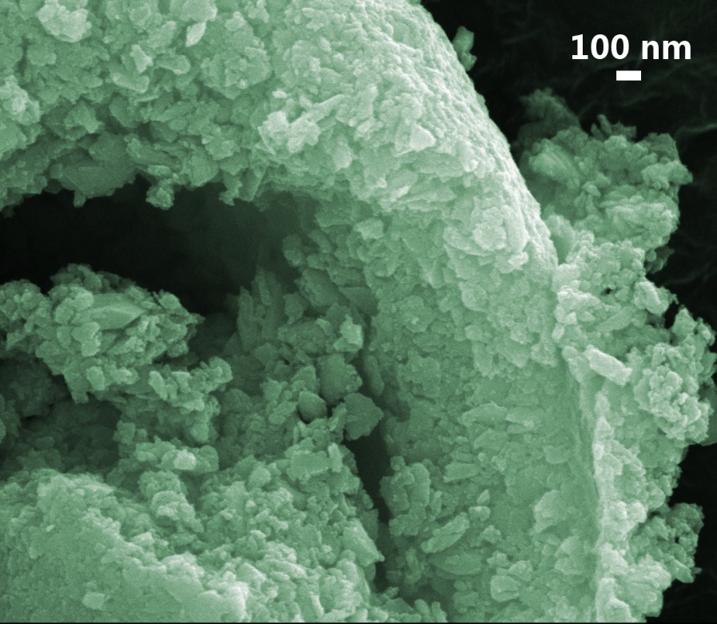 | 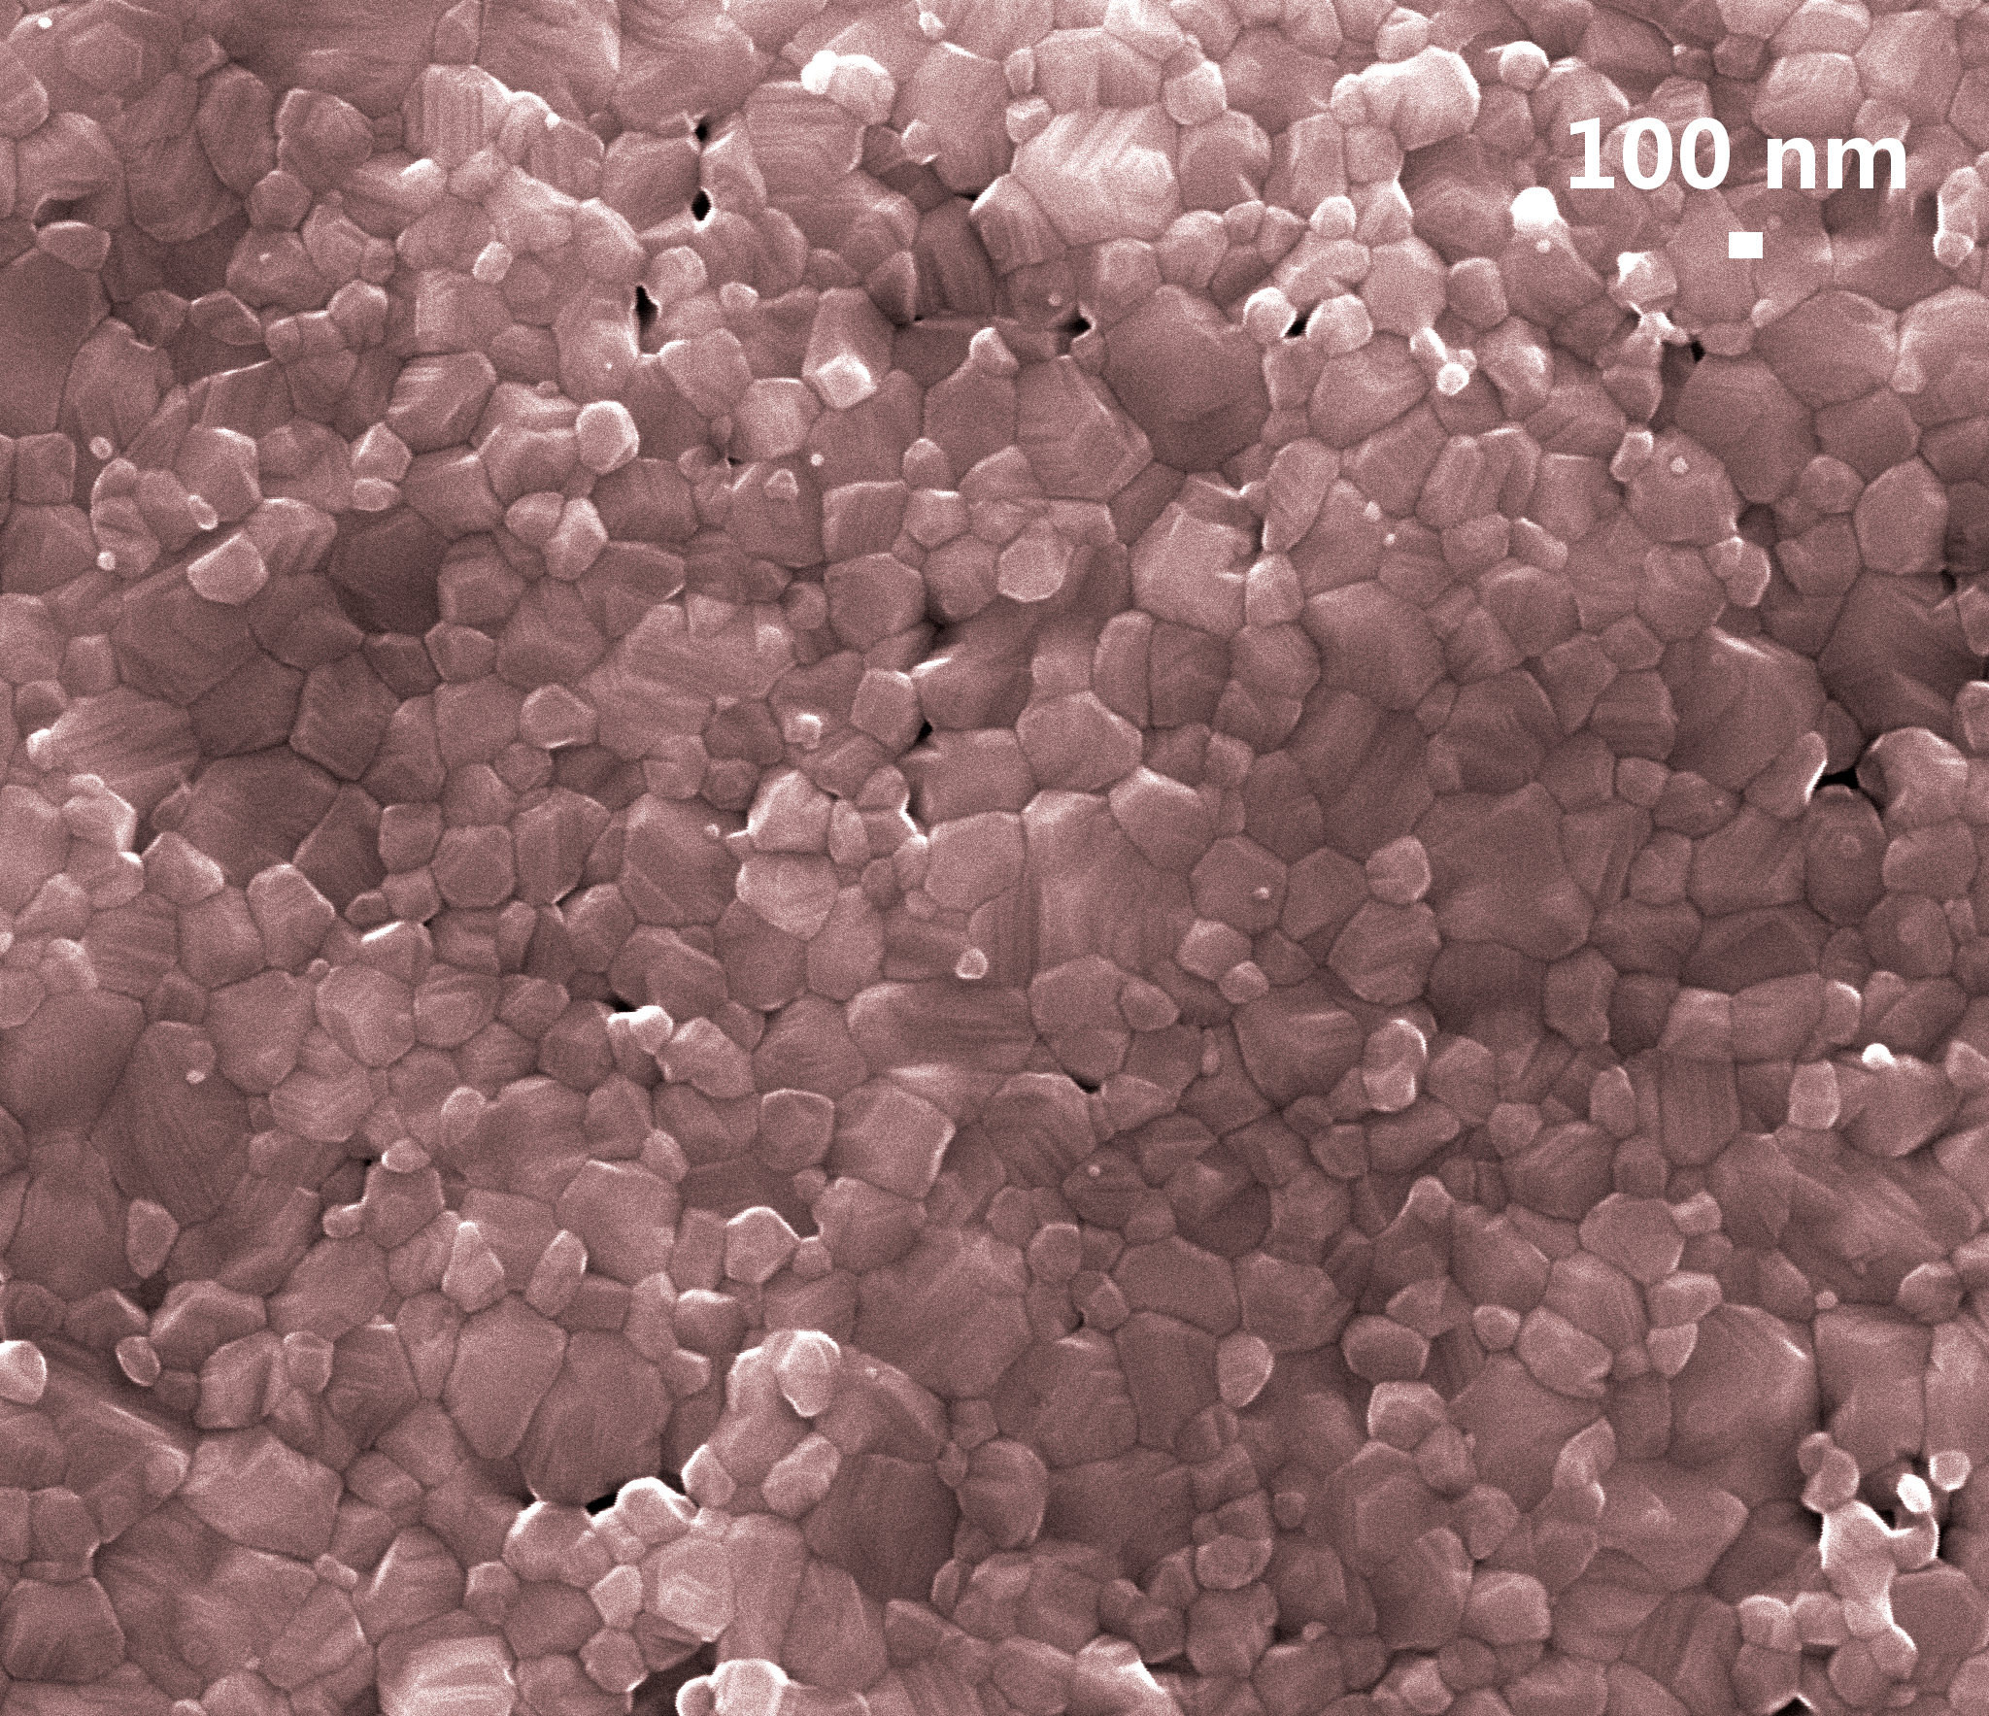
(a) | (b)
Figure 1. SEM micrographs of nanoparticles granules with an average particle size of 48 nm (a) and of sintered microstructure with an average grain size of 270 nm (b).

Recent Publications
- Clausell C, Barba A (2018) Processing–microstructure–properties relationshipin a CuNiZn ferrite. Boletín de la Sociedad Española de Carámica y Vidrio 56:29-39.
- Barba A, Clausell C, Nuño L, Jarque JC (2017) ZnO and CuO crystal precipitation in sintering Cu-doped Ni-Zn ferrites. II. Influence of sintering temperature and sintering time. Journal of the European Ceramic Society 37:169-177.
- Clausell C, Barba A, Nuño L, Jarque JC (2016) Electromagnetic properties of ferrite tile absorber as a function of compaction pressure. Ceramics International 42:17303-17309.
- Clausell C, Barba A, Nuño L, Jarque JC (2016) Effect of average grain size and sintered relative density on the imaginary part – μ″ of the complex magnetic permeability of (Cu_{0.12}Ni_{0.23}Zn_{0.65})Fe₂O₄ system. Ceramics International 42:4256-4261.
- Barba A, Clausell C, Jarque JC, Monzó M, (2012) Obtainment of nanoparticulate CuNiZn ferrite powder by high-energy milling. Journal of the Ceramic Society of Japan 120:311-316.

 Biography
PhD in Chemical Engineer in 2008 and MsC in Chemical Engineer in 1998, both from Jaume I University. Member of the “Ceramic Technology” research group since 1997 and, since 2012, teaching and research staff at the Chemical Engineering Department of this same university. Her research career is focused in the application of the chemical engineering principles to the ceramic materials production processes, which she develops at the research group and the department that she belongs to. Furthermore, she is a member of the collaborating research group “Chemistry of electromagnetic radiation processed materials” between the Jaume I University and the Spanish National Research Council (CSIC), through the Aragón Materials Science Institute (ICMA), called. She has collaborated in 38 research projects, funded by public institutions and private companies, resulting in 2 patents, numerous scientific articles in international journals of the ceramic materials field indexed in the Journal Citation Report and several contributions to national and international conferences of the same research field.
Email: cclausel@uji.es

Notes/Comments:

