Lipidic additives for polymeric materials
Benoit Briou, PhD, ICGM – UMR 5253, CNRS-UM-ENSCM, Montpellier, France
Sylvain Caillol, Dr., ICGM – UMR 5253, CNRS-UM-ENSCM, Montpellier, France
Jean-Jacques Robin, Prof, ICGM – UMR 5253, CNRS-UM-ENSCM, Montpellier, France
Vincent Lapinte, Dr., ICGM – UMR 5253, CNRS-UM-ENSCM, Montpellier, France

Abstract
Facing the toxicity of many plastics and the increasingly drastic regulations, many studies on novel additives, especially bio-based additives, for polymers are sought. Herein, we illustrated this keen interest with bio-based plasticizers and surfactants as alternatives to phthalate plasticizers and nonylphenol ethoxylated surfactants, respectively.
Poly(vinylchloride) (PVC) is one of the most attractive industrial plastics (biomedical, textile industry, plastic toys, packaging...) because available as rigid or soft materials. In the latter case, flexibility and processability come from a plasticizer-additive in high amount (30-50 %w/w). Nowadays, the most widespread plasticizers are the phthalates even if severe public health-care issues as reprotoxic and endocrine disruptor effects are attested. Most of phthalates will be banned by standards and regulations (Reach Annex XIV).
In our lab, two generations of phthalate-free plasticizers have been developed using green chemistry. Phosphonated lipids prove to be an efficient additive as primary plasticizers for PVC as well as flame retardants. Otherwise, cardanol-based plasticizers of PVC reach good PVC plasticizing properties and reveal no impact on environment and no endocrine perturbation activity. These results are attractive in order to replace phthalates in soft PVC formulation industry.
Among the nonionic surfactants, nonylphenol ethoxylated (NPE)s have widely demonstrated their efficiency even if a high toxicity to aquatic organisms was proved. Regarding the many sectors, including textile processing, pulp and paper processing, paints, resins and protective coatings, oil and gas recovery in which they were employed, substituents seem to be a major issue. It has been reported that the ethoxylation of cardanol, bio-sourced lipidic phenol, produced a nonionic surfactant characterized by a low biodegradability. Inspired by these results, we investigated a series of surfactants based on cardanol and polyoxazoline (POx) technology knowing the POx are well-known to be an alternative to PEG.

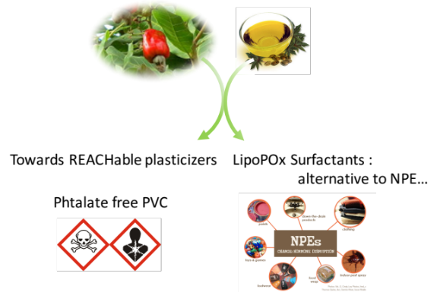
Figure 1: Bio-based additives looking in detail plasticizers and surfactants.
Recent Publications
- Bocqué M., Voirin C., Lapinte V., Caillol S., Robin J. J. (2016) Petro- and Bio-Based Plasticizers: Chemical Structures to Plasticizing Properties. Journal of Polymer Science Part A: Polymer Chemistry 54:11-33.
- Robin J. J., Lapinte V., Zitouni K., Chatillon M., Courault V., Bocqué M. (2016) Plastifiant Flame retardant based on biosourced phosphonated fatty esters. FR 16 62592.
- Giardi C., Lapinte V., Charnay C., Robin J.-J. (2009) Nonionic polyoxazoline surfactants based on renewable source: Synthesis, surface and bulk properties. Reactive and Functional Polymer 69:643-649.
- Stemmelen M., Lapinte V., Travelet C., Borsali R., Robin J.-J. (2013) Synthesis and self-assembling of amphiphilic polymers based on polyoxazoline and vegetable oil derivatives. Polymer Chemistry 4:1445-1458.
- Travelet C., Stemmelen M., Lapinte V., Robin J.-J., Dubreuil F., Borsali R. (2013) Amphiphilic copolymers based on polyoxazoline and grape seed vegetable oil derivatives: Self-assemblies and dynamic light scattering. Journal of Nanoparticle Research 15:1626-1641.
- El Asmar A., Gimello O., Morandi G., Le Cerf D., Lapinte V., Burel F. (2016) Tuning the thermo-sensitivity of micellar systems through a blending approach. Macromolecules 49:11:4307-4315.

 Biography
Vincent LAPINTE, assistant professor at the polymer department of the Institute of Materials Charles Gerhardt of Montpellier (ICGM-France). His area of expertise concerns the bio-based polymers especially peptides and pseudo-peptides such as polyoxazolines regarding synthesis and self-assembly aspects. Bio-based building blocks for polymers were also investigated. He has published more than 50 papers in reputed journals and 7 patents. He co-supervised 18 PhD and 12 post-doctorals.
Email: vincent.lapinte@umontpellier.fr
Notes/Comments:

