An Experimental Investigation of Combustion Synthesis of SiO₂ Nanoparticles Using the Inward Type Premixed Flame Burner
Pil Hyong Lee, PhD, Incheon National University, Korea
Chun Loon Cha, PhD Candidate, Incheon National University, Korea
Ho Yeon Lee, PhD Candidate, Incheon National University, Korea
Sang Soon Hwang, PhD, Incheon National University, Korea

Abstract
Silica (SiO2) nanoparticles are used as additives in plastics and rubbers to improve mechanical properties of elastomers, and in liquid system to improve the suspension behavior. In these applications, the particle morphology, average size, size distribution, and phase composition are considered as the key characteristics of powders that must be controlled.
Flame synthesis is widely used for the production of nanoparticles, as it readily offers the high temperature and oxidizing environment necessary for the growth of such particles. The combustion synthesis is an attractive technique, where particle size, and phase purity can be precisely controlled, along with the potential scale up for high throughput production, giving it an advantage over other methods such as wet chemical and chemical vapor deposition.
The objective of this experimental research was to investigate the synthesis of silicon dioxide nanoparticles using the inward type premixed burner effective to mass production of nanoparticles. In this study, the inward surface premixed flame was examined using a porous baffle plate and alloy metal foam. The results show that the surface and stable premixed flame can be generated by implementing the proper baffle plate and alloy metal foam. The inward surface premixed flame mode is changed into radiation flame, blue flame and lift off flame with decreasing equivalence ratio. The blue flame has a wide stability region and showed the lowest CO and NOx emission at low equivalence ratio. Through preliminary study using flat premixed flame burner it is found for silicon dioxide(SiO₂) nanoparticles to be generated using silane(SiH₄) as precursor. And surface premixed blue flame was retained to be very stable under precursor inlet velocity and silane concentration for synthesis of silicon dioxide nanoparticles.

Image
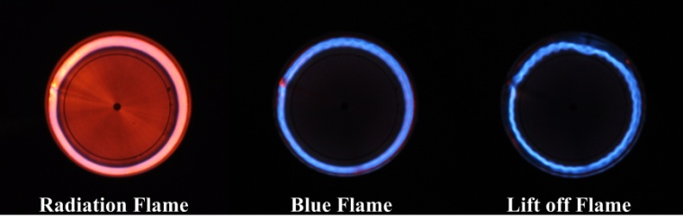
Fig.1. Comparison of flame patterns for synthesis of nanoparticles at different equivalence ratio at heating capacity 5000kcal/h
Recent Publications
- Lee PH, Hwang SS (2016) Superadiabatic flame for production of hydrogen rich gas from methane. International Journal of Hydrogen Energy 41:11801-11810.
- Lee PH, Hwang SS (2013) Formation of Lean Premixed Surface Flame Using Porous Baffle Plate and Flame Holder. Journal of Thermal Science and Technology 8:178-189.
- Lee JY, Lee PH, Park CS, Park BI, Hwang SS (2011) Combustion characteristics of mixture of anode off gas and LNG in reformer. International Journal of Hydrogen Energy 36:5181-5588.
- Hwang SS, Lee PH, Jo SH, Cha CL, Hong SW, Han SS (2012) Transient behavior of proton exchange membrane fuel cell under non-isothermal condition. Renewable Energy 42:54-59.
- Lee PH, Park BI, Hwang SS (2010) Three Dimensional Computational Study on Proton Exchange Membrane Fuel Cell by Operation Conditions. Journal of Thermal Science and Technology 5:178-188.

 Biography

Sang Soon Hwang is a professor at Incheon National University in Korea. Professor Hwang has his expertise and passion in combustion area. He graduated from Seoul National University and got a Master and Ph.D degree from Seoul National University. His early research focused on liquid fuel spray and internal combustion engine. He also participated in developing the engine at Hyundai Motor research center. After the inauguration of the professor, he expanded his research area to study not only combustion but also new energy and materials for example fuel cell and synthesis of nanoparticle materials.

Email: hwang@inu.ac.kr

Notes/Comments:

