Crystallography of the Corneal Nanonipple Structure on Butterfly Eyes
Uwe Erb and Ken C. Lee, Department of Materials Science and Engineering, University of Toronto, Toronto, Ontario, Canada

Abstract
One specific type of corneal nano-nipple arrays found on many insect compound eyes are hexagonally arranged protrusions in the shape of inverted paraboloids. Prior studies have focused on the anti-reflection properties of the eyes due to the nano-nipple structure [e.g. 1], which depends mainly on the shape of individual nipples. However, in the past little attention was given to the details of the arrangement of nano-nipples, which was qualitatively described as consisting of multiple domains. In the current study, remarkable defect structures were found through structural analysis using crystallographic principles.
The investigated species is the Mourning Cloak butterfly (Nymphalis antiopa), which is common in North America as well as Europe and Asia. On its corneas, nano-nipples are predominantly in 2-D hexagonal arrangement with an average diameter of 170 nm and an average lattice parameter of 205 nm [2]. An eye with 2 mm in diameter has approximately 10,000 ommatidia and 140 million nipples. However, within the hexagonal structure, there are nipples that deviate from the regular arrangement by having different numbers of nearest neighbours (NN); instead of 6 NN required by hexagonal symmetry, about 10% of nano-nipples have 5 or 7 NN and are described as 5- and 7-fold coordination defects (disclinations), respectively. Since the 5- and 7-fold disclinations usually occur adjacent to each other, they are collectively referred to as 5-7 defects (see image).

An individual 5-7 defect pair affects the nipple structure in a similar fashion as a dislocation in 2-D crystals. Furthermore, the 5-7 defects are not arranged randomly; instead, they show a strong preference to align in rows to divide the domains of nano-nipples like grain boundaries between crystals [2, 3]. The distribution of the domain sizes is log-normal, and analysis of the orientations of nipple domains indicate no preferred orientation. This intriguing structure will be discussed in reference to protrusion formation theories by i) microvilli secretion [4] and ii) reaction-diffusion controlled coating development [5], respectively. Finally, a comparison will be presented with similar structural defects found in man-made 2-D materials such as self-assembled monolayers or graphene.

Image
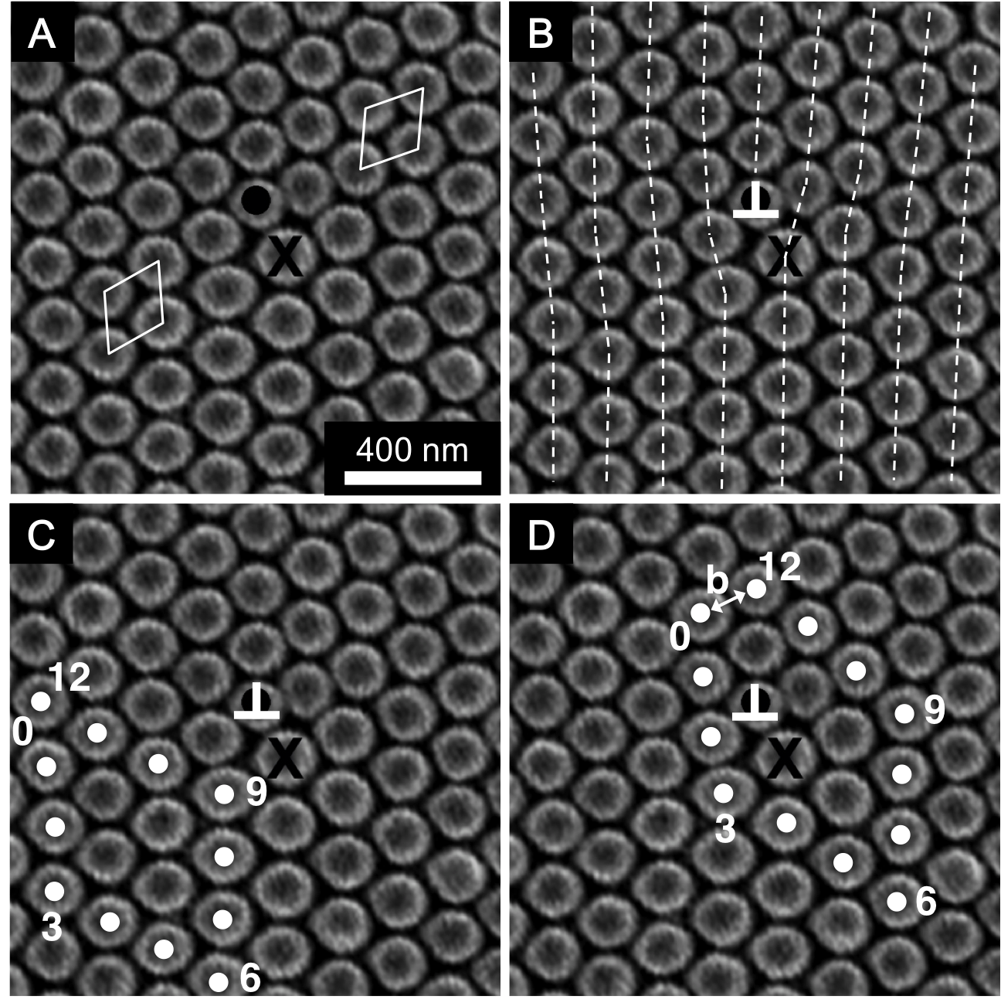
Recent Publications
- S. J. Wilson and M. C. Hutley, The Optical Properties of “Moth Eye” Antireflection Surfaces, Opt. Acta 29, 993 (1982).
- K. C. Lee and U. Erb, Remarkable Crystal and Defect Structures in Butterfly Eye Nano-nipple Arrays, Arthropod Struct. Dev. 44, 587 (2015).
- K. C. Lee, Qi Yu, U. Erb, Mesostructure of Ordered Corneal Nano-nipple Arrays, Scientific Reports | 6:28342 | (2016).
- G. Gemne, Ontogenesis of Corneal Surface Ultrastructure in Nocturnal Lepidoptera, Phil. Trans. Roy. Soc. Lond. B 262, 343 (1971).
- A. Blagodatski, A. Sergeev, M. Kryuchkov, Y. Lopatina, V. L. Katanaev, Diverse Set of Turing Nanopatterns Coat Corneae Across Insect Lineages, Proc. Natl. Acad. Sci. U. S. A. 112, 10750 (2015).



Biography:

Dr. Erb received his Ph.D. (1980) in Materials Science from the University of the Saarland (Germany). He currently is a Professor in Materials Science and Engineering at the University of Toronto. He is named as inventor on 18 patents related to the synthesis of nanostructured materials by electrochemical methods, and has authored about 250 scientific publications in the field of nanomaterials. Professor Erb and his research team were the first to synthesize fully dense nanostructured materials in 1985, and developed numerous industrial applications for these materials with various companies. More recently, Professor Erb’s research has been broadened to include bio-inspired nanostructures.

Email: uwe.erb@utoronto.ca

