Dynamic decellularization and recellularization of vascular grafts
Jana Zarubova¹, Roman Matejka^{1,2}, Marie Steinerova¹, Elena Filova¹, Lucie Bacakova¹
¹Department of Biomaterials and Tissue Engineering, Institute of Physiology of the Czech Academy of Sciences, Prague, Czech Republic
²Faculty of Biomedical Engineering, Czech Technical University in Prague, Kladno, Czech Republic

Abstract
Cardiovascular diseases are one of the leading causes of death worldwide [1]. A common treatment option to replace the diseased blood vessels is vascular grafting using patient’s own blood vessels. The availability of such grafts is however limited by the patient’s age or pathology. Artificial alternatives to the autologous grafts are currently made of relatively inert non-degradable materials such as expanded polytetrafluoroethylene and polyethylene terephthalate [2]. These polymers have been successfully used for the replacements of blood vessels with a high blood flow and an internal diameter larger than 6 mm. However, smaller-diameter grafts show very poor long-term patency, largely due to the thrombogenicity of the artificial surface under low flow conditions and intimal hyperplasia [3, 4]. Recently, decellularized tissues have emerged as promising scaffolds for constructing replacements of various tissues and organs. In this study, decellularization of porcine vessels in a perfusion dynamic system was examined and compared with the manual decellularization procedure. The composition of extracellular matrix proteins [5], structure and mechanical properties of decellularized vessels were tested and compared with native blood vessels. Decellularized scaffolds were then seeded with endothelial cells and adipose-derived stem cells and cultured in a bioreactor with defined shear stress in order to simulate physiological conditions in the body. It was shown that dynamic decellularization dramatically shortens the time needed for decellularization. It also enables standardization of the decellularization process resulting in a consistent scaffold material. Cultivation of recellularized vessels under dynamic conditions induces anti-thrombogenic phenotype in endothelial cells and improves cell adhesion and ingrowth into the scaffold.
This work was supported by the Grant Agency of the Czech Rep. (grant No. P108/12/G108), by the Technology Agency of the Czech Rep. (grant No.TA04011345), the Agency for Healthcare Research, Ministry of Health of the Czech Republic (grant No. 15-29153A) and by BIOCEV – Biotechnology and Biomedicine Centre of Academy of Sciences and Charles University (CZ.1.05/1.1.00.02.0109).

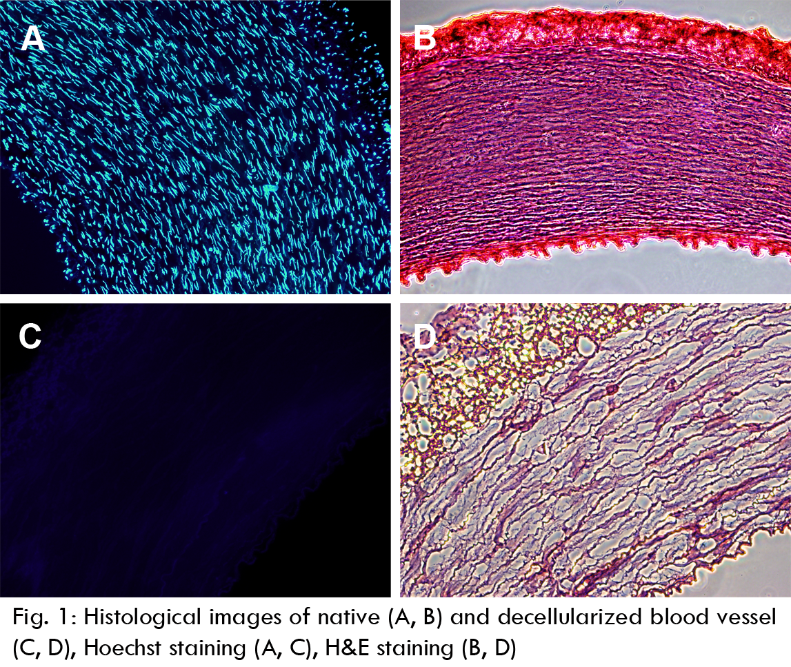
References
1. Mozaffarian, D., et al., Heart disease and stroke statistics--2015 update: a report from the American Heart Association. Circulation, 2015. 131(4): p. e29-322.
2. Chlupac, J., E. Filova, and L. Bacakova, Blood vessel replacement: 50 years of development and tissue engineering paradigms in vascular surgery. Physiol Res, 2009. 58 Suppl 2: p. S119-39.
3. Wang, X., et al., Development of small-diameter vascular grafts. World J Surg, 2007. 31(4): p. 682-9.
4. Catto, V., et al., Vascular Tissue Engineering: Recent Advances in Small Diameter Blood Vessel Regeneration. ISRN Vascular Medicine, 2014. 2014: p. 1-27.
5. Chlupac, J., et al., The gene expression of human endothelial cells is modulated by subendothelial extracellular matrix proteins: short-term response to laminar shear stress. Tissue Eng Part A, 2014. 20(15-16): p. 2253-64.

 Biography
Jana Zarubova gained her Ph.D. in Biochemistry from the Charles University in Prague. Her research focuses mainly on the design and biological evaluation of materials for vascular and bone tissue engineering. Jana Zarubova participates in the development of bioreactors for dynamic cell culture. She has long-term experience with mesenchymal stem cell culture, differentiation and their co-culture with different cell types. Jana Zarubova is also interested in the extracellular matrix and its influence on cell behavior.
Email: jana.zarubova@fgu.cas.cz

Notes/Comments

