Graphene/cement composite materials: Flexural strength and microstructure
Na Zhang, School of Materials Science and Technology, China University of Geosciences, Beijing, China

Abstract (300 word limit)

Cement, as the most commonly used building materials in civil engineering, plays an important role in building construction. However, because of its brittle characteristic and low strength against tension, it is difficult for them to meet some aspects of the engineering demands. With the development of nanotechnology and nonamaterials, the concept of introducing nanomaterials into composites has attracted more and more researchers’ interests to enhance the performance of composite materials. The purpose of this study is to discover the effect of graphene in the cementitious material and describe the interaction between graphene sheets and hydration products in the composite cement. The flexural strength and microstructure of graphene/cement composite materials were investigated in depth. Scanning electron microscopy (SEM) was adopted to observe the microstructure of graphene/cement composites. It was found that graphene can increase the flexural strength of cement mortars. The SEM images show that the hydration products such as ettringite and C-S-H gel can be connected with graphene sheets, which forms a 3-D structure that can bridge the cracks and fill the pores in cement matrix. With the increase of hydration ages, the 3-D structure becomes more complicated, and the connection between the graphene and hydration products of the cementitious materials becomes stronger. X-ray diffraction (XRD) quantitative analysis indicates that the amount of ettringite increases with the increasing of grapheme content, suggesting that graphene sheets are helpful to promote the formation of ettringite.

Image
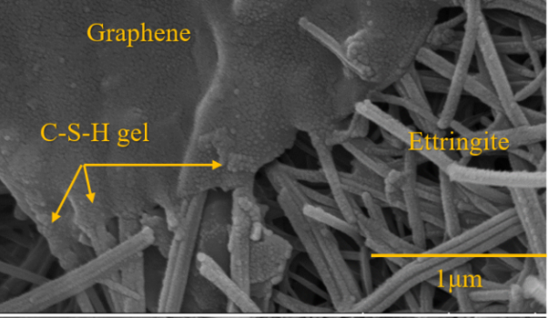
Figure 1: SEM image of the graphene/cement composite material
(showing the connection between graphene and hydration
products of cementitious materials)
Recent Publications (minimum 5)
- Zhang N, et al. (2016) Hydration characteristics and environmental friendly performance of a cementitious material composed of calcium silicate slag. Journal of Hazardous Materials 306: 67-76.
- Zhang N, et al. (2016) Hydration mechanism and leaching behavior of bauxite-calcination-method red mud-coal gangue based cementitious materials. Journal of Hazardous Materials 314: 172-180.
- Zhang N, et al. (2016) Properties evaluation of silica-alumina based concrete: Durability and environmental friendly performance. Construction and Building Materials 115: 105-113.
- Zhang N, et al. (2016) Hydration kinetics of cementitious materials composed of red mud and coal gangue. International Journal of Minerals, Metallurgy and Materials 23(10): 1215-1224.
5. Zhang N, et al. (2017) Electron probe microanalysis for revealing occurrence mode of scandium in Bayer red mud. Rare Metals 36(4): 295-303.

 Biography (150 word limit)
Na Zhang is an associate professor of China University of Geosciences, Beijing. She has her expertise in utilizing industrial solid wastes to prepare building and construction materials, and also introducing nanomaterials into the cementitious materials to enhance the performance of composite materials. So far, she has published 21 SCI papers in the related research field.
Email: nazhang@cugb.edu.cn
Phone: +86-136-8101-6619

Notes/Comments:

