Studying the mechanisms of the secondary phase precipitation in spark plasma sintered Duplex stainless steel
Olanipekun Ayorinde Tayo, Msc
Metallurgy Engineering Department, University of Johannesburg, South Africa

Abstract
Precipitated intermetallic secondary phases in duplex stainless steel can severely deteriorate the mechanical properties of duplex stainless steel. The problem can be handled by appropriate heat treatment. However, finding an optimal heat treatment routine can be challenging. Precipitation kinectics of secondary phase or intermetallics was studied on heat treated spark plasma sintered duplex stainless steel, subjected to solution treatment at 1050°C followed by water quenching. Etched sintered and solution treated samples were analysed by metallography examination, scanning Electron Microscopy, Electron backscattered diffraction(EBSD), optical microscopy, Transmission electron microscopy (TEM), X-ray diffraction(XRD) and evaluation of mechanical properties. Ferrite content of sintered and solution treated DSS were measured by Fischer ferritoscope. The microstructure of solution treated DSS revealed presence of more volume of ferrite grains than in sintered condition. It was observed also, that wear rates decreased as the percentage of sigma phase on the microstructure increases. The solution treatment result to increase in ferrite content and intermetallics is completely removed. The highest tensile strength of 610Mpa was observed in the spark plasma sintered duplex stainless steel while an increase in tensile strength of 702Mpa was observed after solution treatment.

Image

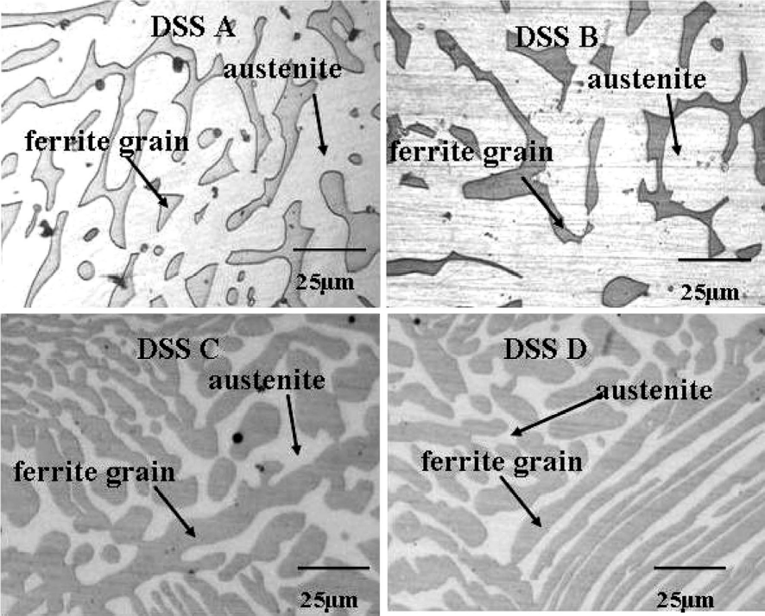

Fig. 10 Microstructure of solution treated spark plasma sintered

Recent Publications
1.Chandra, T. and Kuchlmayr, R. (1988) Effect of strain rate on sigma formation in ferrite-austenite stainless steel at high temperatures. Journal of
materials science, 23(2), pp. 723-728.

2.Chen, T., Weng, K. and Yang, J. (2002) The effect of high-temperature exposure on the microstructural stability and toughness property in a
2205 duplex stainless steel. Materials Science and Engineering: A, 338(1-2), pp. 259-270.

3.Dakhlaoui, R., Baczmański, A., Braham, C., Wroński, S., Wierzbanowski, K. and Oliver, E. (2006) Effect of residual stresses on individual phase
mechanical properties of austeno-ferritic duplex stainless steel. Acta materialia, 54(19), pp. 5027-5039.

4. Davanageri, M., Narendranath, S. and Kadoli, R. (2017) Influence of ageing time on hardness, microstructure and wear behaviour of AISI2507
super duplex stainless steel. Materials Research Express, 4(8), pp. 086506.

5. De Lacerda, J., Cândido, L. C. and Godefroid, L. B. (2015) Effect of volume fraction of phases and precipitates on the mechanical behavior of
UNS S31803 duplex stainless steel. International Journal of Fatigue, 74, pp. 81-87.microglia in various regions of human alcoholic brain”.
Experimental neurology 213:10-17.



Biography
I have expertise in Material science engineering, I apply the principle of physics and chemistry melding them in the process to the interrelationship between structure, properties and performance of complex materials with technological applications, and also putting to effective use design and simulation skills to address product development requirements more accurately and efficiently, while aiming to enhance the communication between experimental materials research and computational material science working on both existing and new advanced materials, their application leveraging on the proliferation of computing power as an enabling exciting new approach to simulate properties of new materials. Am currently having my Doctoral research Centre for Nanoengineering and Tribocorrosion
School of Mining, Metallurgy and Chemical Engineering University of Johannesburg

Email: 218079776@student.uj.ac.za
+27783847078

