ferromagnetism and spintronic devices based on van der Waals heterostructures
Lan Wang
School of Science, RMIT University, Melbourne, VIC 3000, Australia

Abstract (300 word limit)
Two dimensional (2D) van der Waals (vdW) materials, consisting of atomically thin layers, have fascinating physical properties and intriguing thickness-dependent characteristics. To date, research on these materials has predominantly focused on various devices based on their optical and electronic properties, whilst reports on magnetic and spintronic devices based on 2D vdW materials are scarce, because vdW materials with desirable magnetic properties have yet to be found. By performing anomalous Hall-effect transport measurements, we reveal that the magnetic properties of single crystalline vdW Fe₃GeTe₂ vary dramatically with thickness. Importantly, a single hard magnetic phase with a near square-shaped magnetic loop, large coercivity (up to 550 mT at 2 K) and strong perpendicular magnetic anisotropy were all observed in Fe₃GeTe₂ nanoflakes. These merits make Fe3GeTe2 the first vdW ferromagnetic material suitable for fabricating vdW magnetic heterostructures. Based on this material, various spintronic devices has been designed and fabricated.

References:
1. Cheng Tan etc., Nature Communicationsvolume 9, Article number: 1554 (2018)

Image
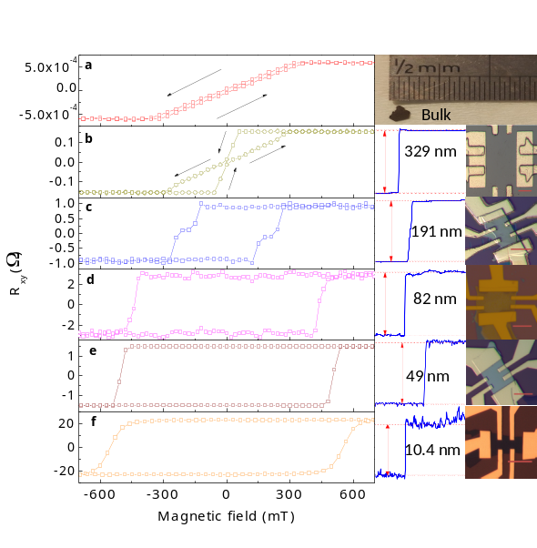

Lan Wang was awarded a PhD degree in Materials Sciences in 2006 at the University of Minnesota – Twin Cities. After the defence of Wang’s PhD thesis in Jan 2006, Wang became an Assistant Professor at Nanyang Technological University in Singapore. He was the Principle Investigator of the Magnetic Materials and Spintronics Lab for the whole period at Nanyang Technological University (from 2006 to 2014). Dr. Wang has published over 90 peer reviewed articles in prestigious journals, including Nature Communications, Physical Review Letters, Nano Letters, etc. In November 2014, he joined RMIT University as an Associate Professor of Physics in the School of Science. Lan Wang is now the Leader of theme B of the ARC CoE – Future Low Energy Electronics Technologies.

His research interests focus on various quantum materials, including topological insulators, 2D semiconductors, etc. The aims are to understand the fundamental physics of these novel materials and to fabricate the next generation prototype electronic and spintronic devices.
.
Email: lan.wang@rmit.edu.au

