Optimizing mechanical performance of biomimetic PE/TiO₂ nanolayered composites by tailoring thickness ratio
Bin Zhang and Yu-Jia Yang, Key Laboratory for Anisotropy and Texture of Materials, Ministry of Education, School of Materials Science and Engineering, Northeastern University, China
Guang-Ping Zhang, Shenyang National Laboratory for Materials Science, Institute of Metal Research, Chinese Academy of Sciences, China

Abstract (300 word limit)
Biological materials (such as bones or shells, etc.) with multiscale and hierarchical structures consisting of thick, hard inorganic mineral layers and thin, soft organic layers exhibit an excellent combination of strength and toughness. How to design and synthesize high performance bio-inspired materials has given rise to extensive attention based on mechanics principles learned from nature. In this talk, we will present a systematic investigation on synthesis and haracterization of mechanical performance of a bio-inspired (polyelectrolyte(PE)/TiO₂)n nanolayered composite (NLC) with different thickness ratios of TiO₂ to amorphous PE layers, which were synthesized by layer-by-layer self-assembly and chemical bath deposition methods. Microstructures of the nanolayered composite were investigated by scanning electron microscopy, secondary ion mass spectroscopy, and high-resolution transmission microscopy. Mechanical performance of the NLCs including strength, nominal fracture toughness and fatigue strength was examined by instrumented indentation and dynamic fatigue bending. The results show that mechanical properties of the bio-inspired NLCs can be optimized by tailoring the layer thickness ratio. Strengthening ability, cracking resistance and fatigue reliability of the biomimetic NLCs were discussed.
Image
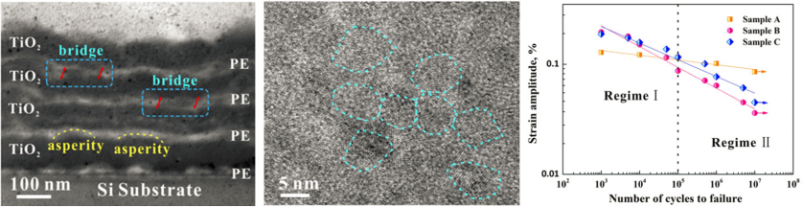
Figure 1 Microstructure and fatigue performance of the bio-inspired (PE/TiO₂)₄ nanolayered composite.

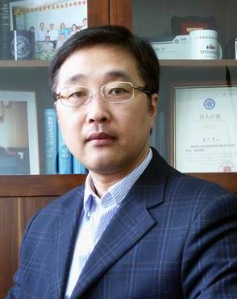 Biography (150 word limit)
Guang-Ping Zhang, a professor in Shenyang National Laboratory for Materials Science, Institute of Metal Research (IMR), Chinese Academy of Science. He got his Ph.D. degree from IMR in 1997. He was a JSPS postdoctoral in Tokyo Institute of Technology, Japan (1999-2001) and a visiting scientist in Max-Planck-Institut für Metallforchung, Germany (2002-2003). His research focuses on mechanical behavior, microstructure and reliability of materials at small scales, design and development of high-performance layer-structured composites, nanostructured surfaces and coatings inspired by length scale and interface, evaluation of microstructure degradation and fatigue/creep reliability of advanced engineering materials. He has published more than 130 peer-reviewed international journal articles, and 1 book chapters. He has delivered some invited talks internationally including GRC, MRS and TMS meetings, etc. He was granted 5 patents of invention.
Email: gpzhang@imr.ac.cn

Notes/Comments:

