Spiro[4H-pyran-3,3′-oxindoles] derived from 9,10-dihydroacridine
Mousa Alipour, Organic Chemistry PhD, Islamic Azad University, IRAN

Abstract (300 word limit)
Spiro compound is a bi- or polycyclic organic compound with rings connected orthogonally by one common atom. The rings can be different in nature or identical. The connecting atom is also called spiro atom or spiro carbon, most often a quaternary carbon.
Spirocyclic compounds have attracted considerable attention with regard to their biological activity, industrial, electronical and optical applications and the various approaches directed towards their synthesis. For example, chiral spirooxindoles are a class of important lead compounds for a variety of biologically active molecules. Spiro-linked aryl systems have been used as blue-emitting materials in OLEDs. Optical ampliﬁcation experiments for thin ﬁlms of spiro-linked oligophenyls have been reported. Due to the far-blue emission spectrum of oligophenyls, they can be used as blue electroluminescent emitters.
Due to the various applications of spirocompounds, in the present work, N-phenyl anthranilic acid was synthesized from readily available 2-chloro benzoic acid and aniline, and followed by cyclization to acridone under acidic condition. Acridone was reduced to acridan with Na in 1-butanol. Reaction of acridan with oxalyl chloride in two steps produced the base dione. One pot reaction of the dione with 1,3-dicarbonyl compounds such as dimedone and malononitrile or ethyl cyano acetate in the presence of triethylamine or copper ferrite as cathalyst produced the corresponding new spirocyclic compounds.

Image
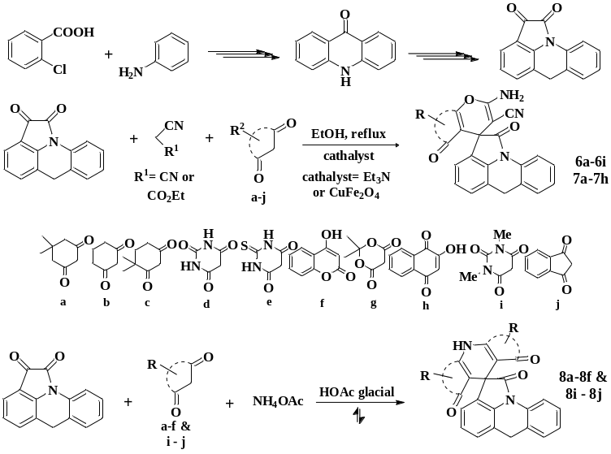
Recent Publications (minimum 5)
- Salbeck J, Schörner M, Fuhrmann T (2002) Thin Solid Films 417:20.
- R. Pudzich · T. Fuhrmann-Lieker · J. Salbeck (2006) Adv Polym Sci (2006) 199: 83–142.
- Manfred Braun, Anahita Hessamian-Alinejad, Boris Féaux de Lacroix, Birte Hernandez Alvarez, and Gunter Fischer (2008) Novel Spiroannulated 3-Benzofuranones. Synthesis and Inhibition of the Human Peptidyl Prolyl cis/trans Isomerase Pin1. Molecules 13, 995-1003.
- Jia Liu, Yulong Sun, Xuehong Zhang, Xiaolei Liang, Yanjing Wu, Yiqing Wang, Xianxing Jiang (2014) doi: 10.14800/ics.372
- Bahman Ebrahimi Saatluo, Mehdi M. Baradarani, Ewa Różycka-Sokołowska, Piotr Bałczewski, and John A. Joule (2017) Spiro[4H-2,3-dihydropyran-3,30-oxindoles] derived from 1,2,3,4-tetrahydroquinoline. Journal of Heterocyclic Chemistry. DOI 10.1002/jhet.3030

 Biography (150 word limit)
Paste your Logo here
Mousa Alipour is currently Assistant Professor of Organic Chemistry at Islamic Azad University of IRAN. He earned his B.Sc. in pure chemistry at Tabriz University, in 1996, and his M.Sc. in polymer synthesis from the same university in 1997. He graduated from PhD in organic chemistry from the Urmia University of IRAN in 2017 under supervision of Professor M. M. Baradarani. His thesis work was about the synthesis of spirocyclic compounds.
.
Email: moussaalipour@gmail.com

Notes/Comments:
Presenting author details
Full name: Mousa Alipour
Contact number:00989144143115
Twitter account:
Linked In account: linkedin.com/in/mousa-alipour-b1641440
Session name/ number:
Category: (Oral presentation/ Poster presentation)

