
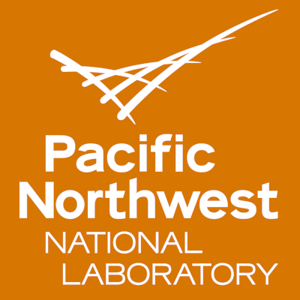

Title: Rugged Nanoparticle Tracers for Mass Tracking in Explosive Events
Name: Ryan Sumner

Pacific Northwest National Laboratory, WA 99354, USA

Tracing the flow of solid matter during an explosion requires a rugged tag that can be measured by a unique, identifiable signature. Small semiconductors coined “Quantum Dots” provide a unique tunable photoluminscent signature that can be tuned by the material’s composition and core/shell thickness. The particles can be ruggedized by the growth of a silica surface around the quantum dots (QDs) that acts as a sacrificial layer during finite periods of elevated temperatures and pressures. Incorporating the QDs into a matrix allows for identification of the debris by its’ unique photoluminescence.
Five different types of zinc sulfide QDs were synthesized and encapsulated in silica shells. The silica shelled QDs were covalently bound to an inexpensive commercially available luminescent powder. The combination of 5 dots and 5 powders enables a matrix of 25 unique pigments that fluoresce at different excitations wavelengths. These pigments can be applied for mass tracking and model conformation. The use of commercial luminescent powder with the QDs allows for field identification and laboratory conformation.
The QD bound powders were suspended in a hydrated silica gel pending incorporation into temperature resistant paints, synthetic stone, and controlled porous glass. The incorporation of temperature resistant QD bound powders has enabled unique identifiers, which allows for the tracking of mass through explosive events and other inaccessible environments.

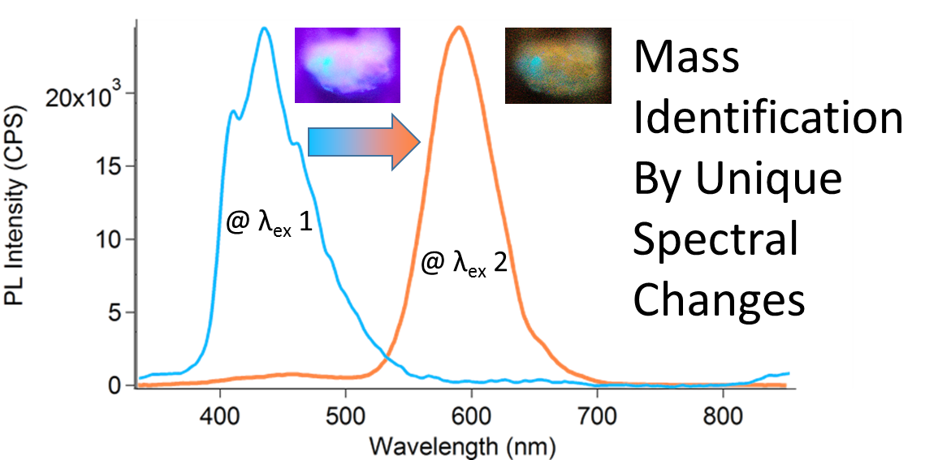

Biography

Ryan Sumner has completed his M.Sc. and B.S. in Chemistry from Western Washington University. He is currently a staff materials/analytical scientist at Pacific Northwest National Laboratory focusing on nanomaterial fabrication/integration, method development, and instrumentation. He has papers related to nanomaterial integration for renewable energies. Current research includes studies on nanoparticles for mass tracking, isolation of individual isotopes via mass-spec, and development of radiochemical separations.

