Colorimetric contact lens type sensor consisting of cerium oxide nanoparticles and glucose oxidase for tear glucose detection
Sijin Park, Woo Ri Bae, Dong Yun Lee*
Department of Bioengineering, College of Engineering, and BK21 PLUS Future Biopharmaceutical Human Resource Training and Research Team, Hanyang University, Seoul 133-791, Republic of Korea
*Corresponding author: dongyunlee@hanyang.ac.

Abstract (300 word limit)
A contact lens is ideal to monitor glucose levels in tear. We designed a contact lens-based biosensor comprised of glucose oxidase (GOX) and cerium oxide nanoparticle (CNP) to detect glucose levels in tear. GOX catalyzes the oxidation of glucose to hydrogen peroxide (H₂O₂) and gluconolactone. Then, CNP catalyzes the reduction of H₂O₂. At this moment, Ce³⁺ being colorless shift to Ce⁴⁺ state that is shown yellow color. Glucose levels can be determined by analyzing the change of color. B value of RGB color is used to determine glucose levels, being shown the correlation with glucose concentration. To confirm the synthesized CNP structure, we perform the XPS, XRD, HR-TEM. GOX is immobilized on a modified-CNP using PEG spacer; it is CNP-PEG-GOX. The formation of CNP-PEG-GOX is determine via quantitative analysis of GOX. The contact lens sensor maintains its mechanical properties compared with HEMA contact lens. and has correlation with glucose levels in buffer and artificial tear.

Image
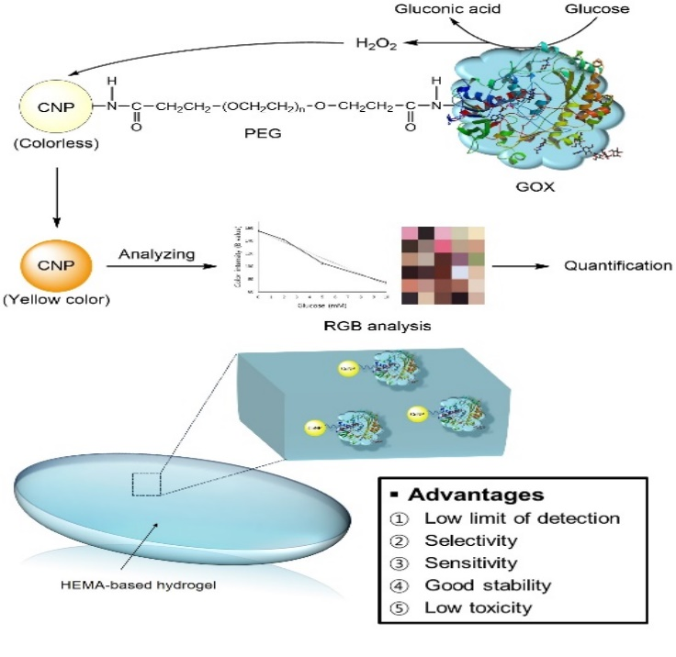
Recent Publications (minimum 5)
- Sijin Park, Dong Yun Lee (2017) The anterior chamber of the eye as a site for pancreatic islet transplantation. Journal of Industrial and Engineering Chemistry 50:29-35.

Biography (150 word limit)
Sijin Park graduated from Hanyang University, Department of Bioengineering at the age of 24, and progressed to master’s course. She is mainly working on diabetes. In particularly, she studies the development of glucose sensors for the management of blood glucose in diabetic patients. She has identified the disadvantages of the Fingerprick test, which is currently the most commonly used method, and invented a breakthrough method to overcome the drawbacks. Instead of measuring blood in the fingertips, she has developed a method for sensing blood glucose non-invasively through glucose concentration in the tear.
Email: santiagom@naver.com

Notes/Comments:

