High performance carbon supercapacitor electrodes derived from a triazine-based covalent organic polymer

Minjae Kim, Seokhoon Jang, Eunbeen Na and Sang Eun Shim*

Department of Chemistry & Chemical Engineering, Inha University 100 Inharo, Namgu, Incheon 402-751, Republic of Korea

Abstract (300 word limit)

Highly microporous carbon materials were produced by carbonization of a triazine-based covalent organic polymer (COP) followed by carbonization and CO₂ physical activation. The N-containing porous COP was prepared from easily available economic monomer precursors via a simple Friedel-Crafts reaction, which produced a predominantly microporous structure with a high surface area. Carbonization at 600−900 °C produced predominantly microporous carbons with a narrow pore size distribution in the range of 0.5−1.5 nm. Upon further activation using CO₂, more micropores were formed, accompanied by an increase in the surface area (to 2003 m² g⁻¹) and the nitrogen level in the carbon structure was maintained at ca. 2 wt.%. The electrochemical properties of the samples were measured by employing a three-electrode system with 6 M KOH electrolyte. Among the prepared carbon samples, the electrode fabricated using the carbon activated at 900 °C (AC-900) had a specific capacitance of 278 F g⁻¹ at a current density of 1 A g⁻¹, which is significantly higher than that of a commercial activated carbon (130 F g⁻¹) and ranks among the highest reported so far. This improved performance was attributed to the highly microporous structure of the nitrogen-doped carbon with a narrow pore size distribution.

Image

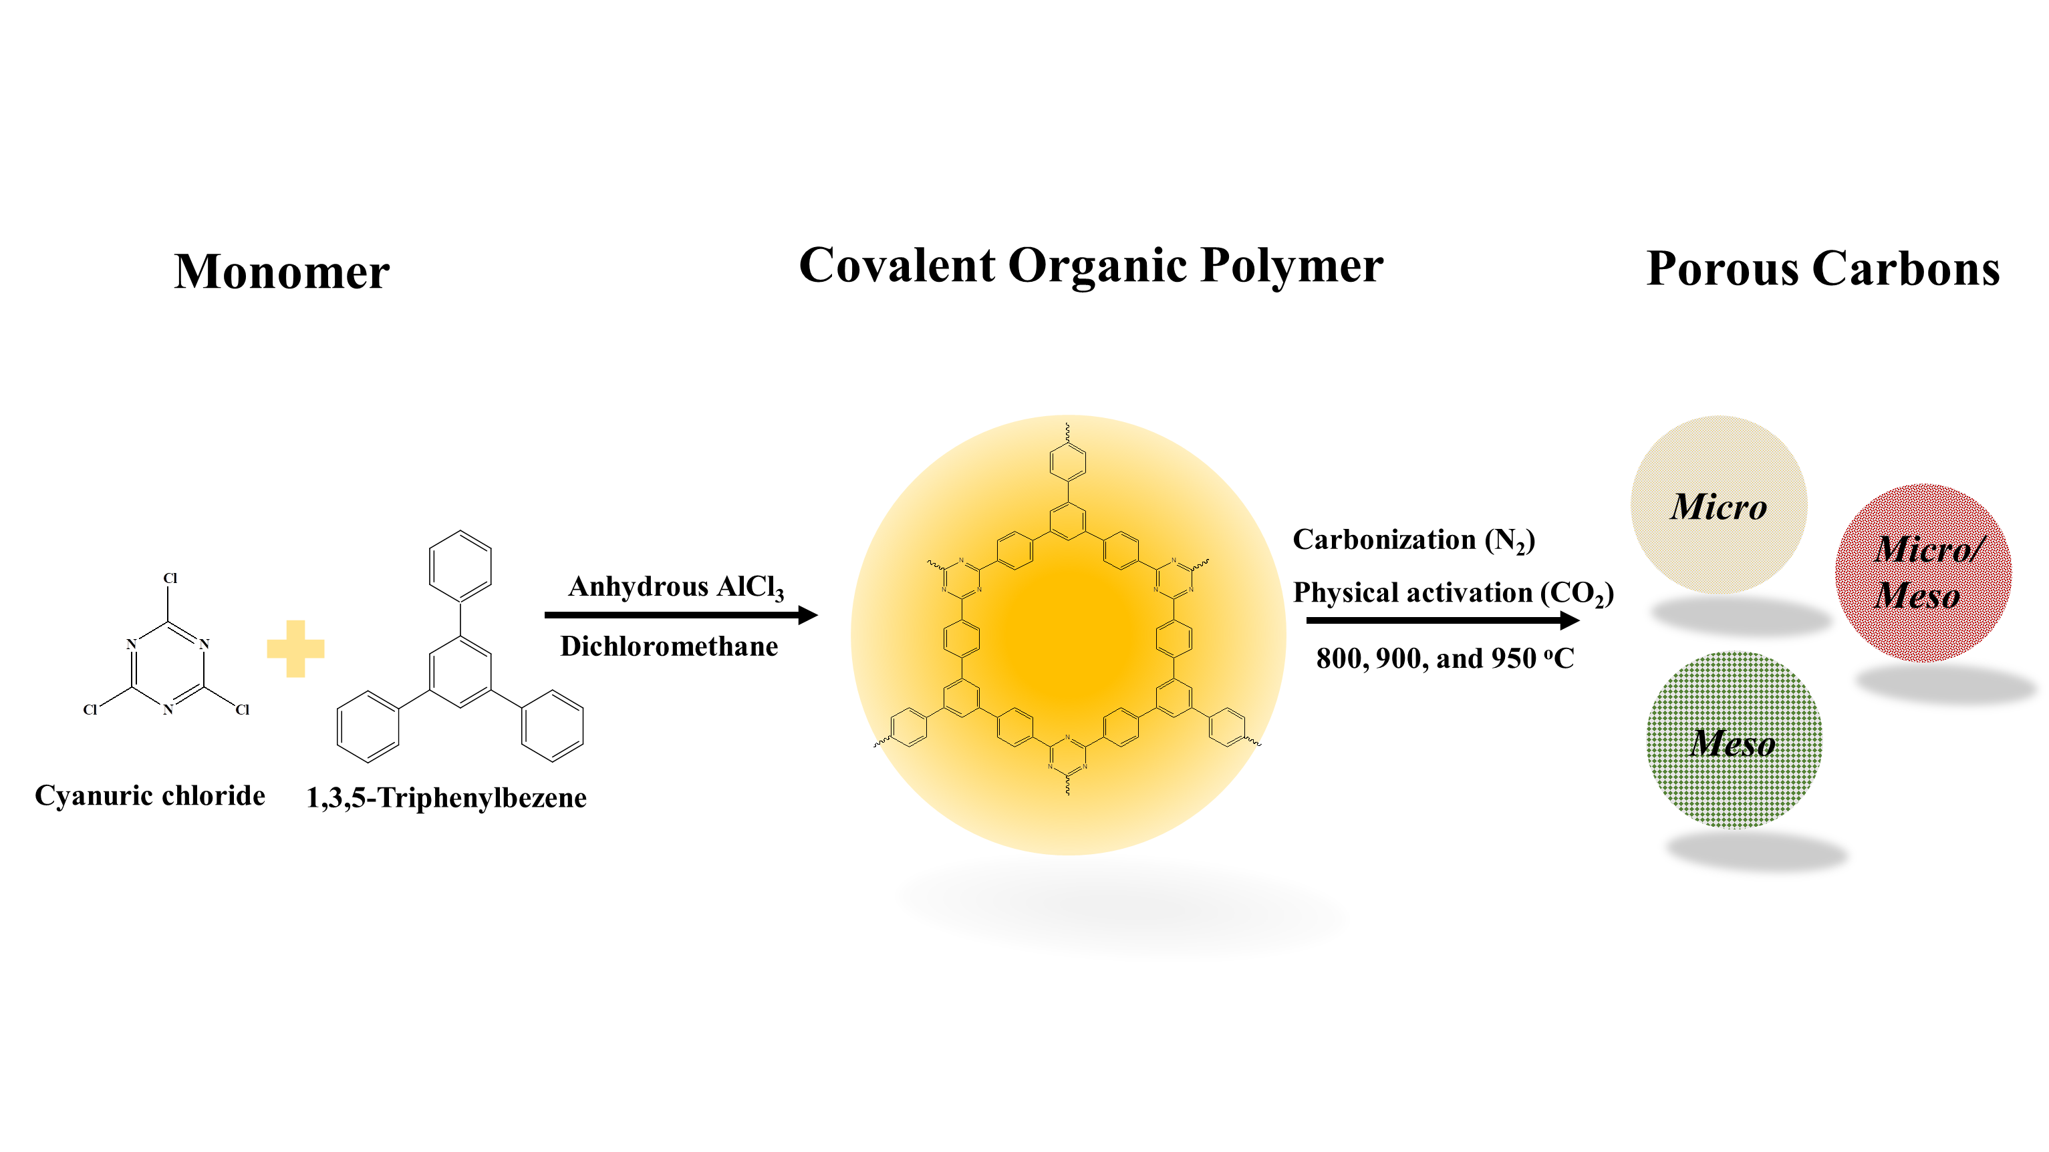
Figure 1. Schematic illustration for the fabrication of porous carbons derived from a triazine-based polymer.

Recent Publications (minimum 5)
- M. Kim, Y. Kim, K. M. Lee, S. Y. Jeong, E. Lee, S. H. Baeck, S. E. Shim (2015) Electrochemical improvement due to alignment of carbon nanofibers fabricated by electrospinning as an electrode for supercapacitor. Carbon 99:607-618.
- Y. Kim, Y. Qian, M. Kim, J. Ju, S.-H. Baeck, S. E. Shim (2017), A one-step process employing various amphiphiles for an electrically insulating silica coating on graphite. RSC Advances 7:24242-24254.
- K. Zin, M. Kim, E. Lee, G. Lee. S. H. Baeck, S. E. Shim (2017), Biodegradable polymer-modified graphene/polyaniline electrodes for supercapacitors. Synth. Met. 227:61-70.
- E. Lee, M. Kim, J. Ju, S. Jang. S. H. Baeck, S. E. Shim (2017), The electrochemical enhancement due to the aligned structural effect of carbon nanofibers in a supercapacitor electrode. Synth. Met.
365: 519-530.
5. K. M. Lee, M. Kim, E. Lee, S. H. Baeck, S. E. Shim (2016), Nylon 6,6/Polyaniline Based Sheath Nanofibers for High-Performance Supercapacitors. Electrochim. Acta 213:124-131.

Biography (150 word limit)
Minjae Kim was born on October 10, 1984 in Seoul, Korea. During his childhood, he grew up and matched the children of his peers. From junior high to high school, he was absorbed in American rock music, went into the band and played guitar and singing. In March 2003, he entered the Department of Chemical and Biomolecular Engineering at Inha University and met with Professor Sang-Eun Sang and graduated from Chemical Engineering and went on to graduate school. After graduation, in January 2012, he was involved in business development at the LG Hausys Technical Strategy Team, and then again as a Ph.D. in Chemical Engineering at Inha University. We have synthesized polymer-based carbon materials and applied them to the field of energy storage. Currently, he is studying post-doctoral programs at Inha University.
Email: upspine@gmail.com

Notes/Comments:

