Transport Properties of II-VI Semiconductor (CdSe/CdTe) Nanoparticles
Sayantani Das, PhD Student, Department of Physics, University of Calcutta, 92, A.P.C Road, Kolkata-700009, India
S. Banerjee, PhD, Department of Physics, University of Calcutta, 92, A.P.C Road, Kolkata-700009, India
T. P. Sinha, PhD, Department of Physics, Bose Institute, 93/1, A. P. C. Road, Kolkata-700009, India

Abstract (300 word limit)
Cadmium selenide and cadmium telluride (CdSe/CdTe) are the interesting members of the II-VI semiconductor family due to their high photosensitivity and suitable band gap (~ 1.74 eV and 1.35 eV at 300 K respectively) [1-3]. In this work we have studied the structural and transport properties of CdSe/CdTe nanoparticles prepared by soft chemical route. The x-ray diffraction (XRD) pattern indicates the cubic structure of the synthesized materials. The average crystallite size of the nanoparticles is obtained from XRD pattern using Debye-Scherrer formula. We have carried out the transmission electron microscope (TEM) shown in Fig. 1 to find out the shape and size of the synthesized nanoparticles. Impedance spectroscopy is applied to investigate the dielectric relaxation of the sample in a temperature range from 323 to 473 K and in a frequency range from 42 Hz to 1.1 MHz. The complex impedance plane plot has been analyzed by an equivalent circuit consisting of two serially connected R-CPE units, each containing a resistance and a constant phase element. We have adopted the complex modulus formalism and impedance formalism to investigate the relaxation mechanism in CdSe. All the peaks shift to higher frequencies as the temperature is increased and show the thermally activated nature of the relaxation time. The frequency dependent conductivity spectra are found to obey the power law. The Raman spectrum is analyzed to obtain the 1st and 2nd order phonon modes (longitudinal optical, transverse optical modes) of the sample. Raman spectrum of the sample is taken in the range of 80-500 cm-1. The spectrum exhibits a number of deconvulated peaks along with the main peaks. The sum of 9 Lorentzian peaks is used to fit the Raman spectrum.
Keywords: Semiconductor, Nanoparticles, Electron microscopy, Raman spectra.

Image
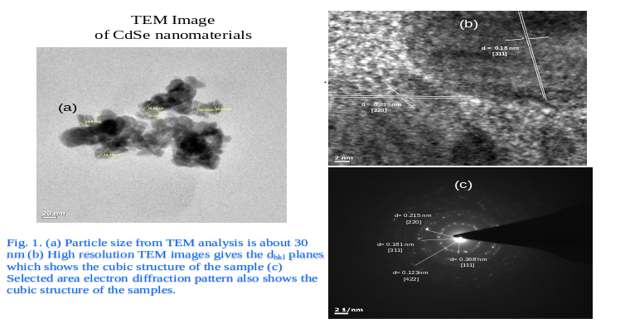
Recent Publications
- Das S, Dutta A, Banerjee S, Sinha TP (2014) Phonon modes and activation energy of Fe-doped CdSe nanoparticles. Materials Science in Semiconductor Processing 18:152-159.
- Das S, Dutta A, Banerjee S, Ghosg B, Sinha TP (2014) Dielectric Relaxation of CdSe Nanoparticles. Journal of Physics and Chemistry of Solids 75:1245-1251.
- Das S, Dutta A, Banerjee S, Sinha TP (2015) Vibrational and thermal studies of CdSe nanorods. Materials Science in semiconductor Processing 40:412-417.
- Das S, Banerjee S, Sinha TP (2016) Structural and AC Conductivity Study of CdTe Nanomaterials. Physica E 78:73–78.
- Das S, Banerjee S, Bandapadhaya S, Sinha TP (2017) Magnetic and dielectric properties of Fe-doped CdSe nanoparticles. Electronic materials letters DOI: 10.1007/s13391-017-6265-8.

Biography (150 word limit)
Sayantani Das has her expertise in synthesis of semiconductor nanomaterials. She has prepared the nanomaterials in a very easier chemical technique. She is the first to explain the systematic study of the dielectric and vibrational properties of some of the II-VI semiconductors. She also have shown some of the important magnetic properties of transition metal doped semiconductors in a different approach. She has a total number of 18 publication in international journals during her Ph.D. study.
Email: sayantanidas22@yahoo.com

Notes/Comments:

I am an experimental physicist. I have a plan to use my materials in multilayered structure and some application based work.
This conference may help me to grab some ideas for my future research plan.

