Luminescent white Security Paper erected from electro spun fiber
Amit K Gangwar, PhD, Alternative Energy Materials Section, Advanced Materials and Devices Division, CSIR - National Physical Laboratory, Dr K S Krishnan Road, New Delhi, 110012, India
Bipin K Gupta, Scientist, Alternative Energy Materials Section, Advanced Materials and Devices Division, CSIR - National Physical Laboratory, Dr K S Krishnan Road, New Delhi, 110012, India

Abstract

The Counterfeiting has become the serious health and security issue worldwide. It is a prime need of any government or industrial organization to protect their products from forgery activities. Herein, we report a luminescent fiber paper for anti-counterfeiting application, synthesized by the electro spinning technique by mixing the NaYF4:Eu³⁺ in the Polyvinyl alcohol (PVA) medium and prepared the fiber sheet, which gives the emission of red color at the excitation of 254 nm source. The structural/microstructural analysis were characterized by X-ray diffraction, scanning electron microscopy, Energy dispersive X-ray analysis and photoluminescence behaviour characterized by fluorescent spectroscopy. This luminescent fiber is a new and very unique idea for securing the products from counterfeiting.

Image

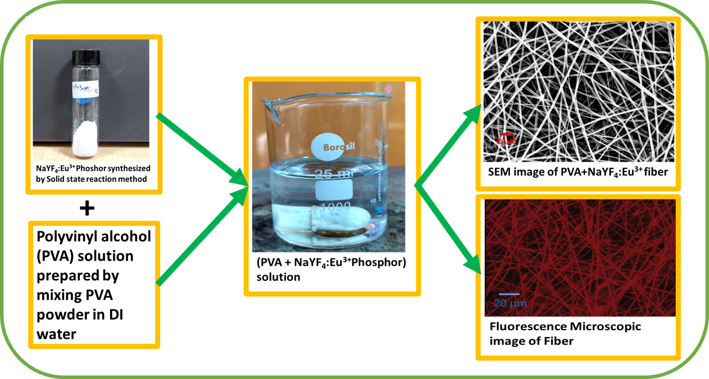

Recent Publications (minimum 5)
- Kyungtaek Min, Sookyoung Kim, Chang Gun Kim and Sunghwan Kim (2017) Colored and fluorescent nanofibrous silk as a physically transient chemosensor and vitamin deliverer. Nature Scientific Reports 7: 5448.

- Li M, Zhang J, Zhang H, Liu Y, Wang C, Xu X, Tang Y and Yang B (2007) Fluorescent Quantum Dots in Nanofibers without Förster Resonance Energy Transfer. Advanced Functional Materials 17: 3650–3656.
- Yogesh Ner, James G, Grote, Jeffrey A, Stuart, Gregory A and Sotzing (2008) Enhanced fluorescence in electrospun dye-doped DNA nanofibers 4:1448–1453.
- Aline P. Roque, Luiza A. Mercante, Vanessa P. Scagion, Juliano E. Oliveira, Luiz H. C. Mattoso, Leonardo De Boni, Cleber R. Mendonca, Daniel S. Correa (2014) Fluorescent PMMA/MEH-PPV Electrospun Nanofibers: Investigation of Morphology, Solvent, and Surfactant Effect. Journal of Polymer Physics 52:1388–1394.
- Masaki Hasegawa, Yuki Hirayama, and Stephan Dertinger (2015) Polarized fluorescent emission from aligned electrospun nanofiber sheets containing semiconductor nanorods. Applied Physics Letters 106:051103.

 Biography
Amit Kumar Gangwar has his expertise in Material sciences completed his graduation from University of Delhi, Delhi, India. He is pursuing his Ph.D degree from Academy of Scientific and Innovative Research, CSIR-NPL New Delhi. He is the recipient of prestigious fellowship from the Council of Scientific and industrial Research, India. His research interests includes the understanding of microstructures, Phase transformations, nucleation and growth mechanisms of lanthanide doped nanophosphors.
Email: amitkumargangwar852@gmail.com

Notes/Comments:

