Novel Microwave Assisted Continuous Flow Synthesis and Characterization of Calcium Deficient Hydroxyapatite Nanorods
Aneela Anwar*
Department of Basic Sciences and Humanities, University of Engineering and Technology, KSK Campus, GT Road, Lahore, 39020, Pakistan.

Abstract
Synthetic calcium deficient hydroxyapatite (CDHA) nanorods (<100nm) were rapidly produced through a novel microwave assisted continuous flow synthesis reactor in 5 minutes only from aqueous solution of calcium hydroxide and orthophosphoric acid at pH 8.5. The product was collected as a pure material with a stoichiometric Ca:P molar ratio of 1.5. No decomposition of CDHA into other calcium phosphate phases was seen even after heating at 650 °C in air for 1h. The phase purity, particle size and morphology of the powder samples were characterized by techniques such as X-ray diffraction analysis, transmission electron microscopy, scanning electron microscopy and FTIR and Raman spectroscopy. The chemical analysis was performed using X-ray photoelectron spectroscopy. Dynamic light scattering measurements were taken into account to estimate the particle size. The results showed that the employed synthesis procedure offered an efficient and economical route to achieve high quality nano-sized products with suitable size and low level of impurities.
Key words: Bioceramics; Calcium Deficient Hydroxyapatite; Microwave; Nanomaterials; Bone regeneration; X-Ray Diffraction.

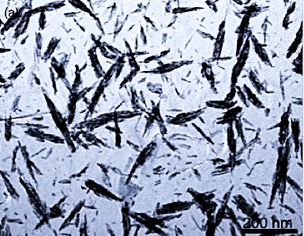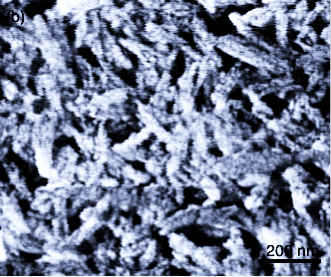
200 nm
200 nm
(a)
(b)

Fig 1. TEM images of as precipitated calcium deficient hydroxyapatite samples with scale bars (a) = 200 nm, (b) = 500 nm, made via microwave assisted continuous flow synthesis reactor.

Recent Publications

- Samina Akbar, Aneela Anwar, Abdullah Ayish, Joanne M Elliott, Adam M Squires, Phytantriol based smart nano-carriers for drug delivery applications, European Journal of Pharmaceutical Sciences 101 (2017) 31–42. IF:3.77.

- Aneela Anwar, Ihtesham U Rehman, Jawwad A Darr, Low Temperature Synthesis and Surface Modification of High Surface Area Calcium Hydroxyapatite Nanorods Incorporating Organofunctionalized Surfaces, The Journal of Physical Chemistry C, 2016, 120 (51), pp 29069–29076. IF:4.50

- Aneela Anwar, Samina Akbar, Ayesha Sadiqa, Mohsin Kazmi, Novel continuous flow synthesis, characterization and antibacterial studies of nanoscale zinc substituted hydroxyapatite bioceramics, Inorganica Chimica Acta 453 (2016) 16–22. IF: 2.1

- S. Akbar, A. Anwar, Q. Kanwal, Electrochemical behaviour and electrochemical determination of Folic Acid: A short review Analytical Biochemistry, Analytical Biochemistry 510 (2016) 98-105. IF: 2.5

- Aneela Anwar, Qudsia Kanwal · Samina Akbar, Aisha Munawar, M. Hassan Farooq, Synthesis and Characterization of Pure and Nanosized Hydroxyapatite Bioceramics, Nanotechnology Reviews, 2017; 6(2): 149–157. IF: 2.04

- Anwar A, Asghar MN, Kanwal Q, Kazmi M, Sadiqa A. Low temperature synthesis and characterization of carbonated hydroxyapatite nanocrystals. Journal of Molecular Structure 2016;1117:283-6. IF: 1.8



Biography
Dr Aneela Anwar completed her PhD from University College London, UK, on Islamic Development Bank Merit Scholarship. She returned to her organization, University of Engineering and Technology and has been chairing the basic sciences department. She has presented her quality research work at various national and international podia. The nature of her work, supreme presentation skills and innovation ideas had been appreciated much. She holds a patent besides various research publications. Her research mainly deals with the investigation of novel synthesis methodologies and analysis of various high purity nanoscale biomedical materials as medical device for hospitals/orthopaedic surgeon and research field.

Email: a.anwar@uet.edu.pk

