Adsorption of 1-(acyl/aroyl)-3-substituted) thioureas on gold surface. Image
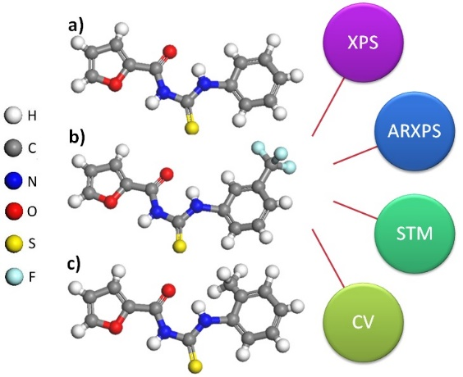
Gema Navarro-Marin, MSc, IMRE-UH, Cuba
Mayra P Hernandez, PhD, IMRE-UH, Cuba
Osvaldo Estevez, PhD, IMRE-UH, Cuba
Mario H. Farias-Sanchez, PhD, CNyN-UNAM, Mexico
Jose Valenzuela B., PhD, CNyN-UNAM, Mexico

Abstract

We report on a series of 1-(acyl/aroyl)-3-substituted) thioureas, which were prepared and used to modify polycrystalline gold and Au(111) surfaces. Three investigated compounds are the 1-(2-furoyl)-3- phenyl-, the 1-(2-furoyl)-3-[3-(trifluoromethyl)phenyl]- and the 1-(2-furoyl)-3-[(o-tolyl)phenyl]- thioureas. X-ray Photoelectron Spectroscopy (XPS), Angle Resolved X-ray Photoelectron Spectroscopy (ARXPS), Cyclic Voltammetry (CV), and Scanning Tunneling Microscopy (STM) studies were used to characterize the modified surfaces. For preparation of the samples the thiourea derivatives were dissolved in ethanol. The polycrystalline metallic substrates were first annealed in butane flame until obtaining monocrystalline terraces with (111) preferential orientation. Then they were submerged in these solutions during a period of 24 h. Finally the substrates were removed from solutions and consecutively rinsed and dried. The XPS data and STM micrographics show that 1-(2-furoyl)-3-[(o-tolyl)phenyl]thiourea decompose on gold surfaces while 1-(2-furoyl)-3- phenyl- and the 1-(2-furoyl)-3-[3-(trifluoromethyl)phenyl]- thioureas conserved the molecular structures. The decomposition leads to the adsorption of sulfur and ejection of the other groups. High resolution STM imaging showed the well-known quasi-square patterns formed by eight sulfur atoms (octomers). The cyclic voltammetry data confirm these results. The analysis of the ARXPS spectrum determined the molecular orientation on solid substrates. These results are important because (i) they provide experimental evidence that there are not direct interaction between the π-electrons of the phenyl groups and the Au-5d band, (ii) they show that the substitute groups and its position in the phenyl ring possibly determine the conservation of the molecular structures on gold, and (iii) very importantly, they show the adlayer nature of the sulfur modified gold surface which has been a heavily debated question.

Figure 1. Molecular structures of 1-(acyl/aroyl)-3-substituted) thioureas. a) 1-(2-furoyl)-3- phenyl-, b) 1-(2-furoyl)-3-[3-(trifluoromethyl)phenyl]- and c) 1-(2-furoyl)-3-[(o-tolyl)phenyl]- thioureas.
Recent Publications (minimum 5)
- Hernández-Sánchez M P, Navarro-Marín G, Estévez-Hernández O, Farías M H (2017) Angle-Resolved X-Ray Photoelectron Spectroscopy study of the thiourea derivative adsorption on Au(111) from Ethanolic Solution. Revista Cubana de Física. Accepted.
- Jiménez-Hernández L, Estévez-Hernández O, Hernández-Sánchez M P, Díaz J A, Farías- Sánchez M, Reguera E (2017) On the state of Mn in MnxZn1-xO nanoparticles and their surface modification with isonipecotic acid. Journal of Solid State Chemistry. Journal of Solid State Chemistry. 247:43–52.
- Hernandez-Tamargo C E, Barzaga R, Mikosch H, Martínez J A, Herrera J A, Farías M H, , Mikosch H, Hernández M P (2016) Density Functional Theory Study of the Adsorption of Sulfur Multilayers on Au(100), Physical Chemical Chemistry Physics 18:29987.
- Martínez J A, Valenzuela J, Cao-Milán R, Herrera J A, Díaz J A, Farías M H, Mikosch H, Hernández M P (2015) Study of sulfur adlayers on Au(111) from basic hydrolysis of piperazine bis(dithiocarbamate) sodium salt. Applied Surface Science 345:394–399
- Jiménez-Hernández L, Estévez-Hernández O, Hernández-Sánchez M P, Díaz J A, Farías- Sánchez M, Reguera E (2016) 3-mercaptopropionic acid surface modification of Cu-doped ZnO nanoparticles. Their properties and peroxidase conjugation. Colloides Surface A: Physicochemical and Engineering Aspects Colloids and Surfaces A: Physicochem. Eng. Aspects 489:351–359.



Biography (150 word limit)
Gema Navarro Marín got her B.S at the Physics Faculty of University of Havana. The material science, specifically the surfaces and interfaces studies constitute her scientific interests. Her areas of expertise are: the instrumentation for nanotechnology, the microscopy by tunnel effect and electron spectroscopy. Recently she is working in the studies of phenomena of adsorption of thiourea derivatives on metallic surfaces, analyzing how the position of the substituent and its chemical composition can affect the adsorption process. The investigation of the electronic properties of this junction are focus in the development of electronic nanodevices.
Email: gnavarro@imre.uh.cu

Notes/Comments

