Laboratory for strategic materials: extraction, processing, and utilization of strategic materials
Gisele Azimi, Assistant Professor, University of Toronto, Canada

Abstract (300 word limit)
Rare earth elements (REEs) are classified under strategic materials, i.e., those with high demand and subject to supply risk. These elements offer unique physicochemical properties, thus they are the key component of many critical and emerging green technologies, including magnets for wind turbines and batteries for electric vehicles. Since these technologies are dominating the world to meet the GHG emission target, the demand for REEs is increasing fast, causing sustainability challenges. The current raw materials for REEs are enough to accommodate several decades of increased demand; however, bringing these sources into the supply chain is challenging. Opening a new mine and building a refinery is challenging and may take 10-15 years. Thus, it is imperative to find new secondary sources for these elements through technospheric and urban mining. Here we present efficient extraction processes based on hydrometallurgy and supercritical fluid extraction to recover REEs from industrial process residues: phosphogypsum and red mud, as well as nickel metal hydride (NiMH) batteries and neodymium iron boron (NdFeB) magnets. Our hydrometallurgical process employs a modified version of sulfuric acid leaching and subsequent impurity removal by selective precipitation. Our supercritical fluid extraction process is robust, as it relies on an inert, safe, and abundant solvent (CO₂), runs at low temperature, and generates minimum waste. In all cases, we obtained more than 90% extraction efficiency for REEs. Another challenge with REEs is supply imbalance, i.e., the more critical ones are less abundant, and because they occur together, there is a surplus of less critical ones, such as cerium. In a recent discovery, we showed that robust REE oxide ceramics are hydrophobic, thus they can enhance the efficiency of various industries. Research in our group is twofold: extraction and processing of REEs from secondary sources, and their utilization to fabricate super-nonwetting materials with far-reaching technological impact.

Image
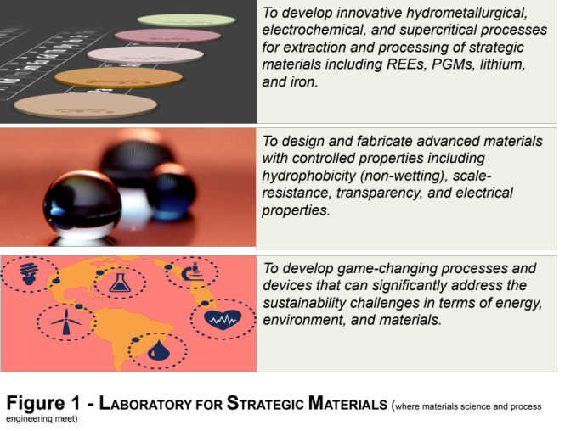
Recent Publications (minimum 5)
- Reid, S., Tam, J., Yang, M., Azimi, G. (2017) Technospheric mining of rare earth elements from bauxite residue (red mud): process optimization, kinetic investigation, and microwave pretreatment. Scientific Reports, 7, 15252, 1-9.
- Tam, J., Palumbo, G., Erb, U., Azimi, G. (2017) Robust, hydrophobic nickel-cerium oxide metal matrix composite electrodeposits,” Adv. Mater. Interf. 1700850.
- Ang, C.A., Zhang, F., Azimi, G. (2017). Waste valorization process: sulfur removal and hematite recovery from high pressure acid leach residue for steelmaking, ACS Sustainable Chemistry and Engineering 5, 8416-8423.
- Judge, W.D., Azimi, G. (2017) Thermodynamic Investigation of the Reduction-Distillation Process for Rare Earth Metals Production,” JOM 69, 1987-1991.
- Judge, W.D., Allanore, A., Sadoway, D.R., Azimi, G. (2017). E-logpO2 diagrams for ironmaking by molten oxide electrolysis,” Electrochemica Acta 247, 1088–1094.
- Azimi, G., Dhiman, R., Kwon, H.M., Paxson, A.T., Varanasi, K.K. (2013). Hydrophobicity of rare-earth oxide ceramics, Nature Materials, 12, 315–320.

Biography (150 word limit)
Gisele Azimi is an Assistant Professor cross-appointed between the Departments of Chemical Engineering & Applied Chemistry and Materials Science & Engineering at the University of Toronto. She is an expert in the fields of materials extraction, processing, and recovery using hydrometallurgical, electrochemical, and supercritical processes. Her research program is mainly focused on the extraction and recovery of strategic materials, mainly rare earth elements, precious metals, lithium, and iron. This includes molten salt electrolysis and supercritical fluid extraction of rare earth elements as well as recovery of these elements from secondary sources. Another thrust of her research program is focused on the design and fabrication of advanced materials and surfaces with controlled properties. She has received a number of awards including TMS Light Metals/Extraction & Processing Subject Award, CIM Gordon Ritcey Outstanding Award, and TATP teaching excellence award.
Email: g.azimi@utoronto.ca

Notes/Comments:

