Official Photo  University/Organization Logo

Information entropy for transformation of molecular structure
Anatoly V. Stepanov, National Ozone Monitoring Research & Educational Centre, Belorussian State University, Republic of Belarus

Abstract (300 word limit)
There are two processes for transformation of molecular structure: a high-temperature transformation (Arrhenius dependence) and molecular tunneling (low-temperature plateau). Calculation of information entropy for these processes gives us some useful information, namely probabilities of occurrence of the reactions under considerations, their efficiency and mean-square fluctuations of the distribution function parameters. Essentially, this investigation is an evolution of Perrin’s radiation hypothesis proposed in 1919. Almost one century has passed…And now a fuller picture of the elementary activation act for unimolecular chemical reaction begins to emerge.

Key words: Shannon entropy, Information entropy of activation, Thermal equilibrium radiation, Boltzmann-Arrhenius model, Activation process model

Image
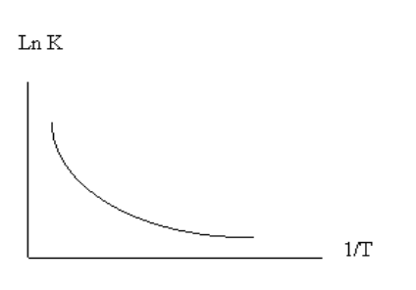
Arrhenius dependence with low-temperature plateau.
Recent Publications (minimum 5)
- Stepanov A.V., Stepanov M.A. (2018) Information entropy of molecular tunneling. Proceedings 2:151-162.
- Stepanov A.V. (2015) Information entropy of activation process: Application for low-temperature fluctuations of a myoglobin molecule. International Journal of Modern Physics B 29:1550016-1-18.
- Stepanov A.V. (2011) Modeling of metamaterials: a globular protein as a metamaterial prototype for electromagnetic-acoustic conversion at low temperatures. Proc. of SPIE 8070:807013-1-13.
- Stepanov A.V. (2007) Activation process model: Einstein coefficients for activation barrier. Journal of Molecular Structure: THEOCHEM 805:87-90.
- Stepanov A.V. (2002) Interaction model of thermal radiation with molecule at low temperatures: molecular tunneling. Journal of Molecular Structure: THEOCHEM 578:47-61.

Biography
1976: graduation of the BSU; 1983 - 1986: post-graduate studentship in the BSU; 1989 up to the USSR disintegration: WATOC member; 1997 - 2000: NYAS member. Current research activity - there are a few problems in physics and chemistry that are in interest for me: an elementary activation act in solid state diffusion and chemical transformation; compensation effect in chemical kinetics; adiabatic and non-adiabatic approximation in molecules physics; dynamic properties of protein mobility; IR multi-photon absorption and photodissociation; molecular structure; molecular tunneling; prebiotic evolution; Einstein coefficients for activation barrier; low-temperature equilibrium fluctuations and functionally important motions in a globular protein; information entropy for activation process and molecular tunneling.
Presenting author details
Full name (As per the passport): Anatoly Stepanov
University/Industry/Organization name: Belorussian State University
Designation (Director/Prof/Assistant or Associate prof/Researcher/Student): Head of laboratory
Country: Republic of Belarus
Mobile number (country code – number): +375298650405
Email: stepav@bsu.by
Track number: 3-1
Category (Oral presentation/ Poster presentation/Young researcher forum/E-poster): E-poster
Research interest: Why and how do proteins work in nature ?
Your profile page URL in your department: http://ozone.bsu.by
Year of birth: 1954
Linked In/Facebook/twitter account: no

Note: Please fill up the Red mark fields so that it would be easier for us to cite your details in the conference particulars. (Please do not forget to fix your photo and Logo above the title)

