


InAs-based nanowire quantum structures for advanced optoelectronics
Q. D. Zhuang1,3, Z. M. Jin1, H. Alradhi1, X. R. Chen2, J. Shao2, H. H. Fang2, W. D Hu2, H. D. Li3, Z. M. Wang3 A. M. Sanchez4,
1: Physics department, Lancaster University, Lancaster, UK LA1 4YB
2: Physics Department, Warwick University, Warwick, UK CV4 7AL
3: Institute of Fundamental and Frontier Sciences, University of Electronic Science and Technology of China, Chengdu 610054, China
4: National Laboratory for Infrared Physics, Shanghai Institute of Technical Physics, Chinese Academy of Sciences, 200083 Shanghai, People’s Republic of China

Abstract (300 word limit)
Owing to the unique structural properties, one-dimensional nanowire (NW) semiconductor materials have been proposed to be promising candidates in realizing advanced optoelectronic and electric devices. In the last few years, InAsSb NWs have attracted increasing attention for their direction bandgap, high electron mobility and low bandgap energy which enable device applications in infrared photodetectors/emitters and high mobility devices. However, the poor crystalline quality and the large surface states degrade the performance of the resulting devices. Here we report that the optical properties of InAs NW can be improved efficiently through use of Sb-modulated superlattice and core-shell confined heterostructures.
InAs-based nanowire quantum structures were grown on Si (111) substrate by molecular beam epitaxy (MBE). The sample of InAs/InAsSb suplerlattice NW was obtained via alternative growth of InAs and InAsSb segments with thickness of ~10 nm. For core-shell NWs, two types of shell layers, e.g. AlSb and GaSb were grown on bare InAs NWs at reduced growth temperature. As shown in figure 1, high-resolution transmission microscopy (HRTEM) and scanning electron microscopy (SEM) studies demonstrated the success of the core-shell structures of the NWs. photoluminescence (PL) was performed to explore the optical properties of the NWs. as can be seen from figure 2, a dramatic increase of photoluminescence (PL) was observed in comparison with bare InAs NW (Figure 2), e.g. up to 20 times is visible for the core-shell NWs, and more efficient improvement in the Sb-modulated InAs/InAsSb superlattice NW. Such improvements are associated with the efficient surface passivation resulted from the shell layer and the development in crystalline quality. Single NW field effect transistors were fabricated. A large dark current reduction (2 magnitude of order) was observed in the core-shell NW device in comparison with bare InAs NW device, which reveals the efficient surface passivation from core-shell structures.

Key words: core-shell nanowire, MBE, photodetector, phototransistor

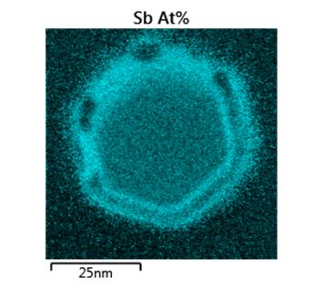
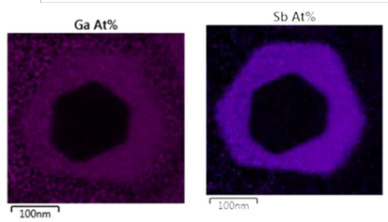

Figure 1. 45º - tilted SEM image of InAs/AlSb core-shell NWs
Figure 1. left: SEM image of InAs/AlSb core-shell NWs; left: cross-section TEM for InAs/AlSb (top) and InAs/GaSb (bottom).

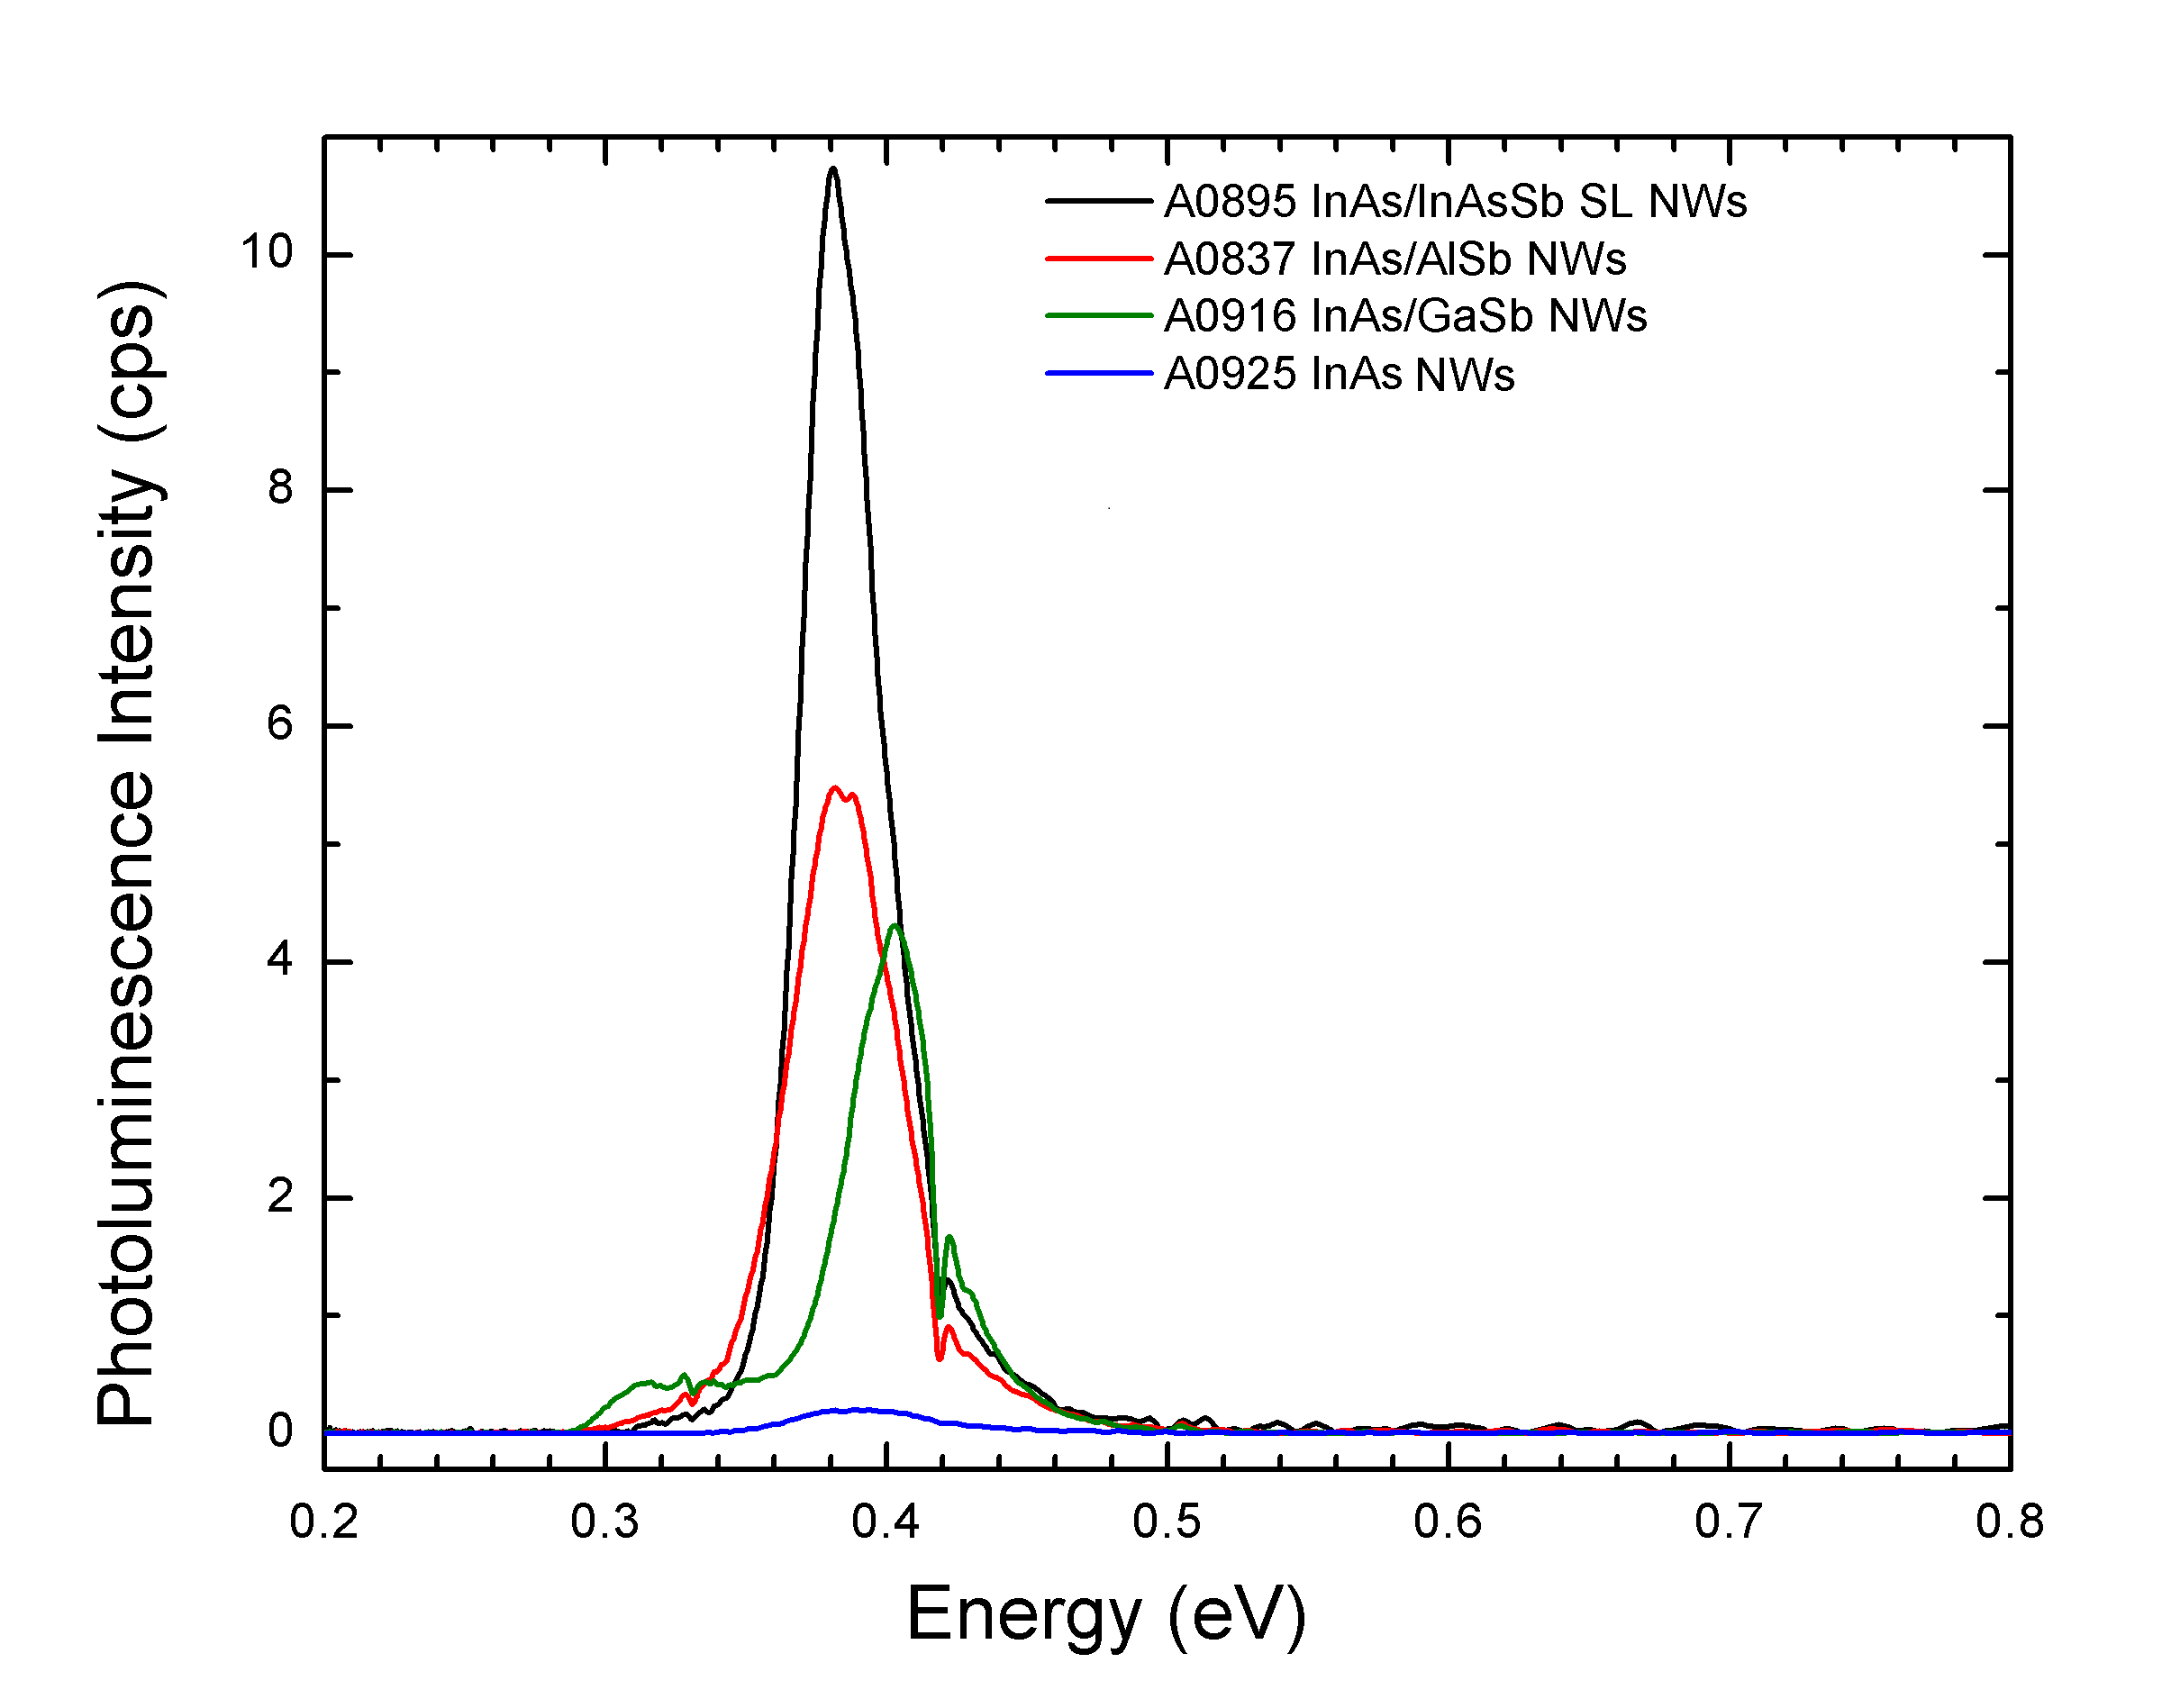
Figure 2. The 4K PL of InAs/AlSb and InAs/GaAs core-shell NWs, InAs/InAs superlattice NWs and bare InAs NWs.

Recent Publications (minimum 5)
- Optimization of self-catalyzed InAs nanowires grown on flexible graphite for infrared photodetection, Ezekiel A. Anyebe, Z. M. Jin, I.Sandall, Mohana. Rajpalke, Timothy D. Veal, Ana M. Sanchez, R. Sundaram, Y. C. Cao, H. D. Li, R. Harvey, and Q. D. Zhuang, Nature Sci. Reports, in press
- Radiative recombinations and substrate effects in vertically aligned InAs nanowires by wide temperature-range infrared photoluminescence, Xiren Chen, Qiandong Zhuang, Liangqing Zhu, Xin Chen and Jun Shao, Nano Lett., 17, 1545 (2017)
- Realization of vertically aligned, ultra-high aspect ratio InAsSb nanowires on graphite, E. A. Anyebe, A. M. Sanchez, S. Hindmarsh, X. Chen, J. Shao, M. K. Rajpalke, T. D. Veal, B. J. Robinson, O. Kolosov, F. Anderson, R. Sundaram, Z. M. Wang, V. Falko and Q. Zhuang, Nano Lett. 15, 4348 (2015)
- Sb-induced phase control of InAsSb nanowires grown by molecular beam epitaxy, Q. D. Zhuang, Ezekiel A Anyebe, R. Chen, H. Liu, Ana M Sanchez, Mohana K Rajpalke, Tim D Veal, Z. M. Wang, Y. Z. Huang, and H. D. Sun, Nano Lett. 15, 1109 (2015)
- Linear magnetoresistance due to multiple-electron scattering by low-mobility islands in an inhomogeneous conductor, N.V. Kozlova, N. Mori, O. Makarovsky, L. Eaves, Q. D. Zhuang, A. Krier and A. Patane, Nature Communications 3, 109 (2012)

Biography
Dr Qian-Dong Zhuang is a Senior Lecturer in the Physics Department at Lancaster University, UK. He gained his PhD from the Institute of Semiconductors, CAS, China in 1999. Since then he worked at Nanyang Technological University (Singapore) and Glasgow University (UK) as a Research Scientist. In 2003, he joined Lancaster University as a Lecturer. He has subsequently established MBE Research Laboratory (molecular beam epitaxy) in the Physics Department where he has been leading the research in MBE grown semiconductor nanostructures and device applications. His current research is focused on nanostructured III-V compound semiconductors with specific interest in novel dissimilar alloys, quantum dots, nanowires and semiconductor/Si and semiconductor/graphene functional hybrid material systems), ranging from MBE epitaxial growth to development of optoelectronics through fundamental physics studies. He has published 2 book chapters and more than 80 papers in peer-reviewed scientific journals including Nano Letters, Nature Communication, Nano Research, Applied Physics Letters and Physical Review B. He is an Editorial Board Member of Nature Scientific Reports.Deanna Mulvihill has her expertise in evaluation and passion in improving the health and wellbeing. Her open and contextual evaluation model based on responsive constructivists creates new pathways for improving healthcare. (Up to 100 words).

Presenting author details
Full name (As per the passport): Qiandong Zhuang
University/Industry/Organization name: Lancaster University
Designation (Director/Prof/Assistant or Associate prof/Researcher/Student): Senior Lecturer
Country: UK
Mobile number (country code – number): 447973844380
Email: q.zhuang@lancaster.ac.uk
Track number: http://materialsphysics.physicsmeeting.com/call-for-abstracts.php (For track number follow this link)
Category (Oral presentation/ Poster presentation/Young researcher forum/E-poster): Oral
Research interest: semiconductor, quantum materials, optoelectronics,
Your profile page URL in your department: http://www.physics.lancs.ac.uk/people/qiandong-zhuang
Year of birth: 1968
Linked In/Facebook/twitter account:

Note: Please fill up the Red mark fields so that it would be easier for us to cite your details in the conference particulars. (Please do not forget to fix your photo and Logo above the title)

