Shape and size effect of doped ZnO nanoparticles on their antimicrobial efficacy
Yongling Wu, PhD, Shandong University of Technology, China

Abstract (300 word limit)
Silver ion and silver nanoparticles are well known for their ability to kill bacteria effectively[1]. However, the side effect of high dose silver on humans especially children has been a major concern when designing antimicrobial coatings for daily life environment. ZnO quantum dots have been studied intensively by doping with different levels of elements, which emit the constituents of white light covering violet, blue, green, yellow, and red [2], making it very attractive for the application as luminescent material and bio-markers [3]. ZnO nanorod arrays were used to fabricate LED light and highly sensitive chemical sensors for O₂ and NO₂ [4] and hydrazine (N₂H₄) [5] respectively. The most important property of ZnO is its antimicrobial property and photocatalytic activity under UV-light [6] owning to the disruption of cell membrane during the nanoparticles interaction with the bacterial [7]. In this paper, we report a study into the effect of size, shape and metal ions doping of ZnO nanoparticles on the bacterial killing efficacy. We use a solution synthesis method varying the way of adding precursors, the doping element type and amount, the surface capping agents, and the processing parameters. We obtained several shapes (spherical, hexagonal prism, nanorod, flower-like etc.) in different sizes ranging from 30nm to 100nm. We analyzed the morphological structures of the particles, measured the antibacterial properties using JIS Z2801 method, and finally confirmed that the combined effect of size, doping, shape and surface morphology contributed to the antibacterial property of ZnO nanoparticles. Our research suggests that only 0.05-0.2% of silver doping into ZnO could effectively reduce the size of ZnO nanoparticles with Ag ions preferentially located on surface of particles making high efficacy of antibacterial property.

Image

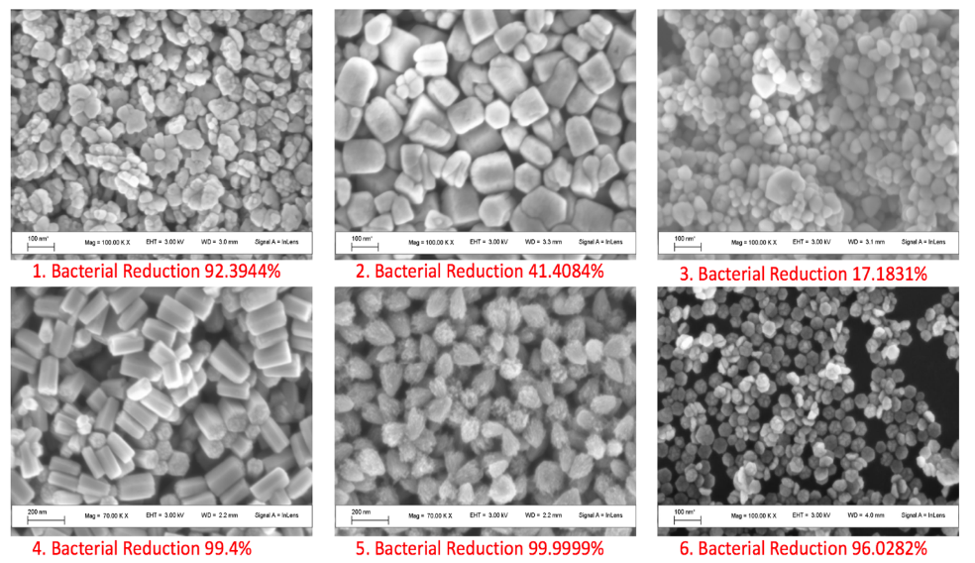
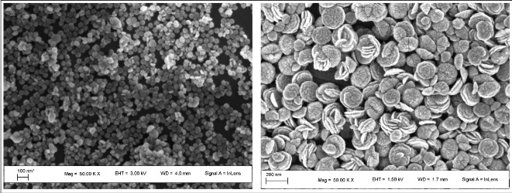
Hot injection versus gradual heating up of Zn(AcAc)₂ precursor

Recent Publications (minimum 5)
- A Kędziora, M Speruda, E Krzyżewska, J Rybka et al. (2018) Similarities and Differences between Silver Ions and Silver in Nanoforms as Antibacterial Agents. Int. J. Mol. Sci. 19:444.
- M. Willander, O. Nur, Q. X. Zhao, L. L. Yang, M. Lorenz, B. Q. Cao (2009) Zinc oxide nanorod based photonic devices: recent progress in growth, light emitting diodes and lasers. Nanotechnology 20:332001.
- Y.L. Wu, S Fu, A I Y Tok, XT Zeng, C S Lim, LCKwek and F C Y Boey (2008) A dual-colored bio-marker made of doped ZnO nanocrystals. Nanotechnology 19:345605-345613.
- J. Park, S.-W. Choi, and S. Kim (2009) Fabrication of a Highly Sensitive Chemical Sensor Based on ZnO Nanorod Arrays. Nanoscale Research Letters 5:353-359.
- R. Ahmad, N. Tripathy, D.-U.-J. Jung, and Y.-B. Hahn (2014) Highly sensitive hydrazine chemical sensor based on ZnO nanorods field-effect transistor. Chemical Communications 50:1890-1893.
- N. Jones, B. Ray, K. T. Ranjit, and A. C. Manna (2008) Antibacterial activity of ZnO nanoparticle suspensions on a broad spectrum of microorganisms. FEMS Microbiology Letters 279:71-76.
- Y. Xie, Y. He, P. L. Irwin, T. Jin, and X. Shi (2011) Antibacterial Activity and Mechanism of Action of Zinc Oxide Nanoparticles against Campylobacter jejuni. Applied and Environmental Microbiology 77:2325-2331.

Biography (150 word limit)
Professor WU Yongling gained her B.Eng and M.Phil in Mechanical Engineering from Tsinghua University in 1985 and 1988 respectively, and Ph.D in nanomaterials synthesis and coating from Nanyang Technological University of Singapore in 2009. Prior to joining Shandong University of Technology (SDUT), she was a Senior Scientist in the Agency for Science, Technology and Research (A-STAR) of Singapore leading a research team in Surface Technology. Her research field include chemical synthesis of nano-materials for bio-imaging and functional coatings (Quantum Dots, photochromic, IR absorption, antimicrobial, UV shielding etc.); sol-gel chemistry and technology, chemical formulation of coating materials for multi-functional coatings, hydrophobic hard coating, anti-reflective coating, coloured decorative coatings for plastics and metals, non-stick, low friction, scratch resistant and abrasion resistant coatings, antimicrobial and bio-compatible coatings.
Email:ylwu06@sdut.edu.cn

Notes/Comments:

