Adsorption assessment of acetylsalicylic acid in bacterial nanocellulose for colorectal cancer prevention and treatment.
Rodriguez M. Sebastian, UPB, Colombia.

Abstract
Bacterial nanocellulose (BNC) is a natural, nontoxic, biocompatible hydrogel that presents good mechanical properties, composed of a dense array of cellulose fibrils, which provide great surface areas. This makes it ideal in medical applications like tissue engineering, wound treatments and controlled drug delivery, amongst others. Acetylsalicylic acid, on the other hand, has proven to be effective in the prevention of adenomas and colorectal cancer; it even plays a role in the treatment of cancer. Due to its surface area, BNC has the potential to adsorb drugs, protect them from the acids in the digestive tract and safely deliver them to the intestine where they can be absorbed in the body; therefore, this investigation aims to evaluate the adsorption capacity of acetylsalicylic acid in nanocellulose as a treatment for colorectal cancer. The bacterial nanocellulose was synthesized with Komagateibacter Medellinensis in an acid medium and was loaded with the active principle diluted in ethanol. The absorption measurements were made by determining the concentration in different time fractions using UV-Vis spectroscopy. This curves revealed three main events: first, a rapid absorption of the active ingredient during the first 0-10 min, followed by a small desorption, and finally, a second absorption that stabilizes from 20, up to 60 min. This data confirms the affinity of this principle on the bacterial nanocellulose fibrils and serves as a starting point for further improvements in cancer treatments.

Image

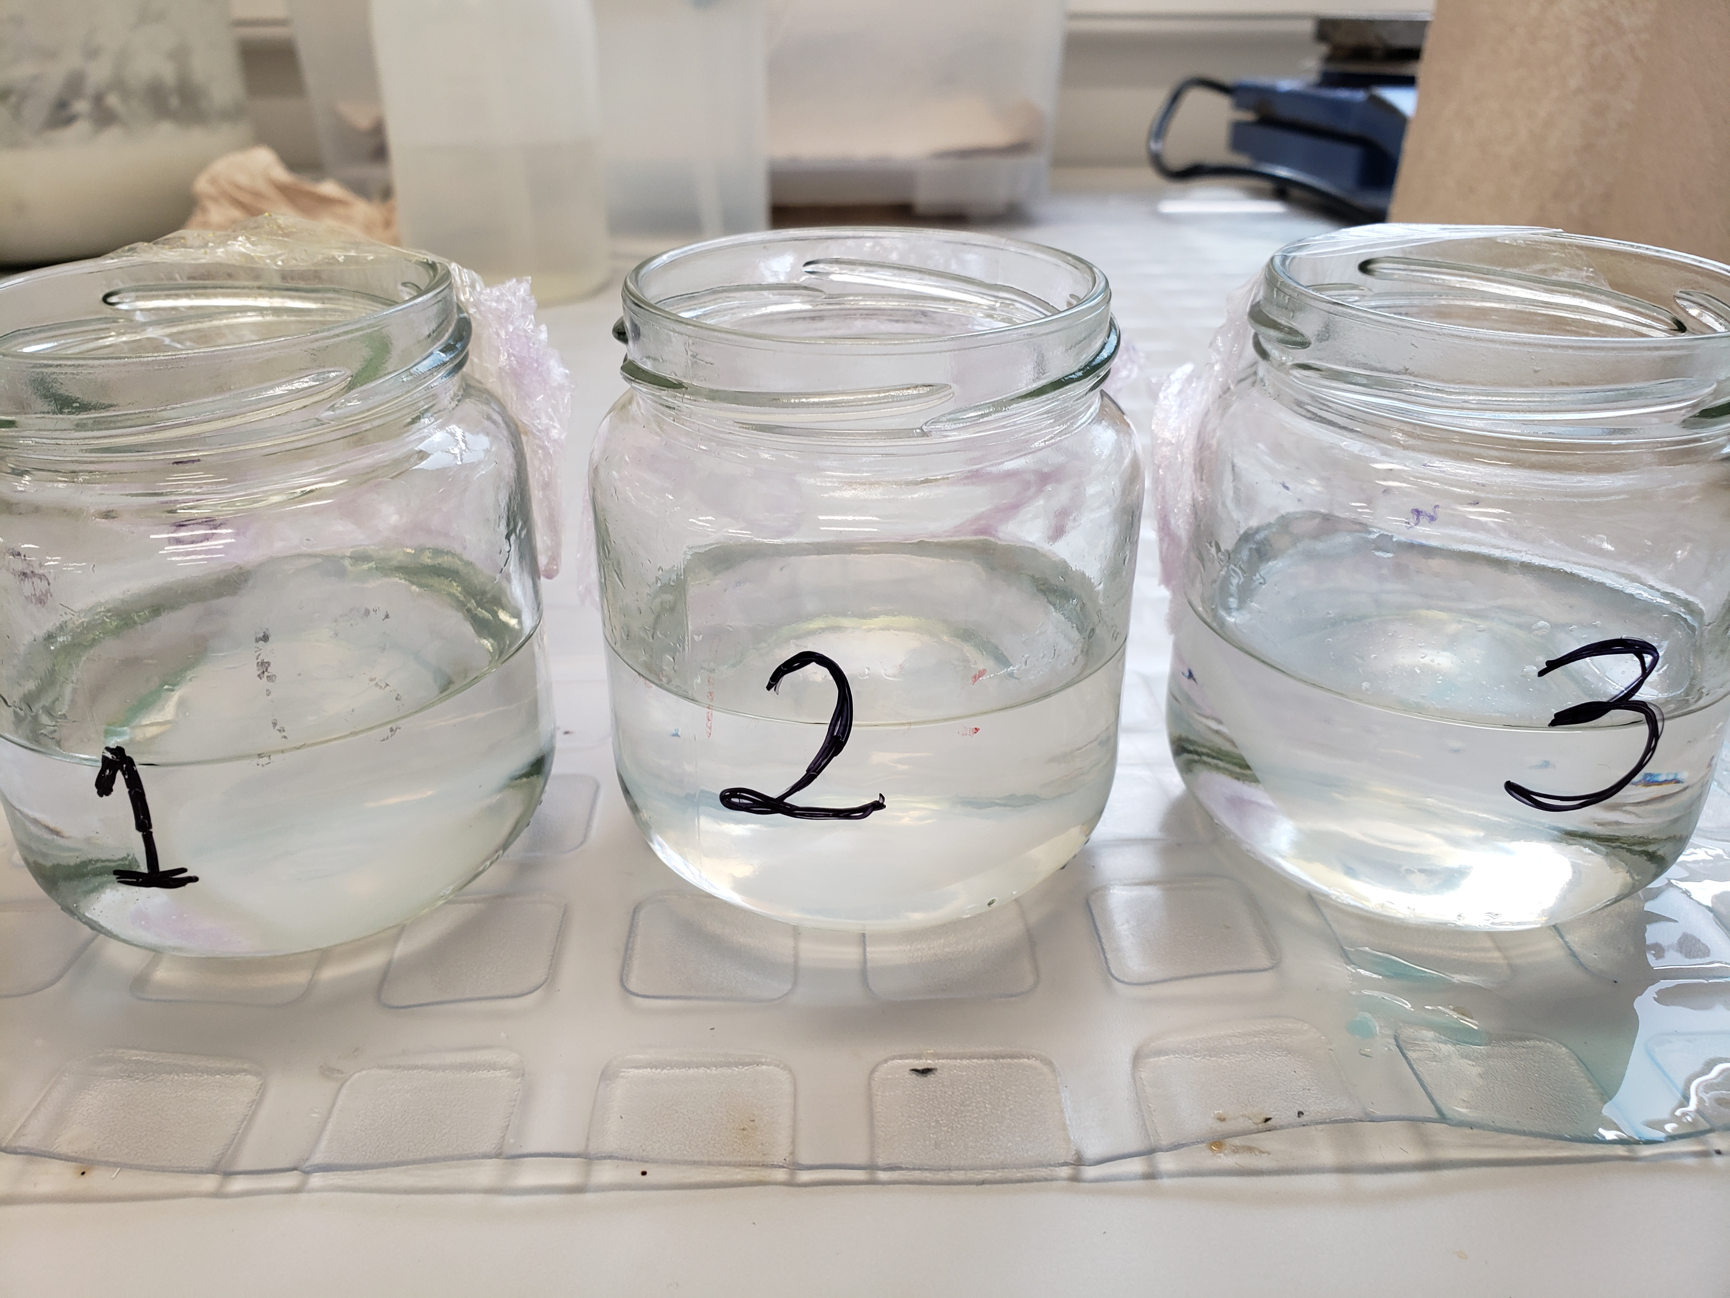
Bacterial nanocellulose membranes loaded with acetylsalicylic acid in ethanol

Recent Publications
- García Rodríguez L.A. Soriano Gabarró M. (2017) New use of low-dose aspirin and risk of colorectal cancer by stage at diagnosis: a nested case–control study in UK general practice. BMC Cancer. 17: 637.
- Coyle, C., Cafferty, F. H., & Langley, R. E. (2016). Aspirin and Colorectal Cancer Prevention and Treatment: Is It for Everyone? Current Colorectal Cancer Reports, 12(1), 27–34.
- Castro C, Zuluaga R, Putaux JL (2011) Structural characterization of bacterial cellulose produced by Gluconacetobacter swingsii sp. from Colombian agroindustrial wastes. Carbohydrate Polymers. 84(1), 96-102
- Castro C, Álvarez C, Gañán P (2012) Bacterial cellulose produced by a new acid-resistant strain of Gluconacetobacter genus. Carbohydrate Polymers. 89(4) : 1033-1037.
5. Curvello R, Raghuwanshi VS, Garnier G (2019) Engineering nanocellulose hydrogels for biomedical applications. Advances in Colloid and Interface Science. 267:47-61

 Biography
Sebastian Rodriguez is a 4th year undergraduate student in Universidad Pontificia Bolivariana, in Medellin, Colombia. He studies Nanotechnology Engineering and he is part of the New Materials Research Group (GINUMA). He has been a part of different projects involving material analysis, especially in biopolymers and product development in novel silver nanoparticle applications in electronics.

Notes/Comments:

