Effect of chemical interaction on nanohardness of FCC metals during friction in lubricated conditions
Alexey Moshkovich ¹, Vladislav Perfilyev ¹, Tatyana Bendikov ²Lev Rapoport ¹*

¹ Holon Institute of Technology, Holon 58102, Israel
² The Weizmann Institute of Science, Rehovot 76100, Israel

Abstract
Friction of metals in lubricated conditions is accompanied by a strong gradient of grain sizes, and dislocation density in surface layers [, 2]. The effect of a gradient of plasticity in surface layers leads to an increase in nanohardness at small depths. Plastic deformation and strain gradient as well as friction and wear depend strongly on stacking fault energy (SFE). In light of the above, we evaluate here the effect of plastic deformation on chemical composition and nanohardness, friction and wear properties of FCC metals with different SFE. All friction tests were conducted using pure polycrystalline FCC metals Ag, Cu, Ni and Al in lubricant conditions. The hardness variations with a depth of indeintataion is shown in Fig. 1. Chemical interaction leads to a variation of hardness with depth of penetration and thus affects the friction and wear. It was shown that a strong gradient of the hardness at thin surface layers of Al is mainly associated with oxidation and carbonization. A connection between micro and nanohardness of thin surface layers was observed. A correlation between the work of deformation during nanoindentation and chemical composition of thin surface layers appeared. The effect of SFE on the wear coefficient, micro and nanohardness was evaluated.

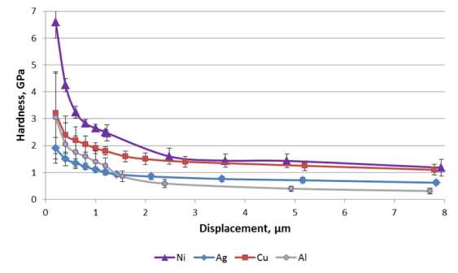

Fig. 1 The hardness variations with the indentation depth for four FCC metals after friction

Recent Publications
- Moshkovich A., Lapsker I., Feldman Y., Rapoport L. (2017) Severe plastic deformation of four FCC metals during friction under lubricated conditions Wear 386-387: 49-57.
- Popov. I., Moshkovich A., Cohen S. R., Perfilyev, V.A., Rapoport L. (2018) Microstructure and nanohardness of Ag and Ni under friction in boundary Lubrication Wear 404–405: 62–70.
3. Popov I., Moshkovich A., Bendikov T., Rapoport L. (2018) Deformation Microstructure and Chemical Composition of Surface Layers of Cu and Al Under Friction in Lubricated Conditions Trib. Lett. 66:78 (11 pages).

Biography (150 word limit)
Professor Rapoport is the Head of the Center for Materials Engineering and the Laboratory of Tribology at the Holon Institute of Technology. Friction and wear properties of fullerene-like nanoparticles were studied at first in the laboratory of Prof. Rapoport. Last some years he studied the interaction between structure friction and wear. Prof. Rapoport is a principal investigator in several research grants sponsored by the Israel Ministry of Science, the Bi-national Israel-USA and Germany-Israel Funds. Prof. Rapoport is the author more than 100 publications.
Email: rapoport@hit.ac.il

