Multiscale 3D Printing with Polymers
Geoffrey Mitchell PhD, Centre for Rapid and Sustainable Product Development, Institute Polytechnic of Leiria, Portugal

3D printing is part of the family of Direct Digital Manufacturing processes in which a part is prepared with a particular external form defined in a digital manner without the use of complex tooling or moulds. Such an approach is revolutionising manufacturing. It creates a new paradigm for design and in aerospace, the concept is already in use to prepare parts such as turbine blades with shapes which hitherto were impossible. The fact that each part can have an individual design identifies that this technology has much to offer to medical devices. Now of course a part is not just defined by its external form but also by the microscale structure which develops in the part during the manufacturing process. In this presentation we review the materials and molecular mechanisms available to deliver controlled and defined morphology during 3D printing technology and how this influences properties. We present a novel methodology for delivering orthogonal control of the semi-crystalline morphology of poly(ε-caprolactone) in biomedical devices. We take examples from recent research at CDRSP and consider its impact on scaffolds for tissue engineering.

This work is supported by the Fundação para a Ciência e a Tecnologia (FCT) through the Project references: UID/Multi/04044/2013; PAMI - ROTEIRO/0328/2013 (Nº 022158), MATIS (CENTRO-01-0145-FEDER-000014 – 3362 and UC4EP PTDC/CTM-POL/7133/2014)

Image
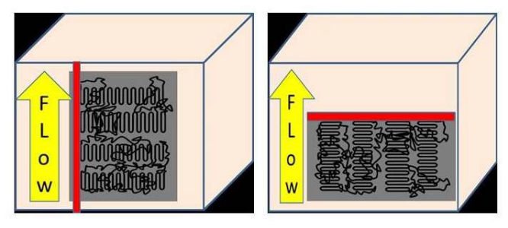

Recent Publications

- G.R.Mitchell and Ana Tojeira editors “Controlling Controlling the Morphology of Polymers: Multiple Scales of Structure and Processing." Springer 2016 ISBN 978-3-319-39320-9
- G.R.Mitchell, Donatella Duraccio, Imran Khan, Aurora Nogales, R.H.Olley ‘Templated Crystallisation in Polymer Nanocomposites’ in “Controlling the Morphology of Polymers: Multiple Scales of Structure and Processing." Springer 2016 ed G.R.Mitchell and A.Tojeira ISBN 978-3-319-39320-9
- G.R.Mitchell, F.J.Davis, R.H.Olley and S.Wangsoub ‘Directing the Crystallisation of Polymers using nanoparticles of sugar alcohol derivatives’ in “Controlling Controlling the Morphology of Polymers: Multiple Scales of Structure and Processing." Springer 2016 eds G.R.Mitchell and A.Tojeira ISBN 978-3-319-39320-9
- Geoffrey R Mitchell and Robert H Olley Orthogonal templating control of the crystallisation of poly(ε-caprolactone) Polymers, 2018, 10(3), 300; doi:10.3390/polym10030300
- Ana Tojeira and G.R.Mitchell “Controlling Morphology in 3-D Printing” in “Controlling Controlling the Morphology of Polymers: Multiple Scales of Structure and Processing." Springer 2016 ISBN 978-3-319-39320-9


Geoffrey Mitchell is Professor and Vice-Director of the Centre for Rapid and Sustainable Product Develop at the Institute Polytechnic of Leiria. Geoffrey Mitchell is passionate about direct digital manufacturing (DDM) which enables products to be manufactured directly from a digital design without the need for specialist tooling or moulds and the development of novel materials to support the emerging technologies. He is fascinated by the opportunities that arise from merging electrospinning in to the family of DDM technologies. He brings a wealth of experience working with polymer based materials both natural and synthetic. He is particularly interested in the scales of structure present in all materials and especially biopolymers. He has developed and made extensive use of x-ray and neutron scattering methods coupled to computational molecular modelling and electron microscopy techniques.
Email: Geoffrey.mitchell@ipleiria.pt

