Study of imidazolium-based cations as Structure Directing Agents in the synthesis of AlPOs and SAPOs
Gabrielli Almeida, Master’s student at Instituto Federal do Maranhão, Brazil
Alex Rojas, Post-Doctoral Researcher at Instituto Federal do Maranhão, Brazil
J. M. Rivas Mercury, Head Professor of Chemistry Department at Instituto Federal do Maranhão, Brazil

Abstract

Zeolites are crystalline, inorganic and porous materials of great industrial and scientific interest. Due to their topological and compositional diversity, they may perform a wide range of applications (e.g. adsorbents, catalysts, sensors), specially the synthetic ones. However, the understanding of factors that control phase selectivity in zeolite crystallization (SDE, Structure Directing Effects), under different synthesis conditions, is still a central issue in this field. Among the SDE already identified, the use of organic cations as Structure Directing Agent (SDA) in the synthesis stands out. These cations size, shape and flexibility are core variables for a performance as SDA as they provide greater or less specificity towards the crystallization of a desired phase based on host/guest interactions. Recently, organic cations based on imidazolium ring have proven themselves efficient SDAs as previous studies report that their use enabled the synthesis of new zeolitic structures, new compositions for already known structures and greater stability for some zeolitic phases. Hence, this work’s main goal is to contribute to the understanding of SDE, specifically evaluating the performance of 3 cations based on imidazolium ring, 2-ethyl-1,3,4-trimethylimidazolium (2E134TMI), 1,2,3-triethyl-4-methylimidazolium (123TE4MI) and 1,2,3-triethylimidazolium (123TEI), as SDAs in the hydrothermal synthesis of aluminophosphates (AlPOs) and silicoaluminophosphates (SAPOs). In order to achieve that, the organic cations were synthetized, characterized and applied in zeolites synthesis. The inorganic materials obtained also underwent characterization through a structural, chemical and physicochemical perspective to assess structure directing abilities of each cation using experimental and computational methods. By the time, the SDAs applied have led to crystallization of AFI and CHA structural types. The order of specificity for each cation towards CHA phase is given by 123TE4MI>2E134TMI>123TEI, being the opposite for AFI.

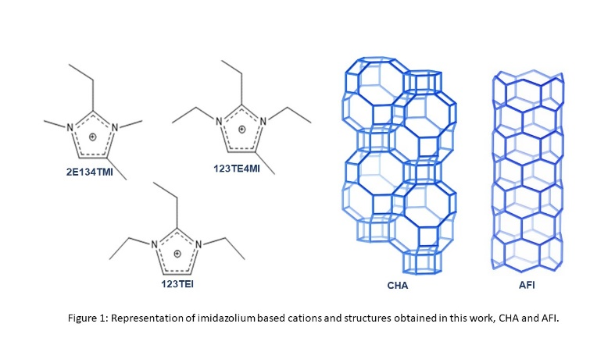
Recent Publications
- Park, Gi Tae; Jo, Donghui; Ahn, Nak Ho; Cho, Jung; Hong, Suk Bong. Synthesis and structural characterization of CHA-type AlPO₄ molecular sieve with penta-coordinated framework aluminum atoms. Inorg. Chem., 2017, 56, 8504-8512.
- Vinaches, Paloma; Pergher, Sibele. Organic Structure-Directing Agents in SAPO synthesis: the case of 2-ethyl-1,3,4-trimethylimidazolium. Eur. J. Inorg. Chem., 2017, 10.1002/ejic.201701002.
- Variani, Y. M.; Rojas, A.; Gómez-Hortigüela, L.; Pergher, S. B. C. Study of imidazolium-derived cations as structure directing agents in the synthesis of zeolites in fluoride media. New. J. Chem., 2016, 40, 7968.
- Lee, Jeong Hwan; Kim, Eun Jeong; López-Arbeola, Fernando; Hong, Suk Bong; Camblor, Miguel A. Microporous Aluminophosphates synthetized with 1,2,3-trimethylimidazolium and fluoride. Dalton Trans., 2016, 45, 7616.
- Rojas, A.; Camblor, Miguel A. Structure – direction in the crystallization of ITW zeolites using 2-ethyl-1,3,4-trimethylimidazolium. Dalton Trans., 2014, 43, 10760.

Gabrielli Almeida is a Materials Science and Engineering master’s student. Highly motivated, always seek new objectives, challenges and tasks to achieve. Under the orientation of Alex Rojas, an experient porous materials researcher, and professor Rivas Mercury of Federal Institute of Maranhão, the group intends to contribute for the science in this field worldwide and also inspire local students in this path.
Email: almeidagabrielli@gmail.com

