Modulation of Cellular Differentiation and Behavior via Engineering Cell Microenvironment
Lay Poh TAN, PhD, School of Materials Science and Engineering, Nanyang Technological University, Singapore

Abstract (300 word limit)
Material surface is an important and versatile avenue for manipulation of cell-material interaction which eventually leads to modulation of cellular behavior. In our laboratory, we work on surface patterning to modulate cellular morphology with the hypothesis that cellular morphology has an intimate relationship with the cellular behavior. We also study the physical cues including physical stiffness, coupled with surface patterning in modulating stem cell differentiation. In particular, we found that micropatterning micro islets on polymeric substrate could directly modulate stem cell fate. Here we will show the stem cell differentiation into skeletal muscle lineage through micropatterning. We have designed patterns of 1 by 7 micron that are attached with ITG-β1 antibodies. hMSCs were then cultured on this biofunctionalized patterned substrate. After 2 weeks of culture, myotubes were observed and the relevant markers were positively exhibited. This micropatterning technique could also be adopted as a generic method to steer cellular behavior such as cell migration or polarization in wound healing applications.

Image
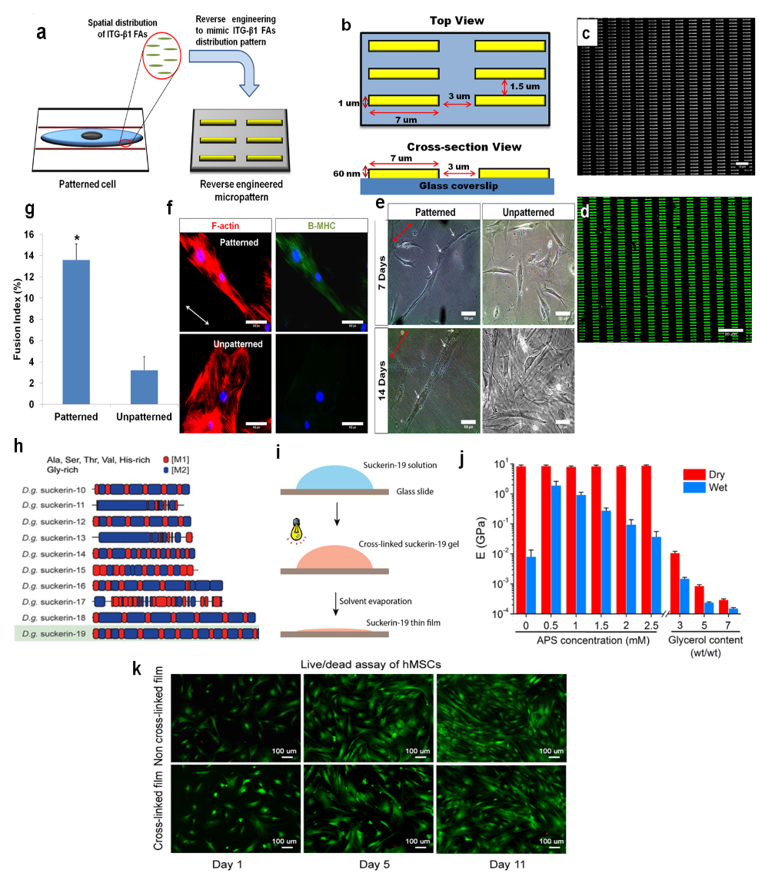
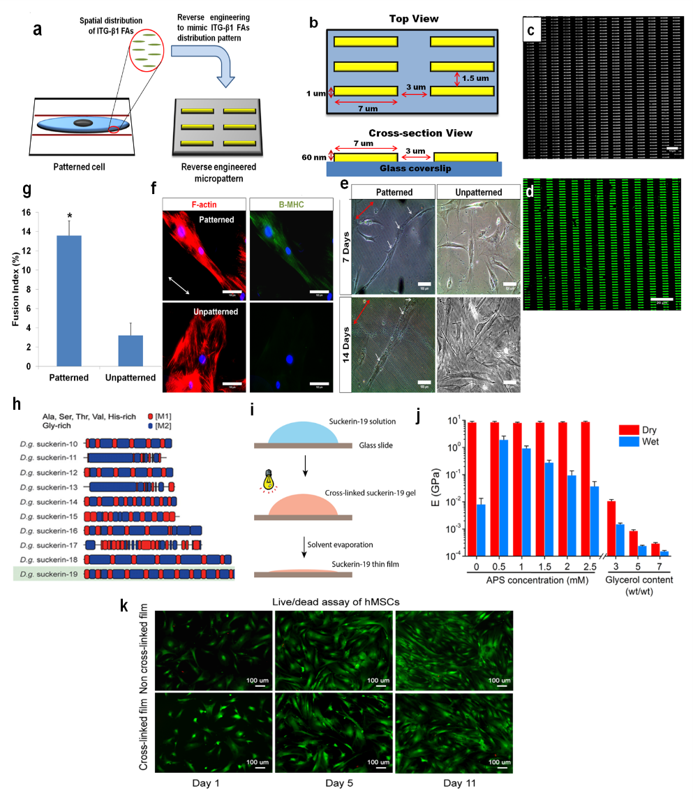
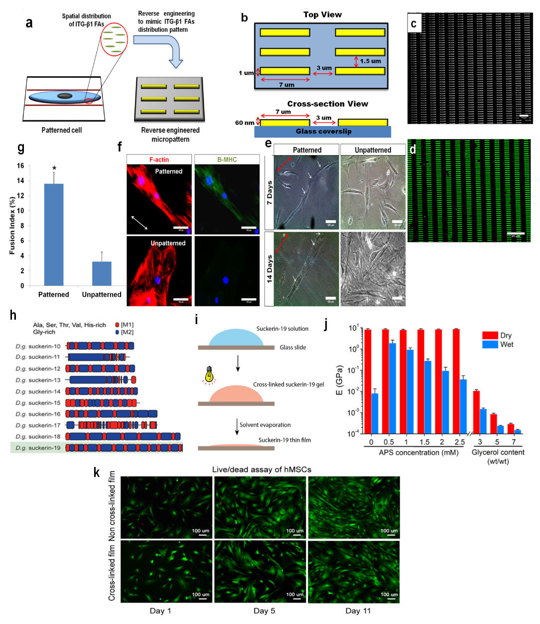
b
c
a

d

(a) Schematic illustrating top- and cross-section view of micropatterned substrate.(b) Phase contrast image of fabricated gold micropatterned substrate (Scale bar: 10 µm). (c) Confocal image of PEG passivated gold micropatterned substrate displaying precise immobilization of ITG-β1 antibodies to the gold micropattern lanes (Scale bar: 20 µm). (d) Immunofluorescent staining of F-actin (red) and β-MHC (green) from both cell groups validated the myotubes formation on patterned substrate (Scale bar:100 µm).
Recent Publications (minimum 5)
- Li, Huaqiong; Wen, Feng; Chen, Huizhi; Tan LP (2016), Micropatterning Extracellular Matrix Proteins on Electrospun Fibrous Substrate Promote Human Mesenchymal Stem Cell Differentiation Toward Neurogenic Lineage; ACS Applied Materials & Interfaces Volume: 8 Issue: 1 Pages: 563-573
- Tay, Chor Yong; Wu, Yun-Long; Cai, Pingqiang; Tan LP et al. (2015), Bio-inspired micropatterned hydrogel to direct and deconstruct hierarchical processing of geometry-force signals by human mesenchymal stem cells during smooth muscle cell differentiation, NPG Asia Materials Volume: 7
- Tijore, Ajay; Cai, Pingqiang; Nai, Mui Hoon; Tan LP et al (2015); Role of Cytoskeletal Tension in the Induction of Cardiomyogenic Differentiation in Micropatterned Human Mesenchymal Stem Cell, Advanced Healthcare Materials Volume: 4 Issue: 9 Pages: 1399-1407.
- Tijore, Ajay; Wen, Feng; Lam, Chee Ren Ivan; LP Tan (2014) Modulating Human Mesenchymal Stem Cell Plasticity Using Micropatterning Technique, PLOS ONE Volume: 9 Issue: 11 Article Number: e113043
- Tijore, Ajay; Hariharan, Srivats; Yu, Haiyang;.LP Tan (2014), Investigating the Spatial Distribution of Integrin beta(1) in Patterned Human Mesenchymal Stem Cells Using Super-Resolution Imaging, ACS APPLIED MATERIALS & INTERFACES Volume: 6 Issue: 18 Pages: 15686-15696.

 Biography (150 word limit)
A/Prof Tan Lay Poh is an Assoc Prof in the School of Materials Science and Engineering, NTU, Singapore. Her training is on Polymer Engineering and has been working on biodegradable polymers and biopolymers for the past decade. She has published extensively in the top journals of biomaterials and tissue engineering.
Her research interest focuses on developing engineering platforms to investigate cell-material interactions that eventually guide the development of 3D scaffolds and cell culture platforms for soft tissue engineering. For 3D systems, we have developed highly porous fibrous scaffold that mimics ECM physical properties. Hydrogel is also a major focus of our group where we develop ECM bio-chemistry mimicking systems which could be applied individually or combined with the fibrous platform to form hybrid ECM mimicking systems.
Email: lptan@ntu.edu.sg

Notes/Comments:

