Nonisothermal kinetics of nickel laterite ore reduction
Sahand Sarbishei, University of British Columbia, Canada
Leili Tafaghodi, University of British Columbia, Canada

Abstract (300 word limit)
According to the diminishing availability of nickel sulfide ores, laterites are considered as one of the main sources for producing nickel and cobalt. Partial reduction of the ore at temperatures below 1000 °C is a primary step of pyrometallurgical extraction for nickel from laterites. Investigation on kinetics of laterite ore reduction provides valuable information on reducibility of nickel laterites. In order to understand the kinetics of the process, nonisothermal TGA/DSC tests were done using coal as the reducing agent. Moreover, X-ray diffraction analysis was performed to find out the reduction behavior of laterites. Kinetic parameters were calculated based on general model of simple reaction f(α)=(1-α)^{n} by the thermogravimetric curves using Coats–Redfern method. Based on TGA/DSC results, nonisothermal reduction of nickel laterite ore was divided into three stages for 30-130 ⁰C, 130-600 ⁰C, and 600-990 ⁰C. Furthermore, for each stage of the process, five numbers of n (order of reaction) was used and the best fitted line with the highest coefficient of determination was selected as the proper function of reaction.

Image
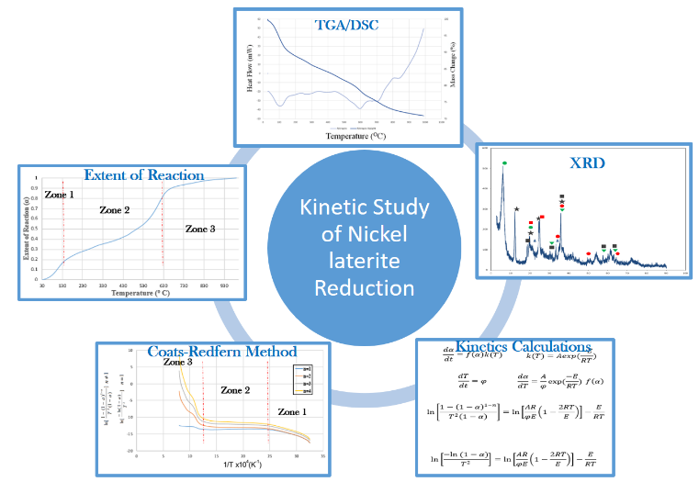

Recent Publications (minimum 5)

- S. Sarbishei, L. Tafaghodi, “A TGA/DSC study on the kinetics of nickel laterite ore reduction" Conference of Metallurgists (COM), Canada (2017).

- S. Sarbishei, M.A. Faghihi Sani, M.R. Mohammadi, “Effects of alumina nanoparticles concentration on microstructure and corrosion behavior of coatings formed on titanium substrate via PEO process”, Ceramics International 42 (2016) 8789-8797.

- S. Sarbishei, M.A. Faghihi Sani, M.R. Mohammadi, “Study plasma electrolytic oxidation process and characterization of coatings formed in an alumina nanoparticle suspension”, Vacuum 108 (2014) 12-19.

- S. Sarbishei, M.A. Faghihi sani, M.R. Mohammadi, “Fabrication of alumina-silicate nanocomposite coating on titanium substrate via micro arc oxidation method and investigation of current density effect on the wear behavior of coating”, The First International and the Sixth Joint Conference of Iranian Metallurgical Engineering Society and Iranian Foundrymen's Society, Iran (2012).

- S. Sarbishei, M.A. Faghihi Sani, M.R. Mohammadi, “Effect of time in plasma electrolytic oxidation process on titanium substrate with addition nano alpha alumina powder in electrolyte and investigate wear behavior of coating”, 13th International Conference on Plasma Surface Engineering (PSE), Germany (2012).

 Biography

Sahand Sarbishe is a PhD candidate of Materials Engineering at the University of British Columbia. .He is currently working on extraction of nickel from laterites, thermodynamics, and combustion phenomena in pyrometallurgical processes. He received B.A.Sc. and M.A.Sc. in materials engineering from Tehran University and Sharif University of Technology, respectively. He published 2 journal papers; one of which is selected as the top 20 most cited articles in Vacuum journal. Moreover, he received several scholarships and awards such as Four Year Fellowship Award from UBC, CIM Graduate Award (Canadian Institute of Mining, Metallurgy and Petroleum), and International Tuition Award from UBC. His PhD thesis is the industrial project that is supported by Hatch Ltd. and the proposal is accepted for Mitacs Accelerate program. Furthermore, he served as the reviewer of the 6th Global Conference in Materials Science and Engineering (CMSE 2017).

Email: sarbishei.s@alumni.ubc.ca

Comments:
According to the previous discussion with committee members of the conference, I would like to consider as young researcher forum. Since I will come from long distance to this conference, I am interested in the oral presentation.

